Date: September 2016

Precise Semantics of UML State Machines (PSSM)

Revised Submission (draft)
In response to the Precise Semantics of UML State Machines RFP (ad/2015-03-02)
__________________________________________________
OMG Document Number: ad/2016-11-xx
Machine Readable File(s):
PSSM Syntax Metamodel XMI, ad/2016-11-xx
PSSM Semantics Model XMI, ad/2016-11-xx
PSSM Test Suite Model XMI, ad/2016-11-xx
_________________________________________________
Submitted by:
BAE Systems
Model Driven Solutions
No Magic, Inc.
Supported by:
Airbus Group
Commissariat á l'Energie Atomique et Alternatives (CEA)
LieberLieber Software
Simula Research Laboratory

Copyright © 2016 Airbus Group
Copyright © 2016 BAE Systems
Copyright © 2016 Commissariat á l'Energie Atomique et Alternatives (CEA)
Copyright © 2016 Data Access Technologies, Inc. (Model Driven Solutions)
Copyright © 2016 LeiberLeiber Software
Copyright © 2016 No Magic, Inc.
Copyright © 2016 Simula Research Laboratory

COPYRIGHT WAIVER
Each of the entities listed above: (i) grants to the Object Management Group, Inc. (OMG) a nonexclusive, royalty-free, paid up, worldwide license to copy and distribute this document and to modify this document and distribute copies of the modified version, and (ii) grants to each member of the OMG a nonexclusive, royalty-free, paid up, worldwide license to make up to fifty (50) copies of this document for internal review purposes only and not for distribution, and (iii) has agreed that no person shall be deemed to have infringed the copyright in the included material of any such copyright holder by reason of having used any OMG specification that may be based hereon or having conformed any computer software to such specification.

Table of Contents

0 Submission Introduction vii
0.1 Overview vii
0.2 Submitters vii
0.3 Mandatory Requirements vii
0.4 Non-Mandatory Features xi
0.5 Issues To Be Discussed xii
1 Scope 1
2 Conformance 1
2.1 General 1
2.2 Conformance Levels 2
2.2.1 PSSM-only Conformance 2
2.2.2 Joint PSSM and PSCS Conformance 2
2.3 Genericity of the Execution Model 2
3 Normative References 3
4 Terms and Definitions 3
5 Symbols 4
6 Additional Information 5
6.1 Changes to Adopted OMG Specifications 5
6.2 Acknowledgments 5
7 Abstract Syntax 6
7.1 Overview 6
7.2 Common Structure 8
7.2.1 Overview 8
7.2.2 Constraints 9
7.3 Values 9
7.3.1 Overview 9
7.3.2 Constraints 10
7.4 Classification 10
7.4.1 Overview 10
7.4.2 Constraints 11
7.5 Common Behavior 11
7.5.1 Overview 11
7.5.2 Constraints 12
7.6 State Machines 12
7.6.1 Overview 12
7.6.2 Behavior State Machines 12
7.6.2.1 Overview 12
7.6.2.2 Constraints 14
7.6.3 State Machine Redefinition 16
7.6.3.1 Overview 16
7.6.3.2 Constraints 17
8 Execution Model 18
8.1 Overview 18
8.2 Values 21
8.3 Structured Classifiers 21
8.4 Common Behavior 22
8.5 State Machines 23
8.5.1 Overview 23
8.5.2 Behavior State Machines 24
8.5.2.1 State Machine Execution 24
8.5.2.2 State Machine Semantic Visitors 26
8.5.2.3 State Machine Configuration 33
8.5.2.4 State Activations 35
8.5.2.5 Pseudostate Activations 43
8.5.2.5.1 Initial Pseudostate Activations 44
8.5.2.5.2 Fork Pseudostate Activations 44
8.5.2.5.3 Join PseudostateActivation 45
8.5.2.5.4 Connection Point Pseudostate 46
8.5.2.5.5 Conditional Pseudostate Activation 48
8.5.2.5.6 History Pseudostate Activation 50
8.5.2.5.7 Terminate Pseudostate Activation 51
8.5.2.6 Transition Activations 52
8.5.2.7 Event Occurrences 54
8.5.2.7.1 Completion Event Occurrence 54
8.5.2.7.2 Call Event Occurrence 55
8.5.2.7.3 Deferred Event Occurrence 55
8.5.2.8 Event Data Passing 56
8.5.2.8.1 EventTriggeredExecution 57
8.5.2.8.2 Event Data Passing and Static Analysis 58
8.5.3 State Machine Redefinition 58
8.5.3.1 Background 58
8.5.3.2 Extending State Machine Execution 61
8.6 Loci 62
9 Test Suite 63
9.1 Overview 63
9.2 Utilities 63
9.2.1 Overview 63
9.2.2 Architecture 63
9.2.2.1 Architecture Concepts 63
9.2.2.2 Architecture Class Descriptions 65
9.2.2.2.1 Tester 65
9.2.2.2.2 Target 65
9.2.2.2.3 SemanticTest 66
9.2.2.2.4 SemanticTestSuite 67
9.2.3 Protocol 69
9.2.3.1 Protocol Overview 69
9.2.3.2 Synchronization Signal Descriptions 70
9.2.3.2.1 Start 70
9.2.3.2.2 End 70
9.2.3.2.3 TestEnd 71
9.2.4 Tracing 71
9.3 Tests 72
9.3.1 Overview 72
9.3.2 Behavior 73
9.3.2.1 Overview 73
9.3.2.2 Test Behavior 001 73
9.3.2.3 Test Behavior 002 74
9.3.2.4 Test Behavior 003 – A 75
9.3.2.5 Test Behavior 003 – B 78
9.3.2.6 Test Behavior 004 79
9.3.3 Transition 80
9.3.3.1 Transition 001 80
9.3.3.2 Transition 007 81
9.3.3.3 Transition 010 83
9.3.3.4 Transition 011 – A 85
9.3.3.5 Transition 011 – B 86
9.3.3.6 Transition 011 – C 88
9.3.3.7 Transition 011 – D 89
9.3.3.8 Transition 011 – E 91
9.3.3.9 Transition 015 93
9.3.3.10 Transition 016 94
9.3.3.11 Transition 017 95
9.3.3.12 Transition 019 97
9.3.3.13 Transition 020 99
9.3.3.14 Transition 022 101
9.3.4 Event 102
9.3.4.1 Overview 102
9.3.4.2 Event 001 102
9.3.4.3 Event 002 104
9.3.4.4 Event 008 105
9.3.4.5 Event 009 106
9.3.4.6 Event 010 108
9.3.4.7 Event 015 109
9.3.4.8 Event 016 – A 111
9.3.4.9 Event 016 – B 113
9.3.4.10 Event 018 115
9.3.5 Entering 117
9.3.5.1 Overview 117
9.3.5.2 Entering 004 117
9.3.5.3 Entering 005 119
9.3.5.4 Entering 009 120
9.3.5.5 Entering 010 121
9.3.5.6 Entering 011 123
9.3.6 Exiting 124
9.3.6.1 Overview 124
9.3.6.2 Exiting 001 124
9.3.6.3 Exiting 002 126
9.3.6.4 Exiting 003 128
9.3.6.5 Exiting 004 129
9.3.6.6 Exiting 005 130
9.3.7 Entry 132
9.3.7.1 Overview 132
9.3.7.2 Entry 002 – A 132
9.3.7.3 Entry 002 – B 133
9.3.7.4 Entry 002 – C 135
9.3.7.5 Entry 002 – D 136
9.3.7.6 Entry 002 – E 137
9.3.8 Exit 138
9.3.8.1 Overview 138
9.3.8.2 Exit 001 138
9.3.8.3 Exit 002 140
9.3.8.4 Exit 003 141
9.3.9 Choice 143
9.3.9.1 Overview 143
9.3.9.2 Choice 001 143
9.3.9.3 Choice 002 144
9.3.9.4 Choice 003 146
9.3.10 Fork 147
9.3.10.1 Overview 147
9.3.10.2 Fork 001 147
9.3.10.3 Fork 002 149
9.3.11 Join 150
9.3.11.1 Overview 150
9.3.11.2 Join 001 150
9.3.11.3 Join 002 152
9.3.12 Terminate 153
9.3.12.1 Overview 153
9.3.12.2 Terminate 001 153
9.3.12.3 Terminate 002 155
9.3.12.4 Terminate 003 156
9.3.13 Final 158
9.3.13.1 Overview 158
9.3.13.2 Final 001 158
9.3.14 Deferred 159
9.3.14.1 Overview 159
9.3.14.2 Deferred 001 160
9.3.14.3 Deferred 002 161
9.3.14.4 Deferred 003 163
9.3.14.5 Deferred 004 – A 165
9.3.14.6 Deferred 004 – B 167
9.3.15 Standalone 169
9.3.15.1 Overview 169
9.3.15.2 Standalone 001 169
9.3.16 Other Tests 171
9.3.16.1 Overview 171
9.3.16.2 Transition Execution Algorithm Test 171
9.4 Test Coverage and Traceability 173
9.4.1 Overview 173
9.4.2 Behavior 173
9.4.3 Transition 173
9.4.4 Event 176
9.4.5 Entering 179
9.4.6 Exiting 180
9.4.7 Encapsulated 180
9.4.8 Entry 181
9.4.9 Exit 181
9.4.10 Choice 182
9.4.11 Join 182
9.4.12 Terminate 182
9.4.13 Final 182
9.4.14 Deferred 183
9.4.15 History 183
9.4.16 Junction 184
9.4.17 Region 184
9.4.18 Configuration 185
A Protocol State Machines 187
A.1 Overview 187
A.2 Abstract Syntax 187
A.3 Semantics 188
A.3.1 Controlled Events 188
A.3.2 Protocol States Configuration 188
A.3.3 Protocol Violation 189
B State Machines for Passive Classes 190
B.1 Background and Rationale 190
B.2 Semantics 191

Submission Introduction

Overview
This is OMG document ad/2016-92-xx, entitled Precise Semantics of UML State Machines, which may be abbreviated “PSSM”. It is submitted in response to the RFP for Precise Semantics of UML State Machines (PSSM) (ad/2015-03-02). Similarly to previous Executable UML specifications on the Semantics of a Foundational Subset for Executable UML Models (fUML) and the Precise Semantics of UML Composite Structures (PSCS), the proposed PSSM specification defines the subset of the UML abstract syntax relevant to UML state machines, as an extension of the fUML abstract syntax subset (see Clause 7), and an operational semantics for that subset, as an extension to the fUML/PSCS execution model (see Clause 8). In addition, as required in the RFP, the proposed specification includes a suite of tests that may be used to validate the conformance of an execution tool to the specification (see Clause 9).

Submitters
The following OMG member organizations (with the given contact individuals) are jointly submitting this proposed specification.
- BAE Systems (Jeffery Smith, jeffrey.smith5@baesystems.com)
- Model Driven Solutions (Ed Seidewitz, ed-s@modeldriven.com)
- No Magic, Inc. (Nerijus Jankevicius, nerijus@nomagic.com)
The following OMG members organizations are supporters of and contributors to this proposed specification, but not formal submitters. All have licensed any contributed material as necessary to one of the formally submitting organizations.
- Airbus
- Simula Research Laboratory
- LieberLieber
- CEA

Mandatory Requirements
The following table describes how this proposed specification responds to each of the mandatory requirements of the PSSM RFP.
Requirement | Response
6.5.1a Proposals shall provide precise semantics for UML behavior state machines, including the following underlying metaclasses:  - FinalState  - Pseudostate (all kinds)  - Region (except for redefinition)  - State (except for redefinition and submachine states)  - StateMachine (except state machine extension)  - Transition (except for redefinition), including completion transitions (with no triggers) and transitions with triggers for the following kinds of events:  - Call Event  - Signal Event  - Vertex | This proposal provides precise semantics for all required elements, as captured in the execution model described in Clause 8.
6.5.1b Proposals shall define how data associated with event occurrences shall be accessed by transition guards and passed to transition effect behaviors and state behaviors during the process of event dispatching and transition triggering. | The syntactic approach for the proposed approach for event data passing is described in 7.6.2.1. The semantics for it are defined in 8.5.2.8.
6.5.1c The precise semantics shall cover at least the cases of the standalone execution of state machines (i.e., with no other behaviored classifier as context) and state machines used as classifier behaviors of active classes. | The abstract syntax for state machines is restricted in this proposal to just the two cases of standalone state machines and state machines used as classifier behaviors (see the pssm_state_machine_context constraint in 7.6.2.2). Both of these cases are covered by the precise semantics described in 8.5.
6.5.1d The precise semantics for state machines shall include the meaning of specifying a port on a trigger in a state machine. The proposed semantics for this (and any other potential touch points with UML composite structure as identified by submitters) shall be consistent with the semantics of composite structures as defined in the Precise Semantics of UML Composite Structures (PSCS) specification. This consistency shall be such that there would be no conflict in a tool conforming to both the proposed state machine semantics and PSCS. However, proposals shall not require that a tool necessarily formally conform to the entire PSCS specification in order to conform to the precise semantics for state machines. | The semantics of a trigger with “port” references is covered as part of the execution model for state machines in 8.5. The proposed PSSM execution model is defined as an extension to the PSCS execution model, in order to ensure compatibility with PSCS. However, the proposal also provides a “PSSM-only” conformance level, which does not require a tool to conform to PSCS, as well as a “Joint PSSM and PSCS” conformance level, which requires conformance to both PSSM and PSCS (see the discussion in Clause 2).
6.5.1e The semantic description shall establish explicit relationships with fUML, for example by specifying a precise formal model transformation from the metaclasses listed above to metaclasses which are part of the fUML subset and/or by extending the fUML execution model, for example with appropriate visitor classes. Whatever the way the execution semantics are actually specified, proposals shall be readable as if they are additions to fUML semantics, rather than separate specifications. | This proposal defines the precise semantics for state machines using an execution model that extends the PSCS execution model, which is itself an extension of the fUML execution model.
6.5.1f Proposals shall extend the base semantics of fUML with specific axioms for UML state machines only if necessary. These new axioms shall have explicit relationships with existing axioms of fUML base semantics. These axioms shall be expressed in Common Logic Interchange Format (as was done for fUML). Submitters shall demonstrate, through manual or automated means, that the new axioms are consistent with fUML axioms. | This proposal does not extend the fUML base semantics.
6.5.2a Proposals shall precisely identify any allowed semantic variabilities. These semantic variabilities shall be in the scope of semantic variabilities allowed by UML state machines (potentially including only a subset of allowed UML semantic variabilities, as was the case for fUML). | This proposal does not define any semantic variabilities beyond those already allowed in fUML (see also the discussion 2.3).
6.5.2b Proposals shall define rules for defining semantic variants, where a semantic variant is an internally consistent set of values for the different semantic variabilities allowed from requirement 6.5.2.a. | This proposal does not define any semantic variants beyond those already allowed in fUML.
6.5.3a Proposals shall conform to the current version of the UML 2 metamodel and notation. | The proposed PSSM syntactic subset is a subset of the UML 2.5 abstract syntax metamodel (see Clause 7).
6.5.3b Proposals shall use the current version of the fUML specification. | The proposed PSSM semantics is based on the fUML 1.2.1 execution model. However, fUML 1.2.1 is based on UML 2.4.1, which has a different syntactic package structure than UML 2.5. In order to be consistent with the UML 2.5 package structure used in the PSSM syntactic subset, this proposal proposes that the fUML abstract syntax and execution models ibe reorganized into a structure consistent with UML 2.5 (see 6.1).
6.5.3c Proposals shall use the current version of the PSCS specification. | The proposed PSSM semantics are based on the PSCS 1.0 execution model. However, PSCS 1.0 is based on UML 2.4.1, which has a different syntactic package structure than UML 2.5. In order to be consistent with the UML 2.5 package structure used in the PSSM syntactic subset, this proposal proposes that the PSCS abstract syntax and execution models be reorganized into a structure consistent with fUML 2.5, (see 6.1).
6.5.3d For any extension to the fUML base semantics using CLIF, proposals shall conform to the current version of the ISO Common Logic standard. | This proposal does not extend the fUML base semantics.
6.5.4a Proposals shall provide a suite of test cases that can demonstrate conformance to this specification. | The proposed test suite is described in Clause 9.
6.5.4b Proposals shall demonstrate the coverage by the test suite of all proposed state machine semantic functionality and the traceability of each test case to specific required functionality. | The test suite traces to a set of 108 semantic requirements identified from the semantic specification for state machines in Clause 14 of the UML specification [UML]. The proof-of-concept implementation developed by the submission team (see 0.5, issue 5) passes all tests in the test suite, verifying that the execution model defined in Clause 8 satisfies all 108 requirements.

Non-Mandatory Features
The following table describes whether and how this proposed specification provides the non-mandatory features listed in the PSSM RFP.
Feature | Response
6.6.1 Proposals may provide precise semantics of submachine states, as represented by the A_submachineState_submachine meta-association and including the ConnectionPointReference metaclass. | This proposal does not cover submachine states.
6.6.2 Proposals may provide precise semantics of UML protocol state machines, including the following underlying metaclasses:  - ProtocolConformance  - ProtocolStateMachine  - ProtocolTransition | The operational semantics of protocol state machines require the raising of exceptions in certain cases. However, fUML does not currently define the semantics of exceptions. Consequently, the submission team considered it inappropriate to define exception handling for all of fUML, based on just the PSSM-specific requirement to handle protocol state machine. Therefore, the proposal only includes a non-normative discussion of protocol state machine behavior, without a formal execution model (see Annex A).
6.6.3 Proposals may provide precise semantics for state machine redefinition, as represented by the following meta-associations:  - A_extendedRegion_region  - A_extendedStateMachine_stateMachine  - A_redefinedState_state  - A_redefinedTransition_transition  - A_redefinitionContext_region  - A_redefinitionContext_state  - A_redefinitionContext_transition | This proposal includes semantics for state machine redefinition (see 8.5.3).
6.6.4 Proposals may provide precise semantics for asynchronous operation calls (which are not currently allowed in fUML). If provided, such semantics should include the handling of asynchronous calls both by call event triggers in state machines and by operation methods. Proposals may additionally provide semantics for accepting call events in activities, as covered by the AcceptCallAction and ReplyAction metaclasses. | This proposal does not provide semantics for asynchronous operation calls.
6.6.5 Proposals may provide precise semantics for triggers with ChangeEvents. | This proposal does not provide semantics for triggers with change events.
6.6.6 Proposals may use the Action language for Foundational UML (Alf) as a concrete syntax for specifying the execution semantics of state machines. | This proposal currently uses Java as the concrete syntax for specifying detailed operation behaviors (as was also done in fUML and PSCS).

Issues To Be Discussed

Proposals shall discuss how state machines may be used to specify the behavior of passive classes.
The use of state machines for describing the behavior of instances of passive classes can be found in several UML tools, notably in Rhapsody and RSA RTE (both from IBM). In fact, the original 1.x series of UML specifications explicitly discusses the case of passive state machines (e.g., section 2.12.4.7 in the UML 1.3 specification). In particular, it mentions a possible means for ensuring preservation of run-to-completion semantics for passive classes whose behavior is specified via state machines.
However, the semantics of state machines used with passive classes is not entirely consistent with the normative semantics for behavior state machines for active classes, as specified in this proposal. Nevertheless, the submitters feel that the use of state machines with passive classes will still be of interest to those applying the PSSM specification, so we have included a discussion of this usage as informative Annex B.

Proposals shall address issues with the UML abstract syntax involved in the specification of the accessing and passing of data from event occurrences, as required in 6.5.1b.
This proposal addresses the issue of passing event data to and from effect, entry, exit and doActivity Behaviors, without changing the UML abstract syntax, by allowing Parameters on such Behaviors by which such data can be passed. This covered syntactically in 7.6.2, particularly by the constraints pssm_state_behavior_parameters and pssm_transition_behavior_parameters, and is captured semantically in the state machine execution model in 8.5.2.8.
The passing of data to Transition guard Behaviors is proposed to be handled in a similar way. However, transition guards are actually Constraints (see [UML], subclause 14.3.2, and Figure 7.6 in this proposal), and the executable Behavior for such a guard must be given as the behavior of an OpaqueExpression acting as the specification of the constraint. Since such a Behavior is not allowed to have any other Parameters than a return Parameter, it is not currently possible to use a Parameter-based mechanism for event-data passing in this case. Therefore, this proposal proposes an update to UML 2.5 to allow OpaqueExpression behaviors to have input Parameters (see 6.1).

Proposals shall discuss the relationship of the proposed precise semantics for UML state machines to the causality model defined for the UML Profile for MARTE.
The causality model defined in the UML Profile for MARTE integrates the various mechanisms by which a behavior can be triggered upon the reception of an event occurrence. This model takes its semantics from UML 2.1 and explicitly declares conformance to Clause 13 of the draft UML 2.1 specification in course of preparation at the time.
The two key aspects if the MARTE causality model are: the fact that a behavior occurs due to the existence of an event occurrence to which a time instant (or partial order) may be associated, and the need to indicate the active object (thread, concurrent unit, etc.) that will process the event occurrence in order to trigger the execution of a behavior. The causality model in MARTE treats behaviors in general, it makes no explicit distinction for state machines, though it states that the dispatching may be precisely described in the semantics of the high level or concurrency mechanisms used. The basic elements in this model are events, triggers and behaviors, plus the request to describe the communication of events among active elements.
The level of detail at which the relevant semantic aspects are described in MARTE, allows this proposal to fix the semantics of state machines freely as far as it is possible to distinguish the start and termination event occurrences associated to each behavior execution. Additionally, when a communication is needed among active elements, it must be possible to indicate the invocation occurrence and the receive occurrence in the concrete instances involved.
In general terms it can be seen that the relationship of the precise semantics for UML state machines described in this proposal to the causality model in MARTE is conditioned by the evolution of UML since its version 2.1. However, there still seems to be general consistency with the UML 2.5 Common Behavior semantics (see [UML], Clause 13).

Proposals shall discuss the relationship of the proposed precise semantics for UML state machines to the specification of a state machine ontology and, particularly, to the integration approach of OntoIOP.

This issue will be addressed in the revised submission of this proposal.

Proposals shall discuss the relationship of the proposed precise semantics for UML state machines to the semantics defined for state machines in the W3C State Chart XML (SCXML) specification.
It is fairly clear that SCXML was inspired in great part by UML. There is a significant conceptual, semantic, and even terminological overlap. However, there are also some important differences.
- No structural context. The general environment of SCXML state machines is completely different from that of UML state machines. In SCXML, a state machine is an independent self-contained entity that can interact with other, or external, entities located in a Web-based environment (e.g., external entities are accessed via URIs). External entities can be other SCXML state machines or any other kind of Web-based application. This interaction can be either synchronous or asynchronous. In other words, unlike UML, in SCXML there is no explicit structural context defined in which a state machine is defined; i.e., the (single) state machine is the top-level concept.
- No support for certain kinds of pseudostates. SCXML only supports three kinds of pseudostates: initial, deep history, and shallow history. This means that it does not support exit and entry points, fork and join points, or terminate pseudostates. Also, there is no support for submachine states or state machine redefinition.
- No support for “doActivity” behaviors. The UML concept of “doActivity” behaviors associated with states is not directly supported in SCXML. The SCXML “invoke” is a somewhat similar capability, however, in the case of SCXML, the invoked service is "external" rather being limited to the context of the state machine or its owning classifier. Further, the semantics of when the invocation actually occurs and how the invoked service may communicate with its invoking state machine are not the same as for a UML “doActivity” behavior.
- No support for protocol state machines. (But protocol state machines are only covered informatively in this PSSM proposal anyway.)
- No support for submachines. (But submachines are also not included in this PSSM proposal).
- States can own local extended data variables. An SCXML document defines a single state machine as a set of states and a set of associated data (i.e., its “extended” state). States of any kind can optionally own local sets of data, something that has no equivalent in UML.
- Different data and event models. The data and event models are specific to SCXML and not equivalent to those in UML.
- More refined model of completion events. Like UML, SCXML supports completion event, but, in contrast to UML, these events are named and used to explicitly trigger completion transitions. However, their effect is the same, although it appears that SCXML gives the modeler more control over the triggering because individual completion events can be differentiated. For example, it is possible to define a trigger that refers explicitly to the completion of a particular state. This cannot be done in UML since completions event triggers are implicit.
- SCXML-specific action language. The action language of SCXML is specific to it, although most action language (executable content) elements can be mapped to standard programming language equivalents.
On the other hand, it seems that the semantics of those SCXML concepts that have UML equivalents are compatible with UML semantics. Because of this semantic consistency, it is possible to define a mapping from a subset of the UML state machine abstract syntax into SCXML, such that a mapped state machine model will execute according to the SCXML specification with semantics that conform to those given in this proposal for UML state machines.

Proposals shall describe a proof of concept implementation that can successfully execute tests from the conformance test suite, without violating any tests from the PSCS conformance test suite.
CEA has developed a prototype proof-of-concept implementation of the execution model defined in Clause 8 of this specification. It is integrated into the Papyrus model execution framework Moka as a specific execution engine. Papyrus and Moka tooling are based on the Eclipse implementation of the UML 2.5 metamodel. Therefore, models that can be interpreted by the prototype must conform to this metamodel implementation.
The execution model implemented by the prototype is built on top of the one defined to capture the PSCS semantics. The prototype is able to execute any model conforming to subset that is covered both by fUML and PSCS. In addition it also able to execute models including syntax elements that are covered by the subset of behavior state machines identified in this specification (see 7.6.2).
The PSSM execution model does not conflict with PSCS execution model. Both execution models can be used jointly. To demonstrate the absence of conflicts, the PSCS test suite was executed using the PSSM execution model. No regressions were detected. Execution traces generated by PSCS and PSSM during test suite execution are the same.
As required, this proposal also includes a conformance test suite, which is intended to validate conformance to the execution model (see Clause 9). The proof of concept implementation passes all tests in the test suite.

Scope
The Precise Semantics of UML State Machines (PSSM) specification is an extension of the Semantics of a Foundational Subset for Executable UML Models standard (known as “Foundational UML” or “fUML”) [fUML] that defines the execution semantics for UML state machines. Syntactically, this specification extends fUML with a (large) subset of the abstract syntax of state machines as given in the OMG Unified Modeling Language specification [UML] (Clause 14, for UML 2.5 and later). Semantically, this specification extends the fUML execution model in order to specify the operational execution semantics of the state machine abstract syntax subset.
The semantic model defined in this specification is actually an extension of the model from the Precise Semantics of UML Composite Structures (PSCS) standard [PSCS], which is itself an extension of fUML. This is done in order to ensure that the semantics given in this specification are compatible with the extensions defined in PSCS and to allow for the definition of the semantics of triggers reference specific ports of an enclosing composite structure. However, this latter feature is the only point for which the semantics of state machines presented here depends in any way on the PSCS semantic extensions, and it is possible for an execution tool to conform to this specification without also conforming to the PSCS specification (see Clause 2).
Figure 1.1 shows schematically the relationship of PSSM to the syntactic and semantic models from the fUML and PSCS specifications.
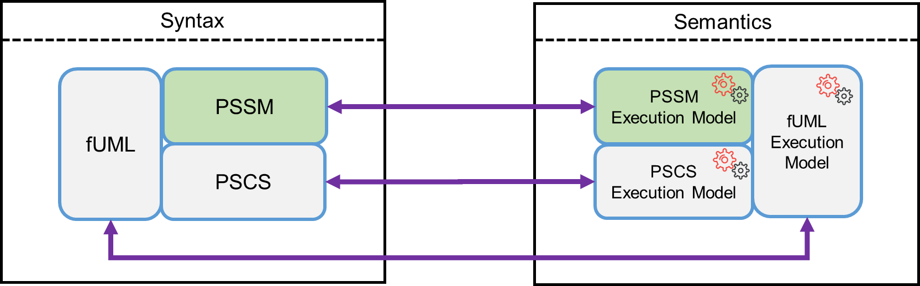
Figure 1.1 - Scope of this specification

Conformance

General
The PSSM specification is based on fUML. Hence, except where explicitly noted in this clause, the definitions, interpretations (meaning), and types of conformance and related terms in this specification fully match their corresponding definitions, interpretations, and types in fUML (see [fUML], Clause 2). Thus, as in fUML, conformance to this specification has two aspects:
- Syntactic Conformance – A conforming model must be restricted to the abstract syntax subset defined in Clause 7 of this specification.
- Semantic Conformance – A conforming execution tool must provide execution semantics for a conforming model consistent with the semantics specified in Clause 8 of this document.

Conformance Levels
The semantic model in Clause 8 are specified as an extension to the semantic model given in [PSCS]. However, the only point at which the semantics given in this specification actually depend on the PSCS semantics is for triggers with “port” references (see [UML], 13.3). There are two levels of conformance defined for this specification, depending on whether an execution tool conforms only to PSSM or conforms to PSSM and PSCS, including the semantics for triggers with “port” references. Both of these have syntactic and semantic aspects, as specified in the following subclauses.

PSSM-only Conformance
- Syntactic Conformance – A conforming model must be restricted to the abstract syntax subset defined in Clause 7 of this specification, including the satisfaction of all additional constraints.
Note. The abstract syntax subset defined in Clause 7 is a superset of the subset defined in [fUML]. Thus, every syntactically conforming fUML model is also a syntactically conforming PSSM model. The PSSM subset does not itself include Ports, so a model syntactically conforming to only the PSSM subset cannot have “port” references on any triggers.
- Semantic Conformance – A conforming execution tool must provide execution semantics for a conforming model consistent with the semantics specified in Clause 8 of this specification. Demonstrating semantic conformance to fUML (as defined in Clause 2 of [fUML] and passing all the tests of the test suite in Clause 9 of this specification, except for those related to triggers with “port” references, is sufficient to demonstrate semantic conformance at this level.

Joint PSSM and PSCS Conformance
- Syntactic Conformance – A conforming model must be restricted to the abstract syntax subset defined by the union of the subset defined Clause 7 of this specification and the subset defined in Clause 7 of [PSCS]. The model shall satisfy all constraints as specified in this specification and in [PSCS].
- Semantic Conformance – A conforming execution tool must provide execution semantics for a conforming model consistent with the semantics specified in Clause 8 of this specification and the semantics specified in Clause 8 of [PSCS]. Demonstrating semantic conformance to fUML (as defined in Clause 2 of [fUML]) and passing all the tests of the test suite in Clause 9 of this specification and all the tests in Clause 9 of [PSCS] is sufficient to demonstrate semantic conformance at this level.

Genericity of the Execution Model
To support a variety of different execution paradigms and environments, the specification of the execution model incorporates a degree of genericity. This is achieved in two ways: (1) by leaving some key semantic elements unconstrained, and (2) by defining explicit semantic variation points. A particular execution tool can then realize specific semantics by suitably constraining the unconstrained semantic aspects and providing specifications for any desired variation at semantic variation points.
The semantic areas that are not explicitly constrained by the execution model in this specification are the same as the ones defined in subclause 2.3 of [fUML]. Different execution tools may semantically vary in these areas in executing the same model, while still being conformant to the semantics specified by the execution model in this specification. Additional semantic specifications or constraints may be provided for a specific execution tool in these areas, so long as it remains, overall, conformant to the execution model. For instance, a particular tool may be limited to a single centralized time source such that all time measurements can be fully ordered.
In contrast to the above areas, subclause 2.3 of [fUML] defines a set of explicit semantic variation points. The execution model as given in this specification by default fully specifies the semantics of these items. However, it is allowable for a conforming execution tool to define alternate semantics for them, so long as this alternative is fully specified as part of the conformance statement for the tool. This specification does not define any further semantic variation points in addition to those defined in fUML. Note, however, that the default event dispatching strategy defined for fUML is replaced by the default strategy given in subclause 8.4.1.2.1 of [PSCS], but this is only relevant for Joint PSSM and PSCS Conformance (see 2.2.2).
If a conforming execution tool wishes to implement a semantic variation in one of the above areas, then a specification most be provided for this variation via a specialization of the appropriate execution model class as identified above. This specification must be provided as a fUML model in the “base UML” subset interpretable by the base semantics of Clause 10 of [fUML]. Further, it must be defined in what cases the variation is used and, if different variants may be used in different cases, when each variant applies, and/or how what variant to use, is to be specified in a conforming model accepted by the execution tool.

Normative References
The following normative documents contain provisions which, through reference in this text, constitute provisions of this specification. For versioned references, subsequent amendments to, or revisions of, any of these publications do not apply.
[fUML] Semantics of a Foundational Subset for Executable UML Models (fUML), Version 1.2.1, http://www.omg.org/spec/FUML
[PSCS] Precise Semantics of UML Composite Structures (PSCS), Version 1.0, http://www.omg.org/spec/PSCS
[UML] OMG Unified Modeling Language (OMG UML), Version 2.5, http://www.omg.org/spec/UML
Note. The semantics of state machines given in this specification are intended to be consistent with the syntax and semantics given in UML 2.5. However, fUML and PSCS are currently formally based on UML 2.4.1 (though PSCS incorporates UML 2.5 clarifications of the semantics of composite structures). For consistency, it is expected that the normative references given here for fUML and PSCS will be updated to versions consistent with UML 2.5, as soon as these become available.
[UTP] UML Testing Profile (UTP), Version 2, Initial Submission, OMG document ad/2014-05-01
Note. UTP v2 is expected to be adopted and finalized before the finalization of PSSM.

Terms and Definitions
For the purposes of this specification, the following terms and definitions apply.

Base Semantics
A definition of the execution semantics of those UML constructs used in the execution model, using some formalism other than the execution model itself. Since the execution model is a UML model, the base semantics are necessary in order to provide non-circular grounding for the execution semantics defined by the execution model. The base semantics provide the “meaning” for the execution of just those UML constructs used in the execution model. The execution model then defines the “meaning” of executing any UML model based on the full foundational subset. Any execution tool that executes the execution model should reproduce the execution behavior specified for it by the base semantics. (The base semantics for this specification are as specified in [fUML].)

Behavioral Semantics
The denotational mapping of appropriate language elements to a specification of a dynamic behavior resulting in changes over time to instances in the semantic domain about which the language is making statements.

Execution Model
A model that provides a complete, abstract specification to which a valid execution tool must conform. Such a model defines the required behavior of a valid execution tool in carrying out its function of executing a UML model and therefore provides a definition of the semantics of such execution.

Execution Semantics
The behavioral semantics of UML constructs that specify operational action over time, describing or constraining allowable behavior in the domain being modeled.

Execution Tool
Any tool that is capable of executing any valid UML model that is based on the abstract syntax subset defined in this specification and expressed as an instantiation of the UML 2 abstract syntax metamodel. This may involve direct interpretation of UML models and/or generation of equivalent computer programs from the models through some kind of automated transformations. Such a tool may also itself be concurrent and distributed.

Static Semantics
Possible context sensitive constraints that statements of a language must satisfy, beyond their base syntax, in order to be well-formed.

Structural Semantics
The denotational mapping of appropriate language elements to instances in the semantic domain about which the language makes statements.

Syntax
The rules for how to construct well-formed statements in a language or, equivalently, for validating that a proposed statement is actually well-formed.

Symbols
There are no symbols or abbreviated terms necessary for the understanding of this specification.

Additional Information

Changes to Adopted OMG Specifications
As specified in 7.6.2.2, the PSSM abstract syntax subset for behavior StateMachines requires that the source and target Vertexes of any Transition be contained in the same StateMachine as the Transition. As discussed in 8.5.3.1, this constraint means that, when a new Transition is added to an extending StateMachine with the intention of having an existing Vertex in the extended StateMachine as its source or target, then that source or target Vertex actually needs to be redefined in the extending StateMachine. This, in turn, implies that any kind of Vertex, whether State or Pseudostate, must be redefinable. However, the UML abstract syntax currently defines State as a RedefinableElement, but not Pseudostate (see [UML], subclause 14.3.2). The UML abstract syntax shall therefore be changed to make Vertex a specialization of RedefinableElement instead of State, and a redefinedPseudostate association shall be added to Pseudostate, with the constraint that the redefining and redefined Pseudostates shall be of the same kind.
Submission Note. It may also be necessary to alter the abstract syntax for Transition guards to allow for event data to be passed into the evaluation of the guard expression. However, this has not been determined yet. (See also 0.5, issue 2.)

Acknowledgments
The following people directly contributed to the development of this specification.
- Yves Bernard, Airbus
- Nerijus Jankevicius, No Magic
- Ed Seidewitz, Model Driven Solutions
- Bran Selic, Simula Research Laboratory
- Daniel Siegl, LieberLieber
- Jeffery Smith, BEA Systems
- Jérémie Tatibouet, CEA

Abstract Syntax

Overview
This clause defines the subset of the UML abstract syntax [UML] for which precise semantics are provided in this specification. Models that syntactically conform to this subset (see 2.1) are simply UML models constructed from the limited set of UML abstract syntax metaclasses included in the PSSM subset defined here. The definition of the subset thus consists of identifying exactly which metaclasses are included.
The subset definition is captured in the package PSSM_Syntax::Syntax, which imports into its namespace exactly those UML metaclasses included in the PSSM subset (see Figure 7.1). A UML model that syntactically conforms to this subset shall have an abstract syntax representation that consists solely of instances of metaclasses that are (imported) members of the PSSM_Syntax::Syntax package. For simplicity, meta-associations from the UML abstract syntax metamodel are not explicitly imported into the PSSM_Syntax::Syntax package, but it is, nevertheless, permissible for the model elements of a conforming model, within the PSSM subset, to be involved in any meta-associations consistent with both the UML metamodel and any further constraints as defined in this specification.
Note. This approach for defining a subset of the UML abstract syntax is similar to the approach used for defining the metamodel subset covered by a UML profile, in which specially identified PackageImports (metamodelReferences) and ElementImports (metaclassReferences) are used to import the metaclasses from the subset into the namespace of the Profile (see Clause 12 of [UML]).
The PSSM subset is an extension of the fUML subset (as specified in Clause 7 of [fUML]), and PSSM_Syntax::Syntax directly includes (via package import) all metaclasses from the Classification, SimpleClassifiers, StructuredPackages, Activities and Actions packages from the fUML subset model. It also includes all metaclasses in the CommonStructure, Values and CommonBehavior packages from the fUML subset, but, in these cases the PSSM subset also includes additional metaclasses from the corresponding UML abstract syntax packages that are not included in the fUML subset. Therefore, the PSSM_Syntax::Syntax package contains CommonStructure, Values and CommonBehavior subpackages that import all the metaclasses from the corresponding fUML packages, plus the additional required metaclasses from the UML abstract syntax metamodel (as further described in 7.2, 7.3, and 7.5, respectively), and the content of these subpackages is then further imported into the top-level Syntax package. Finally, the major extension provided by the PSSM subset is the inclusion of metaclasses from the UML StateMachines abstract syntax metamodel package (as described in 7.6), which are first grouped into the PSSMSyntax::Syntax::StateMachines subpackage and then imported into the top-level Syntax package.
Submission Note. As of fUML 1.2.1, fUML is stilled based on UML 2.4.1, and the fUML subset is defined by creating a copy of a portion of the UML abstract syntax metamodel, such that a package merge of the fUML subset metamodel back into the UML metamodel results in metamodel that is isomorphic to the original UML metamodel (hence validating that the fUML “subset” is, indeed, a proper subset). Since PSSM is required to be based on UML 2.5 (or later), the subsetting approach used here presumes that fUML will migrate to UML 2.5 in its next revision and adopt a similar subsetting approach.
The PSSM subset specified here is not an extension of the PSCS subset. To satisfy the requirements of the “Joint PSSM and PSCS” conformance level (see 2.2.2), the relevant abstract syntax subset is the union of the PSSM subset specified here and the PSCS subset specified in Clause 7 of [PSCS].
In addition to being representable within the PSSM abstract syntax subset, as described above, a UML model that syntactically conforms to PSSM shall also satisfy all relevant constraints defined in the UML abstract syntax metamodel [UML] and the additional syntactic constraints specified here for PSSM. The PSSM semantics specified in Clause 8 are only defined for well-formed PSSM models that meet all the necessary constraints. In the case of “Joint PSSM and PSCS” conformance (see 2.2.2), a well-formed model must further meet all the syntactic constraints required for PSCS (see Clause 7 of [PSCS]).
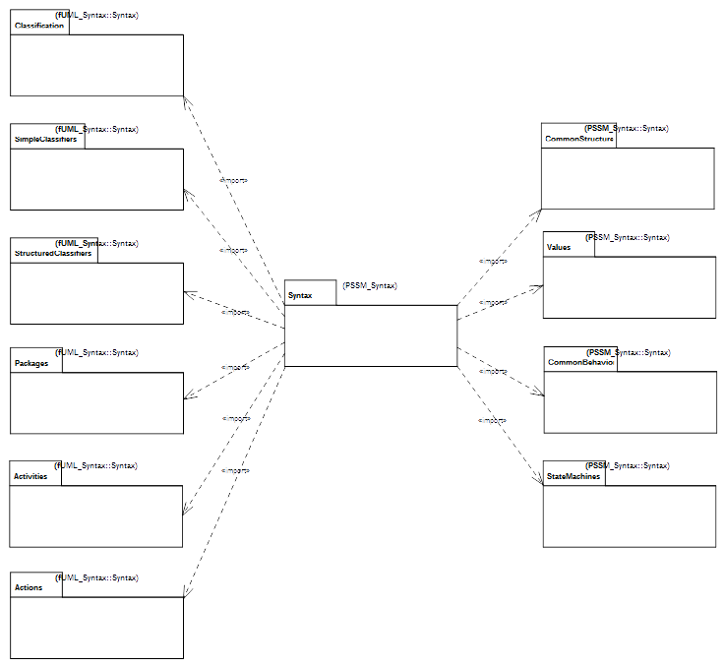
Figure 7.1 - PSSM Syntax Package
The constraints specified for PSSM are all those that are imported members of the PSSM_Syntax::Constraints package (see Figure B.1). Each of these constraints has as its single constrained element the UML abstract syntax metaclass to which the constraint applies.
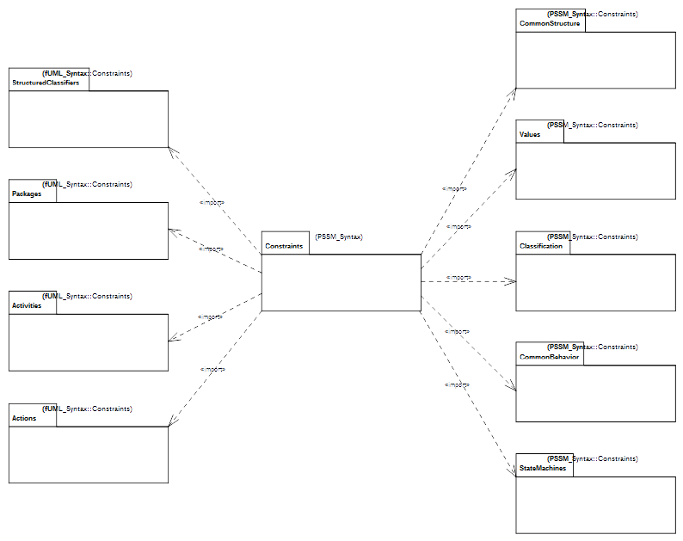Illustration 1 - PSSM Constraints
The PSSM_Syntax::Constraints package includes (via package import) all the constraints from the fUML constraints packages for StructuredClassifiers, Packages, Activities and Actions (see Clause 7 of [fUML]). It also includes all the fUML constraints for CommonStructure, Values and CommonBehavior, but includes additional constraints for the additional metaclasses in the PSSM subset in those areas (see 7.2, 7.3, and 7.5, respectively). In addition, in one case (for Classification::Operation), a constraint from fUML is replaced in PSSM with a less restrictive constraint (see 7.4). Finally, additional constraints are included for the StateMachine abstract syntax specific to PSSM.

Common Structure

Overview
In addition to all the metaclasses included in the fUML subset CommonStructure package, PSSM includes the Constraint metaclass (see Figure 7.2). This metaclass is included in PSSM because the guard of a StateMachine Transition is given as a Constraint (as shown in Figure 7.6). There is also an additional syntactic constraint specified for Constraint, as shown in Figure 7.2 and formally defined in 7.2.2.
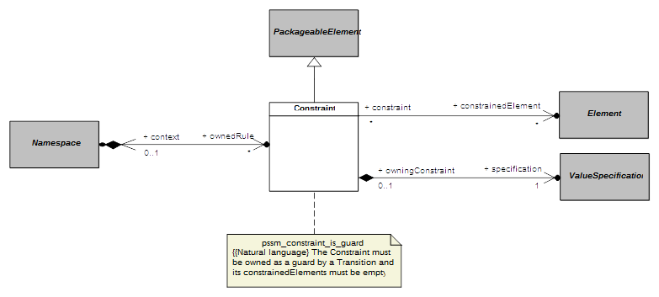Figure 7.2 - Constraints

Constraints

pssm_constraint_is_guard
A Constraint must be owned as a guard by a Transition and its constrainedElements must be empty.
context UML::CommonStructure::Constraint inv:
self.owner.oclIsKindOf(UML::StateMachines::Transition) and
self.constrainedElement->isEmpty()

Values

Overview
In addition to all the metaclasses included in the fUML subset Values package, PSSM includes the Expression and OpaqueExpression metaclasses (see Figure 7.3).
The OpaqueExpression metaclass is included in PSSM in order to provide a way to specify the specification of a Constraint used as the guard of a StateMachine Transition (as shFigure 7.2wn in Figure 7.2). However, in order for such a specification to be precise, an OpaqueExpression is constrained to have a behavior that may be executed to provide the result value of the expression (asFigure 7.3shown in Figure 7.3 and formally d7.3.2fined in 7.3.2).
The Expression metaclass is also used to specify the specification of a guard Constraint, but only in the specific case of an “else” guard on a Transition outgoing from a junction or choice Pseudostate. Such a guard is specified using an Expression show symbol is “else”, with no operands (asFigure 7.3shown in Figure 7.3 and formally d7.3.2fined in 7.3.2). No other forms of Expression are included in PSSM.
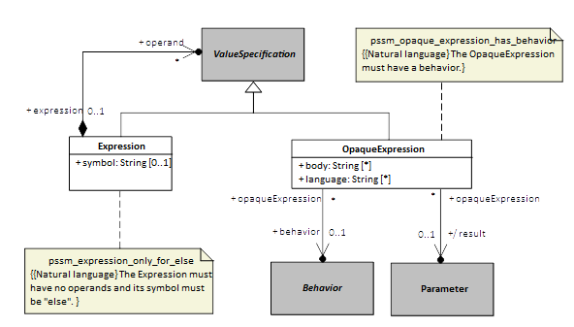
Figure 7.3 - Expressions and OpaqueExpressions

Constraints

pssm_opaque_expression_has_behavior
The OpaqueExpression must have a behavior.
context UML::Values::OpaqueExpression inv:
self.behavior <> null

pssm_expression_only_for_else
The expression must have no operands and its symbol must be “else”.
context UML::Values::Expression inv:
self.symbol = 'else' and self.operand->isEmpty()

Classification

Overview
The PSSM subset includes all the metaclasses in the fUML subset Classification package and does not include any additional ones in this area. However, the fUML constraint zero_or_one_method requires that a concrete Operation have a single associated method. This constraint is too restrictive for PSSM, because PSSM allows an Operation to be handled via a CallEvent trigger on a StateMachine Transition, in which case the Operation cannot have a method (see 7.5). Therefore, the PSSM_Syntax::Constraints::Classification package imports all the constraints from the corresponding fUML package except for the zero_or_one_method constraint, which is replaced with the pssm_operation_has_at_most_one_method constraint (as shown in Figure 7.4 and formally defined in 7.4.2).
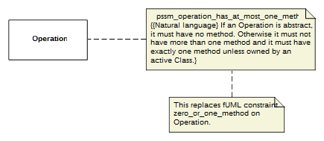Figure 7.4 - Operations

Constraints

pssm_operation_has_at_most_one_method
If an Operation is abstract, it must have no method. Otherwise it must not have more than one method and it must have exactly one method unless owned by an active Class.
context UML::Classification::Operation inv:
if self.isAbstract then self.method->isEmpty()
else
self.method->size() <= 1 and
((self.class = null or not self.class.isActive) implies
self.method->size() = 1)
endif

Common Behavior

Overview
In addition to all the metaclasses included in the fUML subset CommonBehavior package, PSSM includes the CallEvent metaclass (see Figure 7.5). Including CallEvent in the PSSM subset provides the ability for an Operation of a Class in a PSSM conformant model to be handled by a CallEvent trigger on a Transition of a StateMachine acting as the classifierBehavior of that class (see 7.6.2), rather than be implemented by a method. Since the UML specification specifies that having a method on an Operation means all calls on the Operation are handled by executing that method (see [UML], 13.3.3.2), even if there may also be executing Behaviors with CallEvent Triggers for the Operation, Operations on CallEvents in PSSM are constrained not to have a method, in order to avoid confusion. This constraint is shown in Figure 7.5 and formally defined in 7.5.2.
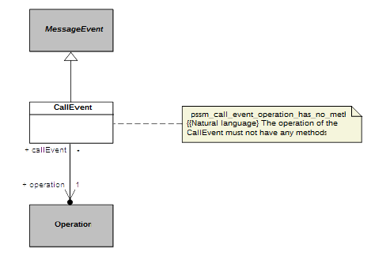Figure 7.5 - CallEvents

Constraints

pssm_call_event_operation_has_no_method
The operation of the CallEvent must not have any methods.
context UML::CommonBehavior::CallEvent inv:
self.operation.method->isEmpty()

State Machines

Overview
Not surprisingly, the largest extension to fUML provided by PSSM is in the area of StateMachines. Within this area, the PSSM subset includes abstract syntax for behavior StateMachines (see 7.6.2) and StateMachine redefinition (see 7.6.3). The formal PSSM subset does not include ProtocolStateMachines, they are discussed non-normatively in Annex A.

Behavior State Machines

Overview
A behavior StateMachine may be used in a PSSM-conformant model either stand-alone or as the classifierBehavior of an active Class. As shown in Figure 7.6, the PSSM subset includes the full UML abstract syntax for behavior StateMachines, except for the ConnectionPointReference metaclass. ConnectionPointReferences are used only in relation to submachine States, and such states are not allowed in a PSSM. Figure 7.6 shows various additional constraints on StateMachines required for PSSM, including the constraints on the usage of StateMachines and the prohibition on submachine States, all of which are formally defined in 7.6.2.2.
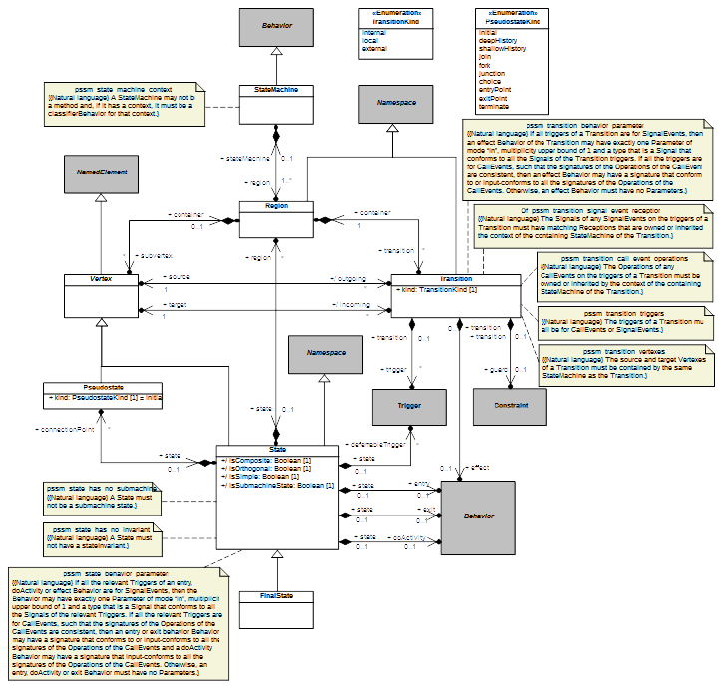Figure 7.6 - Behavior StateMachines

Constraints

pssm_state_machine_context
A StateMachine may not be a method and, if it has a context, it must be a classifierBehavior for that context.
context UML::StateMachines::StateMachine inv:
self.specification = null and
self.context <> null implies self.context.classifierBehavior = self

pssm_state_has_no_submachine
A State must not have a submachine.
context UML::StateMachines::State inv:
not self.isSubmachineState

pssm_state_has_no_invariant
A State must not have a stateInvariant.
context UML::StateMachines::State inv:
self.stateInvariant = null

pssm_state_behavior_parameters
If all the relevant Triggers of an entry, doActivity or effect Behavior are for SignalEvents, then the Behavior may have exactly one Parameter of mode “in”, multiplicity upper bound of 1 and a type that is a Signal that conforms to all the Signals of the relevant Triggers. If all the relevant Triggers are for CallEvents, such that the signatures of the Operations of the CallEvents are consistent, then an entry or exit behavior Behavior may have a signature that conforms to or input-conforms to all the signatures of the Operations of the CallEvents and a doActivity Behavior may have a signature that input-conforms to all the signatures of the Operations of the CallEvents. Otherwise, an entry, doActivity or exit Behavior must have no Parameters.
context UML::StateMachines::State inv:
-- TBD

pssm_transition_vertexes
The source and target Vertexes of a Transition must be contained by the same StateMachine as the Transition.
context UML::StateMachines::Transition inv:
let stateMachine = self.containingStateMachine() in
self.source.containingStateMachine() = stateMachine and
self.target.containingStateMachine() = stateMachine

pssm_transition_triggers
The triggers of a Transition must all be for CallEvents or SignalEvents.
context UML::StateMachines::Transition inv:
self.trigger.event->forAll(
oclIsKindOf(UML::CommonBehavior::CallEvent) or
oclIsKindOf(UML::CommonBehavior::SignalEvent)
)

pssm_transition_call_event_operations
The Operations of any CallEvents on the triggers of a Transition must be owned or inherited by the context of the containing StateMachine.
context UML::StateMachines::Transition inv:
let stateMachine = self.containingStateMachine() in
let context =
if stateMachine.context = null then stateMachine
else stateMachine.context
endif in
context.allFeatures()->includesAll(
self.trigger->select(oclIsKindOf(UML::CommonBehavior::CallEvent)).
oclAsType(UML::CommonBehavior::CallEvent).operation
)

pssm_transition_signal_event_receptions
The Signals of any SignalEvents on the triggers of a Transition must have matching Receptions that are owned or inherited by the context of the containing StateMachine of the Transition.
context UML::StateMachines::Transition inv:
let stateMachine = self.containingStateMachine() in
let context =
if stateMachine.context = null then stateMachine
else stateMachine.context
endif in
context.allFeatures()->select(oclIsKindOf(UML::SimpleClassifiers::Reception)).
oclAsType(UML::SimpleClassifiers::Reception).signal->includesAll(
self.trigger->select(oclIsKindOf(UML::CommonBehavior::SignalEvent)).
oclAsType(UML::CommonBehavior::SignalEvent).signal
)

pssm_transition_behavior_parameters
If all triggers of a Transition are for SignalEvents, then an effect Behavior of the Transition may have exactly one Parameter of mode “in”, multiplicity upper bound of 1 and a type that is a Signal that conforms to all the Signals of the Transition triggers. If all the triggers are for CallEvents, such that the signatures of the Operations of the CallEvents are consistent, then an effect Behavior may have a signature that conforms to or input-conforms to all the signatures of the Operations of the CallEvents. Otherwise, an effect Behavior must have no Parameters.
context UML::StateMachines::Transition inv:
-- TBD

State Machine Redefinition

Overview
The capability for StateMachine redefinition actually does not require any other metaclasses than those already included for behavior StateMachines. However, for clarity, the diagram for StateMachine redefinition from the UML specification is repeated here, showing the additional meta-associations involved (Figure 7.7). This diagram also shows the additional constraint (formally defined in 7.6.3.2) required for the PSSM semantics, which only support the ability of a StateMachine to extend at most one other StateMachine.
Note. Per the discussion in 6.1, the abstract syntax in Figure 7.7 needs to be updated to make Vertex a specialization of RedefinableElement, rather than State.
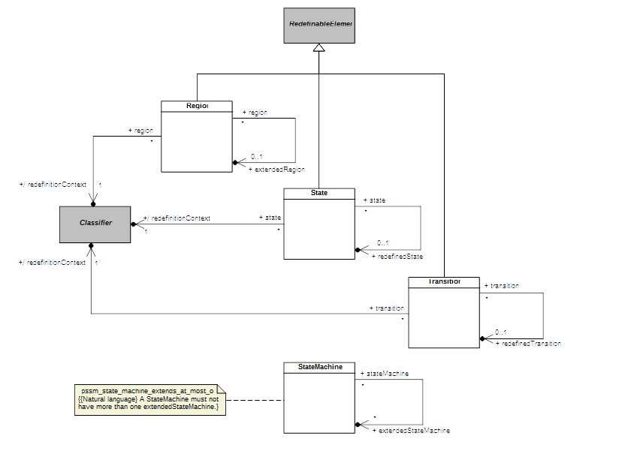Figure 7.7 - StateMachine Redefinition

Constraints

pssm_state_machine_extends_at_most_one
A StateMachine must not have more than one extendedStateMachine.
context UML::StateMachines::StateMachine inv:
self.extendedStateMachine->size() <= 1
Submission Note. Additional constraints need to be defined to enforce the consistency of redefining StateMachine elements with their redefined elements, because the UML 2.5 specification currently only provides default bodies of “true” for the isConsistentWith operations of these elements, which should be enforcing such consistency (see [UML], subclauses 14.5.8, 14.5.9,14.5.10 and 14.5.11).

Execution Model

Overview
This clause defines the precise semantics of the abstract syntax subset specified in Clause 7. This semantic definition is given as an extension to the semantic model for PSCS (see [PSCS], Clause 8), which is itself an extension of the execution model for fUML (see [fUML], Clause 8). This clause includes only the extensions to the PSCS model necessary for PSSM. However, the full semantics for PSSM are given by the fUML execution model as extended for both PSCS and PSSM, which is then a complete, executable fUML model of the operational semantics for the combined PSCS and PSSM subset.
The PSSM execution model is given as an extension of the PSCS model in order to ensure that PSSM semantics are compatible with PSCS semantics. However, the only point at which the PSSM semantic functionality actually depends on PSCS is in the definition of the behavior of Triggers that reference one or more Ports, using the Trigger port property (see [UML], 13.3). An execution tool that conforms at the “PSSM-only Conformance” level (see 2.2.1) is not required to implement the port functionality (since the PSSM-only abstract syntax subset does not include Ports), and none of the reset of the semantic functionality for PSSM depends on the functionality provided by the PSCS execution model extensions. Therefore, a tool conforming at the “PSSM-only” level can effectively treat the PSSM execution model as directly extending the fUML execution model, ignoring all inherited PSCS-specific functionality. A tool conforming at the “Joint PSSM and PSCS Conformance” level (see 2.2.2), on the other hand, must implement the semantics as specified in the entire extension of the fUML execution model by both PSCS and as given for PSSM in this clause.
The circularity of defining PSSM semantics by extending the fUML execution model, which is itself an fUML model, is broken, as it is in fUML. That is, the execution model is defined using only the further subset of fUML whose semantics are separately specified by the fUML base semantics (see [fUML], Clause 10), which do not need to be extended further for the purposes of PSSM. This further subset, known as Base UML (or “bUML”) includes a subset of UML activity modeling that is used to specify the detailed behavior of all concrete operations in the execution model. However, rather than using activity diagram notation to represent such activity models, they are specified in the execution model extensions for PSSM using the Java-syntax textual notation whose mapping to UML is given in Annex A of [fUML].
Submission Note. The Java snippets included in the formal execution model for this initial submission do not fully conform to the limitations of the Java subset as specified in Annex A of [fUML]. The submitters intend to either bring the Java-based textual notation used in the PSSM execution model into complete conformance with the required bUML-subset Java notation or, instead, to define an Alf-subset notation that can be similarly mapped to bUML.
The PSSM extensions to the PSCS execution model are organized into five packages, which are named according to corresponding UML abstract syntax packages. Figure 8.1 shows each of these packages and their dependencies on packages from the fUML, PSCS and PSSM syntactic and semantic models, These dependencies are represented as package-import relationships, which also make the unqualified names of the necessary syntactic and semantics elements visible for use in the detailed behavioral code of each of the PSSM semantics packages. Each PSSM semantic package also publicly exports all its imported members, allowing those packages to be organized in a layered fashion. This layering starts with the small semantic extensions defined in the Values, StructuredClassifiers and CommonBehavior packages, which are used in defining the primary PSSM semantics in the StateMachines package, which are then fully integrated into the semantic infrastructure of the fUML execution model in the Loci package.
Submission Note. Just as the PSSM abstract syntax model in Clause 7 is defined assuming that the fUML abstract syntax model has been reorganized according to UML 2.5, the PSSM execution model presented in this clause presumes that both the fUML and PSCS execution models have been similarly reorganized in a parallel fashion. However, the cross-references given in this clause to fUML and PSCS are to the current specifications documents ([fUML] and [PSSM]), which, at this time, are still organized according to the structure of UML 2.4.1.
The subsequent subclauses in this clause describes each of the PSSM semantics packages in turn. The description includes a class model for the contents of the package and an explanation of the operational semantics defined by the functionality of the classes in the model. The detailed behavior code for the operations of the classes is not included in this document, but can be found in the associated normative XMI file for the PSSM semantic model that is described in this clause.
Submission Note. The detailed behavior code for the operations of the PSSM execution model may be included in the revised submission document, similarly to how such code was included in the fUML and PSCS specification documents.
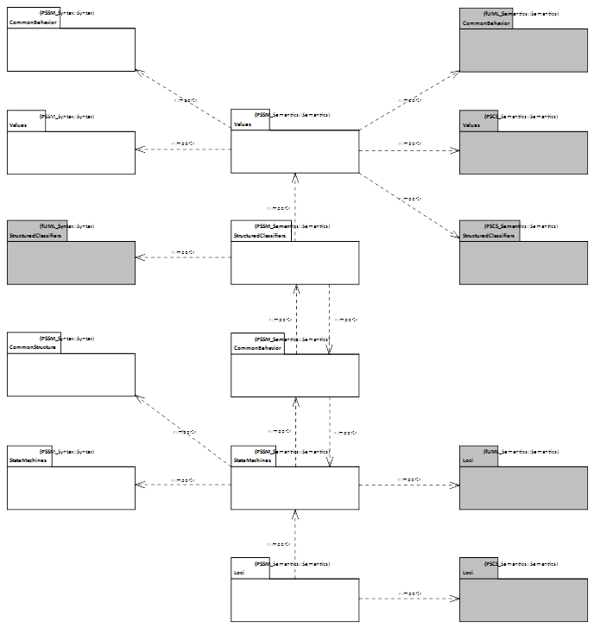Figure 8.1 - PSSM Semantics Package

Values
The Values package in the PSSM abstract syntax subset extends the Values package from the fUML abstract syntax by adding the OpaqueExpression metaclass (see 7.3). As shown in Figure 8.2, the semantics for OpaqueExpressions in PSSM is defined by the corresponding semantic visitor class SM_OpaqueExpressionEvaluation. This class is a specialization of the CS_OpaqueExpressionEvaluation class defined in the PSCS semantics (see [PSCS], 8.3.1.2.2).
An OpaqueExpression in PSSM is required to have an associated behavior. As in PSCS, the evaluation of an OpaqueExpression consists in executing its associated behavior. The functionality for this is provided by the executeExpressionBehavior operation defined in the CS_OpaqueExpressionEvaluation class. The PSSM SM_OpaqueExpressionEvaluation adds a new context attribute and redefines the executeExpressionBehavior operation such that the OpaqueExpression behavior is executed with the given context Object. This extension is necessary to allow an OpaqueExpression used as the specification of a guard Constraint on a StateMachine Transition to be evaluated in the proper context for that StateMachine (see 8.5.2.6).
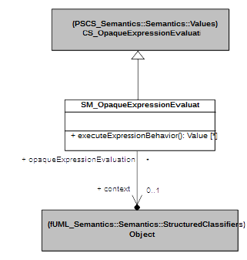Figure 8.2 - Values Extension

Structured Classifiers
The PSSM abstract syntax subset does not extend the StructuredClassifiers package from the fUML abstract syntax. However, the PSSM execution model StructuredClassifiers package includes a specialization of the semantics of Objects, as shown in Erreur : source de la référence non trouvée. The SM_Object class redefines the startBehavior operation from the fUML Object class (which is inherited without change by the PSCS CS_Object class) such that, when the Behavior of an active Object is started, a SM_ObjectActivation (as defined in 8.3) is instantiated for it, rather than the usual fUML ObjectActivation.
SM_Object also redefines the destroy operation from the fUML Object class to ensure that, when an Object is destroyed, any EventOccurrences remaining in the eventPool of the ObjectActivation are also removed, before carrying out the functionality of stopping the ObjectActivation for the Object and removing the Object from its Locus. This avoids the possibility of the event-dispatch loop of the ObjectActivation still getting a next event even once the Object has been removed from the Locus.
SM_RedefinitionBasedDispatchedStrategy redefines dispatch and getMethod from the fUML RedefinitionBasedDisptachStrategy class. Operation getMethod redefinition captures the exact same semantics than fUML except that it is allowed to return null if an Operation does not have an implementation (i.e., an associated behavior). Operation dispatch redefinition ensures in the case where getMethod returns a null value then a CallEventExecution (see 8.5.2.8.2). In any other case, the dispatch operation behaves exactly as in PSSM: it create the required type of execution for the behavior provided as a parameter.

Common Behavior
The CommonBehavior package in the PSSM abstract syntax subset extends the CommonBehavior package from the fUML abstract syntax by adding the CallEvent metaclass (see 7.5). However, the semantics of CallEvent is defined as part of the semantics of the triggering of StateMachine Transitions (see 8.5.2.6), not in the CommonBehavior semantics. Instead, as shown in Figure 8.4, the CommonBehavior package in the PSSM execution model includes the SM_ObjectActivation class, which specializes the ObjectActivation class from fUML (see [fUML], 8.4.3.2.7). The SM_Object class in the StructuredClassifiers package of the PSSM execution model provides the functionality for instantiating an SM_ObjectActivation instead of a regular ObjectActivation when the Behavior of an active Object is started (see 8.3).
The rationale for providing a specialization of the fUML ObjectActivation class is that in the context of PSSM it is required to to add semantics to handle two types of EventOccurrence which are specific to state machines: CompletionEventOccurrence (see 8.5.2.7.1) and DeferredEventOccurrence (see 8.5.2.7.3). This implies that SM_ObjectActivation class redefines operations provided by the fUML ObjectActivation class but also add new attributes and operations.
The SM_ObjectActivation defines a new deferredEventPool of DeferredEventOccurrences, which is used in the specification of the semantics for the deferredEvents of a State (as also given in 8.5.2.4). This pool contain the set of event occurrences that in the current state machine configuration are deferred.
The SM_ObjectActivation redefines the operation getNextEvent provided by the fUML class ObjectActivation. The purpose is to extend the way that events are retrieved from the event pool to account for computation relative to CoomletionEventOccurrence as well as DeferredEventOccurrencee. In the state machines context the action of retrieving an event from the pool is defined as follows:
- While completion event occurrences are available at the event pool, then completion event occurrences are r before any other event occurrences. The dispatching order is the order in which the completion event occurrences were added to the event pool.
- If there is no remaining completion event occurrence in the event pool, then regular event occurrences are dispatched according to the chosen event retrieval strategy (see GetNextEventStrategy in [fUML], 8.4.3.1). The one provided by default relies on FIFO (First In First Out) policy. All event occurrences are handled in an exact same way than fUML, except that in the case of DeferredEventOccurrence, the event occurrence that is retrieved is the one that is referenced by the DeferredEventOccurrence (which is the actual deferred event occurrence).
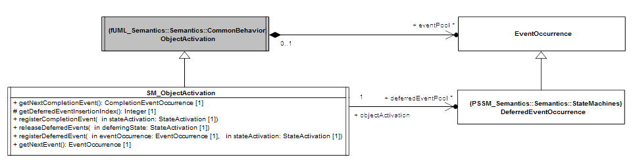
Figure 8.4 - CommonBehavior Extension
The SM_ObjectActivation class also adds the following set of operations:
- registerCompletionEvent operation is used to add a CompletionEventOccurrence to the eventPool of the SM_ObjectActivation when the activation of a StateMachine State completes (see 8.5.2.4). When added to the event pool a CompletionEventOccurrence is always placed after all completion event occurrences already existing in the pool.
- registerDeferredEvent operation is used to add an Eventoccurrence that is requested to be deferred by a state activation to the deferred event pool of the SM_ObjectActivation. The EventOccurrence that is deferred is wrapped into a DeferredEventOccurrence and added at the end of the set of deferred event occurrences.
- releaseDeferredEvent operation is used to release all event occurrences that were deferred by a state activation. The event occurrences that were deferred are removed from the deferred event pool and return to the regular event pool. All events returning to the regular event pool are placed in that pool after all existing completion event occurrences but before any other event occurrence already present in the pool. The order in which the deferred events occurrences return to the pool is the order in which they have been placed in the deferred event pool.

State Machines

Overview
The StateMachines package of the PSSM abstract syntax (see 7.6) defines the subset of the UML abstract syntax for StateMachines that is covered by the PSSM semantics. This subset includes primarily the syntax for so-called behavior StateMachines (see 7.6.2), the primary kind of executable StateMachine included in UML. The semantics for behavior StateMachines are modeled in the StateMachines package of the PSSM execution model, which is described in 8.5.2.
The PSSM subset also includes the additional meta-associations from the UML abstract syntax required in models that use StateMachine redefinition (see 7.6.3). The semantics for StateMachine redefinition is included in the functionality provided by the classes in the StateMachines package of the PSSM execution model. However, in order to clearly describe the interpretation of StateMachine redefinition captured in the PSSM semantics, these semantics are discussed separately in 8.5.3.
Finally, the UML abstract syntax also includes the syntax for ProtocolStateMachines (see [UML], 14.4). However, the operational execution of ProtocolStateMachines requires the raising of exceptions when the protocol defined by the StateMachine is violated, but the semantics of exceptions are not currently included in fUML. Therefore, the PSSM execution model does not include formal operational semantics for ProtocolStateMachines. Instead, Annex A gives a non-normative description of the semantics that is more precise then that given in the UML specification, but without a formal execution model.

Behavior State Machines

State Machine Execution
Figure 8.5 shows the root classes in the StateMachines package of the PSSM execution model related to the execution of a StateMachine.
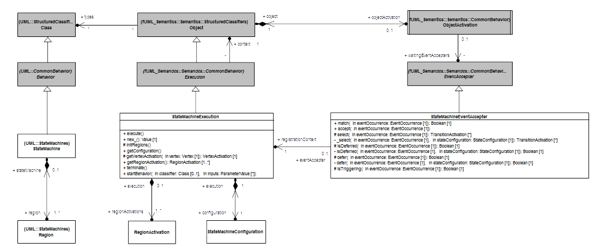Figure 8.5 - StateMachineExecution

StateMachineExecution
In the fUML execution model, the abstract Execution class represents that execution of any kind of Behavior (see [fUML], 8.4.2.1.1). The Execution class is specialized to ActivityExecution to specify the semantics of Activities in fUML. Similarly, the PSSM execution model includes a StateMachineExecution class that acts as the root element for specifying the execution semantics for StateMachines.
In the UML abstract syntax, Behaviors are a kind of Class. Correspondingly, in the fUML execution model, Executions are a kind of Object, and the Behavior being Executed is associated as the (single) type of the Execution, considered as an Object. For a StateMachineExecution, this type will always be a StateMachine.
A StateMachine is composed of one or more Regions (see 7.6.2.1). The semantics of the Regions in a StateMachine are captured in corresponding RegionActivation classes associated with a StateMachine execution for the StateMachine (see 8.5.2.2). The StateMachineExecution is responsible for creating a RegionActivation for each of the Regions of its StateMachine, and the RegionActivations then create (in a cascade) SemanticVisitors for all their contained elements.
The execution of a StateMachine starts when the execute operation is called on a StateMachineExecution for it. Since a StateMachine is always invoked asynchronously in fUML, the CommonBehavior semantics of fUML (see [fUML], 8.4.3) ensure that the invocation of the execute operation of a StateMachineExecution will always take place as part of a run-to-completion (RTC) step for an initial InvocationEventOccurrence for the StateMachineExecution.
The execution of the StateMachine then proceeds by concurrently entering all RegionActivations of the StateMachineExecution (as discussed in 8.5.2.2). The initial RTC step completes once the StateMachine has reached a stable configuration.
The current configuration of a StateMachineExecution is represented as an instance of the StateMachineConfiguration class. A StateMachineConfiguration represents the hierarchy of active States that the StateMachineExecution currently is in (as discussed further in 8.5.2.3). A configuration is stable once all the Transitions triggered in an RTC step have been traversed and any invoked entry Behaviors have completed (see [UML], 14.2.3.4.2). This configuration is used to determine how the StateMachineExecution will proceed in response to subsequent dispatched EventOccurrences accepted by the StateMachineExecution.
A StateMachineExecution completes when all its RegionActivations have themselves completed. A StateMachineExecution may also be terminated when a terminate Pseudostate is reached, regardless of its level of nesting. The termination of a StateMachineExecution implies the termination of all of its RegionActivations, as captured in the behavior of the terminate operation of the StateMachineExecution class. This operation is also called when a StateMachine is terminated due to its context Object being destroyed.

StateMachineEventAccepter
Once the initial RTC step has completed for a StateMachineExecution, the StateMachineExecution will generally need to be able to handle EventOccurrences for Events linked to Triggers on the Transitions of the StateMachine being executed. The fUML CommonBehavior semantics provides a general model for the registration of EventAccepters with the ObjectActivation of an active Object, in order to allow an Execution to respond to EventOccurrences dispatched from the eventPool for that ObjectActivation (see [fUML], 8.4.3). A StateMachineExecution uses this mechanism by registering a single, specialized StateMachineEventAccepter instance with the ObjectActivation of its context Object.
Note. In the fUML execution model, each AcceptEventActionActivation that fires within an ActivityExecution will register its own AcceptEventActionEventAccepter with the ObjectActivation of the context of the ActivityExecution (see [fUML], 8.6.4.2.1 and 8.6.4.2.2). Thus, an ActivityExecution can potentially have several registered EventAccepters associated with it at any one time. In contrast, an executing StateMachineExecution will always have exactly one registered StateMachineEventAccepter associated with it. The reason for this is that, in order to account for priorities, conflicts, etc. between Transitions between these active States, how a StateMachineExecution responds to any specific EventOccurrence requires an analysis of the entire current StateMachineConfiguration It is therefore not possible to associate separate, independent EventAccepters with, say, each individual Transition within the StateMachine being executed.
The fUML EventAccepter class has two abstract operations, match and accept, whose concrete behavior must be provided by any concrete subclass of EventAccepter. The match operation is used to determine if the EventAccepter is able to accept a given EventOccurrence. If the EventAccepter does match an EventOccurrence, and is chosen to actually handle that EventOccurrence, then an RTC step for handling the EventOccurrence is initiated by calling the accept operation on the chosen EventAccepter.
The specified behavior of the match and accept operations for a StateMachineEventAccepter rely on the association of the StateMachineEventAccepter with its registrationContext, that is, the StateMachineExecution that originally registered the StateMachineEventAccepter. A StateMachineEventAccepter will match a dispatched EventOccurrence in the following situations:
- The EventOccurrence is deferred in the current StateMachineConfiguration of the registrationContext. In this case, if the EventOccurrence is subsequently accepted by the StateMachineEventAccepter, it is placed in the deferredEventPool for the ObjectActivation (which, therefore, must be an SM_ObjectActivation, as described in 8.4).
- The EventOccurrence triggers one or more Transitions in the StateMachine of the registrationContext. In this case, if the EventOccurrence is subsequently accepted by the StateMachineEventAccepter, the functionality of the SemanticVisitors associated with various elements of the StateMachine being executed results in the StateMachineExecution moving to a new stable configuration during the course of the RTC step (as described in 8.5.2.2 and following subclauses).
The two aforementioned situations are identified by the analysis of the state machine configuration. This analysis is based on a recursive algorithm that starts from the more nested state activations referenced as being active in the current state-machine configuration. This enables the algorithm to account for transition priorities which are relative to the level of nesting of their source states. The StateMachineEventAccepter class provides to main operations dedicated to the analysis of the state machine configuration : isDeferred and isTriggering. The isDeferred operation returns true if the proposed event occurrence must be deferred in the current state-machine configuration. The isTriggering operation returns true if the proposed event occurrence triggers at least one transition in the current state machine configuration.
Both operations rely on the select operation which is responsible for building the set of transitions that can be fired using the proposed EventOccurrence. The set built by this operation only contains transitions which lead from the current state machine configuration to a valid state machine configuration. Indeed before to enter the set of transition to be fired the entire compound transition is analyzed to determine if it is possible to find at least one valid path to a target state-machine configuration.

State Machine Semantic Visitors
Figure 8.6 shows the base SemanticVisitors introduced in the PSSM semantic model to specify the semantics of the various elements of a StateMachine. VertexActivation captures the basic semantics for Vertexes, and TransitionActivation captures the basic semantics for Transitions. These visitors are both further specialized in the semantic model to respectively capture semantics of different kinds of Vertexes and Transitions. VertexActivations and TransitionActivations are always owned by a RegionActivation, which captures the semantics of the Region that owns the corresponding Vertexes and Transitions.
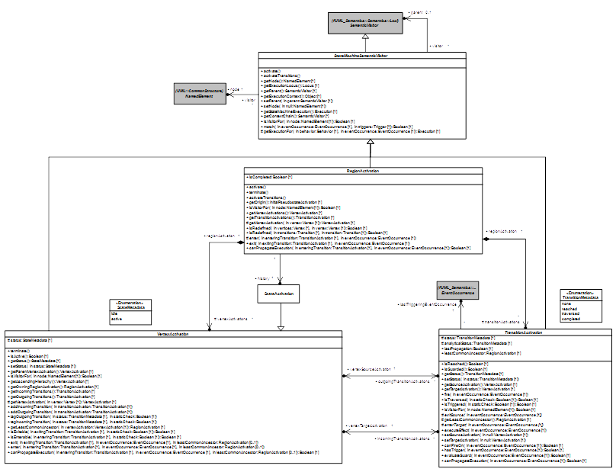
Figure 8.6 - StateMachine SemanticVisitors

StateMachineSemanticVisitor
A StateMachineSemanticVisitor is an fUML SemanticVisitor for an element within a StateMachine (as opposed to the StateMachine itself, whose SemanticVisitor is a StateMachineExecution, as discussed in 8.5.2.1). A StateMachineSemanticVisitor is actually generically associated with a NamedElement, because this is the most specialized kind of UML syntax element that is common to all the elements within a StateMachine that need to be given semantics (e.g., Regions, Vertexes and Transitions). However, as specified for each of the various kinds of StateMachineSemanticVisitor in the following, the node of each kind of StateMachineSemanticVisitor will always be a corresponding kind of StateMachine element.
A StateMachineSemanticVisitor may also generically have another SemanticVisitor as its parent (which will be either itself a kind of StateMachineSemanticVisitor or a StateMachineExecution). The parent-child hierarchy of the StateMachineSemanticVisitors for a StateMachine reflects the hierarchical organization of the StateMachine syntactic elements associated with those StateMachineSemanticVisitors. For example, the StateActivations for all States in a Region will have the RegionActivation for that Region as their parent, and the RegionActivations for all Regions in a composite State will have the StateActivation for that State as their parent. Ultimately, this tree structure of StateMachineSemanticVisitors is rooted in the StateMachineExecution for the StateMachine being executed.
The StateMachineSemanticVisitor class also takes advantage of the generic tree-structured hierarchy of StateMachineSemanticVisitors for a StateMachineExecution in order to provide certain utility operations that are inherited by all specialized StateMachineSemanticVisitors.
- The getStateMachineExecution operation returns the StateMachineExecution at the root of the tree.
- The getExecutionContext operation returns the context object of the root StateMachineExecution.
- The getExecutionLocus operation return the locus at which the root StateMachineExecution resides (in fUML, every Object, including every Execution, resides at a specific Locus; see [fUML], 8.2.2.2.6).
- The isVisitor operation returns true if the current StateMachineSemanticVisitor is a semantic visitor for the given NamedElement. By default this operation returns true if the node attribute of the StateMachineSemanticVisitor is reference the same model element than the one provided in parameter. Specializing classes add functionality to this operation.
- The getExecutionFor operation returns an Execution for the behavior provided in Parameter. If an EventOccurrence is passed to this operation the returned Execution is an EventTriggeredExecution (see 8.5.2.8.1). This is a specific Execution that is able to exploit the given EventOccurrence to pass the data that may be embedded to the behavior that is executed. In any other case, the regular execution type (e.g. ActivityExecution) enabling the behavior to be executed is returned.
Each specialized kind of StateMachineSemanticVisitor adds functionality to the base StateMachineSemanticVisitor class to capture the semantics of a specific kind of StateMachine element. These semantics are always split into two distinct parts:
- After a StateMachineSemanticVisitor is instantiated, it is activated by calling the activate and activateTransitions operations. These operations are redefined in each kind of StateMachineSemanticVisitor in order to specify the appropriate activation semantics.
- Additional operations are defined for each kind of StateMachineSemanticVisitor in order to specify the execution semantics specific to the kind of StateMachine element associated with that kind of StateMachineSemanticVisitor.

RegionActivation
A RegionActivation captures the semantics of a Region. Thus, the node of a RegionActivation is always a Region. The instances of all other kinds of StateMachineSemanticVisitors are always contained in a RegionActivation.
A RegionActivation is responsible for the instantiation of all visitors required to execute model elements contained in the associated Region. To achieve this task a RegionActivation adds functionality to operations activate and activateTransitions. Hence, during the execution of a StateMachine, a RegionActivation owns a set of VertexActivations and TransitionActivations that are the visitors for the Vertexes and Transitions contained in the associated Region.
A RegionActivation is entered by calling the enter operation and exited by calling the exit operation. A RegionActivation may be entered or exited implicitly or explicitly.

Entering a RegionActivation
A RegionActivation can be entered either implicitly or explicitly.
- An implicit entry consists in starting the Region execution using the initial Pseudostate (if any) and firing its continuation Transition. Note that if the initial Pseudostate does not exist, then the RegionActivation is considered as being immediately completed. This leads the execution to properly ignore the execution of that particular RegionActivation.
- An explicit entry occurs when the Region is entered via a Transition with a source outside the Region and a target inside the Region. The Region execution does not then start with an initial Pseudostate. Instead, the RegionActivation is considered to be entered when the VertexActivation for the target Vertex internal to the Region is entered. Note that this case can only happen if the RegionActivation is owned by a StateActivation. The owning StateActivation will always have been entered before any of its RegionActivations are actually started (see 8.5.2.4).

Exiting a RegionActivation
A RegionActivation can be exited either implicitly or explicitly.
- An implicit exit of one or more RegionActivations occurs when a TransitionActivation exits a StateActivation for a composite state. In this case, the all RegionActivations currently executing in the StateActivation are exited. This implies that all VertexActivations located within the RegionActivation are also exited. The exiting sequence for each RegionActivation starts by exiting the most nested VertexActivations.
- An explicit exit of a RegionActivation occurs when a TransitionActivation exits a VertexActivation located in that RegionActivation and the target VertexActivation is located outside the RegionActivation. In this case, the RegionActivation that is exited explicitly starts the exiting sequence using the source VertexActivation (note that if the StateActivation is for a composite state, then active VertexActivation(s) located within are exited first). Other RegionActivation s(if any) start their exiting phase using their innermost VertexActivations.
The final point of exiting either implicitly or explicitly one or more RegionActivations owned by a StateActivation consists in executing the exit behavior (if any) attached to the associated State and traversing the exiting Transition.

Completion of a region activation
RegionActivations never reach completion by being exited either implicitly or explicitly. There are two ways to complete the execution of a region.
- The general rule is that a RegionActivation can only complete if a FinalStateActivation (see 8.5.2.4) for a FinalState owned by the Region is executed. This leads the RegionActivation to be marked as being completed (its isCompleted attribute is set to true).
- The above general rule is violated only in the situation where a VertexActivation owned by a RegionActivation is exited and the TransitionActivation that exits that VertexActivation has as its target the StateActivation owning the RegionActivation. In this case, and only in this case, does the RegionActivation that owns the exited VertexActivation complete.

Termination of a RegionActivation
A RegionActivation can be terminated (using is terminate operation). The termination of a RegionActivation occurs as the result of the termination of the StateMachineExecution. It consists in terminating all VertexActivations owned by the RegionActivation. Finally, the terminated VertexActivations are destroyed.

History of a RegionActivation
The RegionActivation class adds a history attribute. This attribute is a reference to the last known State that was active in that RegionActivation. It can be updated in two situations:
- A state that is directly owned by the region is entered. During its entry sequence the StateActivation updates the history of its containing region. Hence the StateActivation that is referenced is the one which actually performed the entry.
- A final state that is directly owned by the Region is entered.. During its entry sequence, it resets the region's history. The consequence that if the final state is reached the region is considered as having no history.
The single situation in which an RegionActivation can have a history is when it was exited (implicitly or explicitly) while one ifs owned state was active. This information is used by deep and shallow history pseudostates (see XX) to determine how the Region must be restored.

Extension and RegionActivation
A Region can extends another Region. The direct implication of this is that a RegionActivation can be the semantic visitor of a set of regions. This set is built using the extension relationships existing between the regions.
Let consider the example where R1 is extended by R2 which is itself extended by R3. In that situation the RegionActivation instantiated for R3 is of course the state-machine semantic visitor of R3 but also a visitor for R2 and R1. To make this possible, RegionActivation class redefines the isVisitorFor operation.
The possibility to extend a Region has also impact on the instantiation semantics that is provided by a RegionActivation. Indeed vertices and transitions that are present in extended regions but not redefined need to be have dedicated TransitionActivation and VertexActivation visitors. Following this strategy, the RegionActivation constructs a set of visitors that represent the dynamic merge of the extended regions. This set is then used to perform the interpretation of the region.

Evaluation of a RegionActivation
The static analysis of compound transitions that takes place during the matching phase of the StateMachineEventAccepter against a particular EventOccurrence may lead to to check if transitions and vertices located within a Region materialize a valid path to a target state machine configuration.
During the static analysis of the Region two situations can be encountered:
- The target of the transition that is used to enter the Region is an internal vertex vertex of that Region. That means the Region is going to be entered explicitly, therefore no implicit path starting from an initial pseudo-state need to be evaluated.
- The target of the transition that is used to enter the Region is an internal vertex vertex of that Region. That means the static analysis must be propagated through the initial pseudo state activation owned by the Region. If the propagation through of the static analysis through this path is accepted then the path is also valid from the Region standpoint. Conversely if the propagation is refused by the intial pseudostate then the path is considered as being invalid from the region standpoint.
The static analysis of a Region is provided by the canPropagateExecution operation of the RegionActivation class.

VertexActivation
VertexActivation is the base class for all StateMachineSemanticVisitors capturing semantics of specializations of Vertex (i.e., State, FinalState and Pseudostate). A VertexActivation is always owned by a RegionActivation. It is associated with a set of TransitionActivations for the outgoing Transitions of its Vertex and another set for the incoming Transitions.

VertexActivations and StateMachineConfiguration
A VertexActivation captures the status of a Vertex. The Vertex is either idle or active. In essence, if the Vertex is a State then to be active, the State must be in the current StateMachine configuration. Conversely, if the State is not in the StateMachine configuration, it is idle.

VertexActivation entry and exit
The VertexActivation class defines the common way to enter and exit any kind of Vertex.
- A Vertex can only be entered if its prerequisites (specific to each kind of Vertex, based on its redefinition of the VertexActivation isEnterable operation) have been fulfilled. In this case, and only in this case, can the VertexActivation be entered (using its enter operation). The entry semantics are specific to each kind of Vertex. Nevertheless, each specialized Vertex is entered using a given entering Transition and knows about the common ancestor it shares with the source VertexActivation. The entered VertexActivation always takes advantage of the common ancestor (a RegionActivation) information to identify if the parent VertexActivation must also be entered.
- A Vertex can only be entered if its prerequisites (specific to each kind of Vertex, based on its redefinition of the VertexActivation isExitable operation) have been fulfilled. In this case, and only this case, can the VertexActivation be exited (using its exit operation). The exit semantics are specific to each kind of Vertex. Nevertheless, each specialized Vertex is exited using a given exiting Transition and knows about the common ancestor it shares with the target VertexActivation. The exited VertexActivation always takes advantage of the common ancestor (a RegionActivation) information to identify if the parent VertexActivation must be exited before it.

VertexActivation termination
The VertexActivation class does not enforce a particular termination semantics. These semantics are specific to each subclass of VertexActivation. They are captured through the different redefinitions of the terminate operation.

Evaluation of a VertexActivation
The static analysis of compound transitions may lead to traverse a VertexActivation to check the validity of the path currently explored. The VertexActivation class defines how the analysis must be propagated through the a VertexActivation. It consists in propagating the analysis to the parent vertex activation. The propagation in the parent is constrained by the common ancestor computed between the current VertexActivation and the VertexActivation that was the source of the entering transition. This means that while the common ancestor is not encountered the analysis is propagated to the parent. The verdict of the analysis is the verdict of the propagation made to the parent vertex activation.
The static analysis of a Vertex is defined by the canPropagateExecution operation provided the by the VertexActivation class. Note that specialization of VertexActivation add functionality to the static analysis sequence by redefining this operation.

TransitionActivation
A TransitionActivation is the base class for all StateMachineSemanticVisitors capturing Transition semantics. TransitionActivations have the responsibility to link VertexActivations that capture Vertex semantics. A TransitionActivation references the VertexActivation for the source and target Vertices of its Transition. It also has a status that defines the current situation of the Transition. For instance, reach means that the TransitionActivations originates from a VertexActivation that is currently active.

Evaluationof TransitionActivation
A TransitionActivation can evaluate the guard of its associated Transition (using its evaluateGuard operation), if there is one on the visited transition. It is also capable of determining if the Transition can be triggered by a specific EventOccurrence (using its canFireOn operation). These evaluation semantics are common to all kinds of TransitionActivations.
Evaluation sequence of a TransitionActivation always takes place during the analysis of the state machine configuration. It enables to determine that in addition to have a trigger matching the dispatched event occurrence and a guard evaluating to true that the TransitionActivation if fired, will lead the state machine to enter a valid state machine configuration. If this is not the case the TransitionActivation will not be part of set of transitions that need to be fired in the next run-to-completion step.
To make this static analysis possible, the TransitionActivation class provides a canPropagate operation. The operation is responsible of propagating the static analysis on the target VertexActivation of the TransitionActivation. For the TransitionActivation it is required that the static analysis can be propagated through target VertexActivation. This means a valid path was found by the static analysis and therefore the TransitionActivation can be part of the set of TransitionActivation to be fired.
In addition to the canPropagate operation, the TransitionActivation class also adds three attribute to deal with the static analysis:
- analyticalStatus: captures the status of TransitionActivation from the static analysis standpoint.
- lastTriggeringEventOccurrence: references the last event occurrence that was used to during static analysis by the TransitionActivation. It enables to detect if that TransitionActivation was already explored using the same event occurrence.
- lastPropagation: captures the last result of the static analysis propagation when this transition was explored. If the transition was explored using the same event occurrence than the current analysis then instead of performing the analysis another time, the last known result is provided.

Firing
The Transition firing sequence is also common to all kinds of TransitionActivations (using the fire operation). It always consists of the following steps:
- The Transition source may be exited. This depends on the kind of Transition that is actually firing. The exit sequence performed by the exited VertexActivation depends on the type of the source Vertex.
- The effect Behavior of the Transition is always executed.
- The Transition target may be entered. This depends on the kind of Transition that is actually firing. The entry sequence performed by the entered VertexActivation depends on the type of the target Vertex.
A firing sequence can thus be viewed as a chain of calls:
fire()
exit(exitingTransition, eventOccurrence, commonAncestor)
exit(exitingTransition, eventOccurrence, commonAncestor)
…
executeEffect(eventOccurrence)
enter(enteringTransition, eventOccurrence, commonAncestor)
enter(enteringTransition, eventOccurrence, commonAncestor)
end
The fire operation of a TransitionActivation initiates the exit sequence of the source VertexActivation. Assuming that the prerequisites of the source Vertex are fulfilled, the exit sequence consists of a call to the exit behavior of the source VertexActivation. This exit sequence can nest a number of exit calls. These nested calls propagate the exit sequence to parent VertexActivations as long as the common ancestor of the source and the target VertexActivations has not been reached. As soon as the exit sequence is terminated, if the Transition has an associated effect Behavior, it is executed. After the execution of this Behavior, the target VertexActivation is entered via a call to its entry Behavior (assuming that the prerequisites for entering the target VertexActivation are fulfilled). This call can lead to a number of nested enter calls that are used to enter parent VertexActivations before the actual target VertexActivation is entered. The call nesting ends when the common ancestor between the source and the target VertexActivations is reached.
Note. The triggering of the exit or entry sequence of a VertexActivation depends on the kind of Transition. Each specialization of a TransitionActivation is intended to provide the appropriate semantics be redefining the operations exitSource and enterTarget.

State Machine Configuration
A StateMachineExecution always has an associated StateMachineConfiguration. As shown in Figure 8.7, this configuration represents the hierarchy of active States in which the currently executed StateMachine is.
The view that is provided through the StateMachineConfiguration offers a simple way to evaluate:
- Transitions that can be fired using the dispatched EventOccurrence.
- If the currently dispatched EventOccurrence can be deferred.
The StateMachineConfiguration is always evaluated through the StateMachineEventAccepter that is registered in the ObjectActivation attached to the StateMachineExecution context. It determines the way that dispatched EventOccurrences are handled.
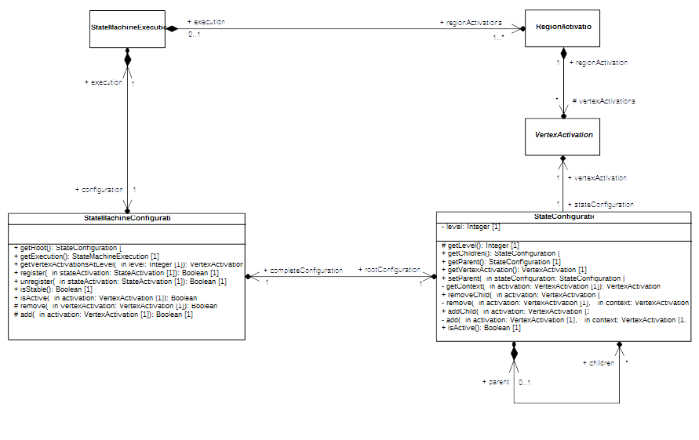Figure 8.7 - StateMachineConfiguration

StateMachineConfiguration
The StateMachineConfiguration attached to a StateMachineExecution is modified either when a StateActivation is entered or when a StateActivation is exited (via its register and unregister operations, respectively).
Note that a StateMachineConfiguration does not evolve between run-to-completion steps. A StateMachineConfiguration only evolves during a run-to-completion step initiated via the acceptance of an event occurrence dispatched from the event pool.
The internal structure of a StateMachineConfiguration is represented as a hierarchy of StateConfigurations. Each StateConfiguration included in the hierarchy actually references a VertexActivation that is active in the currently executed StateMachine.
Note. The additional level of nesting introduced by the presence of RegionActivations is not captured by the StateMachineConfiguration. Nevertheless it is inherent to the state machine configuration tree structure. Indeed each branch of the tree denote the presence of a region.

StateConfiguration
A StateConfiguration is a basic unit of a StateMachineConfiguration, representing the membership of a VertexActivation in the configuration of the executed StateMachine. Each StateConfiguration has a single parent StateConfiguration (if any) any may have zero or more children StateConfiguration(s).

State Activations
Figure 8.8 shows the semantic visitor StateActivation and its further specialization, FinalStateActivation. StateActivation captures simple and composite State semantics while FinalStateActivation captures FinalState semantics.
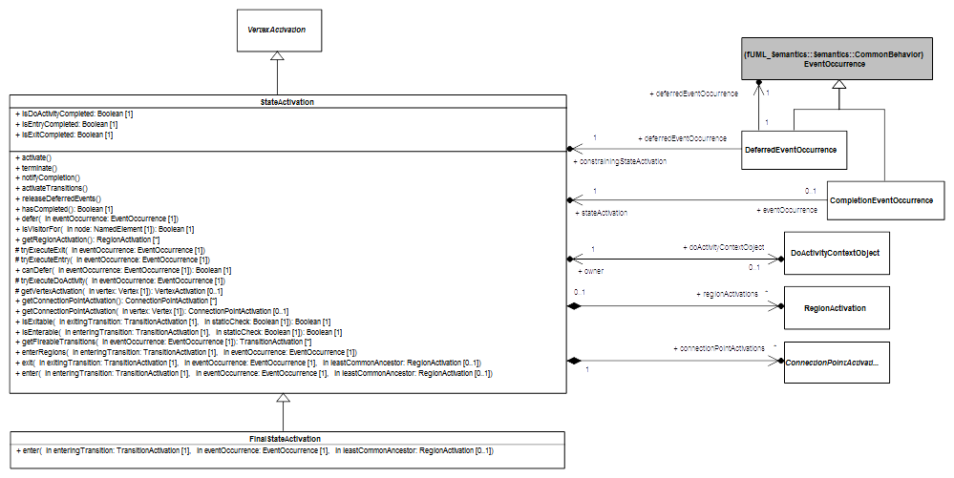
Figure 8.8 - StateActivations

StateActivation
A StateActivation is used to execute a State that is either simple or composite, but not a FinalState.
- A StateActivation can have ConnectPointActivations (see 8.5.2.5), which are semantics visitors for either EntryPoint or ExitPoint.
- A StateActivation for a composite State owns one or more RegionActivations (see 8.5.2.2), one for each Region contained in the composite State. A StateActivation for a simple State does not have any RegionActivations.
- A StateActivation for a State with a doActivity Behavior will have a DoActivityContextObject (see ) to manage the executing of that Behavior.

StateActivation entry
The common ancestor rule requires that, before a StateActivation cab be entered, all parent VertexActivations of a StateActivation must be entered recursively, until the common ancestor (which is a RegionActivation) of the StateActivation being entered and the source VertexActivation is reached. The entry of a StateActivation then involves the following sequential steps:
- If the State of the StateActivation has an entry Behavior, then this Behavior is executed synchronously.
- If the State of the StateActivation has a doActivity Behavior, then this Behavior is invoked asynchronously. A DoActivityContextObject is created, to act as the context object for the Behavior Execution, and associated with the StateActivation (see also on doActivity Behavior execution).
- If the State of the StateActivation is composite, then a RegionActivations are started concurrently for each Region of the composite State. How each RegionActivation is started depends on whether it is entered explicitly or implicitly (see 8.5.2.2).
Once a StateActivation is entered, it is then also registered with the StateMachineConfiguration associated with the containing StateMachineExecution and also referenced by the history of its Region.

StateActivation exit
Exiting a StateActivation involves the following sequential steps:
- If the StateActivation owns any RegionsActivations, they are exited.
- If the StateActivation has a running doActivity, it is aborted.
- If the State of the StateActivation has an exit Behavior, this Behavior is executed synchronously.
The common ancestor rule also applies during exit. All parent VertexActivations located at a more nested level than the common ancestor of the StateActivation being exited and the target VertexActivation are also exited.
Once a StateActivation is exited, it is then unregistered from the StateMachineConfiguration associated with the containing StateMachineExecution.

StateActivation completion
The completion of a StateActivation means that a CompletionEventOccurrence is generated by that StateActivation and placed in the eventPool handled by the ObjectActivation associated with the context Object of the containing StateMachineExecution.
The completion of a StateActivation occurs in the following situations, depending on the structure of the associated State:
- The State is simple and has no associated entry or doActivity Behaviors. The StateActivation generates a CompletionEventOccurrence as soon as it is entered.
- The State is simple with an associated entry Behavior but no doActivity Behavior. The StateActivation generates a CompletionEventOccurrence upon the termination of the entry Behavior Execution.
- The State is simple and has an associated doActivity Behavior. The StateActivation generates a CompletionEventOccurrence only when the doActivity Behavior has completed.
- The State is composite and has no associated entry or doActivity Behaviors. The StateActivation can only generate a CompletionEventOccurrence when all RegionActivations for the Regions of the composite State have completed.
- The State is composite and has an associated doActivity Behavior. The StateActivation can only generate a CompletionEventOccurrence when all RegionActivations for Regions of the composite state have completed and the doActivity Behavior has completed.

StateActivation and deferred events
A StateActivation can defer an EventOccurrence when the following conditions are met:
- At least one StateActivation in the active StateMachineConfiguration is for a State with a deferrableTrigger that matches the EventOccurrence.
- There is no Transition with with a higher priority and able to react to the EventOccurrence in the active StateMachineConfiguration.
When deferred, an EventOccurrence is “captured” by the deferring StateActivation. This means it is placed into the deferredEventPool of the ObjectActivation of the context Object of the containing StateMachineExecution (see 8.4) and will only return to the regular eventPool when the StateActivation that deferred it leaves the StateMachineConfiguration.
Note. The UML specification states that “A State may specify a set of Event types that may be deferred in that State. This means that Event occurrences of those types will not be dispatched as long as that State remains active. Instead, these Event occurrences remain in the event pool.” ([UML], 14.2.3.4.4).However fUML CommonBehavior semantics [fUML] define a dispatching strategy that does not account for deferred events, since these are StateMachine specific. In fUML, once an EventOccurrence is taken from the eventPool, it must either be accepted or it is lost. In order to introduce semantics for deferred events, without changing the base fUML CommonBehavior semantic model, instead of leaving deferred EventOccurrences in the eventPool, the model defined here moves them to a separate deferredEventPool (which is defined on the class SM_ObjectActivation described in 8.4). This solution provides effectively the same semantics as defined in the UML specification, at least for the default first-in-first-out dispatching strategy. However, it may not be compatible with other dispatching strategies, unless they are modified to explicitly account for DeferredEventOccurrences (see also the further discussion of DeferredEventOccurrences below).

Evaluation of StateActivation
When the static analysis is performed during the evaluation process of a compound transition, this analysis may reach a State. The propagation of the static analysis sequence is the following:
- Before to propagate the analysis on the State itself it is first propagated to the parent. If the propagation is accepted by the parent the analysis continues.
- If the State that is reached is simple (i.e. it does not have regions) then analysis ends and is considered as being accepted. The rationale for ending the analysis in such situation can easily be explained that the State that is reached cannot be left in a different way than the dispatching of an event occurrence.
- If the State that is reached is composite then the analysis is propagated to the region(s) owned by this latter. For the propagation to be accepted then all region must accept the propagation of the analysis: in each region a valid execution path must be found.

FinalStateActivation
A FinalStateActivation captures semantics of a FinalState.
As for a regular StateActivation, the common ancestor rule applies when a FinalStateActivation is entered. This means that parent VertexActivations are entered recursively until the common ancestor of the source VertexActivation and the FinalStateActivation is reached.
Once a FinalStateActivation is finally entered, it completes the execution of the RegionActivation in which it is located and reset its history (after the entry of a FinalStateActivation then the owning RegionActivation hs no history). If this RegionActivation is owned by a StateActivation, and all RegionActivations owned by that StateActivation have completed, then a CompletionEventOccurrence is generated for that StateActivation (see also the discussion on StateActivation completion above).

Evaluation of a FinalStateActivation
The way the propagation analysis must be performed when a final state is reached is a subset of the propagation sequence described for a State. Before the to propagate the analysis to the final state, the analysis is propagated to the parent vertex. If the propagation is accepted by the parent vertex then propagation is also accepted by the final state.

“doActivity” Behavior Execution
Figure 8.9 shows part of the PSSM execution model capturing the semantics related to the execution of a doActivity behavior. In section Erreur : source de la référence non trouvée the focus is in presenting semantics that is captured both in DoActivityContextObject as well as DoActivityExecutionEventAccepter.

DoActivityContextObject
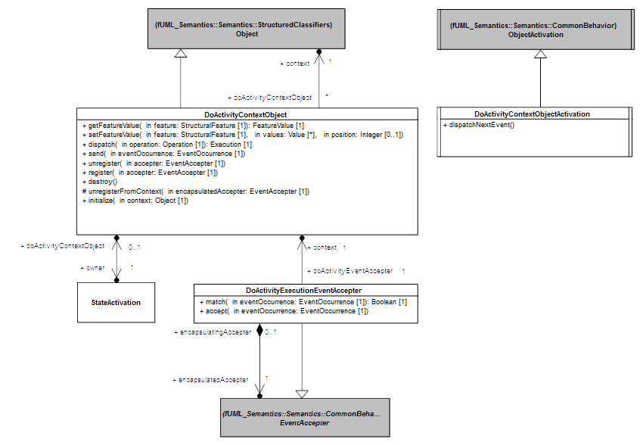
Figure 8.9 - doActivity Behavior Execution
A DoActivityContextObject is a specialized Object ([fUML], Clause 8).
- A DoActivityContextObject has itself a context. This context is the context Object of the StateMachineExecution from which the doActivity behavior was invoked (see association between DoActivityContextObject and Object in Figure 8.9).
- A DoActivityContextObject references the StateActivation which realized the invocation to the doActivity behavior (see association between DoActivityContextObject and StateActivation 8.9).
A doActivity behavior is executed on its own thread of execution. This requirement is introduced by the asynchronous nature of the doActivity behavior. The purpose of the DoActivityContextObject is to define the context Object in which the doActivity behavior will be executed.

Feature access context
Although the doActivity behavior is executed on its on thread of execution (i.e., in its own active object), it still requires to have access to the same context than the StateMachine from which it was invoked. Indeed the doActivity must be able to access features (e.g. an operation, a property) of the StateMachine context.
To satisfy this requirement, a DoActivityContextObject redefines Object class operations to delegate features accesses (see getFeature in Figure 8.9), features updates (see setFeature in Figure 8.9), operation calls(see dispatch in Figure 8.9) and event sending(see send in Figure 8.9) to its context

doActivity accepter registration
A doActivity when executed may have to register accepters for specific event occurrences. An accepter that is registered by the doActivity will be registered in two places:
- The waiting event accepter set handled by the SM_ObjectActivation of the StateMachineExecution context object. The rationale to do so is that the event cannot be addressed directly to a doActivity. Hence to be able to see incoming events the doActivity must share the event pool of the StateMachineExecution context object. The impossibility to target directly a doActivity is justified by the fact that at runtime it is not possible to obtain a reference on the object materializing the running doActivity because the doActivity is started implicitly when the State was entered.
- The resgistered event accepter is also registered in waiting event accepter set handled by the DoActivityContextObjectActivation. The rationale to do so is that when an event occurrence (dispatched from the state machine event pool) is accepted by the doActivity it must trigger a run-to-completion step in that doActivity.

doActivity run-to-completion step
A run-to-completion step in the doActivity is triggered by the acceptance of an event occurrence dispatched from the state machine event pool. The acceptance process implies that one of the DoActivityEventAccepter registered by the doActivity matched the dispatched event occurrence. Hence the DoActivityEventAccepter that matched is removed from the waiting event accepter set handled by the state machine context object activation.
The dispatched event occurrence is transferred to the event pool of the DoActivityContextObjectActivation. This implies the realization of a new run-to-completion step in the context of the doActivity. The step started from the state machine completes trivially upon the transfer of the event occurrence.
Note: In general a running doActivity compete with the state machine to accept event dispatched from the state machine event pool. The competition is materialized by the fact that both the doActivity and the state machine have equivalent chances to get their respective registered accepters elected to accept an event occurrence. Nevertheless, in some situations it is required to ensure that a doActivity is able to accept an event instead of the state machine. Such situations are identified by the modeling pattern:
- In a certain state, a state machine has a deferred trigger for the event in that state. In this case, if the state has a doActivity, then event occurrences deferred by the state machine may be consumed by the doActivity while it is running.
The doActivity priority for the consumption of an event occurrence is given by the following semantic rules:
- If the state machine is about to defer an event occurrence for which the doActivity has also registered an accepter then the state machine is not allowed to defer the event occurrence. The event occurrence can then be accepted by the doActivity.
- If the state machine has deferred an event occurrence for which the doActivity registers an accepter then deferred event occurrence can be accepted directly from the deferred event pool of the state machine.

doActivity finalization
There are two ways for a doActtivity to finalize its execution:
- Completion: This means the doActivity ended its execution naturally (i.e., the execution reached a point where there is no possibility to continue). The detection of the completion is based on the number of remaining event accepters currently registered by the doActivity. If there is no more event accepter registered for the doActivity after a run-to-completion step this means the doActivity completed. When a doActivity complete the state that invoked that doActivity may have to complete too. In this situation upon the completion of the doActivity a completion event occurrence is generated for the StateActivation and placed at the state-machine event pool.
- Destruction: This means the state from which the doActivity was invoked is exited. In this situation the execution of the running doActivity is aborted. The semantics for aborting the doActivity execution is provided by the DoActivityContextObject through its destroy operation. In addition to the semantics provided by fUML when an object is destroyed, all accepters registered by the doActivity in the context of the state machine context object activation are destroyed.

DoActivityContextObjectActivation
The DoActivityContextObjectActivation class is a specialized ObjectActivation. Each DoActivityContextObject has a DoActivityContextObjectActivation.
The DoActivityContextObjectActivation redefines the dispatchNextEvent operation provided by the fUML ObjectActivation class. It adds functionality to this operation in order to check if the doActivity has completed after the last run-to-completion step.

DoActivityExecutionEventAccepter
A DoActivityExecutionEventAccepter is a specialized EventAccepter.
- A DoActivityEventAccepter references its original creation context. This context is the DoActivityContextObject.
- A DoActivityEventAccepter references the original EventAccepter that was registered by the executed doActivity in the DoActivityContextObjectActivation attached to the DoActivityContextObject.

DoActivityEventAccepter registration
A DoActivityEventAccepter is automatically registered in the context of the DoActivityContextObject when the executed doActivity behavior registers an EventAccepter.

DoActivityEventAccepter matching
When a DoActivityEventAccepter tries to match a dispatched event occurrence, the matching process delegates to the match operation of the original event accepter registered by the doActivity. (i.e., the one currently present in the waiting event acepter list of the DoActivityContextObjectActivation). The result of the matching process is the result provided by the match operation of the original event accepter.

DoActivityEventAccepter acceptance
The acceptance of of a dispatched event occurrence through a DoActivityEventAccepter consits in transferring the event occurrence to the event pool handled by the DoActivityObjectActivation of the DoActivityContextObject. This enables the triggering of a run-to-completion step in the doActivity without blocking the state machine.

Pseudostate Activations
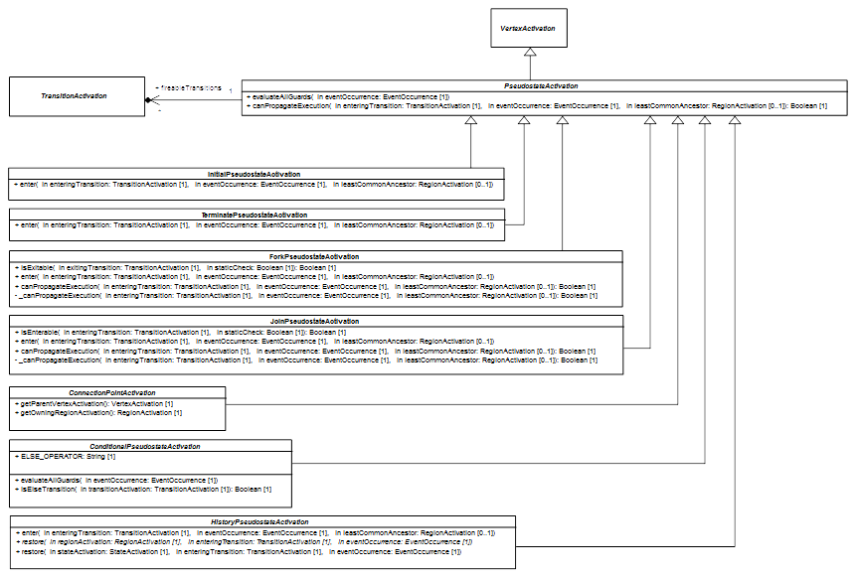Figure 8.10 - PseudostateActivations
PseudostateActivation class (see Figure 8.10) is a specialization of a VertexActivation. It captures pseudostates common semantics.
A PseudostateActivation references a set of TransitionActivation. This set corresponds to the set of outgoing transitions of the pseudostate whose guards have evaluated to true during the static analysis. It is computed each time the analysis is performed (i.e. each time a compound transition needs to be evaluated to be added in the set of transitions to be fired in the next run-to-completion step).
The PseudostateActivation redefines the canPropagateExecution operation provided by the parent class VertexActivation. It adds functionnality describing how the static analysis must be performed in the context of a pseudostate.

State machine configuration and PseudostateActivation
Although a pseudostate is a vertex, pseudostates never enter the statemachine configuration. Indeed pseudostate are traversed along a run-to-completion step but a run-to-completion step never ends on a pseudostate.

Evaluation of a PseudostateActivation
The general sequence to propagate the static analysis through a pseudostate is given by the following steps:
- Before to propagate the analysis on the pseudostate itself it is first propagated to the parent.
- If the propagation was accepted by the parent and the pseudostate on which the static analysis must be performed can be entered (i.e., its preconditions to be entered are all fulfilled) then:
  - If the pseudostate has no outgoing transitions, then the propagation is considered to be accepted.
  - If it has outgoing transitions but the set of fireable transitions remains empty then the propagation cannot be accepted by the pseudostate.
  - If it has outgoing transitions and the set of fireable transitions is not empty then at least one of the TransitionActivation in that set must be able to accept the propagation of the static analysis. If none of them can accept the propagation then the pseudostate cannot accept it too.

Initial Pseudostate Activations
The InitialPseudostateActivation class (see Figure 8.10) is a specialization of PseudostateActivation. It captures the semantics of a pseudostate which is associated to the “initial” kind.

Entry
The InitialPseudostateActivation redefines the enter operation provided by VertexActivation. The entrance to an initial pseudostate implies the firing of its outgoing transition.
Note: UML only allows an initial pseudostate to have a single outgoing transition. Any other model is ill-formed regarding UML specification.

Fork Pseudostate Activations
The ForkPseudostateActivation class (see Figure 8.10) is a specialization of PseudostateActivation. It captures the semantics of a pseudostate which is associated to the “fork” kind.

Entry
The ForkPseudostateActivation class redefines the enter operation provided by VertexActivation. The entrance of a fork pseudostate consists in:
- Entering parent vertex if it has not already been entered. The common ancestor rule applies.
- Firing concurrently all of its outgoing transitions. Transitions are fired without any guard evaluation since UML does not allow transitions outgoing a fork pseudostate to have guards.

Exit
The ForkPseudostateActivation class does not redefine the exit operation provided by VertexActivation. Nevertheless it imposes a constraint on when the generic exit sequence can be performed: a ForkPseudostateActivation cannot be exited until all of its outgoing transitions have been fired.

Evaluation
The ForkPseudostateActivation class redefines the way the static analysis must be performed when it is propagated through a fork pseudo state. The propagation consists in the following steps:
- Propagate the analysis through the parent vertex if required. The common ancestor rule applies.
- If the propagation was accepted by the parent then to consider that the propagation can be made through the fork pseudo state all of its outgoing transitions must accept the propagation. If one them fails to accept the propagation then the fork pseudostate cannot accept the propagation too.

Join PseudostateActivation
The JoinPseudostateActivation class (see Figure 8.10) is a specialization of PseudostateActivation. It captures the semantics of a pseudostate which is associated to the “join” kind.

Entry
The JoinPseudostateActivation redefines the entry operation provided by VertexActivation and add a precondition regarding the situation in which the entry can be performed.
In order to be able to enter a join pseudo all transitions incoming this pseudostate must have been fired before. When this condition is fulfilled then the entering sequence takes place. Entering a join pseudostate consists in:
- Entering the parent vertex if it has not already been entered.
- Fire one of the transition outgoing the join pseudostate. If more than a transition is ready to fire then one is selected in the set of fireable transitions to be effectively fired. The selection is performed via a choice strategy (the default strategy proposed by fUML consist in selecting always the first element in the proposed set).

Evaluation
The JoinPseudostateActivation class redefines the way the static analysis must be performed when it is propagated through a join pseudo state. The propagation consists in the following set of actions:
- Propagate the analysis through the parent vertex if required. The common ancestor rule applies.
- If the propagation was accepted by the parent and the join pseudostate cannot be entered the propagation is considered as being accepted.
- If the propagation was accepted by the parent and the join pseudostate can be entered then at least one of the outgoing transition of that pseudostate must be able to accept the propagation. If it is not case then the join pseudostate cannot accept the propagation too.

Connection Point Pseudostate
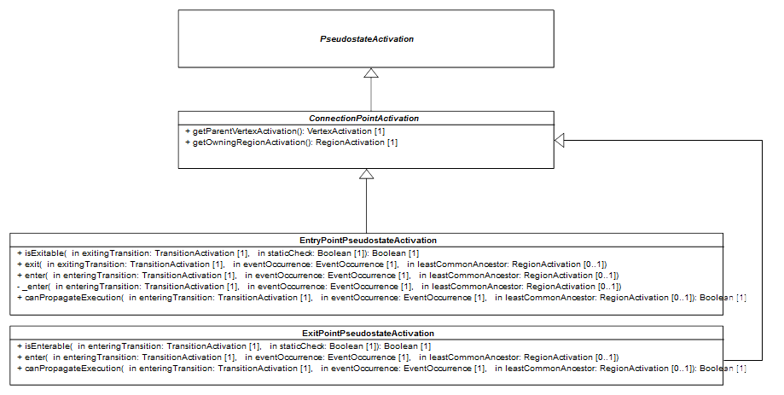Figure 8.11: EntryPointActivation and ExitPointActivation
The ConnectionPointActivation class (see Figure 8.11) is a specialization of PseudostateActivation. It captures the common semantics of an EntryPoint and an ExitPoint. These common semantics define how to determine the parent VertexActivation and the owning RegionActivation of both an EntryPointPseudostateActivation and an ExitPointPseudostateActivation.
- The parent of a ConnectionPointActivation is the StateActivation on which this ConnectionPointActivation is placed.
- The RegionActivation which is said to own the ConnectionPointActivation is the parent RegionActivation of the StateActivation on which the ConnectionPointActivation is placed.
Note: These semantics may evolve in further revisions of the specifications especially if PSSM provides support for sub-machines.

EntryPoint Pseudostate Activation
The EntryPseudostateActivation class is a specialization of ConnectionPointActivation. It captures the semantics of a pseudostate which is associated to the “entryPoint” kind.

Entry
The EntryPointPseudostateActivation class (see Figure 8.11) redefines the enter operation provided by VertexActivation. Then entrance to an entry point pseudostate consists in:
- Enter the State on which the entry point is placed. The common ancestor rule applies (i.e., parent of that State may also need to be entered).
- If no outgoing transitions are defined for the entry point, the State on which this pseudostate is placed performs a default entry (see StateActivation in section 8.5.2.4).
- Otherwise, if outgoing transitions are defined then two situation can occur:
  - The state on which the pseudostate is placed is not orthogonal. One of the transition available in the set of fireable transitions is chosen to be fired. The choice relies on a strategy (see [fUML] ChoiceStrategy).
  - The state on which the pseudostate is placed is orthogonal (i.e. multiple regions). All transitions outgoing the pseudostate are fired concurrently.

Exit
The EntryPointPseudostateActivation class provides a constraint regarding the possibility to exit an entry point pseudostate. Such pseudostate can only be exited when all of its ougoing transitions have been fired. This precondition only applies if the entry point plays the role of a fork pseudostate.

Evaluation
The EntryPseudostateActivation class redefines the way the static analysis must be performed when it is propagated through an entry point pseudo state. The propagation consists in the following set of actions:
- The static analysis is propagated to the state on which the entry point is placed.
- If the propagation is accepted by the parent state then if the entry point has no outgoing transitions the propagation stops and is considered as being accepted by the entry point.
- If the entry point has outgoing transitions two situations can occur:
  - If the state that is entered has multiple regions, then the propagation continues through all outgoing transitions. In that case, all outgoing transitions must accept the propagation. Otherwise the propagation cannot be accepted by the entry point.
  - If the state that is entered has only a single region then only one of the outgoing transitions must be able to accept the propagation to consider it is accepted by the entry point.

ExitPoint Pseudostate Activation
The ExitPseudostateActivation class (see Figure 8.11) is a specialization of ConnectionPointActivation. It captures the semantics of pseudostate which is associated to the “exitPoint” kind.

Enter
The ExitPointPseudostateActivation class redefines the enter operation provided by VertexActivation. Then entrance to an exit point pseudostate consists in:
- Select one of the transition available in the set of fireable transitions. The transition is selected using the a strategy (see [fUML] choice strategy).
- Exit only the state on which the exit pseudostate is placed.
- Fire the selected transition.
The ExitPointPseudostateActivation can only be entered if all of its incoming transitions have been fired.

Evaluation
The ExitPseudostateActivation class redefines the way the static analysis must be performed when it is propagated through an exit point pseudo state. The propagation consists in the following set of actions:
- If the exit point cannot be entered then the propagation is said to be accepted by the pseudostate.
- If the exit point can be entered then at least one of the outgoing transitions must be able to accept the propagation. If this is not the case the exit point cannot accept the propagation too.

Conditional Pseudostate Activation
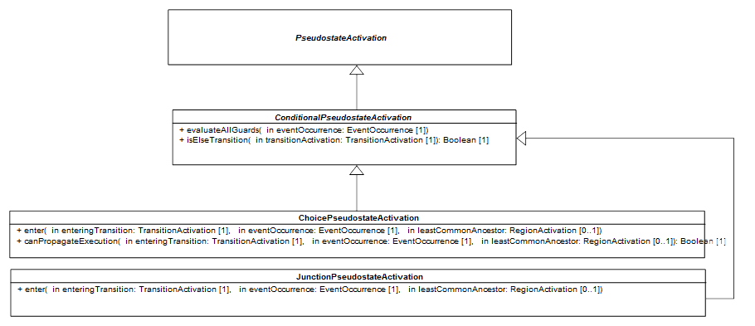Figure 8.12: ChoicePseudostateActivation and JunctionPseudostateActivation
The ConditionalPseudostateActivation class (see Figure 8.12) is a specialization of a PseudostateActivation. It defines semantics common to the ChoicePseudoStateActivation and the JunctionPseudostateActivation.
ConditionalPseudostateActivation redefines the evaluateAllGuard operation provided by PseudostateActivation. When the evaluation takes place, all guards of outgoing transitions are evaluated. Transitions with a guard evaluation to true are added to the set of fireable transitions. If after the evaluation this step the set is empty then if it exists an “else” transition outgoing the pseudostate, this latter is added to the set.
An “else” transition has a guard with a specification defined as an Expression. The expression has a symbol which is the “else” string and has no operands.

Choice Pseudostate Activation
The ChoicePseudostateActivation class is a specialization of ConditionalPseudostateActivation. It captures the semantics of pseudostate which is associated to the “choice” kind.

Entry
The ChoicePointPseudostateActivation class (see Figure 8.12) redefines the enter operation provided by VertexActivation. Then entrance to a choice pseudostate consists in:
- Enter the parent vertex if it has no already been entered (the common ancestor rule applies).
- Evaluate all guards of transitions outgoing the choice. Note that is specific to this pseudostate. Indeed guards of its outgoing transitions are only evaluated when the choice is reached in a run-to-completion step. This is called a “dynamic” evaluation and is opposed to the “static” evaluation which is performed during the static analysis.
- One transition among the set of fireable transitions is selected to be fired. The selection process relies on a strategy (see [fUML] ChoiceStrategy).

Evaluation
The ChoicePseudostateActivation class redefines the way the static analysis must be performed when it is propagated through a choice pseudostate. The propagation is considered as being accepted by the choice if it was accepted by the parent vertex. The static analysis is not propagated by the choice pseudostate outgoing transitions.

Junction Pseudostate Activation
The JunctionPseudostateActivation class (see Figure 8.12) is a specialization of ConditionalPseudostateActivation. It captures the semantics of pseudostate which is associated to the “junction” kind.

Entry
The JunctionPointPseudostateActivation class redefines the enter operation provided by VertexActivation. The entrance to a junction pseudostate consists in:
- Enter the parent vertex if required (the common ancestor rule applies).
- One transition among the set of fireable transitions is selected to be fired. The selection process relies on a strategy (see [fUML] ChoiceStrategy).

History Pseudostate Activation
The HistoryPseudostateActivation class is a specialization of PseudostateActivation. It captures common semantics of ShallowHistoryPseudostateActivation and DeepHistoryPseudostateActivation.
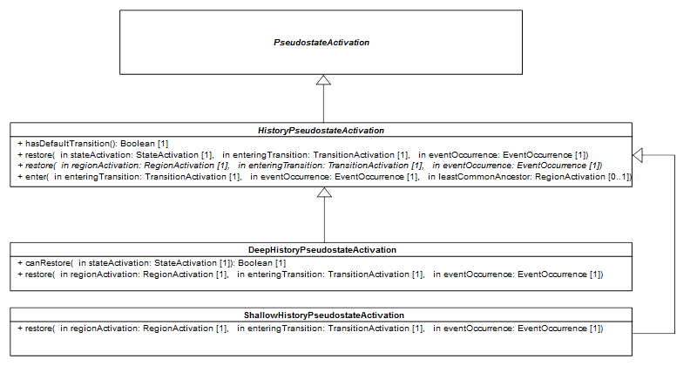Figure 8.13: DeepHistoryPseudostateActivation and ShallowHistoryPseudostateActivation

Entry
The HistoryPseudostateActivation class (see Figure 8.13) redefines the enter operation provided by VertexActivation. Then entrance to a history (deep or shallow) pseudostate consists in:
- If the region containing the targeted history pseudostate has no history and the pseudostate has no default transition (i.e. an outgoing transition which target a vertex directly or indirectly owned by the region) then
  - If the choice pseudostate is nested in a state hierarchy then this latter is entered. The common ancestor rule applies.
- If the choice pseudostate is owned by a top region (i.e. a region owned by a statemachine) then this region performs an implicit entry.
- If the region containing the targeted history pseudostate has a history or at least a default transition then
- If the choice pseudo state is nested in a state hierarchy then this latter is entered and the restoration process starts from the parent vertex of the history pseudostate.
  - If the choice pseudostate is owned by a top region then the restoration process starts from the region.

Restoration
HistoryPseudostateActivation provides two kinds of restoration process (see restore operations in Figure 8.13). One addresses how a state must be restored while the other one specifies how a region must be restored. Both deep and shallow history offer common semantics to restore a state. However the semantics of region restoration is specific to each kind of history.
The restoration of a state consists the following steps:
- The state enters to the state machine configuration.
- The entry and doActivity behaviors that may have been associated to the state are executed (if any). If the state is about to complete, a completion event occurrence is placed in the state machine event pool.
- If the state has regions then all of them are restored concurrently.

Deep History
The DeepHistoryPseudostateActivation class (see Figure 8.13) is a specialization of HistoryPseudostateActivation. It captures the semantics of pseudostate which is associated to the “deepHistory” kind.

Restoration
The DeepHistoryPseudostateActivation class defines the way the restoration process must be realized for a region. It consists in the following steps:
- If the region that is restored is the region that contains the deep history pseudostate then
  - If the region has a history (which is state) then this history is restored by the application of restoration process described by the HistoryPseudostateActivation for a state.
  - If the region has no history but the history pseudostate has a default transition then this transition is fired.
- If the region that is not the one containing the history pseudo state then
  - If the region is a sub-region of the one containing the history pseudostate then this region is restored.
  - Otherwise the region is not restored but performs an implicit entry.

Shallow History
The ShallowHistoryPseudostateActivation class is a specialization of HistoryPseudostateActivation. It captures the semantics of pseudostate which is associated to the “shallowHistory” kind.

Restoration
The ShallowHistoryPseudostateActivation class defines the way the restoration process must be realized for a region. It slightly differs from what is proposed by the DeepHistoryPseudostateActivation. The region containing the shallow history pseudo state is only one to be restored. All other regions (orthogonal regions or sub-regions) are entered using the implicit entry rule.

Terminate Pseudostate Activation
The TerminatePseudostateActivation class (see Figure 8.10) is a specialization of PseudostateActivation. It captures the semantics of pseudostate which is associated to the “terminate” kind.

Entry
The TerminatePointPseudostateActivation class redefines the enter operation provided by VertexActivation. Then entrance to a terminate pseudostate consists in:
- Enter the parent vertex if required (the common ancestor rule applies).
- Terminate the execution of the of the entire state machine. The termination process occurs without execution of exit behaviors of states currently registered in the state machine configuration. It ends with the destruction of the complete state machine semantic visitors hierarchy.
- Finally, the execution context of the state machine is destroyed. Hence, the object activation related to the context object has its event pool cleared and is stopped. No further execution is possible after this step.

Transition Activations
Figure 8.14 shows the three specializations of the transition activation semantic visitor. These specializations respectively capture semantics related to external transitions, local transitions and internal transitions. The different semantics of this kind of transitions are inherent to the way the source vertex activation is exited and the way the target vertex activation is entered.
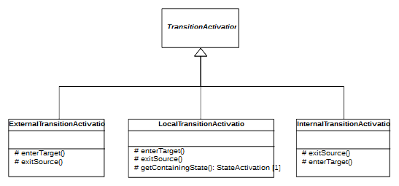Figure 8.14 - TransitionActivations
The different specializations of TransitionActivation keep the base semantics for Guard evaluation and evaluation of the reactivity to a particular event occurrence.

ExternalTransitionActivation

Exit source
In the case of an ExternalTransition the source vertex activation is exited only if all of its prerequisites to be exited are fulfilled (e.g., a ForkPseudostateActivation can only be exited when all its outgoing Transition except the on currently used have been traversed) otherwise it is not exited.
The way of the source VertexActivation is exited also depends on the possibility to enter the target VertexActivation. If this latter is not ready to be entered then the exit sequence of the source VertexActivation is limited to itself. Otherwise if the target VertexActivation is ready to be entered then the exit sequence of the source VertexActivation account sfor the common ancestor rule. This can imply the propagation of the exit sequence to parent VertexActivations until the common ancestor existing between the source and the target is reached.

Enter target
If the prerequisites to enter the target Vertex Activation are fulfilled then this latter is entered and the entering sequence accounts for the common ancestor rule. This means that the entering sequence can be propagate to parent VertexActivation until the common ancestor existing between the source vertex activation and the parent vertex activation is reached.
If the prerequisites are not fulfilled (e.g., the target state is not already active) the target VertexActivation is not entered. Nevertheless if this target is a StateActivation for a composite state, then RegionActivation owning the source Vertex Activation completes. This may lead to the generation of a CompletionEvent for the executed composite State (see situations in which a State activation is ready to complete in section 8.5.2.4).

LocalTransitionActivation

Containing state
The exiting of the source VertexActivation and the entering of the target VertexActivation are conditioned by the identification of the so-called containing state. The containing state of a local Transition can be determined in the following manner:
- If the source VertexActivation of the local Transition is an EntryPointActivation then the containing state is the owner of this EntryPointActivation (i.e., a StateActivation for a composite State).
- If the source VertexActivation contains the target VertexActivation then the containing state is the source VertexActivation. Otherwise the containing state is the target VertexActivation.

Exit source
If the source VertexActivation has fulfilled its requirements to be exited the two execution cases are possible:
- The source is an EntryPointActivation. The exit sequence is trivial, only the EntryPoint is exited through one or more continuation transitions.
- The source is a StateActivation for a composite state and the target of this TransitionActivation is a Vertex Activation located in a RegionActivation owned by the source VertexActivation. In that situation the source VertexActivation cannot be exited since it is also the containing state for the local Transition. If there is already a StateActivation that is active in the same RegionActivation than the target VertexActivation then the StateActivation is exited.

Enter target
If the target VertexActivation has fulfilled its requirement to be entered and this latter is not the containing state of the local Transition then the entering sequence starts and the common ancestor rule applies.

InternalTransitionActivation

Exit source
An internal Transition never exits its source VertexActivation.

Enter target
An internal Transition never enters its target VertexActivation

Event Occurrences
Three types of event occurrences can be accepted via a the event accepter registered by a statemachine: SignalEventOccurrence, CallEventOccurrence and CompletionEventOccurrence. All are specializations of the base class EventOccurrence which enables the representation of the occurrence of an event in the runtime. Note that SignalEventOccurrence is provided by fUML not by PSSM.

Completion Event Occurrence
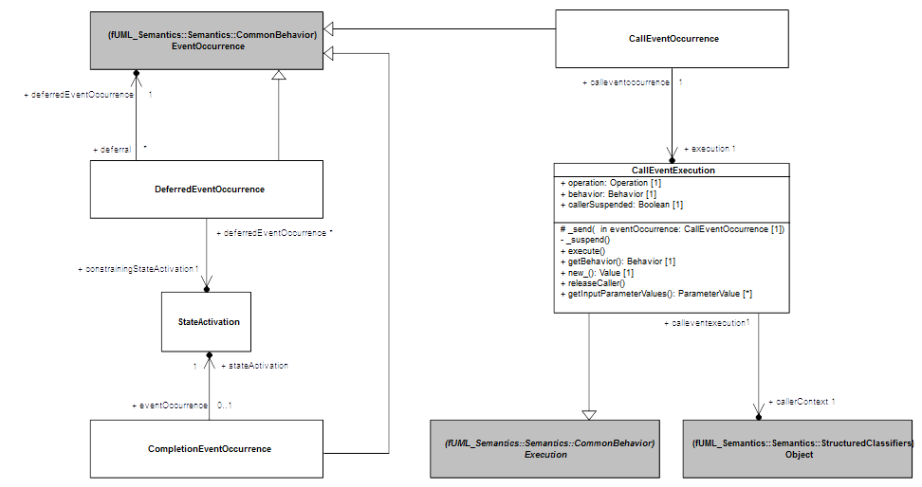Figure 8.15: Event occurrences defined in the semantic model
A CompletionEventOccurrence is specific EventOccurrence which denotes the completion of State.

Scope of completion events
The scope of the CompletionEvent is limited to the StateActivation from which it was generated. This means that when dispatched and accepted the CompletionEvent can only be used to trigger a completion Transition originating from the State which generated the CompletionEvent.
In the case where the State that generated the CompletionEvent has no completion Transition then the CompletionEvent will be lost during dispatching phase.

Priority of completion events
When generated a CompletionEvent is placed in the event pool handled by the ObjectActivation attached to the StateMachineExecution context Object. CompletionEvent added in the event pool have priority over all other EventOccurrence except CompletionEvents. This means that if the event pool (rightmost event is first to be dispatched) contains a SignalEventOccurrence and a CompletionEvent [S, CE(S1)] then CompletionEvent that is currently generated will be placed in the pool after the existing Signal EventOccurrence but before the existing CompletionEvent. In short the event pool will contain the following event occurrences: [S, CE(S2), CE(S1)].

Call Event Occurrence
A CallEventOccurrence is a specific EventOccurrence which denotes the call to an Operation. This type of event is always produced by CallEventExecution.

CallEventExecution
A CallEventExecution is a specific type of Execution. It is only returned by the dispatch operation of an Object when the Operation being dispatched has no implementation (i.e. no behavior playing the role of a method for the Operation). A CallEventExecution has the following attributes:
- operation: this attribute denotes the Operation that is required to be called.
- behavior: the behavior signature corresponding to the operation.
- callerSuspended: this attribute denotes the status of the caller regarding the call. The caller is suspended or not.
- callerContext: references the Object from which the call was emitted.
When a CallEventExecution gets executed (i.e., the operation execute is called) its tole is to produce CallEventOccurrence that is placed in the event pool of the target of the call. This event occurrence as any other event occurrence will be dispatched in one of the run-to-completion step of target.
In the context of PSSM we only address synchronous calls, hence the caller is systematically blocked until the target has terminated the run-to-completion step in which the CallEventOccurrence is dispatched. At this time (i.e. at the end of the accept in of the state-machine event accepter) the target object notifies the object from which the CallEventOccurrence was emitted to let it continue its own execution. The notification process relies on the releaseCaller operation provided by the execution referenced by the CallEventOccurrence that was dispatched..
Note: CallEvents are not state-machine specific. So far their semantics is provided by the PSSM semantic model because fUML does not include CallEvent. Nevertheless in further revisions of this specifications, CallEvent semantics will be included directly in fUML.

Deferred Event Occurrence
A DeferredEventOccurrence is a specific EventOccurrence which denotes the fact that an event was deferred. Such type of EventOccurrence have the following attributes:
- constrainingStateActivation: this attribute references the state activation which was responsible for the deferral of the event occurrence.
- deferredEventOccurrence: this attribute references the event occurrence that is deferred.
An EventOccurrence is always deferred by a StateActivation (see 8.5.2.4). Its deferral occurs under the following conditions:
- In the current state-machine configuration it exists a state which declares a deferring trigger which matches the type of dispatched EventOccurrence.
- It was not possible during the state-machine configuration analysis possible to find a transition with a higher priority which could be fired using the dispatched EventOccurrence.
- It does not exist an “overriding” transition (i.e. a transition outgoing the state declaring the deferring trigger ) capable to fire with the dispatched EventOccurrence.
If the EventOccurrence must be deferred (i.e. the aforementioned conditions hold) then it is wrapped in a DeferredEventOccurrence. This latter is placed in the deferred event pool handled by the context SM_ObjectObjectActivation.
A DeferredEventOccurrence returns to the regular event pool under the following condition:
- The state that was responsible for the deferral of the EventOccurrence has left the state-machine configuration.

Event Data Passing
A run-to-completion step is always started by the acceptance of an EventOccurrence. Along this run-to-completion step a number of Behaviors may be executed. Some of these Behaviors can have access to the EventOccurrence that is dispatched in the run-to-completion step. These Behaviors are:
- guards placed on Transitions (only for guards with a specification defined as an OpaqueExpression associated with a Behavior)
- effects placed on Transitions
- entries placed on States
- doActivities placed on States
- exits placed on sSates
This enables the different Behaviors to use data embedded in the dispatched EventOccurrence when they are executed. This is particularly interesting in the case of guard evaluation where the result may vary according to the input data provided by the EventOccurrence.

EventTriggeredExecution
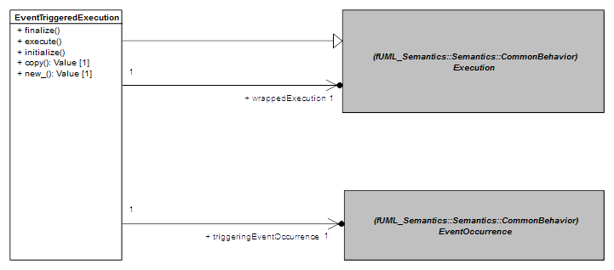Figure 8.16: EventTriggeredExecution
The EventTriggeredExecution (see Figure 8.16) class is a specialization of the fUML Execution class. It captures semantics of Execution which have been triggered by the dispatching of an EventOccurrence. Two attributes are added by the EventTriggeredExecution class:
- wrappedExecution: references the original Execution that may be parametrized with the data embedded in the dispatched EventOccurrence.
- triggeringEventOccurrence: references the EventOccurrence which triggered the execution of the Behavior for which the original Execution was created.

Execution
The EventTriggeredExecution class defines the execute operation provided by the Execution. The sequence of actions that is realized is the following:
- Data embedded in the triggering EventOccurrence are (if possible) extracted and used to parametrized the original Execution.
- The original Execution is executed.
- Extract (if possible) output values produced by the Execution.

Input Parameter Values
In PSSM, only CallEventOccurrence and SignalEventOccurrence can embed data. Hence the input Parameters of the original Execution can only be provided with data embedded by these two types of EventOccurrences. The parametrization is defined by the operation initialize and behaves as follows:
- If the triggering EventOccurrence is for a SignalEvent, then the behavior executed by the original Execution must have either one Parameter or no Parameters. If the behavior has a Parameter, the SignalInstance corresponding to the SignalEventOccurrence is passed to the Execution as the value of the Behavior's Parameter.
- If the triggering EventOccurrence is for a CallEvent, then all executed Behaviors will have either no Parameters or signatures (i.e., Behavior Parameters set) that input-conform to the Operation referenced by the CallEventOccurrence. If the Behavior executed by the original Execution input-conforms to the Operation signature then input ParameterValues of the CallEventOccurrenceExecution are passed to the Behavior's input Parameters.

Output Parameter Value
The single situation where output values may be produced is when a CallEventOccurrence was used to trigger the execution of the original Execution. Indeed, the Operation may have a signature that also includes output Parameters. In such a situation, if the Behavior that is executed by the original Execution does not only input-conform to the Operation signature but also output-conforms to this latter, then values produced on output Parameters of the original Execution are also used as output ParameterValues for the CallEventExecution referenced by the CallEventOccurrence.
In presence of concurrency, the output ParameterValues provided to the CallEventExecution may have changed multiple times. The final output ParametersValues are the ones provided by the last executed Behavior.

Event Data Passing and Static Analysis
While Behaviors placed on States andTransitions are only executed during the realization of a run-to-completion step, guard evaluation (except for those placed on the outgoing transitions of a choice Pseudostate) takes place during the static evaluation of the validity of the compound transitions that might be added to the set of transitions to be fired. Guards which are specified with an OpaqueExpression associated to a Behavior may also require an EventOccurrence to be provided to be evaluated correctly. During the static analysis process all of these guards are evaluated using the EventOccurrence that was taken from the event pool.

State Machine Redefinition

Background
It is common in UML to use StateMachines to describe the classifierBehavior of complex active Classes, and it is natural to expect to be able to specialize UML Classes whose behaviors happen to be specified by StateMachines.
Consider, for example, the StateMachine shown in Figure 8.17, which represents the classifierBehavior of some (active) Class (not shown explicitly in the diagram). Being a classifierBehavior means that this StateMachine is a member of the Namespace of that Class. Because the classifierBehavior qualifies as an inheritableMember of its owning Class (see [UML], subclause 9.9.4.7), it will be inherited by any subclass of that Class.
Note. Although UML does not provide an explicit notation for Regions (only for Region separators), for the purposes of this discussion, they have been represented explicitly using a dashed box with rounded corners, which encloses the Region’s States and Vertexes.
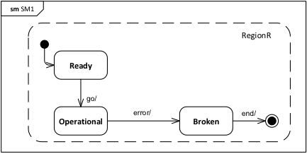Figure 8.17 - An "abstract" StateMachine behavior
Assume that, in this particular case, the Class that owns this StateMachine is an abstract Class and that its classifierBehavior StateMachine describes a general high-level (i.e., “abstract”) behavior intended to be shared by all subclasses of that Class. Starting with this basic behavior, each subclass will need to refine the high-level behavior depending on its particular purpose. For example, each subclass may specify different behavior for its instances when they are in the Operational state.
To achieve this, instead of directly inheriting the StateMachine of its parent, a subclass needs to redefine the parent StateMachines and refine some of its States and Transitions, while also adding new ones to suite the specific needs of the subclass. Figure 8.18 depicts a prototypical example of such refinement for the case of the StateMachine in Figure 8.17.
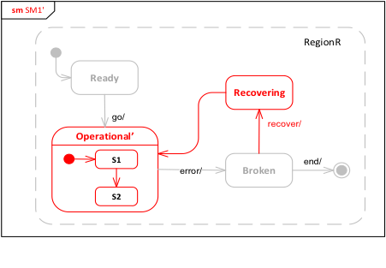
Figure 8.18 - A redefinition and refinement of the "abstract" StateMachine
In this case, the original, simple Operational state from the general StateMachine is refined into a composite state, Operational’, with an internal States and Transitions of its own. Note that, to retain behavioral compatibility, the refined StateMachine retrains the two original Transitions (“go” and “error”) between the Operational State and the Ready and Broken States in the general StateMachine. In addition, the refine StateMachine includes one additional State (Recovering) along with its associated Transitions.
Note. For clarity, the inherited elements are rendered using lighter-colored lines and text, while the new subclass-specific elements are drawn in red.
The UML abstract syntax for StateMachine redefinition given in 7.6.3 supports the kind of refinement shown in Figure 8.18. Figure 8.19 shows schematically how this mechanism is applied to achieve the refinement sketched in Figure 8.18. First, the refined StateMachine SM1' is identified as having SM1 as its extendedStateMachine (StateMachine “extension” in this sense is really an adaptation of the general UML redefinition mechanism for StateMachines) and includes the additional State Recovering, with its incoming and outgoing Transitions. Further, as one might expect, the State Operational' is identified as having as its redefinedState the State Operational in the original StateMachine. However, this is still not sufficient to fully define the desired refinement.
To see why, consider the Transition triggered by “recover” in Figure 8.18, which originates on State Broken and terminates on State Recovering. While Recovering is defined in the extending StateMachine (SM1’), Broken is defined in the extended StateMachine (SM1). However, the constraint pssm_transition_vertexes in 7.6.2.2 precludes Transition from connecting vertexes that belong to two different StateMachines, as would be the case here. To avoid this problem, it is therefore necessary to add a new source state for the transition (called Broken’ in Figure 8.19). This new state has to redefine the original state Broken that, along with the new Transition, is be owned by a Region of the same StateMachine. This requires that a new Region R must be defined in SM1' that redefines the Region in SM1 (as also shown in Figure 8.19).
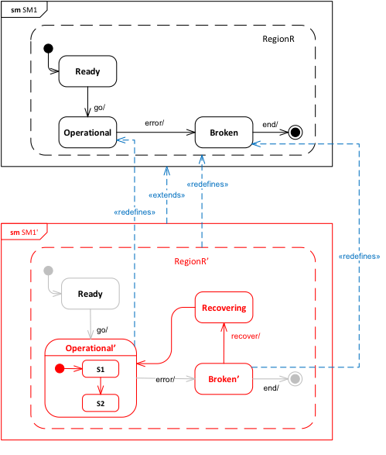Figure 8.19 - Using the StateMachine redefinition mechanism
The result is that, whenever a new member (e.g., Region, Vertex, or Transition) is added, all the containers in the transitive closure of container elements in which that element is defined have to be redefined, up to the top-level StateMachine container, which is “extended”. Furthermore, if a Transition is added, its source and target vertexes need to be either redefined or added (if they are new elements), so that they have the proper incoming and outgoing Transition collections.
Note. As shown in Figure 7.7, State is defined in the UML abstract syntax as a RedefinableElement, but not Pseudostate. However, since a Transition may have a Pseudostate as its source or target instead of a State, it is actually necessary for that Vertex be a RedefinableElement, allowing both States and Pseudostates to be redefined, rather than just States. This requires a change in the UML abstract syntax as currently defined (see 6.1).

Extending State Machine Execution
The execution of an extending StateMachine proceeds under the assumption that the StateMachine satisfies all the necessary constraints, as discussed in 8.5.3.1. In this case, execution is carried out according to the general model for behavior StateMachines described in Erreur : source de la référence non trouvée. The semantics of StateMachine redefinition are captured entirely in how the appropriate SemanticVisitors are instantiated for Vertexes and Transitions during that execution.
- If a Region has a redefinedRegion, then, in addition to VertexActivations and TransitionActivations being instantiated for any Vertexes and Transitions that it owns, VertexActivations and TransitionActivations are also instantiated for any Vertexes and Transitions that are inherited from the redefinedRegion (and that are not themselves redefined).
- When a TransitionActivation is instantiated, if the source and/or target Vertex of its Transition is redefined (directly or indirectly) by a Vertex in the StateMachine containing the Transition, then the corresponding vertexSourceActivation and/or vertexTargetActivation of the TransitionActivation is set to the VertexActivation for the redefining Vertex, rather than the original vertex.
Once all SemanticVisitors are instantiated for an extending StateMachineExecution per the above, the execution proceeds exactly as if the StateMachine being executed was the effective StateMachine resulting from merging all directly and indirectly extended StateMachines into the extending StateMachine (e.g., in the case of the example given in 8.5.3.1, the StateMachine SM1' shown in Figure 8.19 executes as if all the lightly-colored Vertexes and Transitions were all actually contained in SM1').
Submission Note. The above semantics covering StateMachine redefinition have not been incorporated into the formal execution model yet.

Loci
The Loci package in the PSSM execution model includes specializations of the CS_Locus and CS_ExecutionFactory classes from the Loci package of the PSCS execution model. The PSCS classes are specialized, rather than the corresponding fUML execution model classes, so that the PSSM execution model can also handle the SemanticVisitor classes that provide the operational semantics for PSCS, which is necessary to execute a model at the “Joint PSSM and PSCS Conformance” level (see 2.2.2). However, a model at the “PSSM-only Conformance” level, that strictly adheres to the PSSM subset specified in Clause 7, will not include any PSCS-specific elements and, therefore, can be executed without the PSCS functionality inherited by the PSSM Loci classes.
The SM_Locus class redefines the instantiate operation such that, if the given type is not a Behavior, then it is instantiated as an SM_Object (see 8.3), rather than a regular fUML Object. The SM_ExecutionFactory class redefines the instantiateVisitor operation in order to instantiate the new SemanticVisitors for StateMachine elements (as defined in 8.5) and to instantiate the PSSM-specific SM_OpaqueExpressionEvaluation SemanticVisitor for OpaqueExpression (as defined in 8.2).
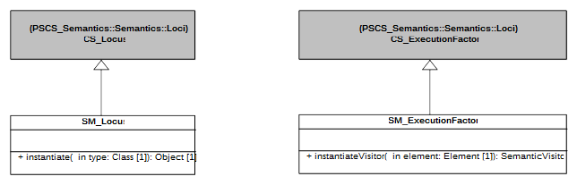
Figure 8.20 - Loci Extensions

Test Suite

Overview
This clause presents a test suite to be used to validate that an execution tool conforms to the semantic model presented in Clause 8 (see also Clause 2 on the requirements for conformance). The test suite is an fUML, PSCS and PSSM conformant model comprising a set of test cases that, when executed by an execution tool, report on whether the expected results are obtained.
The definition of the test suite is based on an analysis of the UML specification of the semantics of state machines ([UML], Clause 14) that identified a set of requirements to be validated by the test cases in the suite. Each requirement is a textual statement about one specific part of the semantics of state machines. Each test case then verifies whether or not an execution tool meets one particular requirement, as formally interpreted according to the semantic model defined in Clause 8.
The test suite is separated into two parts.
- The first part defines the abstract architecture of a test case. This architecture is specialized (in the UML sense) for each test case. A detailed presentation of this part of the test suite model is given in 9.2.
- The second part of the test suite is a set of packages, where each package refers to a particular test category. For example, one test category in the test suite captures all test cases related to transition semantics. Each test case in this category asserts a specific part (identified in the requirements) of the transition semantics. All test cases in the test suite are described in 9.3. Each description includes a statement of the requirement covered by the test case, a model of the state machine being tested and a description of the expected result of running the test.
The purpose of having a strong coupling between the semantic requirements for state machines is to be able to (as in any software development) identify quickly and precisely what is covered by the semantic model in terms of semantics and what is not. Coverage of the requirements by the test suite is discussed in 11.2.

Utilities

Overview
One objective of the PSSM test suite is to define a base architecture to simplify the definition of executable tests cases. This architecture (structure and behavior) is presented in 9.2.2. The communications that take place between the different elements of the architecture are presented in 9.2.3. Finally, 9.2.4 explains the process of generating a trace that captures information about the state machine execution. This trace is used to compare the execution expected for the state machine against the trace actually generated at execution time.

Architecture

Architecture Concepts
This subclause presents the architecture that was defined to describe test cases to assess the PSSM semantic model. The base architecture of the PSSM test suite is inspired by concepts identified by the UML testing profile. The UML testing profile was built to provide “a standardized language based on OMG's Unified Modeling Language for designing, visualizing, specifying, analyzing, constructing, and documenting the artifacts commonly used in and required for various testing approaches, in particular model-based testing (MBT) approaches” [UTP]. The UTP concepts used in the PSSM test suite are:
- TestComponent: “Test components are part of the test environment and are used to communicate with the system under test (SUT) and other test components. The main function of test components is to drive a test case by stimulating the system under test through its provided interfaces and to evaluate whether the actual responses of the system under test comply with the expected ones.” (see subclause 8.2.2.2 of [UTP] to read the complete description of this concept).
- TestCase: “A test case is a behavioral feature or behavior specifying tests. A test case specifies how a set of test components interact with an SUT to realize a test objective. Test cases are owned by test contexts, and therefore have access to all parts of the test configuration, other global variables (e.g., data pools, etc.) or further behavioral features (e.g., auxiliary methods). A test case always returns a verdict.” (see subclause 9.2.2.4 of [UTP] to read the complete description of this concept).
- TestContext: “A test context acts as a grouping mechanism for a set of test cases. The composite structure of a test context is referred to as test configuration. The classifier behavior of a test context may be used for test control” (see subclause 8.2.2.3 of [UTP] to read the complete description of this concept).
Figure 9.1 shows how these concepts are used in the context of the definition of the abstract architecture of a test. Figure 9.2 shows the structure of the semantic test container for such tests. These classes, and their behavior, is described in 9.2.2.2.
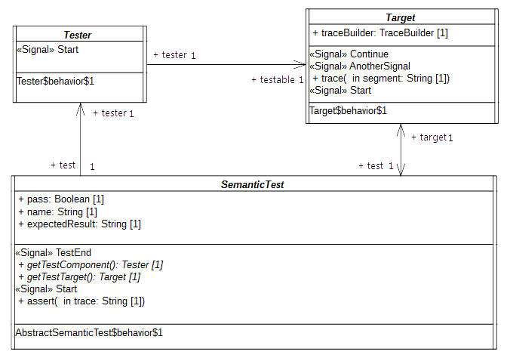Figure 9.1 - Architecture of an Abstract Semantic Test
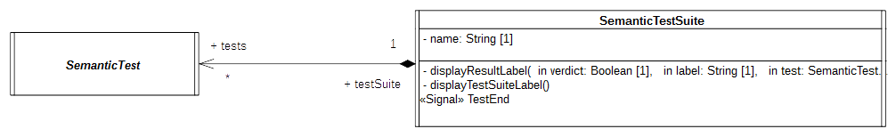Figure 9.2 - SemanticTest and SemanticsTestSuite

Architecture Class Descriptions

Tester

Description
The tester is an abstract active class which encodes in its classifier behavior the stimulation sequence (i.e, a set of event occurrences) that will be sent to the target (i.e., the system under test).
Note that this role matches what is intended for a TestComponent in UTP. This class has the stereotype “TestComponent” applied.

Association Ends
- testable: Target [1] – The SUT (System Under Test) to which the stimulation sequence is sent.
- test: SemanticTest [1] – The test case which controls the tester.

Receptions
- Start – A tester can receive a Start signal

Classifier Behavior
The classifier behavior of the abstract tester is empty. Specializations are intended to provide a new classifier behavior which will encode the user defined stimulation sequence.

Target

Description
The target defines the system under test. Specializations of this class have to provide their classifier behaviors specified as a state machine.
The target receives the stimulation sequence produced by the tester. The dispatching of the events will enable transitions of the state machine playing the role of a classifier behavior to be triggered.
Throughout its execution the state machine generates an execution trace. This trace is stored by the target and finally provided as the result of the execution to the test which controls the target.

Attributes
- traceBuilder: TraceBuilder [1] – Each test target owns a trace builder. It enables the classifier behavior of a target to build a trace of its execution.

Association Ends
- test: SemanticTest [1] - The test case which controls the target.

Operations
- trace(in segment: String[1]) – The operation enables the addition of “segment” (i.e., a new part) to the execution trace. It can be called at any time in the classifier behavior of the target to capture information relative to the executed state machine.

Receptions
- Start – The target is able to receive Start signals
- Continue – The target is able to receive Continue signals
- AnotherSignal – The target is able to receive AnotherSignal signals.
- Pending – The target is able to receive Pending signals.
- Data – The target is able to receive Data signals. Data signal has a property value which is of type Boolean.
- IntegerData – The target is able to receive IntegerData signals. IntegerData signal has a property value which is of type Integer.

Classifier Behavior
The classifier behavior of the abstract Target is empty. All specializations are intended to provide a new classifier behavior which will be the state machine whose execution is performed by the execution model defined for PSSM.

SemanticTest

Description
A SemanticTest is the main artifact of a semantic test case. It is in charge of instantiating and controlling the tester and the target (i.e. the SUT). When the execution of the SUT is done then the execution trace that was produced is provided to the semantic test case for analysis. If the trace matches one of the expected traces for the executed state machine the test pass otherwise it fails.
The classifier behavior of a semantic test has the TestCase stereotype applied.

Attributes
- name: String [1] – The name of the test case name.
- pass: Boolean [1] – The current status (pass or fail) of the test.
- expectedResult: String [1..*] – The set of all possible execution traces that can be expected for the SUT.

Operations
- getTestComponent(): Tester – Abstract operation which returns an instance of the tester controlled by the semantic test whose classifier has been started. This operation is intended to be redefined by specializations of SemanticTest.
- getTestTarget(): Target – Abstract operation which returns an instance of the target controlled by the semantic test whose classifier has been started. This operation is intended to be redefined by specializations of SemanticTest.
- assert(in trace: String[1]) – This operation updates the value of the attribute “pass” by comparing the trace given as a parameter to the expected execution trace known by the semantic test.
- regsiter(in possibleTrace: String[1]) – This operation updates the set of traces that can be expected to be generated by the Target. The specified trace is added to the set of traces.

Receptions
- Start – The semantic test is able to receive Start signals.
- TestEnd – The semantic test is able to receive TestEnd signals.

Classifier Behavior
The classifier behavior of a semantic test is defined as a UML activity (which conforms to the fUML subset). The Alf specification corresponding to this activity is presented in Table 9.1.
The principle of the behavior is the following:
- When the classifier behavior starts it blocks, waiting for the dispatching of a Start signal
- On the reception of the Start signal it creates and instantiates both the tester and the target.
  - The links (instances of associations) are created.
  - The tester and the target receive a Start signal.
  - The semantic test finally blocks again waiting for the dispatching of a TestEnd signal.
- When the TestEnd signal is received, it computes the verdict of the test. The verdict is either PASS or FAIL. In case of a failure of the test the semantic test display the trace generated by the target as well as the set of traces that were expected. Finally, in any case, the semantic test notifies the test suite that controls it about the termination of the test execution.
Note that specializations of a semantic test are not intended to override the dynamic that is captured in this classifier behavior.
private import Util::Protocol::Messages::Start;
private import Util::Protocol::Messages::End;
activity 'AbstractSemanticTest$behavior$1'() {
// Wait for a start signal
accept(Start);
// Tester and target are created and started
target = this.getTestTarget();
tester = this.getTestComponent();
// Create link connection between the two
target.tester = tester;
tester.testable = target;
this.target = target;
this.tester = tester;
// Both are started
target.Start();
tester.Start();
// Wait for the arrival of the result emitted by the target
accept(executionResult : End);
this.pass = this.matches(executionResult.trace);
// Result analysis
if(!this.pass){
WriteLine("[TEST] "+ this.name + " ** FAIL ** - {"+executionResult.trace + "} does not match any of the following");
for(i in 1..this.expectedTraces->size()){
WriteLine("-----> [" + IntegerFunctions::ToString(i)+"] - "+ this.expectedTraces->at(i));
}
}else{
WriteLine("[TEST] " + this.name + " - PASS -");
}
// Provides the result back to the test suite governing this semantic test case
this.testSuite.TestEnd(this.pass);
}
Table 9.1: Specification of SemanticTest Behavior

SemanticTestSuite

Description
A SemanticTestSuite owns a set of SemanticTest. The execution of these tests is orchestrated by the test suite itself. Tests are executed one by one. At the end of each test the verdict is retrieved by the test suite that is charge of displaying the results. This is an active class and is not intended to be specialized.
One can notice that it matches the concept of TestContext proposed by UTP. This class has the stereotype TestContext applied.

Attributes
- name: String [1] – The name of the test suite.

Association Ends
- tests: SemanticTest [*] - the set of semantic tests that is handled by the semantic test suite.

Receptions
- TestEnd – The SemanticTestSuite class is able to received TestEnd signals.

Operations
- displayResultLabel(in verdict: Boolean [1], in label: String[1], in test: SemanticTest [1]) – A convenience operation to display the test result on an output stream.
- displayTestSuiteLabel() - A convenience operation to display the name of the name of the suite on an output stream.

Classifier Behavior
. The test suite is composed of a set of SemanticTest. Each semantic test are executed in sequence. The execution of semantic is started by the sending of a Start signal and ends when the semantic test suite receives the notification TestEnd which includes the information relative to the semantic test verdict. The entire semantic test suite is considered as being failed if at most one of its test fails. In case of failure, the semantic test suite provides the number of failed semantic tests. The classifier behavior of the semantic test suite is presented in Table 9.2 using the Alf notation..
private import Util::Protocol::Messages::TestEnd;
private import Util::Protocol::Messages::Start;

activity 'SemanticTestSuite$behavior$1'() {
accept(Start);
WriteLine("\n[TEST SUITE ("+IntegerFunctions::ToString(this.tests->size())+" tests)] - "+this.name+"\n");
// Execute all semantic tests registered in that test suite
Integer failures = 0;
for(i in 1..this.tests->size()){
// Test gets the authorization to start
this.tests->at(i).Start();
// Test suite waits for the results
accept(testResult : TestEnd){
if(testResult.verdict == false){
failures++;
}
}
}
// There is at least one failure then the test suite is considered as failed
if(failures > 0){
WriteLine("\n[TEST SUITE] - "+this.name + " FAILURE ("+IntegerFunctions::ToString(failures)+" / "+IntegerFunctions::ToString(this.tests->size())+" failed)\n");
}
}
Table 9.2: Specification of SemanticTestSuite Behavior

Protocol

Protocol Overview
The Protocol package of the test suite has two subpackages: Messages and Events.
- Messages contains all signals used to communicate between the different active classes (see the model below).
namespace StateMachine_TestSuite::Util::Protocol;
package Messages {
/* -- Synchronization --*/
public signal Start {}
public signal End {
public trace: String;
}
public signal TestEnd {
public verdict: Boolean;
public label: String[0..1];
}
/* -- Synchronization --*/
/* -- Stimulations --*/
public signal Continue {}
public signal AnotherSignal {}
public signal Pending {}
public signal Data{
public value: Boolean;
}
public signal IntegerData{
public value: Integer;
}
/* -- Stimulations --*/
}
- Events contains the signal events (for the signals located in Messages) that can be directly used by triggers.
The synchronization signals in the Messages package (i.e., Start, End and TestEnd) are used to synchronize executions of different active objects. These signals are further described in 9.2.3.2.
The stimulation signals (i.e., Continue, Pending,AnotherSignal, Data and IntegerData), on the other hand, are used by the tester to stimulate the target (i.e. the system under test). None of these signals contain data except Data and IntegerData. These two signals are used to assess event data passing semantics

Synchronization Signal Descriptions

Start

Description
The Start signal is used for to two purposes in the test suite context. First it enables the test suite to start the execution of a specific semantic test. Second it enables the test to start both its tester and its target. The modeling constraint for the SemanticTest, the Tester and the Target is that they must all register an accepter for the Start signal at the beginning of the execution of their classifier behaviors. Note that Start signal does not include any data (it has no attributes).

End

Description
The End signal enables the Target to provide its controller (i.e., the SemanticTest) with a notification containing its execution trace. The semantic test takes advantage of this notification to compute the test verdict.

Attributes
- trace: String [1] – The execution trace generated by the state machine that plays the role of a classifier behavior for the Target.

TestEnd

Description
The TestEnd signal enables a semantic test to notify its test suite that it has completed. This notification encapsulates two items of information: the test verdict as well as a label indicating in case of a fail the differences between the expected trace and the trace actually produced during the execution.

Attributes
- verdict: Boolean [1] – The verdict of test that is two say pass or fail encoded as Boolean values.
- label: String [0..1] – If the test failed the label presents the difference between the trace that was expected and the one actually produced during the execution.

Tracing
At runtime the target is intended to produce an execution trace. This trace will be used to compute the test verdict by comparing the trace expected by the semantic test against the one actually generated by the target. The production of this trace relies on a small utility class TraceBuilder.
namespace StateMachine_TestSuite::Util::Tracing;
class TraceBuilder {
/*Record the trace as simple String*/
public trace: String;
/*Construction and destruction */
@Create
public TraceBuilder();
@Destroy
public destroy();
/*Add a new segment in the trace*/
public addSegment(in segment: String);
}
The execution information (state entered, behavior executed, etc.) that must be part of the trace is up to the designer of the test. To add new information in the trace, the designer must call the trace operation provided by the target. This latter will delegate to the trace builder. Such call to the trace operation must take place while the state machine is running. Consequently, there are four places at which the calls to trace might occur:
- The entry behavior of a state
- The doActivity behavior of a state
- The exit behavior of a state
- The effect behavior of a transition

Tests

Overview
This subclause presents the different test cases that are currently included in the PSSM test suite. The tests cases are grouped into categories. Each category is related to a dedicated part of the semantics.
Each test included in the test suite specializes the base test architecture presented in 9.2.2.1. Figure 9.3 illustrates such a specialization, for the case of the test Behavior 001 (which is fully described in 9.3.2.2). The Target class presented in 9.2.2.2.2 is specialized in order to provide a specific test target. This specialized class then defines a new classifier behavior, which is the state machine that is going to be executed.
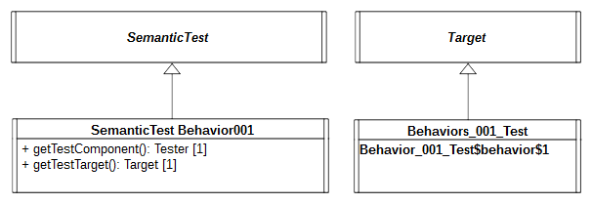
Figure 9.3 - Behavior 001 Test Architecture
The general class SemanticTest is also specialized. This enables the test to provide redefined versions of operations getTestComponent and getTestTarget. These two operations are used to instantiate (and start the classifier behaviors of) both the tester (see 9.2.2.2.1) and the test target (see 9.2.2.2.2).
All test cases in the test suite follow a similar test architecture, except for those in 11.1.7, which test the execution of “standalone” state machines. In the standalone state machine test cases, the state machine is itself the test target, rather than being the classifier behavior of another class. However, these test cases otherwise run in a similar fashion to the other test cases.
Each of the following test descriptions includes:
- A statement of the semantic requirement covered by the test.
- A diagram of the state machine being tested.
- The event sequence that is received by the tested state machine. The order in which the event occurrences are enumerated is the order in which the event occurrences will be received. Each received event occurrence is related to a specific state machine configuration.
- The execution trace generated during the test execution. This trace does not represent the complete execution of the tested state machine. It is only composed of trace messages generated while dedicated model elements composing the state machine are executed. Although the trace built during the execution is not complete, it is always sufficient to evaluate if the state machine was executed in way that conforms to the semantics described for UML state machines.
- An explanatory note detailing the different phases of the execution.
- A table describing the different run-to-completion (RTC) steps realized during the execution of the tested state machine. This table contains the following columns:
- Steps – The identifier of the run-to-completion step
- Event pool – The status of the event pool for the time at which the RTC step is realized. The rightmost event in the pool is the event to be dispatched for that step.
- State machine configuration – The configuration in which the currently executed state-machine at the moment where the RTC step is realized.
- Fired transition(s) – The transitions that are fire during the RTC step.
- A list (if any) of all alternative execution traces that can be be produced by the test. In this situation, one of the trace is chosen and explained through a table describing the different RTC steps leading to the generation of that trace.

Behavior

Overview
Tests presented in this subclause assess that semantics associated with state behaviors (i.e., entry, doActivity and exit) conform to what is specified in UML.

Test Behavior 001
Behavior 001 – ([UML], 14.2.3.4.3)
A State may have an associated entry Behavior. This Behavior, if defined, is executed whenever the State is entered through an external Transition.

Tested state machine
The state machine that plays the role of a classifier behavior for the class Behaviors_001_Test is presented in Figure 9.4. The entry behavior associated with the state S1 of this state machine is intended to be executed when the state is entered. When executed, the behavior will add in the execution trace a message S1(entry). If the message is not part of the trace, then the test is considered to have failed.
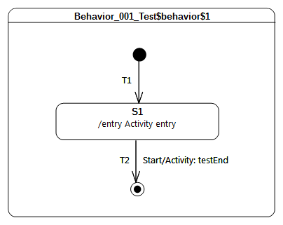Figure 9.4 - Behavior 001 Test Classifier Behavior
The behavior which is associated as an entry to to the state S1 is presented as an activity in Figure 9.5.
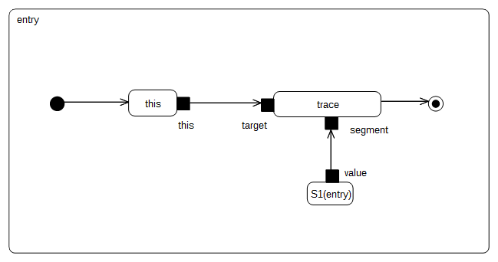Figure 9.5 - S1 entry behavior

Test execution
Received event occurrence(s)
  - Start – received when in configuration S1
Generated trace
- S1(entry)
RTC steps
Step | Event pool | State machine configuration | Fired transition(s)
1 | [] | [] - Initial RTC step | [T1]
2 | [Start, CE(S1)] | [S1] | []
3 | [Start] | [S1] | [T2]

Test Behavior 002
Behavior002 – ([UML], 14.2.3.4.3)
A State may also have an associated exit Behavior, which, if defined, is executed whenever the State is exited.

Tested state machine
The state machine that is executed for this test is presented in Figure 9.6.
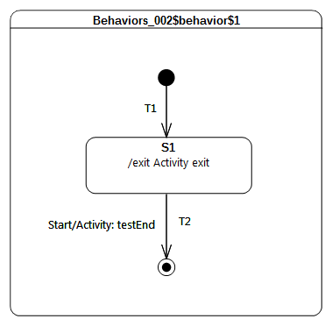
Figure 9.6 - Behavior 002 Test Classifier Behavior

Test execution
Received event occurrence(s)
- Start – received when in configuration S1
Generated trace
- S1(exit)
RTC steps
Step | Event pool | State machine configuration | Fired transition(s)
1 | [] | [] - Initial RTC step | [T1]
2 | [Start, CE(S1)] | [S1] | []
3 | [Start] | [S1] | [T2]

Test Behavior 003 – A
Behavior003 – ([UML], 14.2.3.4.3)
A State may also have an associated doActivity Behavior. This Behavior commences execution when the State is entered (but only after the State entry Behavior has completed) and executes concurrently with any other Behaviors that may be associated with the State, until it completes (in which case a completion event is generated) or the State is exited, in which case execution of the doActivity Behavior is aborted.
In this test the focus is on validating the assertion that if a doActivity is currently executed by a state and the latter is exited, then the doActivity is aborted. The second part of the requirement presented above will be asserted in section 9.3.2.5.

Tested state machine
The state machine that is executed for this test is presented in Figure 9.7.
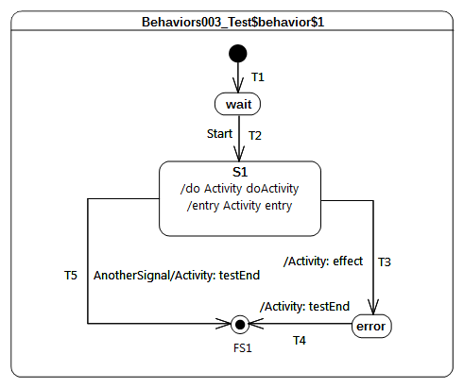
Figure 9.7 - Behavior 003 - A Test Classifier behavior
The doActivity behavior which is executed when the entry of S1 finished is presented in Figure 9.8. When started, this behavior completes the execution trace with the message S1(doActivityPartI) and blocks until the reception of a Continue signal. Only if this signal triggers the continuation of the doActivity will the execution trace be completed with the message S1(doActivityPartII).
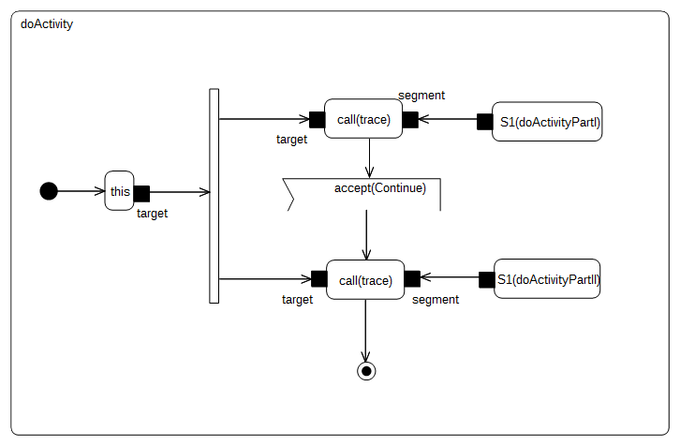
Figure 9.8 - S1 doActivity behavior

Test executions
Received event occurrence(s)
- Start – received when in configuration wait
- AnotherSignal – received when in configuration S1
Generated trace
- S1(entry)::S1(doActivityPartI)
Note. The dispatching of the event AnotherSignal triggered transition T5. The triggering of the latter implies that S1 is exited and hence its running doActivity is aborted. The state machine terminates its execution by reaching the final state.
RTC steps
Step | Event pool | State machine configuration | Fired transition(s)
1 | [] | [] - Initial RTC step | [T1]
2 | [Start, CE(wait)] | [wait] | []
3 | [Start] | [wait] | [T2]
4 | [AnotherSignal] | [S1] | [T5]

Test Behavior 003 – B
Behavior 003 – ([UML], 14.2.3.4.3)
A State may also have an associated doActivity Behavior. This Behavior commences execution when the State is entered (but only after the State entry Behavior has completed) and executes concurrently with any other Behaviors that may be associated with the State, until it completes (in which case a completion event is generated) or the State is exited, in which case execution of the doActivity Behavior is aborted.
This test focuses on validating the assertion that when the doActivity completes then, if the state is in a situation where it is ready to complete, it generates a completion event. For this test the doActivity that is related to S1 is the same as the one presented in Figure 9.8.

Tested state machine
The state machine that is executed for this test is presented in Figure 9.9.

Test execution
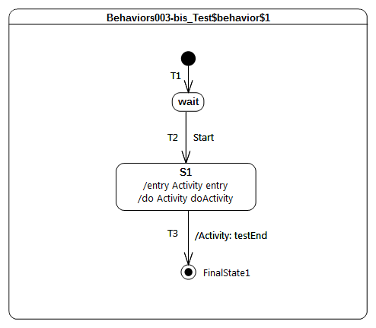
Figure 9.9 - Behavior 003 - B Test Classifier behavior
Received event occurrence(s)
- Start – received when in configuration wait
- Continue – received when in configuration S1
Generated trace
- S1(entry)::S1(doActivityPartI)::S1(doActivityPartII)
Note. In this test case the only way for the state machine to terminate its execution is to traverse the completion transition T3 using the completion event generated by S1. The completion event has to be generated so that the doActivity behavior started by S1 completes. In this case, when Continue gets dispatched, it cannot be accepted by the state machine since there is no transition that has a trigger to react to this event. However, it can be accepted by the doActivity behavior which is currently blocked waiting for a Continue event. The acceptance of this event leads to the doActivity completing, which implies that upon completion state S1 generates a completion event.
RTC steps
Step | Event pool | State machine configuration | Fired transition(s)
1 | [] | [] - Initial RTC step | [T1]
2 | [Start, CE(wait)] | [wait] | []
3 | [Start] | [wait] | [T2]
4 | [Continue] | [S1] | [] - RTC step in the doActivity
5 | [CE(S1)] | [S1] | [T3]

Test Behavior 004
Behavior 004 – (UML 2.5 section 14.2.3.4.3)
The execution of a doActivity Behavior of a State is not affected by the firing of an internal Transition of that State.

Tested state machine
The state machine that is executed for this test is presented in Figure 9.10. It is important to note that if an event does not appear on the diagram, a self internal transition T3 exists for S1. This transition can be triggered on an AnotherSignal event and has an effect behavior. For this test the doActivity that is related to S1 is the same as the one presented in Figure 9.8.
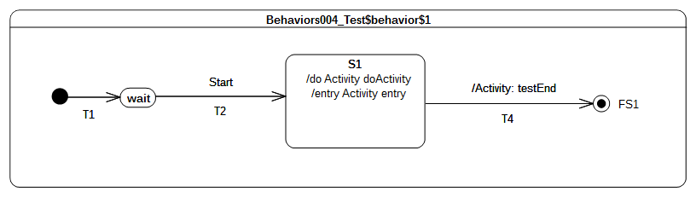
Figure 9.10 - Behavior 004 Test Classifier Behavior

Test execution
Received event occurrence(s)
- Start – received when in configuration wait
- AnotherSignal – received when in configuration S1
- Continue – received when in configuration S1
Generated trace
- S1(entry)::S1(doActivityPartI)::T3(effect)::S1(doActivityPartII)
Note. When in configuration S1, T3 is triggered by the dispatching of AnotherSignal. This triggering has no impact on the doActivity behavior that is currently running. Indeed the behavior is still blocked waiting for the Continue event occurrence. When this event is received, the doActivity consumes it and completes its execution.
RTC steps
Step | Event pool | State machine configuration | Fired transition(s)
1 | [] | [] - Initial RTC step | [T1]
2 | [Start, CE(wait)] | [wait] | []
3 | [Start] | [wait] | [T2]
4 | [Continue, AnotherSignal] | [S1] | [T3]
5 | [Continue] | [S1] | [] - RTC step in the doActivity
6 | [CE(S1)] | [S1] | [T4]

Transition

Transition 001
Transition 001 ([UML], 14.2.3.8)
It may have an associated effect Behavior, which is executed when the Transition is traversed.

Tested state machine
The state machine that is executed for this test is presented in Figure 9.11.
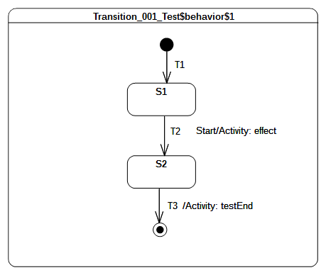Figure 9.11 - Transition 001 Test Classifier Behavior

Test executions
Received event occurrence(s)
- Start – received when in configuration S1.
Generated trace
- T2(effect)
Note. When Start is dispatched it triggers T2 whose execution includes the message T2(effect) to the execution trace.
RTC steps
Step | Event pool | State machine configuration | Fired transition(s)
1 | [] | [] - Initial RTC step | [T1]
2 | [Start, CE(S1)] | [S1] | []
3 | [Start] | [S1] | [T2]
4 | [CE(S2)] | [S2] | [T3]

Transition 007
Transition 007 ([UML], 14.2.3.8)
A Transition may own a set of Triggers, each of which specifies an Event whose occurrence, when dispatched, may trigger traversal of the Transition.

Tested state machine
The state machine that is executed for this test is presented in Figure 9.12.
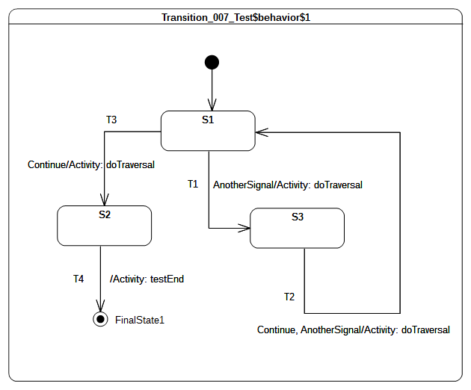Figure 9.12 - Transition 007 Test Classifier Behavior

Test executions
Received event occurrence(s)
- AnotherSignal – received when in configuration S1.
- Continue – received when in configuration S3.
- Continue – received when in configuration S1.
Generated trace
- T1(effect)::T2(effect)::T3(effect)
Note. When AnotherSignal is dispatched, transition T1 is triggered. This is due to the fact that T1 declares a trigger for the signal AnotherSignal. The state machine moves then into configuration S3. There is no difference in situations where there are multiple triggers declared for a transition (see T2 in Figure 9.24). If the dispatched event occurrence matches at least one of them, the transition is traversed. Continue triggers T2.
RTC steps
Step | Event pool | State machine configuration | Fired transition(s)
1 | [] | [] - Initial RTC step | [InitialTransition]
2 | [AnotherSignal, CE(S1)] | [S1] | []
3 | [AnotherSignal] | [S1] | [T1]
4 | [Continue, CE(S3)] | [S3] | []
5 | [Continue] | [S3] | [T2]
6 | [Continue, CE(S1)] | [S1] | []
7 | [Continue] | [S1] | [T3]
8 | [CE(S2)] | [S2] | [T4]

Transition 010
Transition 010 ([UML], 14.2.3.8.1)
kind = internal is a special case of a local Transition that is a self-transition (i.e., with the same source and target States), such that the State is never exited (and, thus, not re-entered), which means that no exit or entry Behaviors are executed when this Transition is executed.

Tested state machine
The state machine that is executed for this test is presented in Figure 9.13. Although it does not appear explicitly in the diagram, it is important to note that it exists as an internal self transition IT for S1. This transition can be triggered when an occurrence of AnotherSignal is dispatched.

Test executions
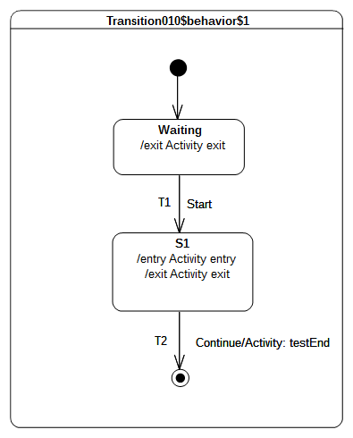Figure 9.13 - Transition 010 Test Classifier Behavior
Received event occurrence(s)
- Start - received when in configuration waiting.
- AnotherSignal – received when in configuration S1.
- AnotherSignal – received when in configuration S1.
- Continue – received when in configuration S1.
Generated trace
- waiting(exit)::S1(entry)::IT(effect)::IT(effect)::S1(exit)
Note. The trace demonstrates here that S1 is not exited and re-entered when transition IT is traversed. In the trace, one can observe that IT(effect) appears twice. This illustrates the fact that this transition is triggered for each dispatching of an occurrence of AnotherSignal. The dispatching of the Continue event occurrence implies that T2 is traversed and the state machine execution completes by reaching the final state.
RTC steps
Step | Event pool | State machine configuration | Fired transition(s)
1 | [] | [] - Initial RTC step | [InitialTransition]
2 | [Start, CE(waiting)] | [waiting] | []
3 | [Start] | [waiting] | [T1]
4 | [AnotherSignal, AnotherSignal, CE(S1)] | [S1] | []
5 | [AnotherSignal, AnotherSignal] | [S1] | [IT]
6 | [Continue, AnotherSignal] | [S1] | [IT]
7 | [Continue] | [S1] | [T2]

Transition 011 – A
Transition 011 ([UML], 14.2.3.8.1)
kind = local is the opposite of external, meaning that the Transition does not exit its containing State (and, hence, the exit Behavior of the containing State will not be executed)

Tested state machine
The state machine that is executed for this test is presented in Figure 9.14.
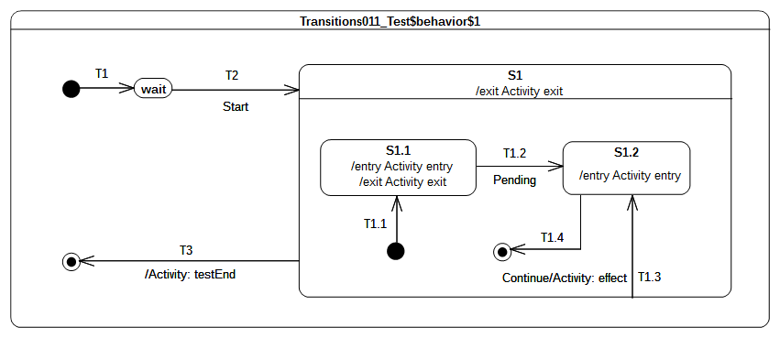Figure 9.14 - Transition 011- A Test Classifier Behavior

Test executions
Received event occurrence(s)
- Start – received when in configuration wait.
- Continue – received when in configuration S1[S1.1].
Generated trace
- S1.1(entry)::S1.1(exit)::T1.3(effect)::S1.2(entry)
Note. When T1.3 is triggered by the event occurrence Continue, the state machine is in the configuration S1[S1.1]. The traversal of T1.3 implies that S1.1 is exited, the effect behavior is executed and, finally, S1.2 is entered. Upon completion of the entry behavior a completion event is generated for S1.2. The latter is used to trigger T1.4 in the next RTC step.
RTC steps
Step | Event pool | State machine configuration | Fired transition(s)
1 | [] | [] - Initial RTC step | [T1]
2 | [Start, CE(wait)] | [wait] | []
3 | [Start] | [wait] | [T2(T1.1)]
4 | [Continue, CE(S1.1)] | [S1[S1.1]] | []
5 | [Continue] | [S1[S1.1]] | [T1.3]
6 | [CE(S1.2)] | [S1[S1.2]] | [T1.4]
7 | [CE(S1)] | [S1] | [T3]

Transition 011 – B
Transition 011 ([UML], 14.2.3.8.1)
kind = local is the opposite of external, meaning that the Transition does not exit its containing State (and, hence, the exit Behavior of the containing State will not be executed)

Tested state machine
The state machine that is executed for this test is presented in Figure 9.15.
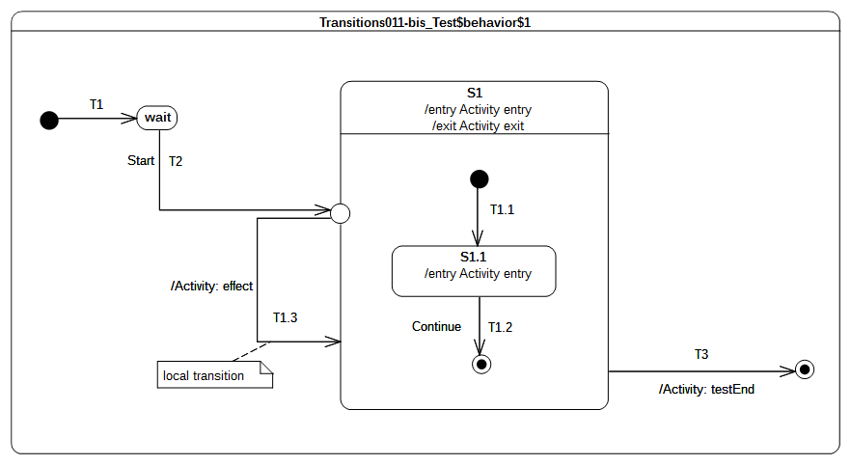
Figure 9.15 - Transition 011 - B Test Classifier behavior

Test executions
Received event occurrence(s)
- Start – received when in configuration wait.
- Continue – received when in configuration S1.
Generated trace
- S1(entry)::S1.1(entry)::T1.3(effect)
Note. When the entry point is reached, S1 is entered and its unique region is entered. The execution of the region starts from the initial pseudostate. Next, the continuation transition T1.1 is traversed, and, finally, S1.1 is entered. At this point, the RTC step initiated by the dispatching of the Start event occurrence is not finished. Indeed, the continuation transition T1.3 outgoing from the entry point is traversed. Since S1 is already active it is not re-entered. This marks the end of the current RTC step. When the Continue event occurrence is dispatched, it triggers T1.2 which leads to the region completion and hence to the completion of S1. The completion event for S1 is used to trigger T3, which leads to the completion of the state machine execution.
RTC steps
Step | Event pool | State machine configuration | Fired transition(s)
1 | [] | [] - Initial RTC step | [T1]
2 | [Start, CE(wait)] | [wait] | []
3 | [Start] | [wait] | [T2(T1.1, T1.3)]
4 | [Continue, CE(S1.1)] | [S1[S1.1]] | []
5 | [Continue] | [S1[S1.1]] | [T1.2]
6 | [CE(S1)] | [S1] | [T3]

Transition 011 – C
Transition 001
kind = external means that the Transition exits its source Vertex. If the Vertex is a State, then executing this Transition will result in the execution of any associated exit Behavior of that State.

Tested state machine
The state machine that is executed for this test is presented in Figure 9.16.
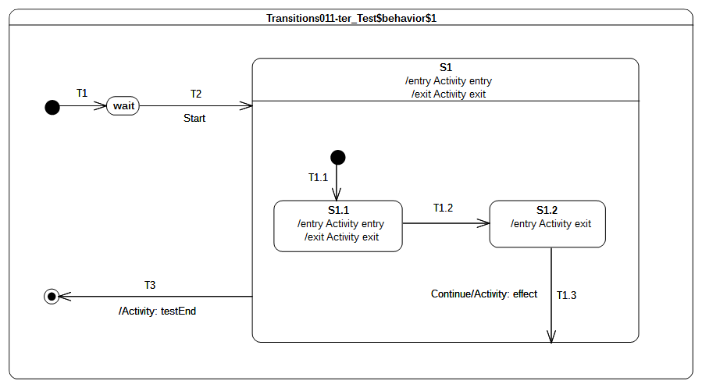
Figure 9.16 - Transition 011 - C Test Classifier Behavior

Test executions
Received event occurrence(s)
- Start – received when in configuration wait.
- Continue – received when in configuration S1[S1.2].
Generated trace
- S1(entry)::S1.1(entry)::S1.1(exit)::S1.2(exit)::T1.3(effect)::S1(exit)
Note. When T1.3 is triggered (by the dispatching of Continue), S1.2 is exited and the effect behavior is executed. However, S1 is not re-entered (it is already active) but the region which contains the last exited state is completed. The completion of the region implies the generation of a completion event for S1. This completion event is used to trigger T3.
RTC steps
Step | Event pool | State machine configuration | Fired transition(s)
1 | [] | [] - Initial RTC step | [T1]
2 | [Start, CE(wait)] | [wait] | []
3 | [Start] | [wait] | [T2(T1.1)]
4 | [CE(S1.1)] | [S1[S1.1]] | [T1.2]
5 | [Continue, CE(S1.2)] | [S1[S1.2]] | []
6 | [Continue] | [S1[S1.2]] | [T1.3]
7 | [CE(S1)] | [S1] | [T3]

Transition 011 – D
Transition 011 ([UML], 14.2.3.8.1)
kind = local is the opposite of external, meaning that the Transition does not exit its containing State (and, hence, the exit Behavior of the containing State will not be executed)

Tested state machine
The state machine that is executed for this test is presented in Figure 9.17.
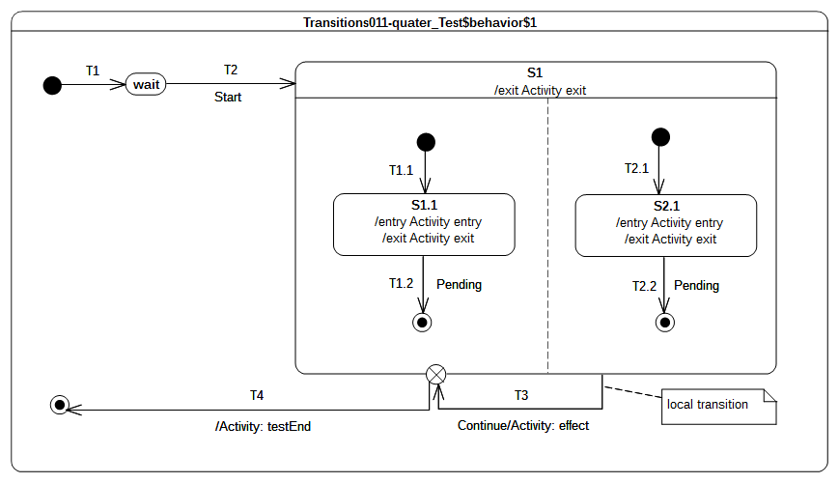
Figure 9.17 - Transition 011- D Test Classifier Behavior

Test executions
Received event occurrence(s)
- Start – received when in configuration wait.
- Continue – received when in configuration S1[S1.1, S2.1].
Generated trace
- S1.1(entry)::S2.1(entry)::T3(effect)::S1.1(exit)::S2.1(exit)::S1(exit)
Notes
- S1 has orthogonal regions; therefore, it is important to notice that the trace presented above is one possible execution path. Alternative execution paths are also possible.
- When the state machine configuration is S1[S1.1, S2.1], the event occurrence Continue is dispatched. This leads to the triggering of the local transition T3. The source state is not exited, the effect behavior is executed and, finally, the exit point is reached. Hence S1.1 and S2.1 are exited immediately, followed by S1. The continuation transition fires and leads to the completion of the state machine execution.
RTC steps
Step | Event pool | State machine configuration | Fired transition(s)
1 | [] | [] - Initial RTC step | [T1]
2 | [Start, CE(wait)] | [wait] | []
3 | [Start] | [wait] | [T2(T1.1, T2.1)]
4 | [Continue, CE(S2.1), CE(1.1)] | [S1[S1.1, S2.1]] | []
5 | [Continue, CE(S2.1)] | [S1[S1.1, S2.1]] | []
6 | [Continue] | [S1[S1.1, S2.1]] | [T3(T4)]

Transition 011 – E
Transition 001 ([UML], 14.2.3.8.1)
kind = local is the opposite of external, meaning that the Transition does not exit its containing State (and, hence, the exit Behavior of the containing State will not be executed)

Tested state machine
The state machine that is executed for this test is presented in Figure 9.18.
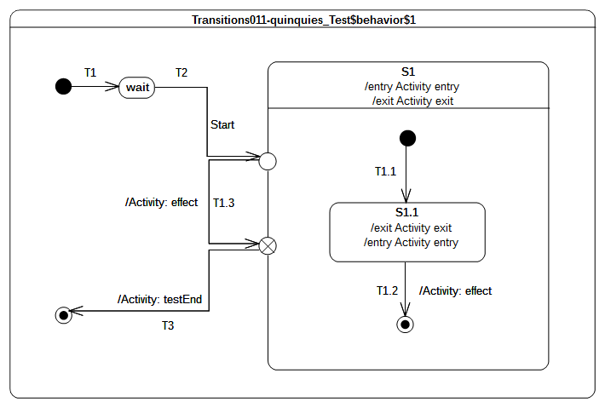
Figure 9.18 - Transition 011 - E Test Classifier Behavior

Test executions
Received event occurrence(s)
- Start – received when in configuration wait.
Generated trace
- S1(entry)::S1.1(entry)::T1.3(effect)::S1.1(exit)::S1(exit)
Note. When the entry point is reached, S1 is entered and the region is entered using the default approach (i.e., an initial transition is sought to start the execution). Hence S1.1 is entered via the transition T1.1. The RTC initiated by the dispatching of Start event occurrence is not ended. The continuation transition T1.3 is traversed and its effect behavior is executed. At the point where the exit point is reached, S1.1 is exited as well as S1. The continuation transition T3 is traversed and leads to the completion of the state machine execution. Transition T1.2 is never traversed in this test case and, consequently, the S1 region never completes.
RTC steps
Step | Event pool | State machine configuration | Fired transition(s)
1 | [] | [] - Initial RTC step | [T1]
2 | [Start, CE(wait)] | [wait] | []
3 | [Start] | [wait] | [T2(T1.1, T1.3, T3)]

Transition 015
Transition 015 ([UML], 14.2.3.8.3)
In case of simple States, a completion event is generated when the associated entry and doActivity Behaviors have completed executing

Tested state machine
The state machine that is executed for this test is presented in Figure 9.19. The doActivity which related to S1 state is exactly the same as the one presented in Figure 9.8.

Test executions
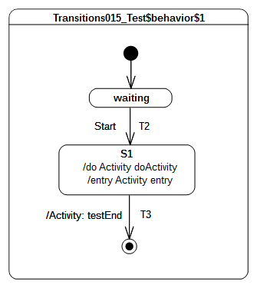Figure 9.19 - Transition 015 Test Classifier Behavior
Received event occurrence(s)
- Start – received when in configuration waiting.
Generated trace
- S1(entry)::S1(doActivity)
Note. When S1 is entered (RTC step started by disptaching Start), its entry behavior is executed. As soon as the entry terminates its execution, the doActivity is started asynchronously. When this doActivity behavior completes its execution, a completion event is generated by S1 (its entry and doActivity are now terminated). This completion event is used to trigger T3.
RTC steps
Step | Event pool | State machine configuration | Fired transition(s)
1 | [] | [] - Initial RTC step | [InitialTransiton]
2 | [Start, CE(waiting)] | [waiting] | []
3 | [Start] | [waiting] | [T2]
4 | [CE(S1)] | [S1] | [T3]

Transition 016
Transition 016 ([UML], 14.2.3.8.3)
If no such Behaviors are defined, the completion event is generated upon entry into the State

Tested state machine
The state machine that is executed for this test is presented in Figure 9.20.
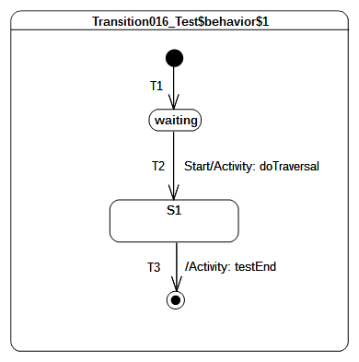Figure 9.20 - Transition 016 Test Classifier Behavior

Test executions
Received event occurrence(s)
- Start – received when in configuration waiting.
Generated trace
- T2(effect)
Note. When Start is dispatched T2 is triggered. Hence, the effect behavior of T2 is executed and S1 is entered. In this test case S1 has no entry or doActivity, so the completion event is generated when it is entered.
RTC steps
Step | Event pool | State machine configuration | Fired transition(s)
1 | [] | [] - Initial RTC step | [InitialTransiton]
2 | [Start, CE(waiting)] | [waiting] | []
3 | [Start] | [waiting] | [T2]
4 | [CE(S1.1)] | [S1] | [T3]

Transition 017
Transition 017 ([UML], 14.2.3.8.3)
For composite States, a completion event is generated under the following circumstances: All internal activities (e.g., entry and doActivity Behaviors) have completed execution, and all its orthogonal Regions have reached a FinalState

Tested state machine
The state machine that is executed for this test is presented in Figure 9.21.

Test executions
Figure 9.21 - Transition 017 Test Classifier Behavior
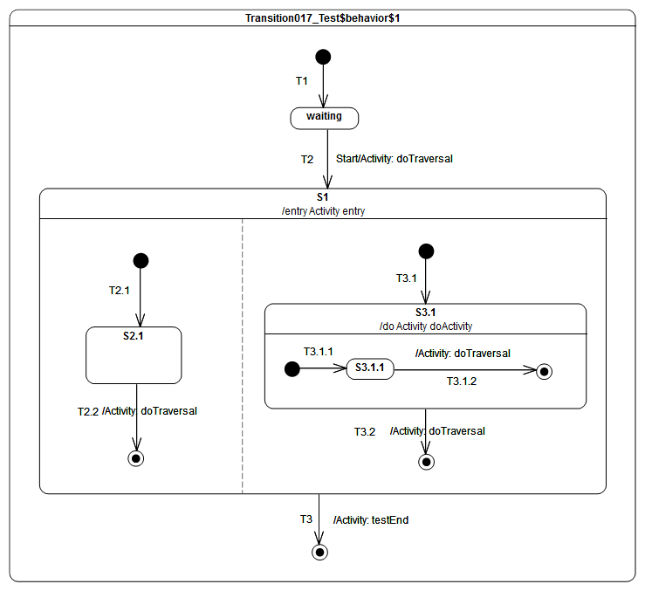
Received event occurrence(s)
- Start – received when in configuration waiting.
Generated trace
- T2(effect)::S1(entry)::T2.2(effect)::T3.2.1(effect)::S3.1(doActivity)::T3.2(effect)
Notes

- The test case presented in Figure 9.21 relies on completion event semantics. When Start is dispatched, T2 fires and implies the entrance of S1. Each region of S1 is entered concurrently using the default entry approach. Let assume that for the described execution:
  - The doActivity placed on S3.1 starts immediately and includes its message in the execution trace before any other RTC step is performed in the state machine.
  - The completion events generated by S2.1 and S3.1 are added in the event pool in the following order: CE(S1.2) is first and CE(S3.1.1) second. With respect to these assumptions the following execution steps occur: T2.2 is triggered by the dispatching of CE(S2.1). When the final state is reached no completion event is generated since the right hand side region of the state machine is still running.
  - T3.1.2 is triggered by the dispatching of CE(S3.1.2). When the final state is reached a completion event is generated for S3.1 since its doActivity behavior has already terminated its execution.
  - T3.2 is triggered by the dispatching of the completion event generated by S3.1. This leads to the completion of S1.
  - The completion event generated by S1 will be then used to trigger T3. The traversal of this transition leads to a final state upon which the state machine execution completes.
RTC steps
Step | Event pool | State machine configuration | Fired transition(s)
1 | [] | [] - Initial RTC step | [T1]
2 | [Start, CE(waiting)] | [waiting] | []
3 | [Start] | [waiting] | [T2(T2.1, T3.1(T3.1.1))]
4 | [CE(S3.1.1), CE(S2.1)] | [S1[S2.1, S3.1[S3.1.1]]] | [T2.2]
5 | [CE(S3.1.1)] | [S1[S3.1[S3.1.1]]] | [T3.1.2]
6 | [CE(3.1)] | [S1[S3.1] | [T3.2]
7 | [CE(S1)] | [S1] | [T3]
Alternative execution traces
The state-machine specifies parallelism through S1 which owns orthogonal regions and S3.1 which provides a doActivity that will evolve on its own thread of execution. For that particular state-machine, the following set of alternative execution traces (the one presented above is not included in that set) is allowed with regards to the UML state machines semantics;
- T2(effect)::S1(entry)::T2.2(effect)::S3.1(doActivity)::T3.1.2(effect)::T3.2(effect)
- T2(effect)::S1(entry)::T2.2(effect)::T3.2(effect)::S3.1(doActivity)::T3.1.2(effect)
- T2(effect)::S1(entry)::T2.2(effect)::T3.2(effect)::T3.1.2(effect)::S3.1(doActivity)
- T2(effect)::S1(entry)::S3.1(doActivity)::T2.2(effect)::T3.1.2(effect)::T3.2(effect)
- T2(effect)::S1(entry)::S3.1(doActivity)::T3.1.2(effect)::T2.2(effect)::T3.2(effect)
- T2(effect)::S1(entry)::T3.1.2(effect)::T2.2(effect)::S3.1(doActivity)::T3.2(effect)
- T2(effect)::S1(entry)::T3.1.2(effect)::S3.1(doActivity)::T2.2(effect)::T3.2(effect)
The alternative trace 6 denotes an execution in which the doActivity behavior includes its trace message after that the RTC steps related to the dispatching of completion events CE(S3.1.1) and CE(S2.1) have been performed. The table below describes the different steps leading to the production of this execution trace.
Step | Event pool | State machine configuration | Fired transition(s)
1 | [] | [] - Initial RTC step | [T1]
2 | [Start, CE(waiting)] | [waiting] | []
3 | [Start] | [waiting] | [T2[T2.1, T3.1(T3.1.1)]]
4 | [CE(S2.1), CE(S3.1.1)] | [S1[S2.1, S3.1[S3.1.1]]] | [T3.1.2]
5 | [CE(3.1), CE(S2.1)] | [S1[S2.1, S3.1]] | [T2.2]
6 | [CE(3.1)] | [S1[S2.1]] | [T3.2]
7 | [CE(S1)] | [S1] | [T3]

Transition 019
Transition 019 ([UML], 14.2.3.8.3)
If two or more completion events corresponding to multiple orthogonal Regions occur simultaneously (i.e., as a result of the same Event occurrence), the order in which such completion occurrences are processed is not defined (p.329)

Tested state machine
The state machine that is executed for this test is presented in Figure 9.22.

Test executions
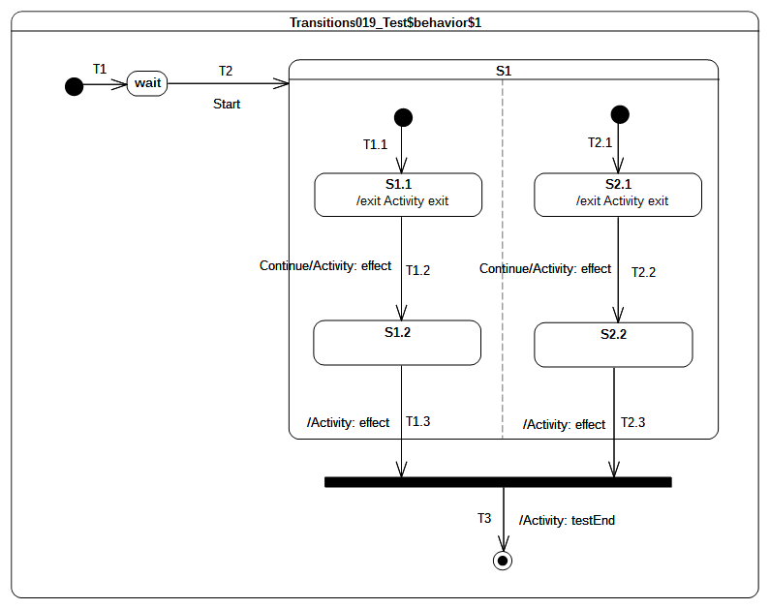Figure 9.22 - Transition 019 Test Classifier Behavior
Received event occurrence(s)
- Start – received when in configuration wait.
- Continue – received when in configuration S1[S1.1, S2.1].
Generated trace
- S1.1(exit)::T1.2(effect)::S2.1(exit)::T2.2(effect)::T1.3(effect)::T2.3(effect)
Notes
- The execution trace that is presented above is one possibility. Other valid execution traces are also possible for this test case.
- At the end of the RTC step initiated by the dispatching of the Start event occurrence, the state machine is in the following configuration: S1[S1.1, S2.1]. Dispatching of the Continue event occurrence implies a simultaneous triggering of both T1.2 and T2.2. Hence, due to the same event occurrence, two completion are generated by S1.2 and S2.2 respectively. The order in which these completion events will be dispatched is the order in which they were placed in the event pool. Assuming that CE(S1.2) is first, then T1.3 will be fired first. CE(2.1) will be triggered next and the join node prerequisite will be satisfied.
RTC steps
Step | Event pool | State machine configuration | Fired transition(s)
1 | [] | [] - Initial RTC step | [T1]
2 | [Start, CE(wait)] | [wait] | []
3 | [Start] | [wait] | [T2(T1.1, T2.1)]
4 | [Continue, CE(S1.1), CE(S2.1)] | [S1[S1.1, S2.1]] | []
5 | [Continue, CE(S1.1)] | [S1[S1.1, S2.1]] | []
6 | [Continue] | [S1[S1.1, S2.1]] | [T1.2, T2.2]
7 | [CE(S2.2), CE(S1.2)] | [S1[S1.2, S2.2]] | [T1.3]
8 | [CE(S2.2)] | [S1[S2.2]] | [T2.3(T3)]
Alternative execution traces
The state machine specifies parallelism thanks to state S1 which owns two orthogonal regions. Hence different interleaving are possible while still conforming to UML semantics. The set of traces below describe the alternative interleaving that can be observed at runtime.
- S1.1(exit)::S2.1(exit)::T1.2(effect)::T2.2(effect)::T1.3(effect)::T2.3(effect)
- S1.1(exit)::S2.1(exit)::T2.2(effect)::T1.2(effect)::T2.3(effect)::T1.3(effect)
- S2.1(exit)::S1.1(exit)::T2.2(effect)::T1.2(effect)::T2.3(effect)::T1.3(effect)
- S2.1(exit)::S1.1(exit)::T1.2(effect)::T2.2(effect)::T1.3(effect)::T2.3(effect)
- S2.1(exit)::T2.2(effect)::S1.1(exit)::T1.2(effect)::T2.3(effect)::T1.3(effect)
The alternative trace 2 denotes an execution where T2.3 effect behavior is executed before T1.3 effect behavior. The table below describes the RTC steps leading to the production of this execution trace.

Step | Event pool | State machine configuration | Fired transition(s)
1 | [] | [] - Initial RTC step | [T1]
2 | [Start, CE(wait)] | [wait] | []
3 | [Start] | [wait] | [T2(T1.1, T2.1)]
4 | [Continue, CE(S2.1), CE(S1.1)] | [S1[S1.1, S2.1]] | []
5 | [Continue, CE(S2.1)] | [S1[S1.1, S2.1]] | []
6 | [Continue] | [S1[S1.1, S2.1]] | [T1.2, T2.2]
7 | [CE(S1.2), CE(S2.2)] | [S1[S1.2, S2.2]] | [T2.3]
8 | [CE(S1.2)] | [S1[S1.2]] | [T1.3(T3)]

Transition 020
Transition 020 ([UML], 14.2.3.8.3)
Completion events have dispatching priority. That is, they are dispatched ahead of any pending Event occurrences in the event pool.

Tested state machine
The state machine that is executed for this test is presented in Figure 9.23.

Test executions
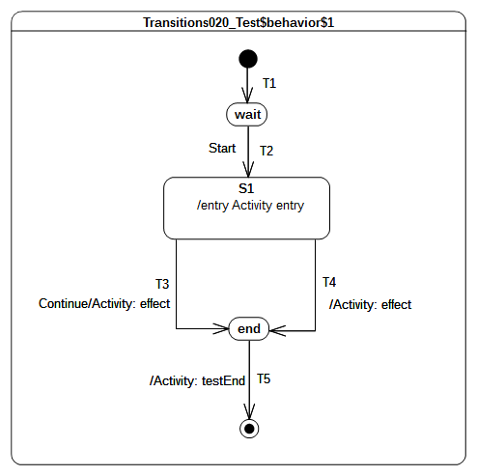Figure 9.23 - Transition 020 Test Classifier Behavior
Received event occurrence(s)
- Start – received when in configuration wait.
- Continue – received when in configuration S1.
Generated trace
- S1(entry)::T4(effect)
Note. When Start is dispatched, transition T2 is triggered. This brings the state machine into configuration S1. The entry of S1 results in the execution of its entry behavior. Upon the termination of the execution of this behavior, S1 is ready to generate a completion event. The latter is placed at the head of the event pool. Consequently, it is iven priority over non-completion event(s) already present in the pool. Therefore, the next RTC step will begin by the dispatching of the completion event generated for S1. This event will trigger transition T4. The Continue event occurrence will never be dispatched.
RTC steps
Step | Event pool | State machine configuration | Fired transition(s)
1 | [] | [] - Initial RTC step | [T1]
2 | [Start, CE(wait)] | [wait] | []
3 | [Start] | [wait] | [T2]
4 | [Continue, CE(S1.1)] | [S1] | [T4]
5 | [Continue, CE(end)] | [end] | [T5]

Transition 022
Transition 022 ([UML], 14.2.3.8)
It may have an associated effect Behavior, which is executed when the Transition is traversed.

Tested state machine
The state machine that is executed for this test is presented in Figure 9.24.
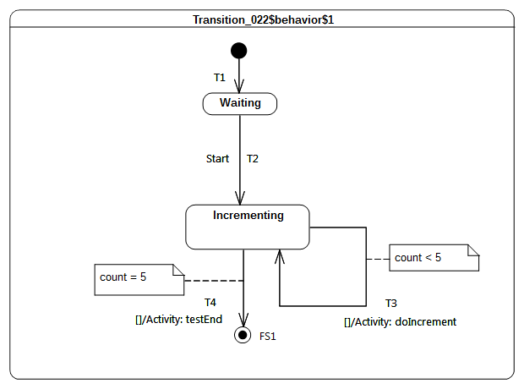Figure 9.24 - Transition 022 Test Classifier Behavior

Test executions
Received event occurrence(s)
- Start – received when in configuration waiting.
Generated trace
- T3(effect)::T3(effect)::T3(effect)::T3(effect)::T3(effect)
Note. the intent of the test is to increment the value of a property of a class that has, as its classifier behavior, the sate-machine presented in Figure 9.24. The value of the property is incremented until it reaches the value 5. The state machine that implements this behavior uses guarded transitions (see T3 and T4). When the event occurrence Start is dispatched, T2 fires and Incrementing is entered. The completion event generated for that state is used to trigger either T4 or T3 based on their guard evaluations.
RTC steps
Step | Event pool | State machine configuration | Fired transition(s)
1 | [] | [] - Initial RTC step | [T1]
2 | [Start, CE(wait)] | [wait] | []
3 | [Start] | [wait] | [T2]
4 | [CE(Incrementing)] | [Incrementing] | [T3]
5 | [CE(Incrementing)] | [Incrementing] | [T3]
6 | CE(Incrementing) | [Incrementing] | [T3]
7 | CE(Incrementing) | [Incrementing] | [T3]
8 | CE(Incrementing) | [Incrementing] | [T3]
9 | CE(Incrementing) | [Incrementing] | [T4]

Transition023
Transition 023 ([UML], 14.2.3.8.3)
Guards are evaluated before the compound transition that contains them is enables, unless they are on Transitions that originate from a choice Pseudostate.
Tested state machine
The state machine that is executed for this test is presented in Figure 9.25.
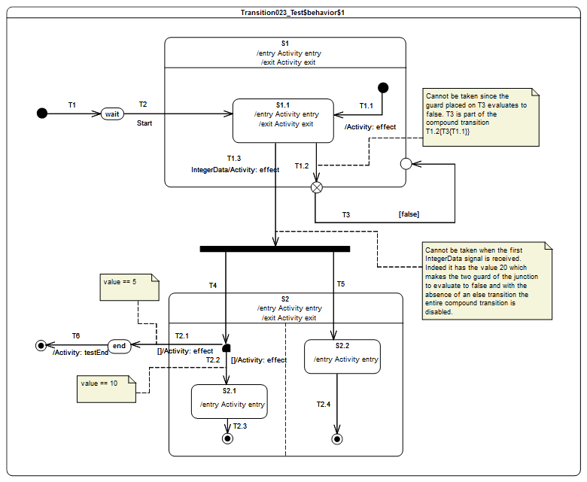Figure 9.25: Transition 023 Test Classifier Behavior

Test executions
Received event occurrence(s)
- Start – received when in configuration wait.
- IntegerData – received when in configuration S1[S1.1]. The property value has the value 20.
- IntegerData – received when in configuration S1[S1.1]. The property value has the value 5.
Generated trace
- S1(entry)::S1.1(entry)::S1.1(exit)::S1(exit)::T1.3(effect)[in=5]::S2(entry)[in=5]::S2.2(entry)[in=5]::S2(exit)[in=5]::T2.1(effect)[in=5]
Note. The purpose of the test is to assess that when an event is about to be dispatched, a static analysis is performed to ensure that from the current state machine configuration we can reach a stable state machine configuration. If no path can be found from the current state machine configuration to the next then configuration then event will be lost and the RTC step completes trivially.
In this test case, the state machines receives three event occurrences: Start, IntegerData(20) and IntegerData(5). The disptaching of the Start event brings the state-machine to the configuration S1[S1.1] thanks to the triggering of T2. The configuration will remain the same until IntegerData(5) is disptached. This can be explained because:
  - The completion event generated for S1.1 when dispatched cannot bring the state machine to a valid configuration. Indeed event if the completion event could have been used to trigger the compound transition starting with T1.2, T3 could not have been traversed since its guard evaluated to false.
  - The received IntegerData(20) signal event cannot bring the state machine to a valid configuration. Indeed even if the event occurrence could have been used to trigger the compound transition starting with T1.3 neither T2.1 or T2.2 could have been traversed since their guards both evaluate to false (because of the value associated to the signal event). Hence IntegerData(20) is lost.
When IntegerData(5) is finally dispatched it triggers the traversal of the compound transition T1.3[T4[T2.1, T2.2], T5].
RTC steps
Step | Event pool | State machine configuration | Fired transition(s)
1 | [] | [] - Initial RTC step | [T1]
2 | [Start, CE(wait)] | [wait] | []
3 | [Start] | [wait] | [T2]
4 | [IntegerData(20), CE(S1.1)] | [S1[S1.1]] | []
5 | [IntegerData(20)] | [S1[S1.1]] | []
6 | [IntegerData(5)] | [S1[S1.1]] | [T1.3[T4[T2.1], T5]]
7 | [CE(end)] | [end] | [T6]
Alternative execution traces
This state machine specifies parallelism thanks to the Fork pseudo-state. This implies that for this state machine an alternative execution is possible. This execution trace is is specified below.
- S1(entry)::S1.1(entry)::S1.1(exit)::S1(exit)::T1.3(effect)[in=5]::S2(entry)[in=5]::S2(exit)[in=5]::T2.1(effect)[in=5]
The difference from the previous trace is that the entry behavior of S2.2 is not executed. This is possible since when the compound transition T1.3[T4[T2.1], T5] is executed the state S2 might be exited through T2.1 before S2.2 was entered.

Event

Overview
Test cases presented in this subclause concern the dispatching and the acceptance of event occurrences in a state machine context.

Event 001
Event 001 ([UML], 14.2.3.9.1)
Upon creation, a StateMachine will perform its initialization during which it executes an initial compound transition prompted by creation, after which it enters a wait point. In case of StateMachine Behaviors, a wait point is represented by a stable state configuration. It remains there until an Event stored in its event pool is dispatched

Tested state machine
The state machine that is executed for this test is presented in Figure 9.26.
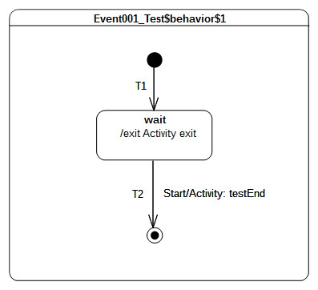Figure 9.26 - Event 001 Test Classifier Behavior

Test executions
Received event occurrence(s)
- Start – received when in configuration wait.
Generated trace
- wait(exit)
Note. The state machine execution starts from the initial pseudo state. The initial RTC step implies that continuation transition T1 is traversed and state wait is entered. At the end of this RTC step the state machine execution enters a wait point. It is only able to leave this configuration when a Start event occurrence is dispatched from the event pool.
RTC steps
Step | Event pool | State machine configuration | Fired transition(s)
1 | [] | [] - Initial RTC step | [T1]
2 | [Start, CE(wait)] | [wait] | []
3 | [Start] | [wait] | [T2]

Event 002
Event 002 ([UML], 14.2.3.9.1)
This Event is evaluated and, if it matches a valid Trigger of the StateMachine and there is at least one enabled Transition that can be triggered by that Event occurrence, a single StateMachine step is executed.

Tested state machine
The state machine that is executed for this test is presented in Figure 9.27.

Test executions
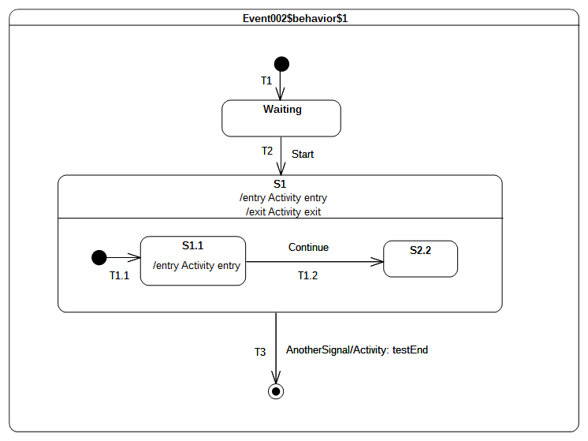Figure 9.27 - Event 002 Test Classifier Behavior
Received event occurrence(s)
- Start – received when in configuration waiting.
- AnottherSignal received when in configuration S1[S1.1].
Generated trace
- S1(entry)::S1.1(entry)::S1(exit)
Note. At the point where AnotherSignal event occurrence is dispatched, the state machine is in configuration S1[S1.1]. This implies that, when T3 is triggered, state S1.1 is exited, followed immediately by S1. The state machine execution completes by reaching the final state. This illustrates the realization of a run-to-completion step initiated by the dispatching of an event occurrence.
RTC steps
Step | Event pool | State machine configuration | Fired transition(s)
1 | [] | [] - Initial RTC step | [T1]
2 | [Start, CE(wait)] | [wait] | []
3 | [Start] | [wait] | [T2(T1.1)]
4 | [AnotherSignal, CE(S1.1)] | [S1[S1.1]] | []
5 | [AnotherSignal] | [S1[S1.1]] | [T3]

Event 008
Event 008 ([UML], 14.2.3.9.1)
When an Event occurrence is detected and dispatched, it may result in one or more Transitions being enabled for firing. If no Transition is enabled and the corresponding Event type is not in any of the deferrableTriggers lists of the active state configuration, the dispatched Event occurrence is discarded and the run-to-completion step is completed.

Tested state machine
The state machine that is executed for this test is presented in Figure 9.28.

Test executions
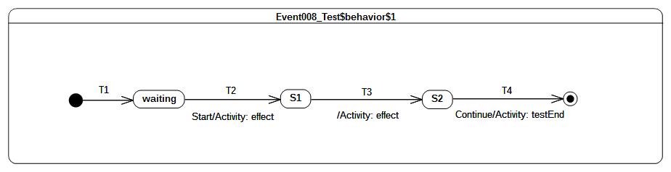Figure 9.28 - Event 008 Test Classifier Behavior
Received event occurrence(s)
- Start – when received in configuration waiting.
- Continue – when received in configuration S2.
Generated trace
- T2(effect)::T3(effect)
Note. When the Start event occurrence is dispatched, the state machine is in configuration waiting. The dispatching of this event implies that T2 is triggered and S1 is entered. Since S1 is a simple state with no entry and doActivity behaviors, a completion event is generated for that state when entered. The dispatching of this completion event triggers T3. Consequently, its effect behavior is executed and S2 is entered. The completion event generated by S2 is dropped. This occurs when there is no possibility to use it for triggering an outgoing transition from that state. The only way to exit S2 is to receive and dispatch a Continue event occurrence.
RTC steps
Step | Event pool | State machine configuration | Fired transition(s)
1 | [] | [] - Initial RTC step | [T1]
2 | [Start, CE(waiting)] | [waiting] | []
3 | [Start] | [waiting] | [T2]
4 | [CE(S1)] | [S1] | [T3]
5 | [Continue, CE(S2)] | [S2] | []
6 | [Continue] | [S2] | [T4]

Event 009
Event 009 ([UML], 14.2.3.9.1)
It is possible that multiple Transitions (in different Regions) can be triggered by the same Event occurrence. The order in which these Transitions are executed is left undefined.

Tested state machine
The state machine that is executed for this test is presented in Figure 9.29.

Test executions
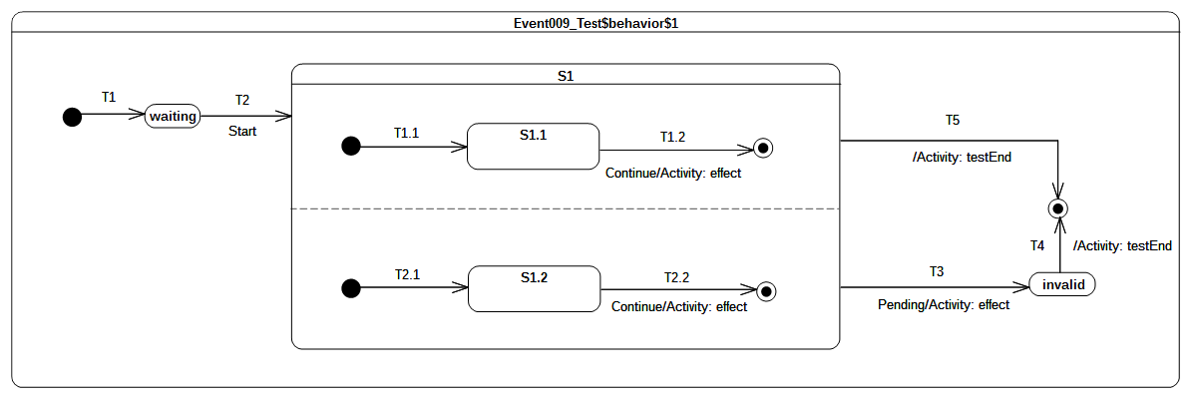Figure 9.29: Event 009 Classifier behavior
Received event occurrence(s)
- Start – received when in configuration waiting.
- Continue – received when in configuration S1[S1.1, S1.2].
- Pending – received when in configuration S1[S1.1, S1.2].
Generated trace
- T1.2(effect)::T2.2(effect)
Notes
- S1 contains orthogonal regions. Hence the trace presented above illustrates one possible execution.
- The Continue event occurrence is dispatched when the state machine execution is in configuration S1[S1.1, S1.2]. The dispatching of this event triggers simultaneously transitions T1.2 and T2.2, which are located in different orthogonal regions. This leads to the completion of the regions of S1 so that a completion event is generated for that state. The latter is used to trigger the completion transition T5. Note that, in the case where Continue just triggered either T1.2 or T2.2, S1 will not have the opportunity to complete. Consequently, T3 can only be triggered by the dispatching of the Pending event occurrence and the expected execution trace would have been invalid.
RTC steps
Step | Event pool | State machine configuration | Fired transition(s)
1 | [] | [] - Initial RTC step | [T1]
2 | [Start, CE(waiting)] | [waiting] | []
3 | [Start] | [waiting] | [T2(T1.1, T2.1)]
4 | [Pending, Continue, CE(S1.2), CE(S1.1)] | [S1[S1.1, S1.2]] | []
5 | [Pending, Continue, CE(S1.2)] | [S1[S1.1, S1.2]] | []
6 | [Pending, Continue] | [S1[S1.1, S1.2]] | [T1.2, T2.2]
7 | [Pending, CE(S1)] | [S1] | [T5]

Event 010
Event 010 ([UML], 14.2.3.9.1)
It is possible for multiple mutually exclusive Transitions in a given Region to be enabled for firing by the same Event occurrence. In those cases, only one is selected and executed.

Tested state machine
The state machine that is executed for this test is presented in Figure 9.30.
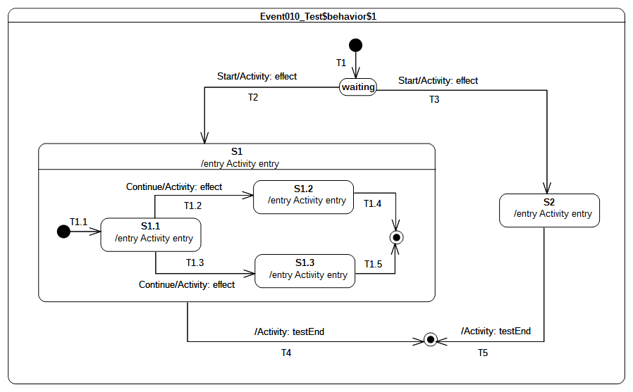Figure 9.30 - Event 010 Test Classifier Behavior

Test executions
Received event occurrence(s)
- Start – received when in configuration waiting.
- Continue – received when in configuration S1[S1.1].
Generated trace
- T1.2(effect)::S1(entry)::S1.1(entry)::T1.2(effect)::S1.2(entry).
Notes
- Note that the execution would have been completely different if a different semantic strategy was used to resolve conflicts.
- This test case highlights the resolving of transition conflicts at run time. The first conflict that is encountered happens when the event occurrence Start is accepted. Many transitions (i.e., T2 and T3) originating from the same state (i.e., waiting) can be triggered using this same event occurrence. Only one of them is chosen using a semantic strategy. Assuming that in this particular case the strategy is to always choose the first one in the list of conflicting transition, T2 will fire. A similar scenario happens when the state machine execution is in configuration S1[S1.1]. The rule is no different when this happens in a nested context. Hence, assuming our chosen semantic strategy, T1.2 will be triggered by the Continue event occurrence.
RTC steps
Step | Event pool | State machine configuration | Fired transition(s)
1 | [] | [] - Initial RTC step | [T1]
2 | [Start, CE(waiting)] | [waiting] | []
3 | [Start] | [waiting] | [T2(T1.1)]
4 | [Continue, CE(S1.1)] | [S1[S1.1]] | []
5 | [Continue] | [S1[S1.1]] | [T1.2]
6 | [CE(S1.2)] | [S1[S1.2]] | [T1.4]
7 | [CE(S1)] | [S1] | [T4]

Event 015
Event 015 ([UML], 14.2.3.9.3)
It is possible for more than one Transition to be enabled within a StateMachine. If that happens, then such Transitions may be in conflict with each other. For example, consider the case of two Transitions originating from the same State, triggered by the same event, but with different guards. If that event occurs and both guard conditions are true, then at most one of those Transition can fire in a given run-to-completion step.

Tested state machine
The state machine that is executed for this test is presented in Figure 9.31.

Test executions
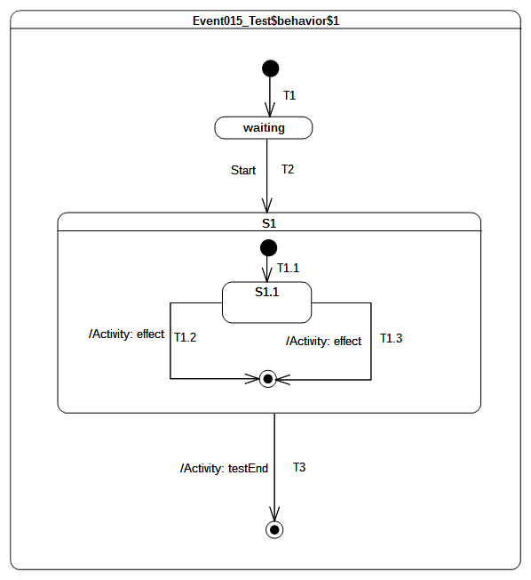Figure 9.31 - Event 015 Test Classifier Behavior
Received event occurrence(s)
- Start – received when in configuration waiting.
Generated trace
- T1.2(effect)
Notes
- Note that the execution could have been different if a different semantic strategy was used to resolve conflicts.
- This test case is similar to the one presented in section 9.3.4.6. Nevertheless it illustrates the situation in which the conflicting situation occurs when a completion event for S1.1 is accepted. The two completion transitions T1.2 and T1.3 can both be triggered using the completion event. Here again, the conflict is resolved using a semantic strategy to determine which of them is actually triggered.
RTC steps
Step | Event pool | State machine configuration | Fired transition(s)
1 | [] | [] - Initial RTC step | [T1]
2 | [Start, CE(waiting)] | [waiting] | []
3 | [Start] | [waiting] | [T2(T1.1)]
4 | [CE(S1.1)] | [S1[S1.1]] | [T1.2]
5 | [CE(S1)] | [S1] | T3

Event 016 – A
Event 016 ([UML], 14.2.3.9.4)
In situations where there are conflicting Transitions, the selection of which Transitions will fire is based in part on an implicit priority. These priorities resolve some but not all Transition conflicts, as they only define a partial ordering. The priorities of conflicting Transitions are based on their relative position in the state hierarchy. By definition, a Transition originating from a substate has higher priority than a conflicting Transition originating from any of its containing States. The priority of a Transition is defined based on its source State.

Tested state machine
The state machine that is executed for this test is presented in Figure 9.32.
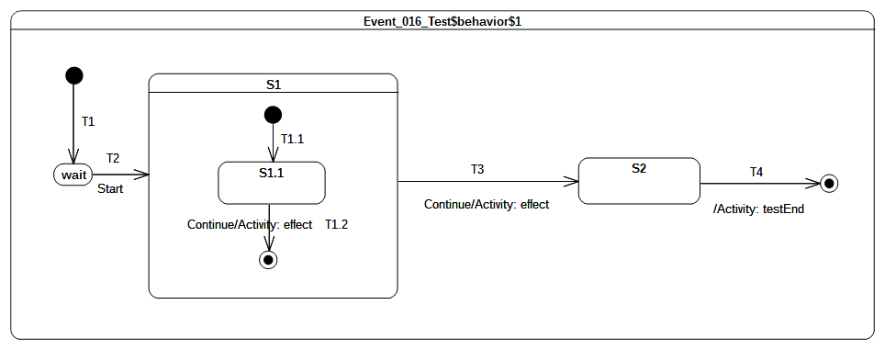Figure 9.32 - Event 016 Test Classifier Behavior

Test executions
Received event occurrence(s)
- Start – received when in configuration wait.
- Continue – received when in configuration S1[S1.1].
- Continue – received when in configuration S1.
Generated trace
- T1.2(effect)::T3(effect)
Note. This test case covers the issue of transition trigger priorities. When the RTC step initiated by accepting the Continue event occurrence starts, the state machine is in configuration S1[S1.1]. At this point, two transitions can be triggered by the same event occurrence. The resolution of this potential conflict is realized by analyzing transition priorities. Since S1.1 is the innermost state in the configuration, transitions originating from this state will have the highest priority. Hence T1.2 is triggered.
RTC steps
Step | Event pool | State machine configuration | Fired transition(s)
1 | [] | [] - Initial RTC step | [T1]
2 | [Start, CE(wait)] | [wait] | []
3 | [Start] | [wait] | [T2(T1.1)]
4 | [Continue, CE(S1.1)] | [S1[S1.1]] | []
5 | [Continue] | [S1[S1.1]] | [T1.2]
6 | [Continue, CE(S1)] | [S1] | []
7 | [Continue] | [S1] | [T3]
8 | [CE(S2)] | [S2] | [T4]

Event 016 – B
Event 016 ([UML], 14.2.3.9.4)
In situations where there are conflicting Transitions, the selection of which Transitions will fire is based in part on an implicit priority. These priorities resolve some but not all Transition conflicts, as they only define a partial ordering. The priorities of conflicting Transitions are based on their relative position in the state hierarchy. By definition, a Transition originating from a substate has higher priority than a conflicting Transition originating from any of its containing States. The priority of a Transition is defined based on its source State.

Tested state machine
The state machine that is executed for this test is presented in Figure 9.33.
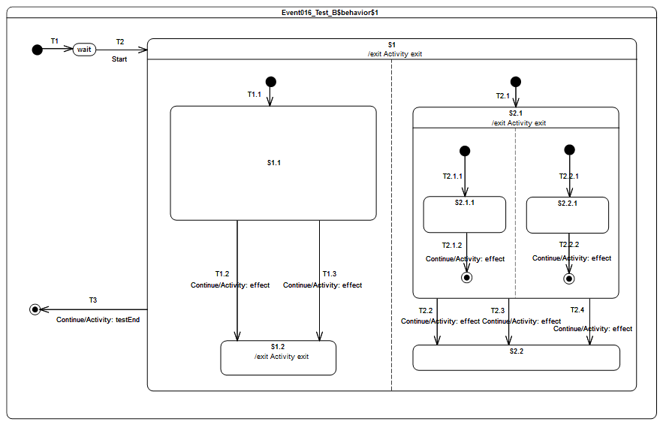Figure 9.33 - Event 016 – B Test Classifier behavior

Test executions
Received event occurrence(s)
- Start – received when in configuration wait.
- Continue – received when in configuration S1[S1.1, S2.1[S2.1.1, S2.2.1]].
- Continue – received when in configuration S1[S1.1, S2.1].
- Continue – received when in configuration S1[S1.2, S2.2].
Generated trace
- T1.2(effect)::T2.1.2(effect)::T2.2.2(effect)::S2.1(exit)::T2.2(effect)::S1.2(exit)::S1(exit)
Note. In this test case, hierarchical states, conflicting transitions and orthogonal regions are combined The purpose is to demonstrate support for conflict resolution, support for transitions priority and firing of multiple transitions on a single execution step..The execution proceeds as follows. The RTC step initiated by the acceptance of the Start event occurrence, brings the state machine to the configuration S1[S1.1, S2.1[S2.1.1, S2.2.1]]]. Completions events generated during this RTC step (respectively for states S1.1, S2.1.1 and S2.2.1) do not trigger any transition when dispatched.
The next RTC step that actually leads to transition triggering is the one initiated by the acceptance of the Continue event occurrence. During this step, T2.1.2, T2.2.2 and T1.2 are fired using the same event occurrence. This is made possible since all of these transitions are located in different regions and have a trigger for the same event type. One can notice that instead of T1.2, the transition T1.3 could have been fired. This is true since both transitions were in conflict (they leave the same state and have a trigger for the same event type) at the time of the step. Such conflicts are resolved automatically by a semantic strategy. The default strategy consists in always choosing the first transition available in the set of conflicting transitions. At the end of the step, the state machine reaches the configuration S1[S1.2, S2.1].
Completion events generated for states S1.2 and S2.1 do not trigger any transition when dispatched. However, when the next Continue event occurrence is dispatched T2.2 is fired. Here again it exists a conflict between T2.2, T2.3 and T2.4 which is solved using the semantic strategy. The last Continue event fires T3 and leads to the completion of the state-machine execution.
RTC steps

Step | Event pool | State machine configuration | Fired transition(s)
1 | [] | [] - Initial RTC step | [T1]
2 | [Start, CE(wait)] | [wait] | []
3 | [Start] | [wait] | [T2(T1.1, T2.1(T2.1.1, T2.2.1))]
4 | [Continue, CE(2.2.1), CE(S2.1.1), CE(S1.1)] | [S1[S1.1, S2.1[S2.1.1, S2.2.1]]] | []
5 | [Continue, CE(2.2.1), CE(S2.1.1)] | [S1[S1.1, S2.1[S2.1.1, S2.2.1]]] | []
6 | [Continue, CE(2.2.1)] | [S1[S1.1, S2.1[S2.1.1, S2.2.1]]] | []
7 | [Continue] | [S1[S1.1, S2.1[S2.1.1, S2.2.1]]] | [T1.2, T2.1.2, T2.2.2]
8 | [Continue, CE(S2.1), CE(S1.2)] | [S1[S1.2, S2.1]] | []
9 | [Continue, CE(S2.1)] | [S1[S1.2, S2.1]] | []
10 | [Continue] | [S1[S1.2, S2.1]] | [T2.2]
11 | [Continue, CE(S2.2)] | [S1[S1.2, S2.2]] | []
12 | [Continue] | [S1[S1.2, S2.2]] | [T3]
Alternative execution traces
The test case specifies concurrency with the orthogonal regions owned by S1 and S2.1. This implies that when the test case is executed it can produce execution traces which are different from the one initially described while remaining correct regarding the semantics specified for UML state machines. These alternative execution traces are presented below:
- T1.2(effect)::T2.2.2(effect)::T2.1.2(effect)::S2.1(exit)::T2.2(effect)::S1.2(exit)::S1(exit)
- T2.1.2(effect)::T1.2(effect)::T2.2.2(effect)::S2.1(exit)::T2.2(effect)::S1.2(exit)::S1(exit)
- T2.1.2(effect)::T2.2.2(effect)::T1.2(effect)::S2.1(exit)::T2.2(effect)::S1.2(exit)::S1(exit)
- T2.2.2(effect)::T1.2(effect)::T2.1.2(effect)::S2.1(exit)::T2.2(effect)::S1.2(exit)::S1(exit)
- T2.2.2(effect)::T2.1.2(effect)::T1.2(effect)::S2.1(exit)::T2.2(effect)::S1.2(exit)::S1(exit)
The alternative trace 5 describes an execution where T2.2.2 effect behavior is executed first and followed by the ones of T2.1.2 and T1.2. The RTC steps that lead to the production of this trace are described in the table below.
Step | Event pool | State machine configuration | Fired transition(s)
1 | [] | [] - Initial RTC step | [T1]
2 | [Start, CE(wait)] | [wait] | []
3 | [Start] | [wait] | [T2(T1.1, T2.1(T2.1.1, T2.2.1))]
4 | [Continue, CE(2.2.1), CE(S2.1.1), CE(S1.1)] | [S1[S1.1, S2.1[S2.1.1, S2.2.1]]] | []
5 | [Continue, CE(2.2.1), CE(S2.1.1)] | [S1[S1.1, S2.1[S2.1.1, S2.2.1]]] | []
6 | [Continue, CE(2.2.1)] | [S1[S1.1, S2.1[S2.1.1, S2.2.1]]] | []
7 | [Continue] | [S1[S1.1, S2.1[S2.1.1, S2.2.1]]] | [T2.2.2, T2.1.2, T1.2]
8 | [CE(S1.2), CE(S2.1)] | [S1[S1.2, S2.1] | []
9 | [Continue, CE(S1.2)] | [S1[S1.2, S2.1]] | []
10 | [Continue] | [S1[S2.2]] | [T2.2]
11 | [Continue, CE(S2.2)] | [S1[S2.2]] | []
12 | [Continue] | [S1[S2.2]] | [T3]

Event 017 – A
Event 017 - A (PSSM Proposal)
In UML, a signal can have properties. At runtime, the properties are associated with values. When a signal event occurrence is dispatched in a RTC step, guard specifications and effect behaviors that will be executed during that step will have access to the values specified by the signal instance. This rule only applies if the behaviors have a single input parameter that is of the type of the signal instance.

Tested state machine
The state machine that is executed for this test is presented in Figure 9.34.

Test executions
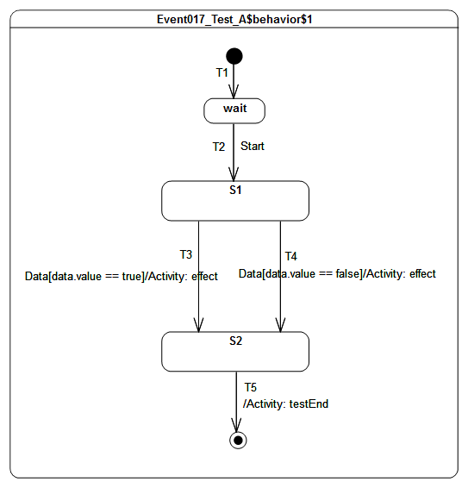Figure 9.34: Event 017 - A Classifier Behavior Specification
Received event occurrence(s)
- Start – received when in configuration wait.
- Data(true) – received when in configuration S1.
Generated trace
- T3(effect)
Note. The purpose of this test is to check that during a RTC step initiated by the dispatching of a signal event occurrence, guard specifications and effect behaviors that are executed can access to properties values of the signal. In that test case, when the state machine is in configuration S1 and Data(true) is received, T3 fires because it guard comparing the value of the property “value” to true evaluates to true. Hence the effect behavior is executed and add the trace fragment: T3(effect). The execution of the state machine completes when the RTC step initiated by the dispatching of S2 completion event ends.
RTC steps

Step | Event pool | State machine configuration | Fired transition(s)
1 | [] | [] - Initial RTC step | [T1]
2 | [Start, CE(wait)] | [wait] | []
3 | [Start] | [wait] | [T2]
4 | [Data(true), CE(S1)] | [S1] | []
5 | [Data(true)] | [S1] | [T3]
6 | [CE(S2)] | [S2] | [T5]

Event 017 – B
Event 017 - B (PSSM Proposal)
In UML, a signal can have properties. At runtime, the properties are associated with values. When a signal event occurrence is dispatched in a RTC step, entry, doActivity and exit behaviors that will be executed during that step will have access to the values specified by the signal instance. This rule only applies if the behaviors have a single input parameter that is of the type of the signal instance.

Tested state machine
The state machine that is executed for this test is presented in Figure 9.35.

Test executions
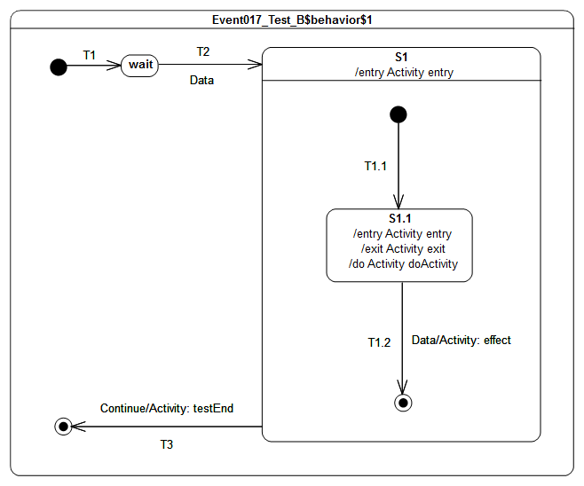Figure 9.35: Event 017 - B Test Classifier Behavior
Received event occurrence(s)
- Data(true) – received when in configuration wait.
- Data(false) – received when in configuration S1[S1.1].
- Continue – received when in configuration S1.
Generated trace
- S1(effect)[in=true]::S1.1(entry)[in=true]::S1.1(doActivity)[in=true]::S1.1(exit)[in=false]::T1.2(effect)[in=false]
- Note. The purpose of this test is to check that state behaviors (i.e., entry, doActivity and exit) have access to the signal instance which initiated the RTC step in which they are executed. In that test case, when the state machine is in configuration wait, the dispatching of Data(true) implies the execution of the compound transition T2(T1.1). Hence during that step S1 entry behavior, S1.1 entry behavior are executed and S1.1 doActivity is invoked. Considering they are all executed the following trace fragment is added to the trace: 1(effect)[in=true]::S1.1(entry)[in=true]::S1.1(doActivity)[in=true]. When the second occurrence of Data(false) is dispatched S1.1 is exited and T1.2 is traversed. The execution of S1.1 exit behavior and T2 effect behavior add the following fragment to the trace: S1.1(exit)[in=false]::T1.2(effect)[in=false]. The state machine execution completes when the RTC step in which T3 is fired by the dispatching of the Continue event occurrence ends.
RTC steps
Step | Event pool | State machine configuration | Fired transition(s)
1 | [] | [] - Initial RTC step | [T1]
2 | [Data(true), CE(wait)] | [wait] | []
3 | [Data(true)] | [wait] | [T2(T1.1)]
4 | [Data(false), CE(S1.1)] | [S1[S1.1]] | []
5 | [Data(false)] | [S1[S1.1]] | [T1.2]
6 | [Continue, CE (S1)] | [S1] | []
7 | [Continue] | [S1] | [T3]
Alternative execution trace(s)
In that test case S1.1 has a doActivity behavior. The doActivity starts to be executed asynchronously from the state machine when the state S1.1 is entered. Hence the doActivity may or may not have the time to contribute to the trace before the state S1.1 is exited. Considering this aspect, the following alternative execution trace can be generated:
- S1(effect)[in=true]::S1.1(entry)[in=true]::S1.1(exit)[in=false]::T1.2(effect)[in=false]

Event 018
Event 018 ([UML], 14.2.3.9.6)
Once a Transition is enabled and is selected to fire, the following steps are carried out in order: 1. Starting with the main source State, the States that contain the main source State are exited according to the rules of State exit (or, composite State exit if the main source State is nested) as described earlier. 2. The series of State exits continues until the first Region that contains, directly or indirectly, both the main source and main target states is reached. The Region that contains both the main source and main target states is called their least common ancestor. At that point, the effect Behavior of the Transition that connects the sub-configuration of source States to the sub-configuration of target States is executed. (A “sub-configuration” here refers to that subset of a full state configuration contained within the least common ancestor Region.) 3. The configuration of States containing the main target State is entered, starting with the outermost State in the least common ancestor Region that contains the main target State. The execution of Behaviors follows the rules of State entry (or composite State entry) described earlier.

Tested state machine
The state machine that is executed for this test is presented in Figure 9.36.

Test executions
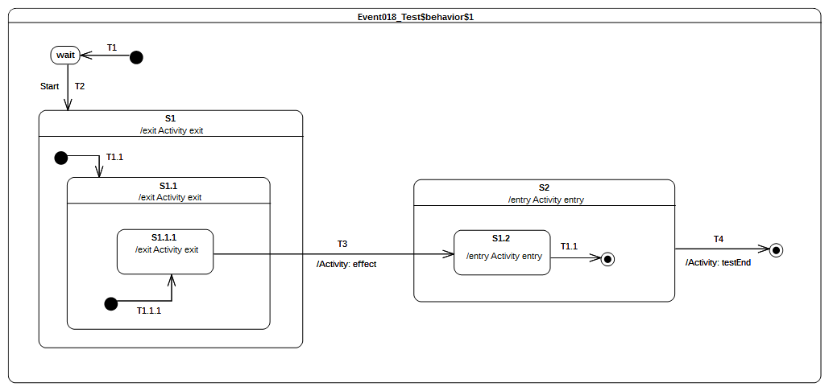Figure 9.36 - Event 018 Test Classifier Behavior
Received event occurrence(s)
- Start – received when in configuration wait.
Generated trace
- S1.1.1(exit)::S1.1(exit)::S1(exit)::T3(effect)::S2(entry)::S1.2(entry)
Note. The focus of this test case is to cover the situation in which transition T3 is triggered by the acceptance of the completion event generated for S1.1.1. The configuration of the state machine at this time is S1[S1.1[S1.1.1]]. When T3 is traversed, it results in the following set of actions:
- S1.1.1, S1.1 and S1 are exited (in this order).
- The effect behavior of the transition is executed.
- S2 and S2.1 are entered (in this order).
RTC steps
Step | Event pool | State machine configuration | Fired transition(s)
1 | [] | [] - Initial RTC step | [T1]
2 | [Start, CE(wait)] | [wait] | []
3 | [Start] | [wait] | [T2(T1.1(T1.1.1))]
4 | [CE(S1.1.1)] | [S1[S1.1[S1.1.1]]] | [T3]
5 | [CE(S1.2)] | [S2[S1.2]] | [T1.1]
6 | [CE(S2)] | [S2] | [T4]

Event 019 – A
Event 019 - A (PSSM Proposal)
In PSSM, Call Event are generated when an operation with no method is called synchronously on an active class. The caller (i.e., the object from which the call is emitted) blocks until the end of the RTC step in which the call event is dispatched in the receiver.

Tested state machine
The state machine that is executed for this test is presented in Figure 9.37.

Test executions
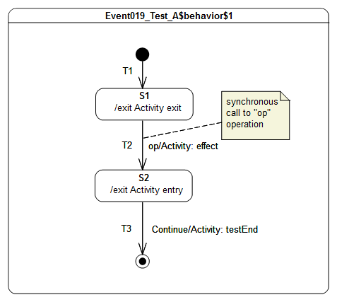Figure 9.37: Event 019 – A Test Classifier Behavior
Received event occurrence(s)
- Call to operation op() – received when in configuration S1. This operation has no parameters.
- Continue – received when in configuration S2.
Generated trace
- S1(exit)::Call(op)::End::S2(entry)
Note. The purpose of this test is ensure that a call event is generated when an operation with no implementation is called on an active object and that this call event is dispatched in a RTC step. In that test case, the initial step brings the state machine to the configuration S1. When the call event is dispatched the transition T2 which has a trigger for call event referencing the operation op is fired. The computations corresponding to the realization of the operation are specified in the effect behavior which is executed during the traversal of the transition. For that test the computations are straightforward and lead to the inclusion of a new trace fragment: Call(op). The state machine execution completes when Continue event occurrence is received and triggers T3 which enables to reach the final state.
RTC steps
Step | Event pool | State machine configuration | Fired transition(s)
1 | [] | [] - Initial RTC step | [T1]
2 | [Call(op[]), CE(S1)] | [S1] | []
3 | [Call(op[])] | [S1] | [T2]
4 | [Continue, CE(S2)] | [S2] | []
5 | [Continue] | [S2] | [T3]

Event 019 – B
Event 019 - B (PSSM Proposal)
A CallEvent can reference an operation with input parameters. When this CallEvent is dispatched, parameters values of the operation are made available (they can be used) to all behaviors with a signature that input conform to the operation signature.

Tested state machine
The state machine that is executed for this test is presented in Figure XX.
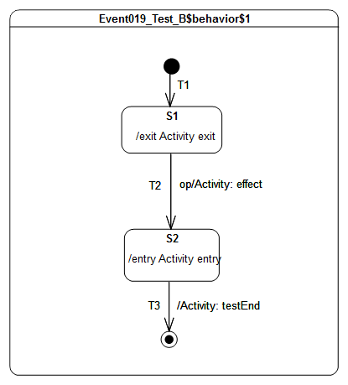Figure 9.38: Event 019 - B Test Classifier Behavior

Test executions
Received event occurrence(s)
- Call to operation op(in p1: Integer, in p2: String) – received when in configuration S1. Values associated to the parameters are (in order): 42 and “input”.
Generated trace
- S1(exit)[in=42][in=input]::T2(effect)[in=42][in=input]::S2(entry)[in=42][in=input]
Note. The purpose of this test is to check that during the dispatching of a call event for an operation with input parameters then all behaviors input conforming to this operation have access to the input parameter values. In that test case the initial step brings the state machine to the configuration S1. The step triggered by the CallEvent implies the execution of the exit behavior of S1. This behavior input conforms to the operation signature. Hence when executed, the behavior has access to the input parameter values 42 and “input” and adds the trace fragment: S1(exit)[in=42][in=input]. T2 effect behavior and S2 entry behavior also input conform to the operation and have access to the input parameter values. The state machine execution completes when the completion event generated by S2 triggers T3 whose traversal lead to the final state.
RTC steps

Step | Event pool | State machine configuration | Fired transition(s)
1 | [] | [] - Initial RTC step | [T1]
2 | [Call(op), CE(S1)] | [S1] | []
3 | [Call(op)] | [S1] | [T2]
4 | [CE(S2)] | [S2] | [T3]

Event 019 – C
Event 019 - C (PSSM Proposal)
A CallEvent can reference an operation with input parameters. When this CallEvent is dispatched, parameters values of the operation are made available (they can be used) to all behaviors with a signature that input conform to the operation signature.

Tested state machine
The state machine that is executed for this test is presented in Figure 9.39.

Test executions
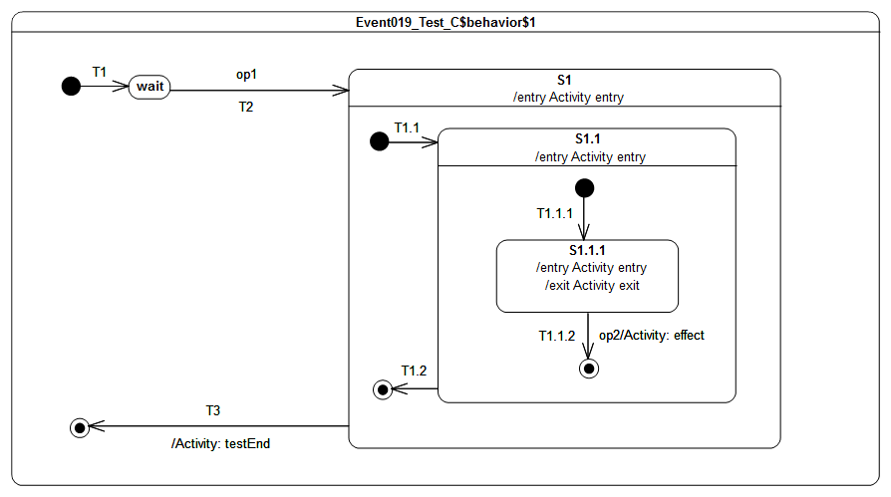Figure 9.39: Event 019 - C Test Classifier Behavior
Received event occurrence(s)
- Call to operation op1(in p1: Integer, in p2: Integer) – received when in configuration wait. Values associated to parameters are: 42 and “input”.
- Call to operation op2(in p1: Boolean) – received when in configuration S1[S1.1[S1.1.1]]. Value associated to parameter p1 is: true.
Generated trace
- S1(entry)[in=42][in=input]::S1.1(entry)[in=42][in=input]::S1.1.1(entry)[in=42][in=input]::S1.1.1(exit)[in=true]::T1.1.2(effect)[in=true]
- Note. The purpose of this test is to check that input parameter values of an operation are made available to input conforming behaviors executed during a step even if they are located at different level of nesting. In that test case the execution proceeds as follows. When the state machine is in the configuration wait the call event for operation op1 is received. The step initiated by the dispatching of op1 implies the execution of the compound transition T2[T1.1[T1.1.1]]. During the step S1 entry behavior, S1.1 entry behavior and S1.1.1 entry behavior are executed. As they all input conform their executions add the following trace fragments: S1(entry)[in=42][in=input], S1.1(entry)[in=42][in=input] and S1.1.1(entry)[in=42][in=input].The second call event that is dispatched triggers the transition T1.1.2, it implies the execution of S1.1.1 exit behavior and T1.1.2 effect behavior. As these two behaviors input conform to op2 signature they add the following fragments to the trace: S1.1.1(exit)[in=true] and T1.1.2(effect)[in=true]
RTC steps

Step | Event pool | State machine configuration | Fired transition(s)
1 | [] | [] - Initial RTC step | [T1]
2 | [Call(op1[42, input]), CE(wait)] | [wait] | []
3 | [Call(op1[42, input])] | [wait] | [T2(T1.1(T1.1.1))]
4 | [Call(op2[true]), CE(S1.1.1)] | [S1[S1.1[S1.1.1]]] | []
5 | [Call(op2[true])] | [S1[S1.1[S1.1.1]]] | [T1.1.2]
6 | [CE(S1.1)] | [S1[S1.1]] | [T1.2]
7 | [CE(S1)] | [S1] | [T3]

Event 019 – D
Event 019 - D (PSSM Proposal)
An operation call on active class may return output values. These values are produced during the step initiated by the dispatching of the call event corresponding to the operation call. The behaviors placed on states and transitions executed during that step are responsible for the production of these values (only if they output conform with the operation signature). In such situation the output values are the values produced by the last executed behavior with a signature output conforming to the operation signature.

Tested state machine
The state machine that is executed for this test is presented in Figure 9.40.
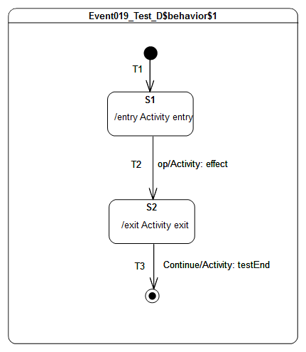Figure 9.40: Event 019 - D Test Classifier Behavior

Test executions
Received event occurrence(s)
- Call to operation op():String – received when in configuration S1.
- Continue – received when in configuration S2.
Generated trace
- S1(entry)::T2(effect)[out=output]::[out=output]::S2(exit)
Note. The purpose of this test is to check that when an operation with output parameters is called on an active class output values might be produced during the step of execution in which the call event is dispatched. In such situation, these output values are made available as output values of the operation. In that test case, the call event corresponding to the call of the operation op is dispatched when the state-machine is in configuration S1. Hence the transition T2 is fired and the effect behavior as well as the exit behavior of S2 are executed. As they both output conform to the operation that is called, the values they produce are made available as operation output. However in that context the exit behavior is the last behavior to be executed before the RTC completes hence the output value produced by this behavior is the output value of the operation.
RTC steps

Step | Event pool | State machine configuration | Fired transition(s)
1 | [] | [] - Initial RTC step | [T1]
2 | [Call(op(), CE(S1)] | [S1] | []
3 | [Call(op)] | [S1] | [T2]
4 | [Continue, CE(S2)] | [S2] | []
5 | [Continue] | [S2] | [T3]

Event 019 – E
Event 019 - E (PSSM Proposal)
An operation call on active class may return output values. These values are produced during the step initiated by the dispatching of the call event corresponding to the operation call. The behaviors placed on states and transitions executed during that step are responsible for the production of these values (only if they output conform with the operation signature). In such situation the output values are the values produced by the last executed behavior with a signature output conforming to the operation signature.

Tested state machine
The state machine that is executed for this test is presented in Figure 9.41.

Test executions
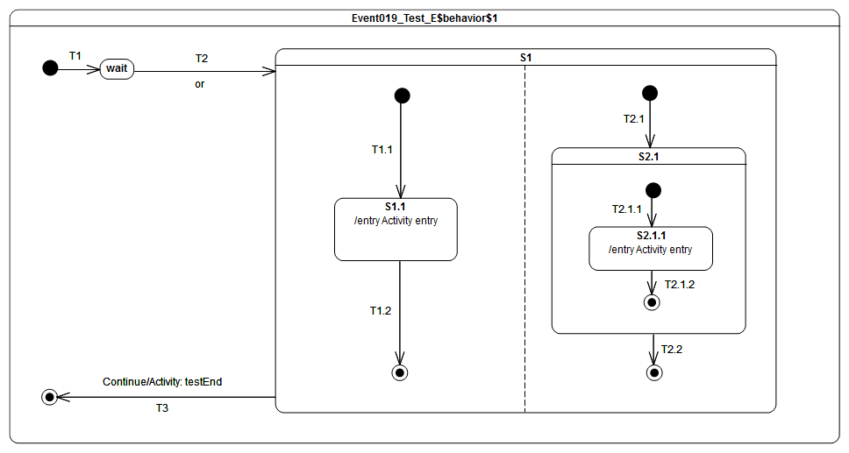Figure 9.41: Event 019 - E Test Classifier Behavior
Received event occurrence(s)
- Call to operation or(in left: Boolean, in right: Boolean, out result: Boolean): Boolean – received when in configuration wait. Values associated to input parameters are true and true.
- Continue – received when in configuration S1.
Generated trace
- S1.1(entry)[in=true][in=true][out=true][out=true]::S2.1.1(entry)[in=true][in=true][out=false][out=false]::[out=false][out=false]
Note. The purpose of this is to check that output values for the operation call or are also produced event if the executed behaviors are located at different levels of nesting. In addition it shows that two possible output values can be finally produced depending on how the orthogonal regions of S1 are interleaved at run time. In that test case, the realization of the operation call is encoded in the entry behaviors (which input and output conform to the operation signature) that are executed during the step initiated by the call event. The output values produced by the S1.1 entry behavior and S2.1.1 entry behavior are different. Indeed, S1.1 behavior realizes the operation by performing a logical OR between the two inputs while S2.1.1 behavior performs a logical XOR. Hence if S1.1 behavior is the last executed behavior is executed and the two inputs have the value true then the output values for the operation will be true. Conversely if S2.1.1 behavior is the last executed behavior and the two inputs have the value true then the output values for the operation will be false.
RTC steps

Step | Event pool | State machine configuration | Fired transition(s)
1 | [] | [] - Initial RTC step | [T1]
2 | [Call(or(true, true), CE(wait)] | [wait] | []
3 | [Call(or(true, true))] | [wait] | [T2(T1.1, T2.1(T2.1.1))]
4 | [CE(S2.1.1), CE(S1.1)] | [S1[S1.1, S2.1[S2.1.1]]] | [T1.2]
5 | [CE(S2.1.1)] | [S1[S2.1[S2.1.1]]] | [T2.1.2]
6 | [CE(S2.1)] | [S1[S2.1]] | [T2.2]
7 | [Continue, CE(S1)] | [S1] | []
8 | [Continue] | [S1] | [T3]
Alternative execution traces
In the test case there is concurrency specified in state S1. This means an alternative execution is possible for the state machine under test. This trace is described below and shows the case where S1.1 entry behavior is executed after the S2.1.1 entry behavior.
- S2.1.1(entry)[in=true][in=true][out=false][out=false]::S1.1(entry)[in=true][in=true][out=true][out=true]::[out=true][out=true]

Entering

Overview
Test cases presented in this subclause deal with entry semantics of composite states.

Entering 004
Entering 004 ([UML], 14.2.3.4.5)
If no initial Pseudostate is defined, there is no single approach defined. One alternative is to treat such a model as ill formed. A second alternative is to treat the composite State as a simple State, terminating the traversal on that State despite its internal parts.

Tested state machine
The state machine that is executed for this test is presented in Figure 9.42.

Test executions
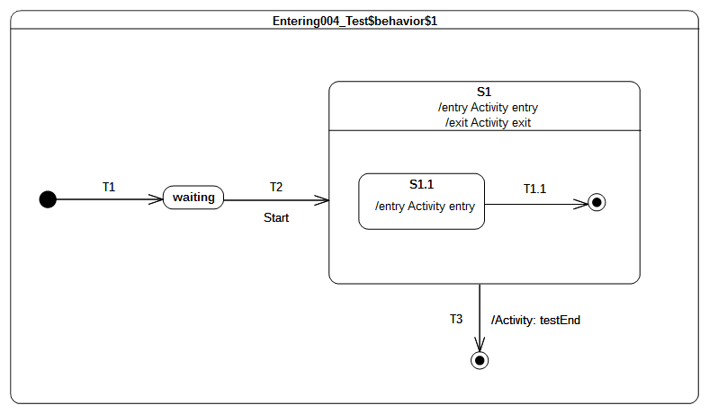Figure 9.42 - Entering 004 Classifier behavior
Received event occurrence(s)
- Start – received when in configuration waiting.
Generated trace
- S1(entry)::S1(exit)
Note. Note that this model omits the initial pseudostate and transition for the composite state S1 – a situation that is syntactically valid but not recommended. Consequently, S1 is treated as if it is a simple state upon the completion of transition T2. This means that, when S1 is entered, it completes right after the termination of its entry behavior. This completion event is used to trigger the transition T3, which leads to the completion of the state machine execution.
RTC steps
Step | Event pool | State machine configuration | Fired transition(s)
1 | [] | [] - Initial RTC step | [T1]
2 | [Start, CE(waiting)] | [waiting] | []
3 | [Start] | [waiting] | [T2]
4 | [CE(S1)] | [S1] | [T3]

Entering 005
Entering 005 ([UML], 14.2.3.4.5)
If the incoming Transition or its continuations terminate on a directly contained substate of the composite State, then that substate becomes active and its entry Behavior is executed after the execution of the entry Behavior of the containing composite State. This rule applies recursively if the Transition terminates on an indirect (deeply nested) substate.

Tested state machine
The state machine that is executed for this test is presented in Figure 9.43.

Test executions
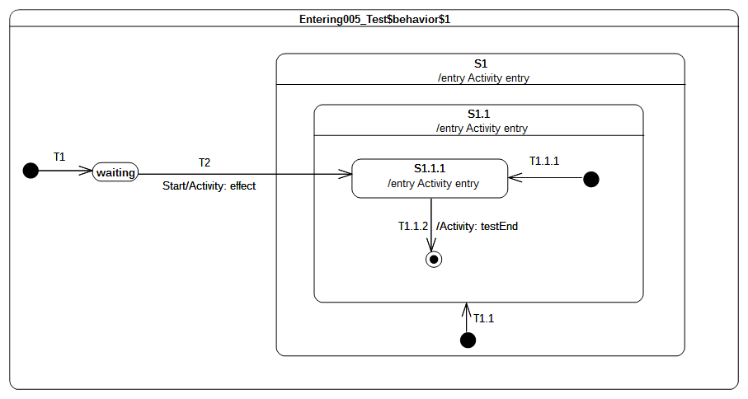Figure 9.43 - Entering 005 Test Classifier Behavior
Received event occurrence(s)
- Start – received when in configuration waiting.
Generated trace
- T2(effect)::S1(entry)::S1.1(entry)::S1.1.1(entry)
Note. This test case illustrates direct entry to the deeply nested state S1.1.1. In this situation, when T2 is triggered, its effect behavior is executed and leads to the entering of S1, S1.1, and S1.1.1 respectively. S1 and S1.1 are composite states whose unique region is entered directly (i.e., even if an initial pseudo-state and transition exist, they will not be taken).
RTC steps
Step | Event pool | State machine configuration | Fired transition(s)
1 | [] | [] - Initial RTC step | [T1]
2 | [Start, CE(waiting)] | [waiting] | []
3 | [Start] | [waiting] | [T2]
4 | [CE(S1.1.1)] | [S1[S1.1[S1.1.1]]] | [T1.1.2]
5 | [CE(S1.1)] | [S1[S1.1]] | []

Entering 009
Entering 009 ([UML], 14.2.3.4.5)
If a Transition enters a composite State through an entryPoint Pseudostate, then the effect Behavior associated with the outgoing Transition originating from the entry point and penetrating into the State (but after the entry Behavior of the composite State has been executed)

Tested state machine
The state machine that is executed for this test is presented in Figure 9.44.

Test executions
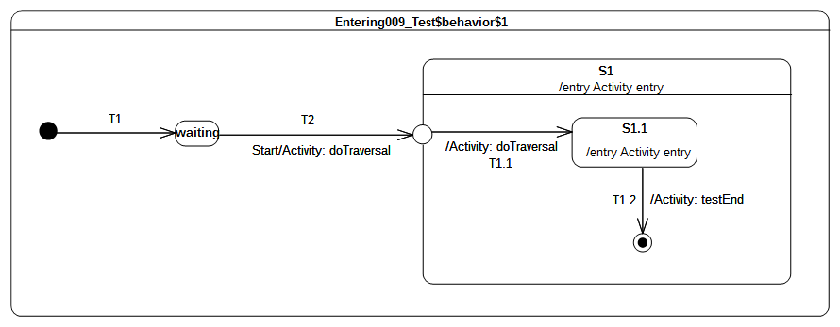Figure 9.44 - Entering 009 Test Classifier Behavior
Received event occurrence(s)
- Start – received when in configuration waiting.
Generated trace
- T2(effect)::S1(entry)::T1.1(effect)::S1.1(entry)
Note. This test case illustrates entering of a composite state through an entry point. In this case, when the entry point is reached, it leads to entering of S1 and the execution of its entry behavior. The region of S1 is then entered immediately after the entry point is reached and transitions T1.1 is traversed. This leads to the entering of S1.1. The latter completes when its entry behavior has executed, after which the completion event is used to trigger the transition T1.2.
RTC steps
Step | Event pool | State machine configuration | Fired transition(s)
1 | [] | [] - Initial RTC step | [T1]
2 | [Start, CE(waiting)] | [waiting] | []
3 | [Start] | [waiting] | [T2(T1.1)]
4 | [CE(S1.1)] | [S1[S1.1]] | [T1.2]
5 | [CE(S1)] | [S1] | []

Entering 010
Entering 010 ([UML], 14.2.3.4.5)
If the composite State is also an orthogonal State with multiple Regions, each of its Regions is also entered, either by default or explicitly.

Tested state machine
The state machine that is executed for this test is presented in Figure 9.45.

Test executions
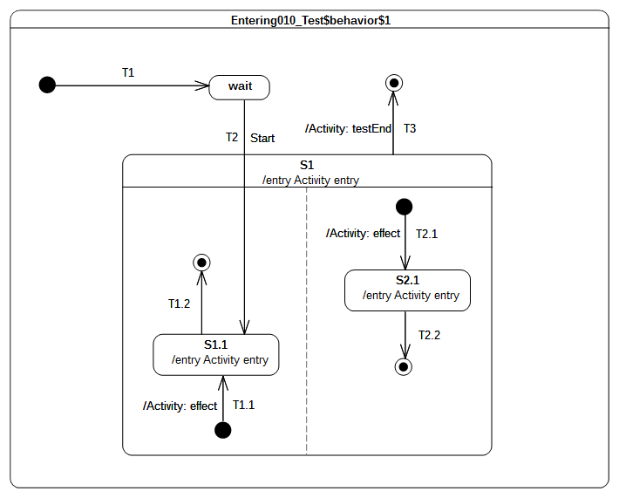Figure 9.45 - Entering 010 Test Classifier Behavior
Received event occurrence(s)
- Start – received when in configuration wait.
Generated trace
- S1(entry)::T2.1(effect)::S2.1(entry)::S1.1(entry)
Note. This test case presents the entry into a composite state with multiple regions. In this case, one region is entered directly whereas the other is entered by default. This occurs in the RTC step initiated by acceptance of the Start event occurrence. First S1 is entered, which leads to the default entry of the right-side region. Next the left hand side region is entered directly (i.e., the initial pseudo state and its outgoing transition are not traversed). This means that state S1.1 is entered. Note that this describes on possible execution, since the concurrency implied by the orthogonal regions of S1 can lead to other valid execution traces. Nevertheless, the rules for default and direct entry of regions remain unchanged.
RTC steps
Step | Event pool | State machine configuration | Fired transition(s)
1 | [] | [] - Initial RTC step | [T1]
2 | [Start, CE(wait)] | [wait] | []
3 | [Start] | [waiting] | [T2(T1.1, T2.1)]
4 | [CE(S1.1), CE(2.1)] | [S1[S1.1, S2.1]] | [T2.2]
5 | [CE(S1.1)] | [S1[S1.1]] | [T1.2]
6 | [CE(S1)] | [S1] | [T3]
Alternative execution traces(s)
In that test case, S1 specifies concurrency thanks to its two orthogonal regions. Hence it also exists traces that might be generated by the test which are different from the one presented above. These traces are:
- S1(entry)::S1.1(entry)::T2.1(effect)::S2.1(entry)
- S1(entry)::T2.1(effect)::S1.1(entry)::S2.1(entry)
Lets consider the trace 2. It shows that S1.1 entry behavior is executed first, followed by the effect behavior of T2.1 and finally the execution of S2.1 entry behavior. The RTC steps lead to the production of this trace are described below:
Step | Event pool | State machine configuration | Fired transition(s)
1 | [] | [] - Initial RTC step | [T1]
2 | [Start, CE(wait)] | [wait] | []
3 | [Start] | [wait] | [T2(T2.1)]
4 | [CE(S2.1), CE(S1.1)] | [S1[S1.1, S2.1]] | [T1.2]
5 | [CE(S2.1)] | [S1[S2.1]] | [T2.2]
6 | [CE(S1)] | [S1] | [T3]

Entering 011
Entering 011 ([UML], 14.2.3.4.5)
If the Transition terminates on the edge of the composite State (i.e., without entering the State), then all the Regions are entered using the default entry rule above.

Tested state machine
The state machine that is executed for this test is presented in Figure 9.46.
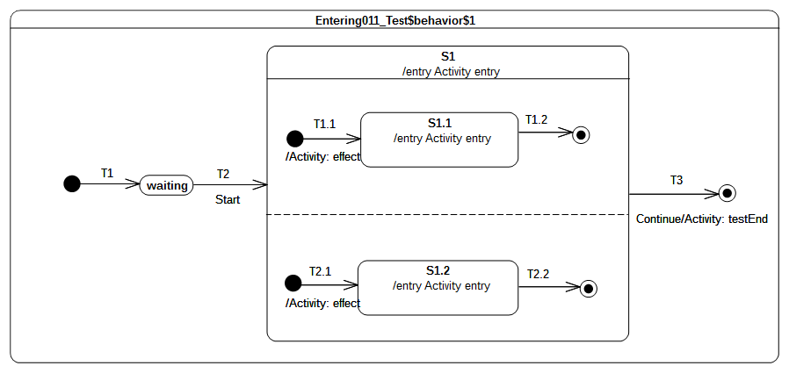Figure 9.46 - Entering 011 Test Classifier Behavior

Test executions
Received event occurrence(s)
- Start – received when in configuration waiting.
- Continue – received when in configuration S1.
Generated trace
- S1(entry)::T2.1(effect)::S1.2(entry)::T1.1(effect)::S1.1(entry)
Note. This test case covers the situation where all regions of a composite state are entered using the default entry rule. The RTC step that was initiated by the acceptance of the Start event occurrence leads to the entering of S1, which means that, after its entry behavior is executed, all region will be started concurrently. The execution of each region starts from its initial pseudo-state. S1 completes when both of its region have completed. This occurs when completion events generated by S1.1 and S1.2 have been dispatched. The S1 completion event is then used to trigger transition T3.
RTC steps
Step | Event pool | State machine configuration | Fired transition(s)
1 | [] | [] - Initial RTC step | [T1]
2 | [Start, CE(waiting)] | [waiting] | []
3 | [Start] | [waiting] | [T2(T1.1, T2.1)]
4 | [CE(1.2), CE(S1.1)] | [S1[S1.1, S2.1]] | [T1.2]
5 | [CE(1.2)] | [S1[S2.1]] | [T2.2]
6 | [Continue, CE(S1)] | [S1] | []
7 | [Continue] | [S1] | [T3]
Alternative execution traces
In this test parallelism is specified thanks to orthogonal regions owned by the composite state S1. The presence of this regions implies that different execution traces can be observed for the tested state machine while being conforming with UML semantics. These execution traces are:
- S1(entry)::T2.1(effect)::T1.1(effect)::S1.2(entry)::S1.1(entry)
- S1(entry)::T2.1(effect)::T1.1(effect)::S1.1(entry)::S1.2(entry
- S1(entry)::T1.1(effect)::T2.1(effect)::S1.1(entry)::S1.2(entry)
- S1(entry)::T1.1(effect)::T2.1(effect)::S1.2(entry)::S1.1(entry)
- S1(entry)::T1.1(effect)::S1.1(entry)::T2.1(effect)::S1.2(entry)
Lets consider trace 4. The RTC steps leading to the production of this trace are described in the table below:
Step | Event pool | State machine configuration | Fired transition(s)
1 | [] | [] - Initial RTC step | [T1]
2 | [Start, CE(waiting)] | [waiting] | []
3 | [Start] | [waiting] | [T2(T1.1, T2.1)]
4 | [CE(S1.1), CE(S1.2)] | [S1[S1.1, S1.2]] | [T2.2]
5 | [CE(S1.1)] | [S1[S1.1]] | [T1.2]
6 | [Continue, CE(S1)] | [S1] | []
7 | [Continue] | [S1] | [T3]

Exiting

Overview
Tests presented in this subclause assess that semantics associated with state exiting rules conform to what is specified in UML.

Exiting 001
Exiting 001 ([UML], 14.2.3.4.6)
When exiting a State, regardless of whether it is simple or composite, the final step involved in the exit, after all other Behaviors associated with the exit are completed, is the execution of the exit Behavior of that State.

Tested state machine
The state machine that is executed for this test is presented in Figure 9.47.
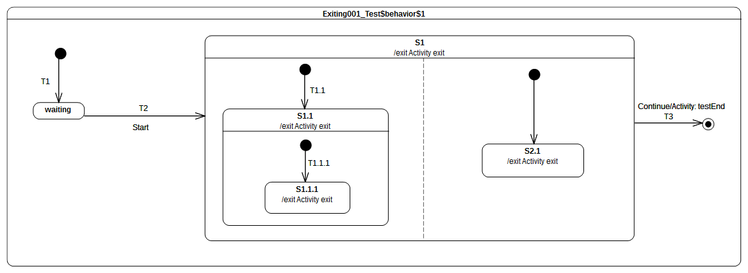Figure 9.47 - Exiting 001 Test Classifier Behavior

Test executions
Received event occurrence(s)
- Start – received when in configuration waiting.
- Continue – received when in configuration S1[S1.1[S1.1.1], S2.1].
Generated trace
- S1.1.1(exit)::S1.1(exit)::S2.1(exit)::S1(exit)
Note. This test illustrates the exit sequence of a composite state with orthogonal regions. When the Continue event occurrence is accepted, it triggers transition T3. The first action encountered by the traversal of T3 is that the exiting of S1. This requires first that all active states in all regions controlled by this state are exited. The exit sequence starts for each region with the innermost active state. Hence, assuming that the left-hand side S1.1.1 is exited first, it will be immediately followed by S1.1. Concurrently, S2.1 is exited in the right-hand region. The exit sequence is concluded by the execution of the exit behavior of S1. Finally, the effect behavior of T3 is executed and the state machine execution completes.
RTC steps
Step | Event pool | State machine configuration | Fired transition(s)
1 | [] | [] - Initial RTC step | [T1]
2 | [Start, CE(waiting)] | [waiting] | []
3 | [Start] | [waiting] | [T2(T1.1(T1.1.1), T2.1)]
4 | [Continue, CE(S2.1), CE(S1.1.1)] | [S1[S1.1[S1.1.1], S2.1]] | []
5 | [Continue, CE(S2.1)] | [S1[S1.1[S1.1.1], S2.1]] | []
6 | [Continue] | [S1[S1.1[S1.1.1], S2.1]] | [T3]
Alternative execution traces
In this test parallelism is specified thanks to orthogonal regions owned by the composite state S1. The presence of this region implies that a different execution trace can be observed for the tested state machine while conforming to UML semantics. This execution trace is:
- S1.1.1(exit)::S2.1(exit)::S1.1(exit)::S1(exit)
- S2.1(exit)::S1.1.1(exit)::S1.1(exit)::S1(exit)
Lets consider the trace 2. This trace is generated when Continue signal event occurrence is dispatched and initiate the process of concurrently exiting S1 orthogonal regions. In that situation, S2.1 exit behavior is executed before S1.1.1 exit behavior.

Exiting 002
Exiting 002 ([UML], 14.2.3.4.6)
If the State has a doActivity Behavior that is still executing when the State is exited, that Behavior is aborted before the exit Behavior commences execution.

Tested state machine
The state machine that is executed for this test is presented in Figure 9.48. The doActivity behavior of S1 has exactly the same behavior as the one presented in Figure 9.37 except that, instead of waiting for a Continue event occurrence, it waits for an AnotherSignal event occurrence.
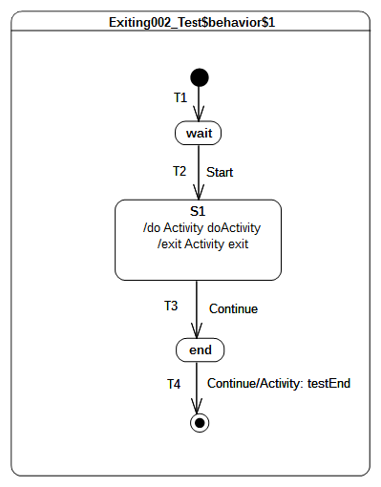Figure 9.48 - Exiting 002 Test Classifier Behavior
The exit behavior is specified as shown in Figure 9.49. It contributes to the trace production by adding a the fragment 'S1(exit)' and sends a signal AnotherSignal to the current context object executing this behavior
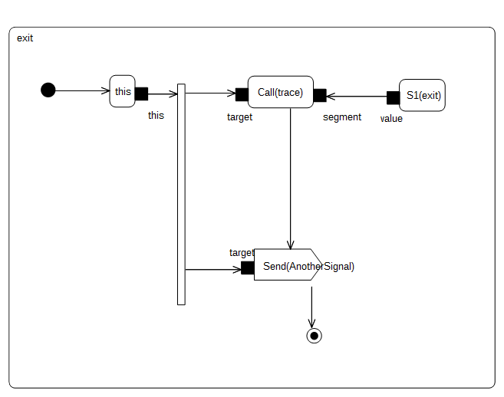Figure 9.49 - S1 exit behavior

Test executions
Received event occurrence(s)
- Start – received when in configuration wait.
- Continue – received when in configuration S1.
- AnotherSignal – received when in configuration S1.
- Continue – received when in configuration end.
Generated trace
- S1(doActivityPartI)::S1(exit)
Note. The purpose of this test is to demonstrate that the doActivity behavior (if it is still running) is aborted before the exit behavior is actually executed. In this test case, the doActivity behavior is started asynchronously after S1 is entered. It is the very last action that takes place during the RTC step initiated by the acceptance of the Start event occurrence.
In this case, when the Continue event occurrence is dispatched, the doActivity behavior is still running. Indeed it waits for an AnotherSignal occurrence. However S1 is now forced to be exited using the transition T3 (due to the acceptance of the Continue event occurrence). Hence, its doActivity behavior is aborted and its exit behavior is executed. To verify that doActivity was effectively aborted before the execution the exit, the exit behavior of S1 sends an AnotherSignal occurrence to the context object. If the doActivity was not aborted, then it would have used this event occurrence to continue its execution and it would have completed the execution trace with the message S1(doActivityPartII).
RTC steps
Step | Event pool | State machine configuration | Fired transition(s)
1 | [] | [] - Initial RTC step | [T1]
2 | [Start, CE(wait)] | [wait] | []
3 | [Start] | [wait] | [T2]
4 | [AnotherSignal, Continue] | [S1] | [T3]
5 | [Continue, AnotherSignal, CE(end)] | [end] | []
6 | [Continue, AnotherSignal] | [end] | []
7 | [Continue] | [end] | [T4]

Exiting 003
Exiting 003 ([UML], 14.2.3.4.6)
When exiting from a composite State, exit commences with the innermost State in the active state configuration. This means that exit Behaviors are executed in sequence starting with the innermost active State.

Tested state machine
The state machine that is executed for this test is presented in Figure 9.50.
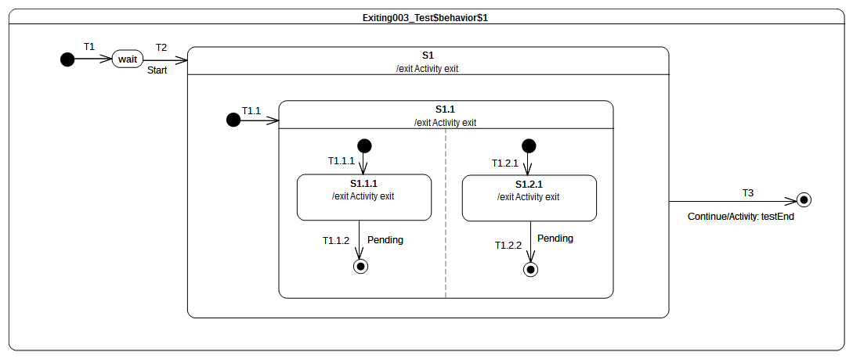Figure 9.50 - Exiting 003 Test Classifier Behavior

Test executions
Received event occurrence(s)
- Start – received when in configuration wait.
- Continue – received when in configuration S1[S1.1[S1.1.1, S1.2.1]].
Generated trace
- S1.1.1(exit)::S1.2.1(exit)::S1.1(exit)::S1(exit)
Note. The purpose of this test is to demonstrate that when a composite state is exited, the exit behaviors that are executed first are those owned by the innermost active state(s). Here when the Continue event occurrence is accepted, the state machine is in configuration S1[S1.1[S1.1.1, S1.2.1]]. This means that to conform to UML state machine semantics, our execution model must start the exit sequence of S1 by first exiting S1.1.1 and S1.2.1. Next, S1.1 is exited and finally this is S1 turn.
RTC steps
Step | Event pool | State machine configuration | Fired transition(s)
1 | [] | [] - Initial RTC step | [T1]
2 | [Start, CE(wait)] | [wait] | []
3 | [Start] | [wait] | [T2(T1.1(T1.1.1, T1.2.1))]
4 | [Continue, CE(S1.2.1), CE(S1.1.1)] | [S1[S1.1[S1.1.1, S1.2.1]]] | []
5 | [Continue, CE(S1.2.1)] | [S1[S1.1[S1.1.1, S1.2.1]]] | []
6 | [Continue] | [S1[S1.1[S1.1.1, S1.2.1]]] | [T3]
Alternative execution traces
In this test parallelism is specified thanks to orthogonal regions owned by the composite state S1.1. The presence of this region implies that a different execution trace can be observed for the tested state machine while conforming to UML semantics. This execution trace is:
- S1.2.1(exit)::S1.1.1(exit)::S1.1(exit)::S1(exit)
Here when the Continue signal event occurrence is dispatched S1.2.1 exit behavior is executed before S1.1.1 exit behavior.

Exiting 004
Exiting 004 ([UML], 14.2.3.4.6)
If the exit occurs through an exitPoint Pseudostate, then the exit Behavior of the State is executed after the effect Behavior of the Transition terminating on the exit point.

Tested state machine
The state machine that is executed for this test is presented in Figure 9.51.
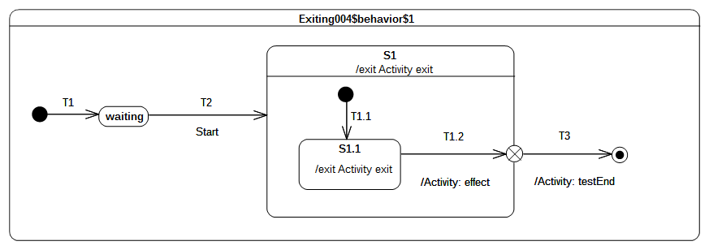Figure 9.51 - Exiting 004 Test Classifier Behavior

Test executions
Received event occurrence(s)
- Start – received when in configuration wait.
Generated trace
- S1.1(exit)::T1.2(effect)::S1(exit)
Note. The purpose of this test is to validate that, when a composite state is left using an exit point, then the effect behavior of the transition entering this pseudo-state is executed before the exit behavior of the state. At the point where the state machine is in configuration S1[S1.1], the completion event generated for S1.1 is dispatched and accepted. This initiates an RTC step during which S1.1 is exited, the effect behavior is of T1.2 is executed, S1 is exited and finally the continuation transition T3 is traversed.
RTC steps
Step | Event pool | State machine configuration | Fired transition(s)
1 | [] | [] - Initial RTC step | [T1]
2 | [Start, CE(waiting)] | [waiting] | []
3 | [Start] | [waiting] | [T2(T1.1)]
4 | [CE(S1.1)] | [S1[S1.1]] | [T1.2(T3)]

Exiting 005
Exiting 005 ([UML], 14.2.3.4.6)
When exiting from an orthogonal State, each of its Regions is exited. After that, the exit Behavior of the State is executed.

Tested state machine
The state machine that is executed for this test is presented in Figure 9.52.
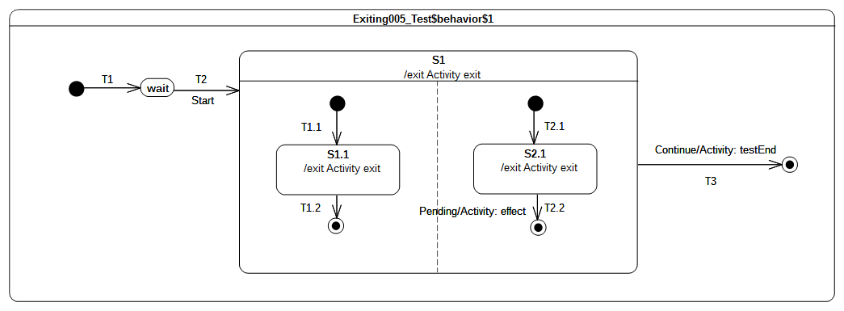Figure 9.52 - Exiting 005 Test Classifier behavior

Test executions
Received event occurrence(s)
- Start – received when in configuration wait.
- Continue – received when in configuration S1[S1.1].
Generated trace
- S1.1(exit)::S2.1(exit)::S1(exit)
Note. The purpose of the test is to ensure that, when exiting S1, which has orthogonal regions, the exit behaviors of S1.1 and S2.1 are executed before the exit behavior of S1. When the Continue event occurrence is dispatched, the state machine is in the configuration S1[S1.1] (the left-hand region has already completed due to the acceptance of the S1.1 completion event). Transition T3 is triggered next and the exit sequence starts with the execution of S2.1 exit behavior followed by the exit behavior of S1.
RTC steps
Step | Event pool | State machine configuration | Fired transition(s)
1 | [] | [] - Initial RTC step | [T1]
2 | [Start, CE(waiting)] | [waiting] | []
3 | [Start] | [waiting] | [T2(T1.1, T2.1)]
4 | [Continue, CE(S2.1), CE(S1.1)] | [S1[S1.1, S2.1]] | [T1.2]
5 | [Continue, CE(S2.1)] | [S1[S2.1]] | []
6 | [Continue] | [S1] | [T3]

Entry

Overview
Tests presented in this subclause assess that semantics associated with entry points conform to what is specified in UML.

Entry 002 – A
Entry 002
If the owning State has an associated entry Behavior, this Behavior is executed before any behavior associated with the outgoing Transition. If multiple Regions are involved, the entry point acts as a fork Pseudostate.

Tested state machine
The state machine that is executed for this test is presented in Figure 9.53.
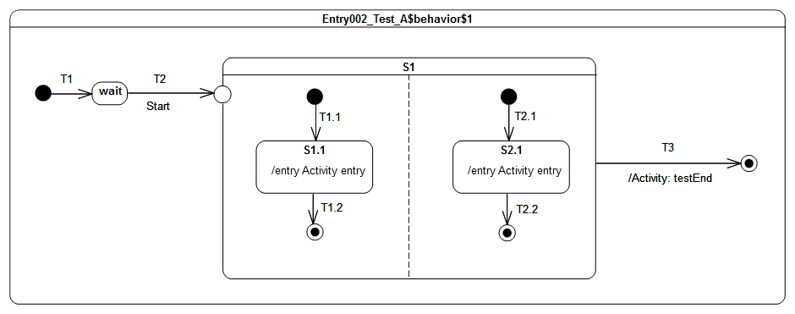Figure 9.53 - Entry 002 - A Test Classifier Behavior

Test execution
Received event occurrence(s)
- Start – received when in configuration wait.
Generated trace
- S1.1(entry)::S2.1(entry)
Note. The fact that the entry behavior of the state owning the entry point is executed before the effect behavior of the transition outgoing the exit point was demonstrated in the test case presented in section 9.3.5.4. The purpose of this test is to demonstrate that, if an entry point is placed on a composite state with orthogonal regions, then this entry point behaves as a fork. When the Start event occurrence is accepted by the state machine, T2 is triggered. At the end of T2 traversal, the entry point is reached, which implies the entry of S1. Since there are no transitions originating from the pseudostate and penetrating into the state, all regions of S1 are entered using the default entry rule (i.e, each region starts is execution using the its initial pseudo state). Hence, both continuation transitions T1.1 and T2.1 are traversed resulting in states S1.1 and S2.1 executing their entry behaviors. At the end of each entry behavior execution, a completion event is generated. This is is the end of the RTC step initiated by the dispatching of the Start event occurrence. The two following RTC steps are related to the dispatching and the acceptance of these completion events. As soon as both regions have completed, a completion event is generated for S1. The last RTC step consist of accepting this completion event to trigger T3 and completing the state machine execution when the final state is reached.
RTC steps
Step | Event pool | State machine configuration | Fired transition(s)
1 | [] | [] - Initial RTC step | [T1]
2 | [Start, CE(wait)] | [wait] | []
3 | [Start] | [wait] | [T2(T1.1, T2.1)]
4 | [CE(S2.1), CE(S1.1)] | [S1[S1.1, S2.1]] | [T1.2]
5 | [CE(S2.1)] | [S1[S2.1]] | [T2.2]
6 | [CE(S1)] | [S1] | [T3]
Alternative execution traces
In the test case there is concurrency specified in state S1. This means an alternative execution is possible for the state machine under test. This trace is described below and shows the case where S1.1 entry behavior is executed after the S2.1 entry behavior.
- S2.1(entry)::S1.1(entry)
The RTC steps leading to the production of this trace are described in the table below.

Step | Event pool | State machine configuration | Fired transition(s)
1 | [] | [] - Initial RTC step | [T1]
2 | [Start, CE(wait)] | [wait] | []
3 | [Start] | [wait] | [T2(T1.1, T2.1)]
4 | [CE(S1.1), CE(S2.1)] | [S1[S1.1, S2.1]] | [T2.2]
5 | [CE(S1.1)] | [S1[S2.1]] | [T1.2]
6 | [CE(S1)] | [S1] | [T3]

Entry 002 – B

Tested state machine
The state machine that is executed for this test is presented in Figure 9.54.
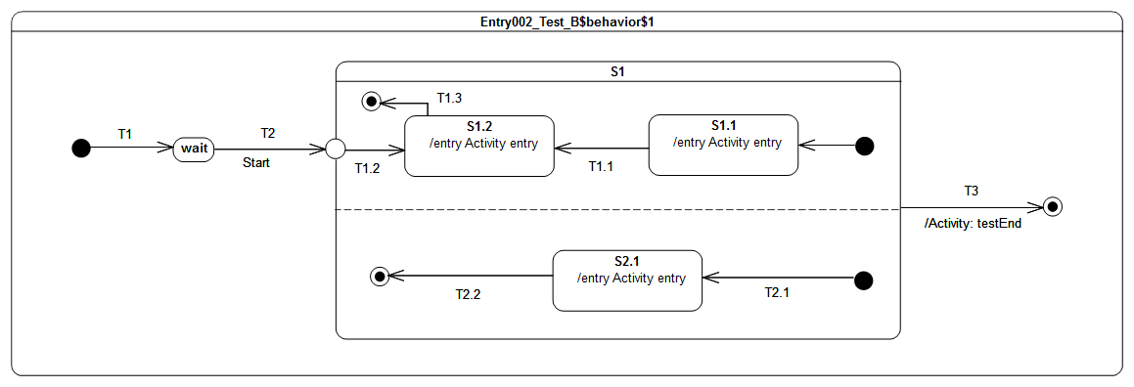Figure 9.54 - Entry 002 - B Test Classifier behavior

Test execution
Received event occurrence(s)
- Start – received when in configuration wait.
Generated trace
- S2.1(entry)::S1.2(entry)
Note. The test case presented in section 9.3.7.4 demonstrates that when a transition outgoing from entry point and penetrating a composite state is traversed then the region containing the targeted state is entered explicitly (i.e., without using the initial pseudo-state). The purpose of this test is to demonstrate that, if orthogonal regions exist in that composite state, then these are entered using the default approach, whereas the first one (i.e., the one containing the target vertex) is entered explicitly. As we can see from the generated execution trace, the S1.1(entry) message does not appear, which indicates the entrance of the upper region of S1 was realized explicitly. In addition, S2.1(entry) is part of the trace, indicating that the other region of S1 was entered using the default entry approach.
RTC Steps
Step | Event pool | State machine configuration | Fired transition(s)
1 | [] | [] - Initial RTC step | [T1]
2 | [Start, CE(wait)] | [wait] | []
3 | [Start] | [wait] | [T2(T2.1, T1.2)]
4 | [CE(S1.2), CE(S2.1)] | [S1[S1.2, S2.1]] | [T2.2]
5 | [CE(S1.2)] | [S1[S1.2]] | [T1.3]
6 | [CE(S1)] | [S1] | T3
Alternative execution traces
In the test case there is concurrency specified in state S1. This means an alternative execution is possible for the state machine under test. This trace is described below and shows the case where S1.2 entry behavior is executed before the S2.1 entry behavior.
- S1.2(entry)::S2.1(entry)
The RTC steps leading to the production of this trace are described in the table below.

Step | Event pool | State machine configuration | Fired transition(s)
1 | [] | [] - Initial RTC step | [T1]
2 | [Start, CE(wait)] | [wait] | []
3 | [Start] | [wait] | [T2(T1.2, T2.1)]
4 | [CE(S2.1), CE(S1.2)] | [S1[S1.2, S2.1]] | [T1.3]
5 | [CE(S2.1)] | [S1[S1.2]] | [T2.2]
6 | [CE(S1)] | [S1] | T3

Entry 002 – C
Entry 002
If the owning State has an associated entry Behavior, this Behavior is executed before any behavior associated with the outgoing Transition.

Tested state machine
The state machine that is executed for this test is presented in Figure 9.55.
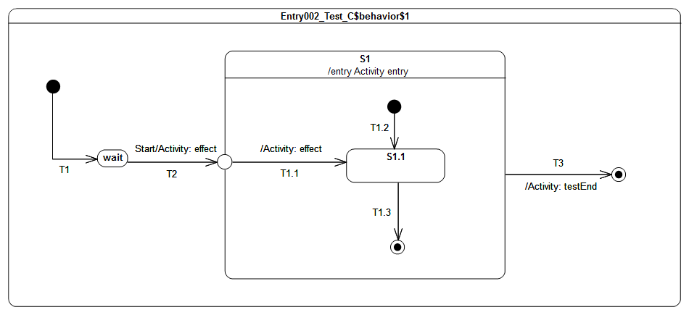Figure 9.55 - Entry 002 - C Test Classifier Behavior

Test execution
Received event occurrence(s)
- Start – received when in configuration wait.
Generated trace
- T2(effect)::S1(entry)::T1.1(entry)
Note. The purpose of this test is to demonstrate that the entry behavior of the state owning the entry point is always executed before the effect behavior(s) of the transition(s) originating from this entry point. When the Start event occurrence is dispatched and accepted by the state machine, T2 is triggered and traversed. This traversal implies the execution of the effect behavior as well as the entrance of the entry point pseudostate. When the entry point is entered, S1 is entered and its entry behavior is executed. As soon as the previous actions have completed, the continuation transition T1.1 can be traversed. Hence its effect behavior is executed and S1.1 is entered.
RTC Steps
Step | Event pool | State machine configuration | Fired transition(s)
1 | [] | [] - Initial RTC step | [T1]
2 | [Start, CE(wait)] | [wait] | []
3 | [Start] | [wait] | [T2(T1.1)]
4 | [CE(S1.1)] | [S1[S1.1]] | [T1.3]
5 | [CE(S1)] | [S1] | [T3]

Entry 002 – D

Tested state machine
The state machine that is executed for this test is presented in Figure 9.56.

Test execution
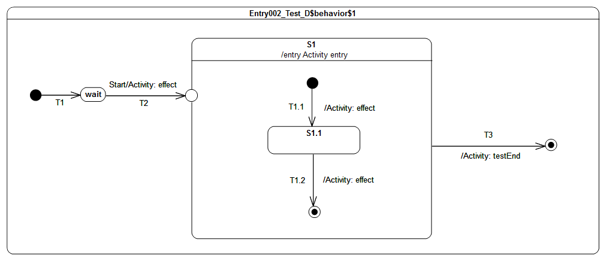Figure 9.56 - Entry 002 - D Test Classifier Behavior
Received event occurrence(s)
- Start – received when in configuration wait.
Generated trace
- T2(effect)::S1(entry)::T1.1(effect)::T1.2(effect)
Note. The purpose of this test is to consolidate what was shown in previous test-cases presented in 9.3.7. It demonstrates that, if the composite has a single region and is entered through an entry with no outgoing transitions, then the region is entered using the default entry approach. When the Start event occurrence is dispatched and accepted by the state machine, T2 is triggered and traversed. This is manifested in the trace by the message T2(effect). Next, S1 is entered and its entry behavior is executed (see message S1(entry) in the trace). Finally, we see the region is entered using the default approach, since the execution of the T1.1 effect behavior adds message T1.1(effect) to the trace.
RTC Steps
Step | Event pool | State machine configuration | Fired transition(s)
1 | [] | [] - Initial RTC step | [T1]
2 | [Start, CE(wait)] | [wait] | []
3 | [Start] | [wait] | [T2(T1.1)]
4 | [CE(S1.1)] | [S1[S1.1]] | [T1.2]
5 | [CE(S1)] | [S1] | [T3]

Entry 002 – E

Tested state machine
The state machine that is executed for this test is presented in Figure 9.57.Test execution
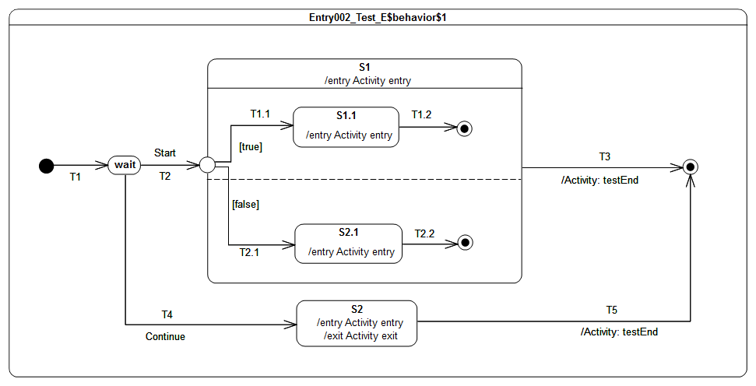Figure 9.57: Entry002 - E Classifier Behavior
Received event occurrence(s)
- Start – received when in configuration wait.
- Continue – received when in configuration wait.
Generated trace
- S1(entry)::S1.1(entry)
Note. The purpose of this test is to demonstrates the impact of the static analysis performed before an event occurrence is actually dispatched on the execution. In that test case, the Start event occurrence is lost. This loss is due to the impossibility to find a path to a valid state machine configuration from the configuration “wait”. Indeed the compound transition T2(T1.1, T2.1) cannot be traversed since T2.1 outgoing transition has a guard evaluating to false. The reason for this choice is that as the entry point plays the same role as Fork pseudo state (because all of its outgoing transitions target states located in orthogonal regions) hence its must be possible to propagate the execution all of its outgoing transitions. When the Continue event occurrence is dispatched the state machine is in configuration wait. Transition T4 is fired using this event occurrence and state S2 is entered. The completion event for S2 when dispatched triggers T5 which enables the state machine execution to reach the final state and to complete.
RTC Steps
Step | Event pool | State machine configuration | Fired transition(s)
1 | [] | [] - Initial RTC step | [T1]
2 | [Start, CE(wait)] | [wait] | []
3 | [Start] | [wait] | []
4 | [Continue] | [wait] | [T4]
5 | [CE(S2)] | [S2] | [T5]

Entry 002 – F

Tested state machine
The state machine that is executed for this test is presented in Figure 9.58.

Test executions
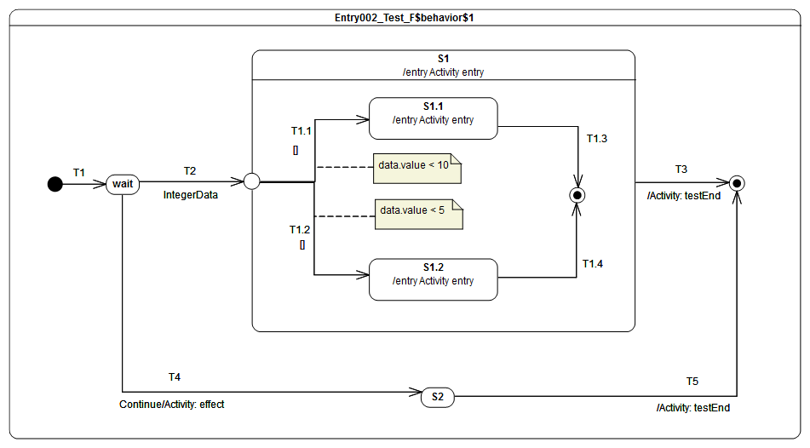Figure 9.58: Entry 002 - F Classifier Behavior
Received event occurrence(s)
- IntegerData(8) – received when in configuration wait.
- Continue – received either on configuration S1 or S2.
Generated trace
- S1(entry)[in=8]::S1.1(entry)[in=8]
Note. In this test the entry point plays the role of a Junction pseudo state (it has outgoing transitions to different states located in the same region). The test case shows that a valid path can be found during the static analysis phase from the wait configuration to the S1[S1.1] configuration. Indeed when IntegerData(8) is dispatched the compound transition T2(T1.1) is traversed because the guard on T1.1 evaluated to true meanwhile the guard on T1.2 evaluated to false. The completion event generated during that step for S1.1 is used in the next one to trigger T1.3. Hence S1 completes and T3 is fired when the completion event is dispâtched.
RTC steps
Step | Event pool | State machine configuration | Fired transition(s)
1 | [] | [] - Initial RTC step | [T1]
2 | [IntegerData(8)] | [wait] | [T2(T1.1)]
3 | [CE(S1.1)] | [S1[S1.1]] | [T1.3]
4 | [Continue, CE(S1)] | [S1] | [T3]

Exit

Overview
Tests presented in this subclause assess that semantics associated with exit points conform to what is specified in UML.

Exit 001
Exit 001 ([UML], 14.2.3.7)
Transitions terminating on an exit point within any Region of the composite State implies exiting of this composite (with execution of its associated exit Behavior)

Tested state machine
The state machine that is executed for this test is presented in Figure 9.59.
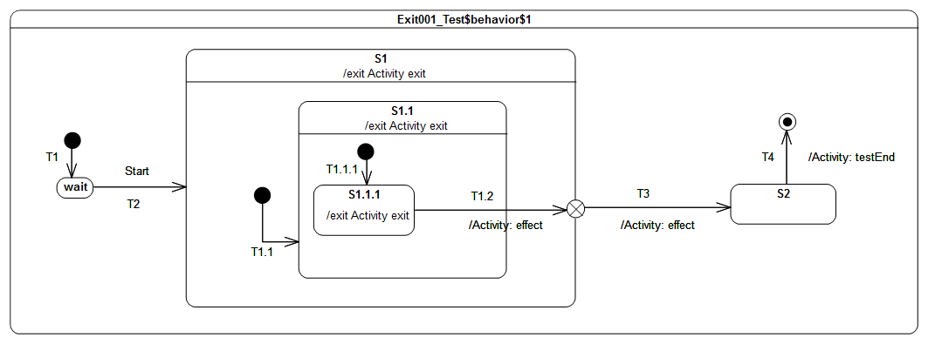Figure 9.59 - Exit 001 Test Classifier behavior

Test executions
Received event occurrence(s)
- Start – received when in configuration wait.
Generated trace
- S1.1.1(exit)::S1.1(exit)::T1.2(effect)::S1(exit)::T3(effect)
Note. The purpose of this test case is to demonstrate the support of exit point pseudostate for exiting a composite state. The completion event generated by S1.1.1 is dispatched and accepted when the state machine is in configuration S1[S1.1[S1.1.1]]. At this point T1.2 is triggered. When traversed, this transition implies first that S1.1.1 is exited as well as S1.1. Next, its effect behavior is executed and, finally, the exit point placed on S1 is reached. The semantics of the exit point requires S1 to be exited and transition T3 to be traversed.
RTC Steps
Step | Event pool | State machine configuration | Fired transition(s)
1 | [] | [] - Initial RTC step | [T1]
2 | [Start, CE(wait)] | [wait] | []
3 | [Start] | [wait] | [T2(T1.1(T1.1.1))]
4 | [CE(S1.1.1)] | [S1[S1.1[S1.1.1]]] | [T1.2(T3)]
5 | [CE(S2)] | [S2] | [T4]

Exit 002
Exit 002 ([UML], 14.2.3.7)
If multiple Transitions from orthogonal Regions within the State terminate on this Pseudostate, then it acts like a join Pseudostate

Tested state machine
The state machine that is executed for this test is presented in Figure 9.60.
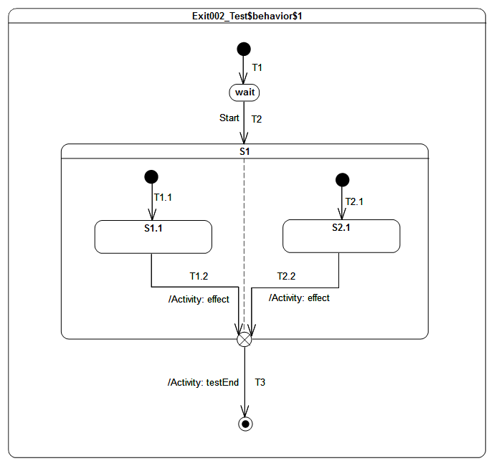Figure 9.60 - Exit 002 Test Classifier Behavior

Test executions
Received event occurrence(s)
- Start – received when in configuration wait.
Generated trace
- T1.2(effect)::T2.2(effect)
Note. The purpose of this test is to demonstrate that, if multiple transitions originating from states located in different orthogonal regions terminate on an exit pseudostate, then this acts (in addition to original semantics) as a join pseudo state.
When the completion event generated by S1.1 is dispatched and accepted by the state machine, then T1.2 is triggered and traversed. This is the first time that the exit point is reached. It cannot be traversed since its prerequisites are not satisfied (i.e., all of its incoming transition have not already been traversed). The next RTC step is initiated by the acceptance of the S2.1 completion event. T2.2 is triggered, after which the execution reaches the exit point for the second time. The latter is traversed and its outgoing transition is taken. The state machine execution completes when the final state is reached.
RTC Steps
Step | Event pool | State machine configuration | Fired transition(s)
1 | [] | [] - Initial RTC step | [T1]
2 | [Start, CE(wait)] | [wait] | []
3 | [Start] | [wait] | [T2(T1.1, T2.1)]
4 | [CE(S2.1), CE(S1.1)] | [S1[S1.1, S2.1]] | [T1.2]
5 | [CE(S2.1)] | [S1[S2.1]] | [T2.2(T3)]
Alternative execution traces
In the test case there is concurrency specified in state S1. This means an alternative execution is possible for the state machine under test. This trace is described below and shows the case where T2.2 effect behavior is executed after the T1.2 effect behavior.
- T2.2(effect)::T1.2(effect)

Exit 003
Exit 003
UML does not provide any constraint on the number of transitions that can originate from an exit point. Hence it means we can have more than one transition that is ready to be traversed. This situation may lead to a conflict.

Tested state machine
The state machine that is executed for this test is presented in Figure 9.61.

Test executions
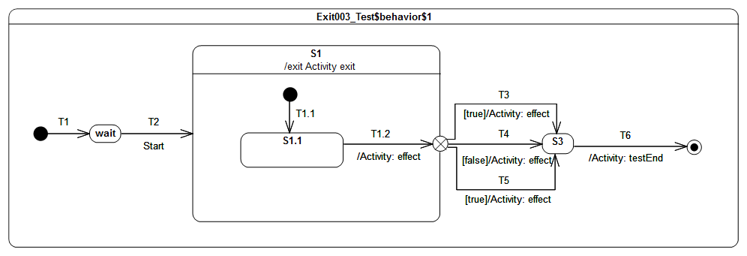Figure 9.61 - Exit 003 Classifier Behavior
Received event occurrence(s)
- Start – received when in configuration wait.
Generated trace
- T1.2(effect)::S1(exit)::T3(effect)
Note. The purpose of this test case is to ensure that, in a situation where multiple transitions outgoing an exit point are ready to be traversed, only one of them will actually be selected for firing. At some point of the execution (acceptance of S1.1 completion event), the exit point that is placed on S1 is reached. The guard placed on transitions originating from this exit point are evaluated. The set of enabled transitions is now composed of T3 and T5. A semantic strategy is used to determine which transition is going to be traversed. Under the assumption that T3 is chosen, it is taken and S3 is entered. The completion event generated by S3 will be dispatched in the next RTC step and the state machine will complete its execution.
RTC Steps
Step | Event pool | State machine configuration | Fired transition(s)
1 | [] | [] - Initial RTC step | [T1]
2 | [Start, CE(wait)] | [wait] | []
3 | [Start] | [wait] | [T2(T1.1)]
4 | [CE(S1.1)] | [S1[S1.1]] | [T1.2(T3)]
5 | [CE(S3)] | [S3] | [T6]

Choice

Overview
Tests presented in this subclause assess that semantics associated with choice pseudostate conform to what is specified in UML.

Choice 001
Choice 001 ([UML], 14.2.3.7)
The guard Constraints on all outgoing Transitions are evaluated dynamically, when the compound transition traversal reaches this Pseudostate

Tested state machine
The state machine that is executed for this test is presented in Figure 9.62.
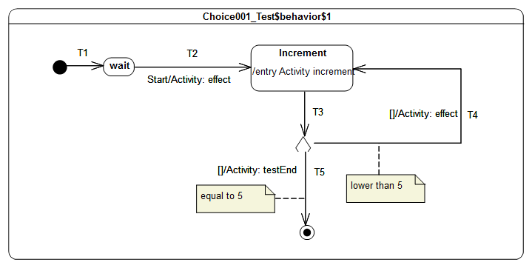Figure 9.62 - Choice 001 Test Classifier Behavior

Test execution
Received event occurrence(s)
- Start – received when in configuration wait.
Generated trace
- T4(effect)::T4(effect)::T4(effect)::T4(effect)
Note. The purpose of this test is to demonstrate how evaluation of transition guards of transitions originating from a choice pseudostate has an impact on the execution flow. When the Start event occurrence is dispatched and accepted by the state machine, T2 is triggered. The execution of its associated effect behavior implies the initialization of the value property of the class for which the state machine plays the role of a classifier behavior. The Increment state is entered and its entry behavior increments the value of property value . Right after the termination of the entry behavior, a completion event is generated for the state Increment. This is the end of the RTC step initiated by the acceptance of the Start event occurrence. The next RTC step is initiated by the acceptance of the completion event generated by the Increment state. This triggers T3, which is the incoming transition of the choice pseudostate. When it is reached, all guards placed on outgoing transitions are evaluated. Only the guard placed on T4 evaluates to true, so that this continuation transition is taken. This leads to re-entering of the Increment state. The next for four RTC steps repeat this execution path. The fifth consists in traversing T5, whose guard now evaluates to true. When the final state is reached the state machine completes its execution.
RTC Steps
Step | Event pool | State machine configuration | Fired transition(s)
1 | [] | [] - Initial RTC step | [T1]
2 | [Start, CE(wait)] | [wait] | []
3 | [Start] | [wait] | [T2]
4 | [CE(Increment)] | [Increment] | [T3(T4)]
5 | [CE(Increment)] | [Increment] | [T3(T4)]
6 | [CE(Increment)] | [Increment] | [T3(T4)]
7 | [CE(Increment)] | [Increment] | [T3(T4)]
8 | [CE(Increment)] | [Increment] | [T3(T5)]

Choice 002
Choice 002 ([UML], 14.2.3.7)
If more than one guard evaluates to true, one of the corresponding Transitions is selected. The algorithm for making this selection is not defined.

Tested state machine
The state machine that is executed for this test is presented in Figure 9.63.

Test execution
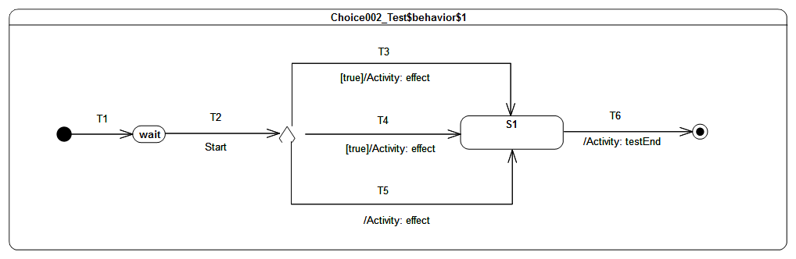Figure 9.63 - Choice 002 Test Classifier Behavior
Received event occurrence(s)
- Start – received when in configuration wait.
Generated trace
- T4(effect)
Note. The purpose of this test is to demonstrate that, if many transitions originating from a choice pseudostate are enabled, then at most one of them is chosen to be traversed. When the Start event occurrence is dispatched and accepted by the state machine, T2 is triggered. The choice pseudostate reached at this point has outgoing transitions. Each guard of each transition is evaluated. It happens at this point that T3, T4 and T5 are all ready to be traversed (a transition with no explicit guard is considered to have a guard that always evaluates to true). Hence a semantic strategy is used to elect the transition that will be fired. Assuming that a first choice strategy is used and that the list of enabled transition is organized with the following order [T4, T5, T3], transition T4 is elected to be traversed.
RTC Steps
Step | Event pool | State machine configuration | Fired transition(s)
1 | [] | [] - Initial RTC step | [T1]
2 | [Start, CE(wait)] | [wait] | []
3 | [Start] | [wait] | [T2(T4)]
4 | [CE(S1)] | [S1] | [T6]

Choice 003
Choice 003 ([UML], 14.2.3.7)
If none of the guards evaluates to true, then the model is considered ill formed. To avoid this, it is recommended to define one outgoing Transition with the predefined “else” guard for every choice Pseudostate.

Tested state machine
The state machine that is executed for this test is presented in Figure 9.64.

Test execution
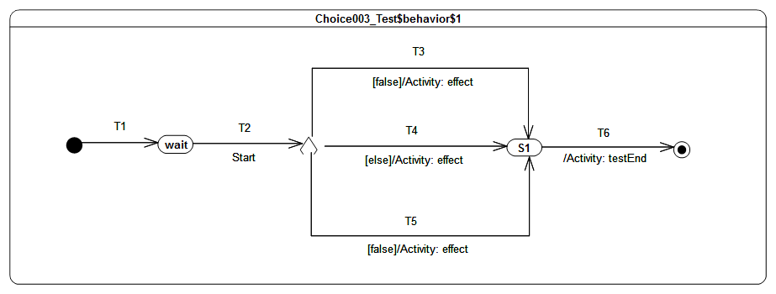Figure 9.64 - Choice 003 Test Classifier Behavior
Received event occurrence(s)
- Start – received when in configuration wait.
Generated trace
- T4(effect)
Note. The purpose of this test is to demonstrate that, if a choice point has an else outgoing transition and all of other outgoing transitions have guards that evaluate to false, then the else transition is chosen and traversed. When the Start event occurrence is dispatched and accepted, T2 is triggered which enables the state machine to reach the choice point. At this point, the guards of transitions T3 and T5 are evaluated. None of them evaluates to true, but there also exists an else transition T4. This transition (i.e., T4) is traversed and S1 is entered. The completion event generated by S1 is used to trigger T6, which leads to the completion of the state machine execution.
RTC Steps
Step | Event pool | State machine configuration | Fired transition(s)
1 | [] | [] - Initial RTC step | [T1]
2 | [Start, CE(wait)] | [wait] | []
3 | [Start] | [wait] | [T2(T4)]
4 | [CE(S1)] | [S1] | [T6]

Choice 004
Choice 004 (PSSM Proposal)
In UML, a signal can have properties. At runtime, the properties are associated with values. When a signal event occurrence is dispatched in a RTC step, guard specifications and effect behaviors that will be executed during that step will have access to the values specified by the signal instance. This rule only applies if the behaviors have a single input parameter that is of the type of the signal instance.

Tested state machine
The state machine that is executed for this test is presented in Figure

Test execution
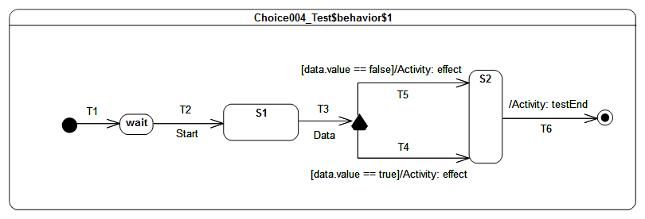Figure 9.65: Choice 004 Test Classifier Behavior Specification
Received event occurrence(s)
- Start – received when in configuration wait.
- Data(true) – received when in configuration S1.
Generated trace
- T4(effect)
Note. The purpose of that test case is to demonstrate that data available in an event occurrence can be made available to guards placed on outgoing transitions of a choice pseudo state. When Data event occurrence is dispatched, the compound transition T3(T4) is traversed. T4 is chosen because its guard evaluates to true. Note that choice outgoing transitions guards are not evaluated during the static analysis phase. They are evaluated at the time the choice is reached by the execution flow. This means that even in the case where the step is accepted by the state machine there is no guarantee that the execution will be able to reach a valid state machine configuration. The dispatching of S2 completion event enables the transition T6 to be fired.
RTC Steps
Step | Event pool | State machine configuration | Fired transition(s)
1 | [] | [] - Initial RTC step | [T1]
2 | [Start, CE(wait)] | [wait] | []
3 | [Start] | [wait] | [T2]
4 | [Data(true), CE(S1)] | [S1] | []
5 | [Data(true)] | [S1] | [T3(T4)]
6 | [CE(S2)] | [S2] | [T6]

Fork

Overview
Tests presented in this subclause assess that Fork semantics conforms to what is specified in UML.

Fork 001
Entering 012 ([UML], 14.2.3.4.5)
If the Transition explicitly enters one or more Regions (in case of a fork), these Regions are entered explicitly and the others by default.
Region 003 ([UML], 14.2.3.2)
An explicit activation occurs when a Region is entered by a Transition terminating on one of the Region’s contained Vertices. When one Region of an orthogonal State is activated explicitly, this will result in the default activation of all of its orthogonal Regions, unless those Regions are also entered explicitly (multiple orthogonal Regions can be entered explicitly in parallel through Transitions originating from the same fork Pseudostate)

Tested state machine
The state machine that is executed for this test is presented in Figure 9.66.
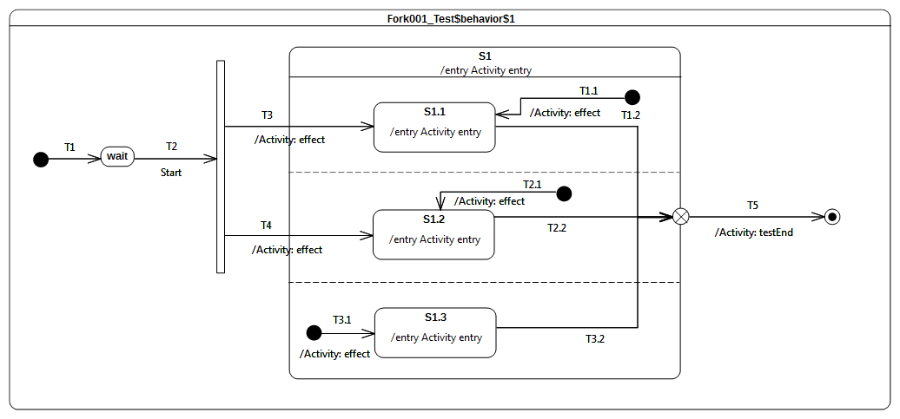Figure 9.66 - Fork 001 Test Classifier Behavior

Test execution
Received event occurrence(s)
- Start – received when in configuration wait.
Generated trace
- T3(effect)::S1(entry)::T3.1(effect)::S1.3(entry)::S1.1(entry)::T4(effect)::S1.2(entry). .
Note. The purpose of this test is to demonstrate the support for Fork pseudostate semantics, as well as the preservation of region entry rules, when this pseudostate is used. When the Start event occurrence is dispatched and accepted by the state machine, it triggers T2. Traversal of this transition brings the state machine to the Fork pseudostate. Both of its outgoing transitions are fired concurrently. However neither S1.1 nor S1.2 are entered immediately. S1 is entered first, its entry behavior is executed, and all regions that are not entered explicitly are started concurrently. This implies that the third region (i.e., the one containing S1.3) starts its execution starting from the initial pseudo state. Hence T3.1 is traversed and S1.3 is entered (a completion event is generated for that state when its entry behavior has finished). Finally both S1.1 and S1.2 are entered. This concludes the RTC step that was initiated by the acceptance of the Start event occurrence. The three completion events generated by S1.3, S1.1 and S2.1 will be used in next RTC steps to trigger T3.2, T1.2 and T2.2.
RTC Steps
Step | Event pool | State machine configuration | Fired transition(s)
1 | [] | [] - Initial RTC step | [T1]
2 | [Start, CE(wait)] | [wait] | []
3 | [Start] | [wait] | [T2(T3.1, T3, T4)]
4 | [CE(S1.2), CE(S1.1), CE(S1.3)] | [S1[S1.1, S1.2, S1.3]] | [T3.2]
5 | [CE(S1.2), CE(S1.1)] | [S1[S1.1, S1.2]] | [T1.2]
6 | [CE(S1.2)] | [S1[S1.2]] | [T2.2(T5)]
Alternative execution traces
The presence of the fork pseudo state and the three orthogonal regions in S1 imply the existence of multiple execution traces. These execution traces are listed below;
- T3(effect)::T4(effect)::S1(entry)::S1.1(entry)::S1.2(entry)::T3.1(effect)::S1.3(entry)");
- T3(effect)::T4(effect)::S1(entry)::S1.1(entry)::T3.1(effect)::S1.2(entry)::S1.3(entry)");
- T3(effect)::T4(effect)::S1(entry)::S1.1(entry)::T3.1(effect)::S1.3(entry)::S1.2(entry)");
- T3(effect)::T4(effect)::S1(entry)::S1.2(entry)::S1.1(entry)::T3.1(effect)::S1.3(entry)");
- T3(effect)::T4(effect)::S1(entry)::S1.2(entry)::T3.1(effect)::S1.3(entry)::S1.1(entry)");
- T3(effect)::T4(effect)::S1(entry)::S1.2(entry)::T3.1(effect)::S1.1(entry)::S1.3(entry)");
- T3(effect)::T4(effect)::S1(entry)::T3.1(effect)::S1.1(entry)::S1.2(entry)::S1.3(entry)");
- T3(effect)::T4(effect)::S1(entry)::T3.1(effect)::S1.1(entry)::S1.3(entry)::S1.2(entry)");
- T3(effect)::T4(effect)::S1(entry)::T3.1(effect)::S1.2(entry)::S1.1(entry)::S1.3(entry)");
- T3(effect)::T4(effect)::S1(entry)::T3.1(effect)::S1.2(entry)::S1.3(entry)::S1.1(entry)");
- T3(effect)::T4(effect)::S1(entry)::T3.1(effect)::S1.3(entry)::S1.1(entry)::S1.2(entry)");
- T3(effect)::T4(effect)::S1(entry)::T3.1(effect)::S1.3(entry)::S1.2(entry)::S1.1(entry)");
- T3(effect)::S1(entry)::T3.1(effect)::T4(effect)::S1.1(entry)::S1.3(entry)::S1.2(entry)");
- T3(effect)::S1(entry)::T3.1(effect)::T4(effect)::S1.1(entry)::S1.2(entry)::S1.3(entry)");
- T3(effect)::S1(entry)::T3.1(effect)::T4(effect)::S1.3(entry)::S1.1(entry)::S1.2(entry)");
- T3(effect)::S1(entry)::T3.1(effect)::T4(effect)::S1.3(entry)::S1.2(entry)::S1.1(entry)");
- T3(effect)::S1(entry)::T3.1(effect)::T4(effect)::S1.2(entry)::S1.1(entry)::S1.3(entry)");
- T3(effect)::S1(entry)::T3.1(effect)::T4(effect)::S1.2(entry)::S1.3(entry)::S1.1(entry)");
- T3(effect)::S1(entry)::T3.1(effect)::S1.1(entry)::T4(effect)::S1.2(entry)::S1.3(entry)");
- T3(effect)::S1(entry)::T3.1(effect)::S1.1(entry)::T4(effect)::S1.3(entry)::S1.2(entry)
- T3(effect)::S1(entry)::T3.1(effect)::S1.1(entry)::S1.3(entry)::T4(effect)::S1.2(entry)
- T3(effect)::S1(entry)::T3.1(effect)::S1.3(entry)::T4(effect)::S1.1(entry)::S1.2(entry)
- T3(effect)::S1(entry)::T3.1(effect)::S1.3(entry)::T4(effect)::S1.2(entry)::S1.1(entry)
- T3(effect)::S1(entry)::T3.1(effect)::S1.3(entry)::S1.1(entry)::T4(effect)::S1.2(entry)
- T3(effect)::S1(entry)::T4(effect)::T3.1(effect)::S1.2(entry)::S1.1(entry)::S1.3(entry)
- T3(effect)::S1(entry)::T4(effect)::T3.1(effect)::S1.2(entry)::S1.3(entry)::S1.1(entry)
- T3(effect)::S1(entry)::T4(effect)::T3.1(effect)::S1.1(entry)::S1.2(entry)::S1.3(entry)
- T3(effect)::S1(entry)::T4(effect)::T3.1(effect)::S1.1(entry)::S1.3(entry)::S1.2(entry)
- T3(effect)::S1(entry)::T4(effect)::T3.1(effect)::S1.3(entry)::S1.2(entry)::S1.1(entry)
- T3(effect)::S1(entry)::T4(effect)::T3.1(effect)::S1.3(entry)::S1.1(entry)::S1.2(entry)
- T3(effect)::S1(entry)::T4(effect)::S1.1(entry)::S1.2(entry)::T3.1(effect)::S1.3(entry)
- T3(effect)::S1(entry)::T4(effect)::S1.1(entry)::T3.1(effect)::S1.3(entry)::S1.2(entry)
- T3(effect)::S1(entry)::T4(effect)::S1.1(entry)::T3.1(effect)::S1.2(entry)::S1.3(entry)
- T3(effect)::S1(entry)::T4(effect)::S1.2(entry)::T3.1(effect)::S1.1(entry)::S1.3(entry)
- T3(effect)::S1(entry)::T4(effect)::S1.2(entry)::T3.1(effect)::S1.3(entry)::S1.1(entry)
- T3(effect)::S1(entry)::T4(effect)::S1.2(entry)::S1.1(entry)::T3.1(effect)::S1.3(entry)
- T3(effect)::S1(entry)::S1.1(entry)::T3.1(effect)::S1.3(entry)::T4(effect)::S1.2(entry)
- T3(effect)::S1(entry)::S1.1(entry)::T3.1(effect)::T4(effect)::S1.3(entry)::S1.2(entry)
- T3(effect)::S1(entry)::S1.1(entry)::T3.1(effect)::T4(effect)::S1.2(entry)::S1.3(entry)
- T3(effect)::S1(entry)::S1.1(entry)::T4(effect)::S1.2(entry)::T3.1(effect)::S1.3(entry)
- T3(effect)::S1(entry)::S1.1(entry)::T4(effect)::T3.1(effect)::S1.2(entry)::S1.3(entry)
- T3(effect)::S1(entry)::S1.1(entry)::T4(effect)::T3.1(effect)::S1.3(entry)::S1.2(entry)
- T4(effect)::T3(effect)::S1(entry)::S1.1(entry)::S1.2(entry)::T3.1(effect)::S1.3(entry)
- T4(effect)::T3(effect)::S1(entry)::S1.1(entry)::T3.1(effect)::S1.2(entry)::S1.3(entry)
- T4(effect)::T3(effect)::S1(entry)::S1.1(entry)::T3.1(effect)::S1.3(entry)::S1.2(entry)
- T4(effect)::T3(effect)::S1(entry)::S1.2(entry)::S1.1(entry)::T3.1(effect)::S1.3(entry)
- T4(effect)::T3(effect)::S1(entry)::S1.2(entry)::T3.1(effect)::S1.3(entry)::S1.1(entry)
- T4(effect)::T3(effect)::S1(entry)::S1.2(entry)::T3.1(effect)::S1.1(entry)::S1.3(entry)
- T4(effect)::T3(effect)::S1(entry)::T3.1(effect)::S1.1(entry)::S1.2(entry)::S1.3(entry)
- T4(effect)::T3(effect)::S1(entry)::T3.1(effect)::S1.1(entry)::S1.3(entry)::S1.2(entry)
- T4(effect)::T3(effect)::S1(entry)::T3.1(effect)::S1.2(entry)::S1.1(entry)::S1.3(entry)
- T4(effect)::T3(effect)::S1(entry)::T3.1(effect)::S1.2(entry)::S1.3(entry)::S1.1(entry)
- T4(effect)::T3(effect)::S1(entry)::T3.1(effect)::S1.3(entry)::S1.1(entry)::S1.2(entry)
- T4(effect)::T3(effect)::S1(entry)::T3.1(effect)::S1.3(entry)::S1.2(entry)::S1.1(entry)
- T4(effect)::S1(entry)::T3.1(effect)::T3(effect)::S1.1(entry)::S1.3(entry)::S1.2(entry)
- T4(effect)::S1(entry)::T3.1(effect)::T3(effect)::S1.1(entry)::S1.2(entry)::S1.3(entry)
- T4(effect)::S1(entry)::T3.1(effect)::T3(effect)::S1.3(entry)::S1.1(entry)::S1.2(entry)
- T4(effect)::S1(entry)::T3.1(effect)::T3(effect)::S1.3(entry)::S1.2(entry)::S1.1(entry)
- T4(effect)::S1(entry)::T3.1(effect)::T3(effect)::S1.2(entry)::S1.1(entry)::S1.3(entry)
- T4(effect)::S1(entry)::T3.1(effect)::T3(effect)::S1.2(entry)::S1.3(entry)::S1.1(entry)
- T4(effect)::S1(entry)::T3.1(effect)::S1.3(entry)::T3(effect)::S1.1(entry)::S1.2(entry)
- T4(effect)::S1(entry)::T3.1(effect)::S1.3(entry)::T3(effect)::S1.2(entry)::S1.1(entry)
- T4(effect)::S1(entry)::T3.1(effect)::S1.3(entry)::S1.2(entry)::T3(effect)::S1.1(entry)
- T4(effect)::S1(entry)::T3.1(effect)::S1.2(entry)::T3(effect)::S1.3(entry)::S1.1(entry)
- T4(effect)::S1(entry)::T3.1(effect)::S1.2(entry)::T3(effect)::S1.1(entry)::S1.3(entry)
- T4(effect)::S1(entry)::T3.1(effect)::S1.2(entry)::S1.3(entry)::T3(effect)::S1.1(entry)
- T4(effect)::S1(entry)::T3(effect)::T3.1(effect)::S1.2(entry)::S1.1(entry)::S1.3(entry)
- T4(effect)::S1(entry)::T3(effect)::T3.1(effect)::S1.2(entry)::S1.3(entry)::S1.1(entry)
- T4(effect)::S1(entry)::T3(effect)::T3.1(effect)::S1.1(entry)::S1.2(entry)::S1.3(entry)
- T4(effect)::S1(entry)::T3(effect)::T3.1(effect)::S1.1(entry)::S1.3(entry)::S1.2(entry)
- T4(effect)::S1(entry)::T3(effect)::T3.1(effect)::S1.3(entry)::S1.2(entry)::S1.1(entry)
- T4(effect)::S1(entry)::T3(effect)::T3.1(effect)::S1.3(entry)::S1.1(entry)::S1.2(entry)
- T4(effect)::S1(entry)::T3(effect)::S1.1(entry)::S1.2(entry)::T3.1(effect)::S1.3(entry)
- T4(effect)::S1(entry)::T3(effect)::S1.1(entry)::T3.1(effect)::S1.3(entry)::S1.2(entry)
- T4(effect)::S1(entry)::T3(effect)::S1.1(entry)::T3.1(effect)::S1.2(entry)::S1.3(entry)
- T4(effect)::S1(entry)::T3(effect)::S1.2(entry)::T3.1(effect)::S1.1(entry)::S1.3(entry)
- T4(effect)::S1(entry)::T3(effect)::S1.2(entry)::T3.1(effect)::S1.3(entry)::S1.1(entry)
- T4(effect)::S1(entry)::T3(effect)::S1.2(entry)::S1.1(entry)::T3.1(effect)::S1.3(entry)
- T4(effect)::S1(entry)::S1.2(entry)::T3.1(effect)::S1.3(entry)::T3(effect)::S1.1(entry)
- T4(effect)::S1(entry)::S1.2(entry)::T3.1(effect)::T3(effect)::S1.3(entry)::S1.1(entry)
- T4(effect)::S1(entry)::S1.2(entry)::T3.1(effect)::T3(effect)::S1.1(entry)::S1.3(entry)
- T4(effect)::S1(entry)::S1.2(entry)::T3(effect)::T3.1(effect)::S1.1(entry)::S1.3(entry)
- T4(effect)::S1(entry)::S1.2(entry)::T3(effect)::T3.1(effect)::S1.3(entry)::S1.1(entry)
- T4(effect)::S1(entry)::S1.2(entry)::T3(effect)::S1.1(entry)::T3.1(effect)::S1.3(entry)
Let consider the trace84. The RTC steps leading to the production of this are presented in the table below.
Step | Event pool | State machine configuration | Fired transition(s)
1 | [] | [] - Initial RTC step | [T1]
2 | [Start, CE(wait)] | [wait] | []
3 | [Start] | [wait] | [T2(T4, T3, T3.1)]
4 | [CE(S1.3), CE(S1.1), CE(S1.2)] | [S1[S1.1, S1.2, S1.3]] | [T2.2]
5 | [CE(S1.3), CE(S1.1)] | [S1[S1.1, S1.2]] | [T1.1]
6 | [CE(S1.3)] | [S1[S1.3]] | [T3.2(T5)]

Fork 002

Tested state machine
The state machine that is executed for this test is presented in Figure 9.67.
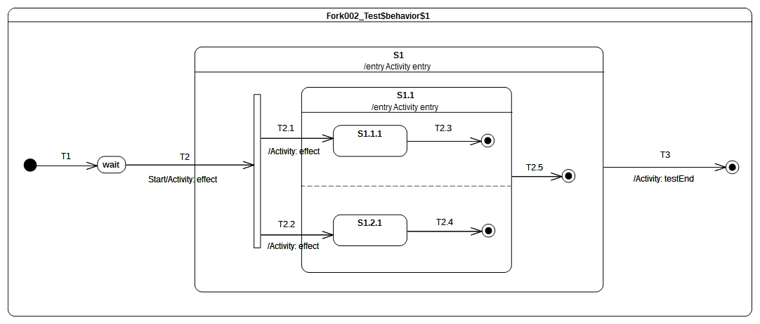Figure 9.67 - Fork 002 Test Classifier Behavior

Test execution
Received event occurrence(s)
- Start – received when in configuration wait.
Generated trace
- T2(effect)::S1(entry)::T2.1(effect)::S1.1(entry)::T2.2(effect).
Note. The purpose of this test is to consolidate Fork semantics by evaluating that, if it is used in a nested context, the composite state explicit entry rule is preserved. When the Start event occurrence is dispatched and accepted by the state machine, T2 is triggered and its effect behavior is executed. This brings the state machine to the Fork pseudostate. As the Fork pseudostate is located within a composite state that is not already active, the latter is entered first. Hence S1 entry behavior is executed. Next, the Fork pseudostate outgoing transitions are traversed. The attempt to enter a state that is not already active leads to entering of that state and the execution of its entry behavior. Only at this point can explicit entry of both regions of S1.1 proceed.
RTC Steps
Step | Event pool | State machine configuration | Fired transition(s)
1 | [] | [] - Initial RTC step | [T1]
2 | [Start, CE(wait)] | [wait] | []
3 | [Start] | [wait] | [T2(T2.1, T2.2)]
4 | [CE(1.2.1), CE(S1.1.1)] | S1[S1.1[S1.1.1, S1.2.1]] | [T2.3]
5 | [CE(1.2.1)] | S1[S1.1[ S1.2.1]] | [T2.4]
6 | [CE(S1.1)] | [S1[S1.1]] | [T2.5]
7 | [CE(S1)] | [S1] | [T3]
Alternative execution traces
The presence of the fork pseudostate and the two orthogonal regions of S1.1 imply the existence of alternative execution traces. These traces are listed below:
- T2(effect)::S1(entry)::T2.1(effect)::T2.2(effect)::S1.1(entry)
- T2(effect)::S1(entry)::T2.2(effect)::T2.1(effect)::S1.1(entry)
- T2(effect)::S1(entry)::T2.2(effect)::S1.1(entry)::T2.1(effect)
Lets consider the trace 3 which shows that T2.1 is fired fired after T2.2. The RTC steps leading to the production of this trace are described below:
Step | Event pool | State machine configuration | Fired transition(s)
1 | [] | [] - Initial RTC step | [T1]
2 | [Start, CE(wait)] | [wait] | []
3 | [Start] | [wait] | [T2(T2.2, T2.1)]
4 | [CE(S1.1.1), CE(S1.2.1)] | [S1[S1.1[S1.1.1, S1.2.1]]] | [T2.4]
5 | [CE(S1.1.1)] | [S1[S1.1[S1.1.1]]] | [T2.3]
6 | [CE(S1.1)] | [S1[S1.1]] | [T2.5]
7 | [CE(S1)] | [S1] | [T3]

Join

Overview
Test cases presented in this sub-clause assesses that Join semantics conforms to what is specified in UML.

Join 001
Join 001 ([UML], 14.2.3.7)
All incoming Transitions have to complete before execution can continue through an outgoing Transition.

Tested state machine
The state machine that is executed for this test is presented in Figure 9.68.
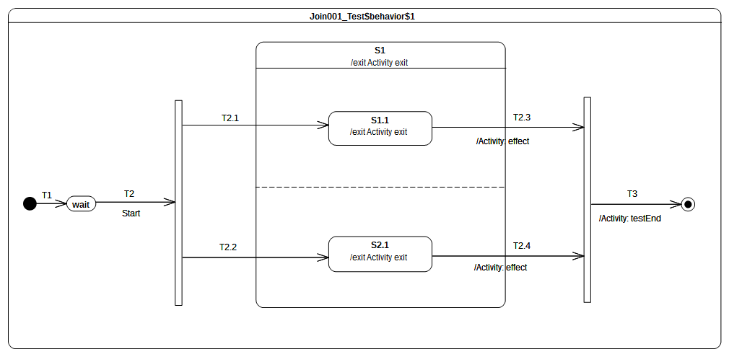Figure 9.68 - Join 001 Test Classifier Behavior

Test execution
Received event occurrence(s)
- Start – received when in configuration wait.
Generated trace
- S1.1(exit)::T2.3(effect)::S2.1(exit)::S1(exit)::T2.4(effect)
Note. The purpose of this test is to demonstrate that the Join pseudo state can only be traversed when all incoming transitions have been traversed. Lets consider the situation where the state machine is currently in configuration S1[S1.1, S2.1]. Two completion events (one for S1.1 and the other one for S2.1) are available in the pool. When the completion event generated by S1.1 is dispatched and accepted, it triggers T2.3. Next, S1.1 is exited, the effect behavior of T2.3 is executed but S1 is not exited and the join pseudostate is not traversed. The next step consists in accepting the S2.1 completion event. This means that T2.4 is triggered, so that S2.1 is exited and T2.4 is executed. In addition, S1 is exited and the join pseudo state is traversed. The continuation transition T3 is traversed. When the final state is reached, the state machine execution completes.
RTC Steps
Step | Event pool | State machine configuration | Fired transition(s)
1 | [] | [] - Initial RTC step | [T1]
2 | [Start, CE(wait)] | [wait] | []
3 | [Start] | [wait] | [T2(T2.1, T2.2)]
4 | [CE(S2.1), CE(S1.1)] | [S1[S1.1, S2.1]] | [T2.3]
5 | [CE(S2.1)] | [S1[S2.1]] | [T2.4(T3)]
Alternative execution traces
The presence of fork pseudo state and the orthogonal regions in S1.1 implies that an alternative execution trace possible for that test case. This trace is:
- S1.2(exit)::T2.4(effect)::S1.1(exit)::S1(exit)::T2.4(effect)
The trace shows that T2.4 is fired before T2.3. The RTC steps leading to the production of that trace are described in the table below.

Step | Event pool | State machine configuration | Fired transition(s)
1 | [] | [] - Initial RTC step | [T1]
2 | [Start, CE(wait)] | [wait] | []
3 | [Start] | [wait] | [T2(T2.2, T2.1)]
4 | [CE(S1.1), CE(S2.1)] | [S1[S1.1, S2.1]] | [T2.4]
5 | [CE(S1.1)] | [S1[S1.1]] | [T2..3(T3)]

Join 002

Tested state machine
The state machine that is executed for this test is presented in Figure 9.69.

Test execution
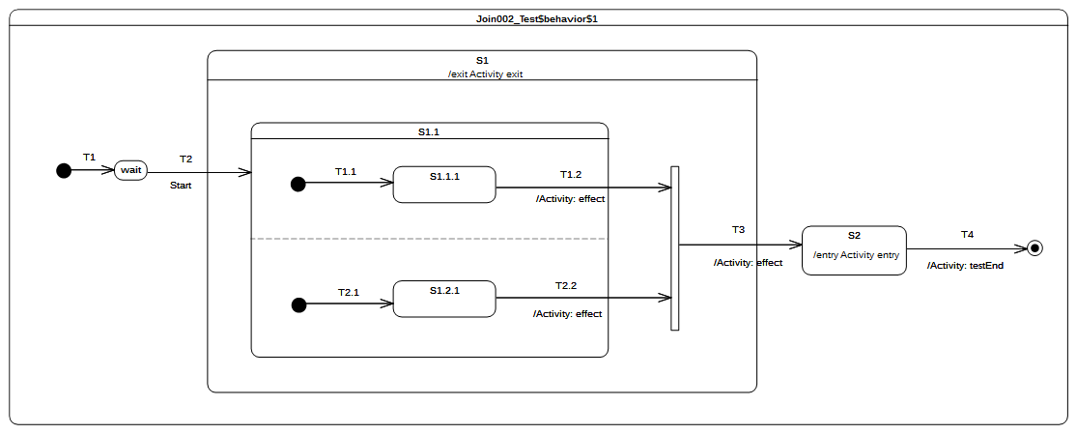Figure 9.69 - Join 002 Test Classifier behavior
Received event occurrence(s)
- Start – received when in configuration wait.
Generated trace
- T2.2(effect)::T1.2(effect)::S1(exit)::T3(effect)::S2(entry)
Note. The purpose of this test is to consolidate Join semantics and demonstrate that, if used in a nested context, the exit rule of a composite state is still preserved. Consider the situation where the state machine is in configuration S1[S1.1[S1.1.1]]. The completion event generated by S1.1.1 is dispatched and accepted. Next, T1.2 is traversed, its effect behavior is executed, S1.1 is exited, and the join pseudostate is reached. All incoming transitions have been fired so the join pseudostate can be traversed. When continuation transition T3 is traversed, S1 is exited, the effect behavior of the transition is executed, and, finally, S2 is entered.
RTC Steps
Step | Event pool | State machine configuration | Fired transition(s)
1 | [] | [] - Initial RTC step | [T1]
2 | [Start, CE(wait)] | [wait] | []
3 | [Start] | [wait] | [T2(T1.1, T2.1)]
4 | [CE(S1.2.1), CE(S1.1.1)] | [S1[S1.1[S1.1.1, S1.2.1]]] | [T1.2]
5 | [CE(S1.2.1)] | [S1[S1.1[S1.2.1]]] | [T2.2(T3)]
6 | [CE(S2)] | [S2] | [T4]

Alternative execution traces
The presence of orthogonal regions in S1.1 implies that an alternative execution trace possible for that test case. This trace is:
- T1.2(effect)::T2.2(effect)::S1(exit)::T3(effect)::S2(entry)
The trace shows the situation where T1.2 is fired after T2.2. The RTC steps leading to the production of that trace are described in the table below.
Step | Event pool | State machine configuration | Fired transition(s)
1 | [] | [] - Initial RTC step | [T1]
2 | [Start, CE(wait)] | [wait] | []
3 | [Start] | [wait] | [T2(T2.1, T1.1)]
4 | [CE(S1.1.1), CE(S1.2.1)] | [S1[S1.1[S.1.1.1, S1.2.1]]] | [T2.2]
5 | [CE(S1.1.1)] | [S1[S1.1[S1.1.1]]] | [T1.2(T3)]
6 | [CE(S2)] | [S2] | [T4]

Join 003
Static Analysis 001 (PSSM proposal)
To move from the current state machine configuration to the next state machine configuration it must exist a valid path between these two configurations. A valid path is materialized by a transition (possibly compound) that when fired ensure we reach the new state machine configuration. Such transition are evaluated statically (i.e., before the RTC step) in order to determine if guard(s) placed on that transition evaluate to true.

Tested state machine
The state machine that is executed for this test is presented in Figure .

Test execution
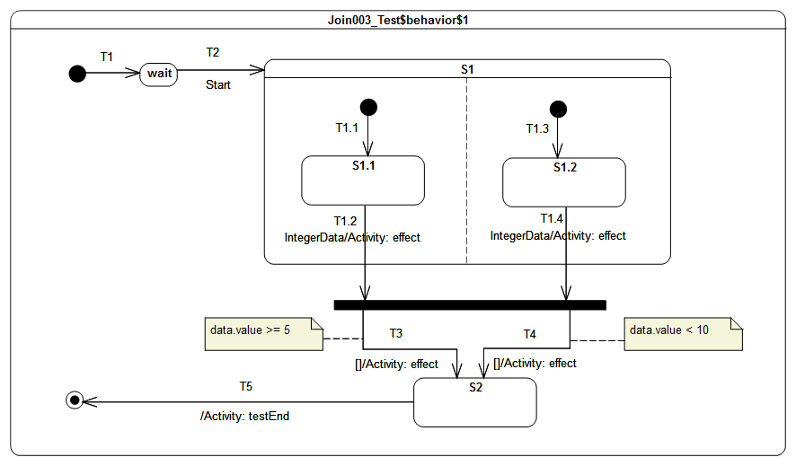Figure 9.70: Join 003 - Test Classifier Behavior Specification
Received event occurrence(s)
- Start – received when in configuration wait.
- IntegerData(8) – received when in configuration S1.1.
Generated trace
- T1.2(effect)[in=8]::T1.4(effect)[in=8]::T3(effect)[in=8]
Note. The test is focused on the application of the static analysis when a join pseudo state is encountered on a compound transition. Nevertheless it also shows triggering of multiple transitions located in different regions (see T1.2 and T1.4) using the same event occurrence and the conflict resolution (see T3 and T4). In that test case, when Start event occurrence is about to be dispatched, the static analysis discover two possible compound transitions ([T1.2, T1.4(T4)] and [T1.2, T4(T3)]) leading to the same state machine configuration. During the RTC step initiated by Start event occurrence one of them is traversed to reach this state machine configuration. One can notice the conflict exiting between T3 and T4. This conflict is resolved by a semantic strategy that choose the first transition available in the set of fireable transitions. For that test case, T3 is always chosen. The last RTC step is realized when the completion event for S2 is dispatched.
RTC Steps

Step | Event pool | State machine configuration | Fired transition(s)
1 | [] | [] - Initial RTC step | [T1]
2 | [Start, CE(wait)] | [wait] | []
3 | [Start] | [wait] | [T2(T1.1, T1.3)]
4 | [IntegerData(8), CE(S1.2), CE(S1.1)] | [S1[S1.1, S1.2]] | []
5 | [IntegerData(8), CE(S1.2)] | [S1[S1.1, S1.2]] | []
6 | [IntegerData(8)] | [S1[S1.1, S1.2]] | [T1.2, T1.4(T3)]
7 | [CE(S2)] | [S2] | [T5]
Alternative execution traces
The orthogonal regions existing in S1 implies the existence of an alternative execution trace. This trace is:
- T1.4(effect)[in=8]::T1.2(effect)[in=8]::T3(effect)[in=8]
The trace shows the situation where T1.4 is fired before T1.2. The RTC steps leading to the production of this trace are described in the table below.

Step | Event pool | State machine configuration | Fired transition(s)
1 | [] | [] - Initial RTC step | [T1]
2 | [Start, CE(wait)] | [wait] | []
3 | [Start] | [wait] | [T2(T1.3, T1.1)]
4 | [IntegerData(8), CE(S1.1), CE(S1.2)] | [S1[S1.1, S1.2]] | []
5 | [IntegerData(8), CE(S1.1)] | [S1[S1.1, S1.2]] | []
6 | [IntegerData(8)] | [S1[S1.1, S1.2]] | [T1.4, T1.2(T3)]
7 | [CE(S2)] | [S2] | [T5]

Terminate

Overview
Test cases presented in this sub-clause assesses that Terminate semantics conforms to what is specified in UML.

Terminate 001
Terminate 001 ([UML], 14.2.3.7)
Entering a terminate Pseudostate implies that the execution of the StateMachine is terminated immediately. The StateMachine does not exit any States nor does it perform any exit Behaviors.

Tested state machine
The state machine that is executed for this test is presented in Figure 9.71.
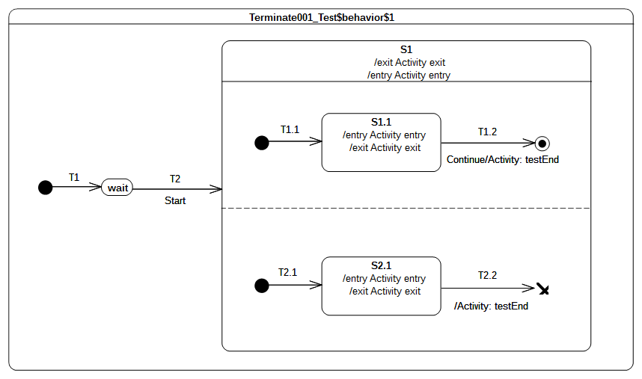Figure 9.71 - Terminate 001 Test Classifier behavior

Test execution
Received event occurrence(s)
- Start – received when in configuration wait.
Generated trace
- S1(entry)::S1.1(entry)::S2.1(entry)::S2.1(exit)
Note. The purpose of this test is to demonstrate support for terminate semantics. Consider the situation where the state machine is in configuration S1[S1.1, S2.1]. Two completion events are in the event pool, one of for S2.1 and the other one for S1.1. When the S2.1 completion event is accepted, it triggers T2.2. The traversal of this transition leads the state machine to reach the terminate pseudostate. To be conformant with UML, no state can be exited when the terminate pseudo-state is entered since the state machine terminates its execution. This behavior can be observed in the generated trace. Indeed neither S1.1 nor S1 have executed their exit behaviors after the execution of the terminate pseudostate.
RTC Steps
Step | Event pool | State machine configuration | Fired transition(s)
1 | [] | [] - Initial RTC step | [T1]
2 | [Start, CE(wait)] | [wait] | []
3 | [Start] | [wait] | [T2(T1.1, T2.1)]
4 | [CE(S2.1), CE(S1.1)] | [S1[S1.1, S2.1]] | []
5 | [CE(2.1)] | [S1[S1.1, S2.1]] | [T2.2]
Alternative execution traces
The orthogonal regions existing in S1 implies the existence of an alternative execution trace. This trace is:
- S1(entry)::S2.1(entry)::S1.1(entry)::S2.1(exit)
The trace shows the situation where S2.1 is entered before S1.1. Such execution implies that S1.1 completion event will never be dispatched because the S2.1 completion event triggers T2.2 which implies the termination of the state machine. The RTC steps leading to the production of this trace are described in the table below.

Step | Event pool | State machine configuration | Fired transition(s)
1 | [] | [] - Initial RTC step | [T1]
2 | [Start, CE(wait)] | [wait] | []
3 | [Start] | [wait] | [T2(T2.1, T1.1)]
4 | [CE(S1.1), CE(S2.1)] | [S1[S1.1, S2.1]] | T2.2

Terminate 002
Terminate 002 ([UML], 14.2.3.7)
Any executing doActivity Behaviors are automatically aborted. Entering a terminate Pseudostate is equivalent to invoking a DestroyObjectAction.

Tested state machine
The state machine that is executed for this test is presented in Figure 9.72.
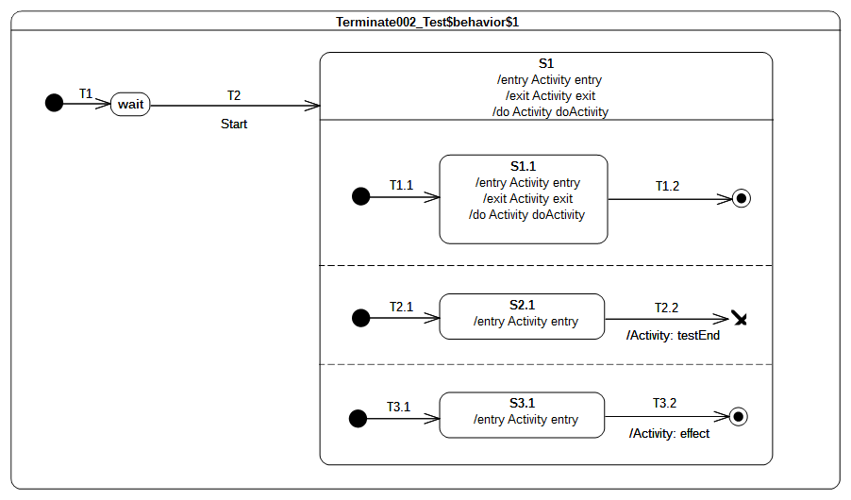Figure 9.72 - Terminate 002 Test Classifier Behavior
The behavior specified for the doActivity placed on S1.1 is presented in table 9.3. It contributes to the trace by producing the fragment “S1.1doActivityPartI” and wait for a Continue event occurrence. This occurrence is never available during the test therefore the doActivity remains suspended until it is aborted.
activity doActivity() {
this.trace("S1.1(doActivityPartI)");
accept(Continue);
this.trace("S1.1(doActivityPartII)");
}
Table 9.3: S1.1 doActivity Behavior

Test execution
Received event occurrence(s)
- Start – received when in configuration wait.
Generated trace
- S1(entry)::S1.1(entry)::S2.1(entry)::S3.1(entry)
Notes
- The purpose of this test is to demonstrate that running doActivity behaviors are aborted if a terminate pseudostate is reached. At the end of the RTC step initiated by the acceptance of the Start event occurrence, the state machine is in configuration S1[S1.1, S2.1, S3.1]. The doActivity behaviors of S1 and S1.1 have been invoked (which does not mean that they have already started) and two completion events are waiting in the pool: one for S2.1 and the other one for S3.1. Assuming that the completion event generated by S2.1 is accepted first, T2.2 fires and the state machine execution is terminated. In addition, the doActivity behaviors of S1 and S1.1 are aborted and no exit behavior is executed.

RTC Steps
Step | Event pool | State machine configuration | Fired transition(s)
1 | [] | [] - Initial RTC step | [T1]
2 | [Start, CE(wait)] | [wait] | []
3 | [Start] | [wait] | [T2(T1.1, T2.1, T3.1)]
4 | [CE(S3.1), CE(S2.1)] | [S1[S1.1, S2.1, S3.1]] | [T22]
Alternative execution traces
The three orthogonal regions of S1 and the doActivity behaviors specified on S1 and S1.1 imply the existence of alternative execution traces. These traces are listed below.
- S1(entry)::S1.1(entry)::S2.1(entry)::S3.1(entry)
- S1(entry)::S1.1(entry)::S3.1(entry)::S2.1(entry)
- S1(entry)::S2.1(entry)::S1.1(entry)::S3.1(entry)
- S1(entry)::S2.1(entry)::S3.1(entry)::S1.1(entry)
- S1(entry)::S3.1(entry)::S1.1(entry)::S2.1(entry)
- S1(entry)::S3.1(entry)::S2.1(entry)::S1.1(entry)
- S1(entry)::S1.1(entry)::S2.1(entry)::S3.1(entry)::S1.1(doActivityPartI)
- S1(entry)::S1.1(entry)::S2.1(entry)::S1.1(doActivityPartI)::S3.1(entry)
- S1(entry)::S1.1(entry)::S3.1(entry)::S2.1(entry)::S1.1(doActivityPartI)
- S1(entry)::S1.1(entry)::S3.1(entry)::S1.1(doActivityPartI)::S2.1(entry)
- S1(entry)::S1.1(entry)::S1.1(doActivityPartI)::S2.1(entry)::S3.1(entry)
- S1(entry)::S1.1(entry)::S1.1(doActivityPartI)::S3.1(entry)::S2.1(entry)
- S1(entry)::S2.1(entry)::S1.1(entry)::S1.1(doActivityPartI)::S3.1(entry)
- S1(entry)::S2.1(entry)::S1.1(entry)::S3.1(entry)::S1.1(doActivityPartI)
- S1(entry)::S2.1(entry)::S3.1(entry)::S1.1(entry)::S1.1(doActivityPartI)
- S1(entry)::S3.1(entry)::S1.1(entry)::S2.1(entry)::S1.1(doActivityPartI)
- S1(entry)::S3.1(entry)::S1.1(entry)::S1.1(doActivityPartI)::S2.1(entry)
- S1(entry)::S3.1(entry)::S2.1(entry)::S1.1(entry)::S1.1(doActivityPartI)
Let consider the trace 17. It shows the situation where the first part of the S1.1 doActivity behavior gets executed before S2.1 is actually entered. This trace is correct since S1.1 doActivity evolves on its own thread of execution an its execution occurs after the entrance of state S1.1. RTC steps leading to the production of this trace are described below.
Step | Event pool | State machine configuration | Fired transition(s)
1 | [] | [] - Initial RTC step | [T1]
2 | [Start, CE(wait)] | [wait] | []
3 | [Start] | [wait] | [T2(T3.1, T1.1, T2.1)]
4 | [CE(S2.1), CE(S3.1)] | [S1[S1.1, S2.1, S3.1]] | [T3.2]
5 | [CE(S2.1)] | [S1[S1.1, S2.1]] | [T2.2]
Here the S1.1 doActivity contributes to the trace during step 3. The doActivity behavior gets aborted at step 5 when the completion event for S2.1 triggers T2.2 which allows the terminate pseudo state to be reached.

Terminate 003

Tested state machine
The state machine that is executed for this test is presented in Figure 9.73.
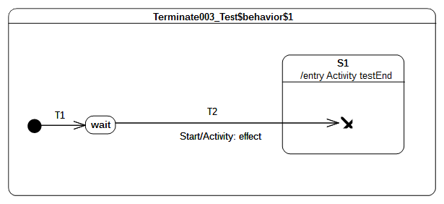Figure 9.73 - Terminate 003 Test Classifier Behavior

Test execution
Received event occurrence(s)
- Start – received when in configuration wait.
Generated trace
- T2(effect)
Note. The purpose of this test is to ensure that, when a terminate pseudostate is used in a nested context, the composite state entry rule is preserved. When the Start event occurrence is dispatched and accepted by the state machine, T2 is triggered. Next, wait is exited, the effect behavior of the transition is executed, S1 is entered, and, finally, the terminate pseudostate is reached. The execution of this pseudostate implies the termination of the state machine. Note that if the entry behavior of S1 was not executed, then the semantic test would not have been notified of the termination of the test target. Hence the test would not have been considered as passed.
RTC Steps
Step | Event pool | State machine configuration | Fired transition(s)
1 | [] | [] - Initial RTC step | [T1]
2 | [Start, CE(wait)] | [wait] | []
3 | [Start] | [wait] | [T2]

Final

Overview
Test cases presented in this sub-clause assesses that final state semantics conforms to what is specified in UML.

Final 001
Final 001
FinalState is a special kind of State signifying that the enclosing Region has completed. Thus, a Transition to a FinalState represents the completion of the behaviors of the Region containing the FinalState.

Tested state machine
The state machine that is executed for this test is presented in Figure 9.74.
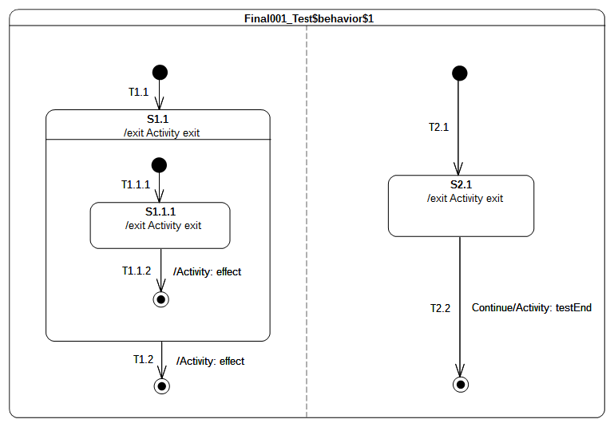Figure 9.74 - Final 001 Test Classifier Behavior

Test execution
Received event occurrence(s)
- Start – received when in configuration wait.
- Continue – received when in configuration [S1[S1.1.1], S2.1].
Generated trace
- S1.1.1(exit)::T1.1.2(effect)::S1.1(exit)::T1.2(effect)::S2.1(exit)
Note. The purpose of this test is to demonstrate support for the Final state, both at the state machine and composite state levels. When the state machine starts its execution, both regions starts their executions concurrently. The initial RTC step ends up with the following configuration: [S1.1[S1.1.1], S2.1]. At this point, there are two completion events placed in the pool. The completion events were generated when S2.1 and S1.1.1 were entered. Assuming that the S2.1 completion event is at the head of the event pool, it is dispatched first. However, it does not initiate an RTC step. Since S2.1 has no completion transition the completion event is lost. The next RTC step consists of dispatching and accepting the S1.1.1 completion event. It triggers traversal of T1.1.2 and leads the state machine to reach the final state located in the S1.1 region. This region completes and a completion event is generated for S1.1. This completion event is dispatched and accepted in the next RTC step. It triggers T1.2 so that the final state is reached, and the left-hand region of the state machine completes. When the Continue event occurrence is dispatched and accepted, T2.2 is triggered. The state machine execution completes when the target final state is reached.
RTC Steps
Step | Event pool | State machine configuration | Fired transition(s)
1 | [] | [] - Initial RTC step | [T1]
2 | [Start, CE(wait)] | [wait] | []
3 | [Start] | [wait] | [T1.1(T1.1.1), T2.1]
4 | [Continue, CE(S2.1), CE(S1.1.1)] | [S1.1[S1.1.1], S2.1] | [T1.1.2]
5 | [Continue, CE(S1.1), CE(S2.1)] | [S1.1, S2.1] | []
6 | [Continue, CE(S1.1)] | [S1.1, S2.1] | [T1.2]
7 | [Continue] | [S2.1] | [T2.2]

Deferred

Overview
Test cases presented in this sub-clause assesses that deferred event semantics conform to what is specified in UML.

Deferred 001
Deferred 001 ([UML], 14.2.3.4.4)
A State may specify a set of Event types that may be deferred in that State. This means that Event occurrences of those types will not be dispatched as long as that State remains active. Instead, these Event occurrences remain in the event pool until a state configuration is reached where these Event types are no longer deferred.

Tested state machine
The state machine that is executed for this test is presented in Figure 9.75.
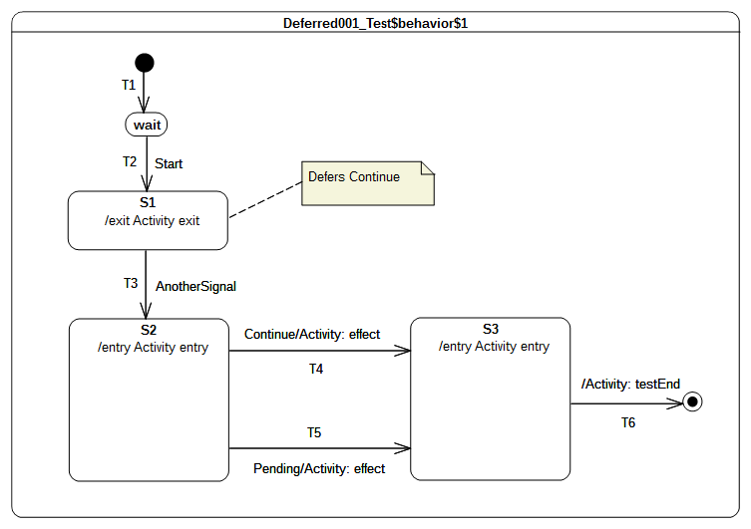Figure 9.75 - Deferred 001 Test Classifier Behavior

Test execution
Received event occurrence(s)
- Start – received when in configuration wait.
- Continue – received when in configuration S1.
- AnotherSignal – received when in configuration S1.
- Pending – received when in configuration S2.
Generated trace
- S1(exit)::S2(entry)::T4(effect)::S3(entry)
Note. The purpose of this test is to demonstrate support for event deferral in the context of simple states. Consider the situation where the state machine is in configuration S1. S1 has no completion transitions, hence its completion event is lost when it is dispatched. The Continue event occurrence is dispatched and can be accepted since it is indicated as being deferred in configuration S1. The acceptance of the event occurrence does not change the state machine configuration. The next RTC step consists of dispatching and accepting AnotherSignal. This leads to the triggering of T3. S1 is exited, which means that the Continue event occurrence is no longer deferred so that S2 is entered. At this point, three event occurrences are available in the pool. The one at the head of the pool is the completion event for S2, the second is the Continue event occurrence, and the last is the Pending event occurrence. The dispatching of the completion event does not trigger a new RTC step since S2 has no completion transition. The next event to be dispatched (i.e., the one that was originally deferred) matches the trigger declared in T4. Hence T4 is taken, its effect behavior is executed, and S3 is entered. As the completion event generated by S3 has priority over the Pending event occurrence, it is dispatched first. The S3 completion transition is traversed and the state machine execution completes when the final state is reached. Note that in this execution the Pending event occurrence is never dispatched. However, if the Continue event occurrence was actually not deferred, a different execution path would have occurred. That is, T5 would have been taken instead of T4.
RTC Steps
Step | Event pool | State machine configuration | Fired transition(s)
1 | [] | [] - Initial RTC step | [T1]
2 | [Start, CE(wait)] | [wait] | []
3 | [Start] | [wait] | [T2]
4 | [AnotherSignal, Continue, CE(S1)] | [S1] | []
5 | [AnotherSignal, Continue] | [S1] | []
6 | [AnotherSignal] | [S1] | [T3]
7 | [Pending, Continue] | [S2] | [T4]
8 | [Pending, CE(S3)] | [S3] | [T6]

Deferred 002
Deferred 002 ([UML], 14.2.3.4.4)
If a deferred Event type is used explicitly in a Trigger of a Transition whose source is the deferring State (i.e., a kind of override option).

Tested state machine
The state machine that is executed for this test is presented in Figure 9.76.
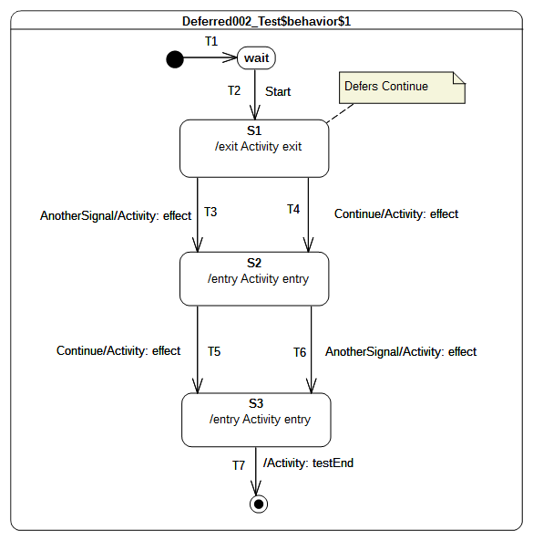Figure 9.76 - Deferred 002 Test Classifier Behavior

Test execution
Received event occurrence(s)
- Start – received when in configuration wait.
- Continue – received when in configuration S1.
- AnotherSignal – received when in configuration S1.
- Continue – received when in configuration S2.
Generated trace
- S1(exit)::T4(effect)::S2(entry)::T6(effect)::S3(entry)
Note. The purpose of this test is to demonstrate that, in a specific situation, an event that is declared as being deferred is not actually deferred. Consider the situation where the state machine is in configuration S1 and the completion event of S1 was dispatched but did not trigger any RTC step. The event pool contains, at this time, two event occurrences. The first one is a Continue event occurrence and the second is an AnotherSignal event occurrence. When the Continue event occurrence is accepted, it is not deferred. Indeed a transition originating from the deferring state has a trigger which explicitly refers to the Continue event type. This overrides the deferring constraint and transition T4 is triggered. Next, S1 is exited, the effect behavior of the transition is executed, and S2 is entered. The completion event generated by S2 will not trigger an RTC step since this state has no completion transition. The next RTC step consists of dispatching and accepting the AnotherSignal event occurrence. This means that T6 is triggered, so that S2 is exited, the effect behavior is executed, and S3 is entered. The completion event of S3 is used to initiate the next RTC step, which leads the state machine to reach the final state and to completing its execution.
RTC Steps
Step | Event pool | State machine configuration | Fired transition(s)
1 | [] | [] - Initial RTC step | [T1]
2 | [Start, CE(wait)] | [wait] | []
3 | [Start] | [wait] | [T2]
4 | [AnotherSignal, Continue, CE(S1)] | [S1] | []
5 | [AnotherSignal, Continue] | [S1] | [T4]
6 | [Continue, AnotherSignal, CE(S2)] | [S2] | []
7 | [Continue, AnotherSignal] | [S2] | [T6]
8 | [Continue, CE(S3)] | [S3] | [T7]

Deferred 003
Deferred 003 ([UML], 14.2.3.4.4)
An Event may be deferred by a composite State or submachine States, in which case it remains deferred as long as the composite State remains in the active configuration.

Tested state machine
The state machine that is executed for this test is presented in Figure 9.77.
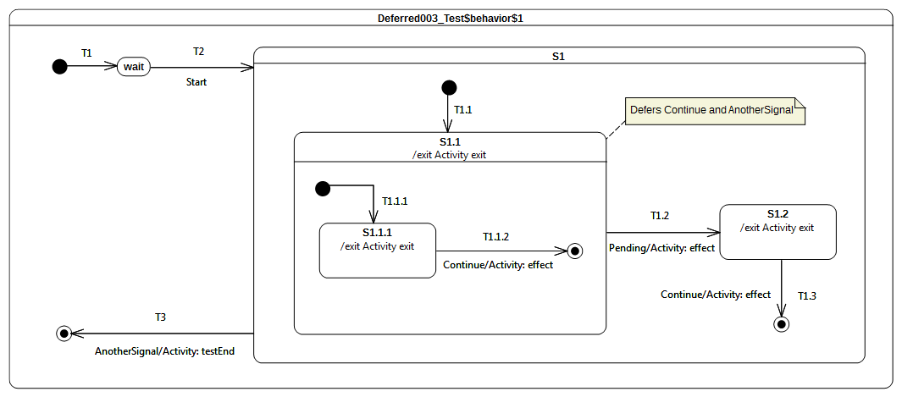Figure 9.77 - Deferred 003 Test Classifier Behavior

Test execution
Received event occurrence(s)
- Start – received when in configuration wait.
- Continue – received when in configuration S1[S1.1[S1.1.1]].
- Continue – received when in configuration S1[S1.1].
- AnotherSignal – received when in configuration S1[S1.1].
- Pending – received when in configuration S1[S1.1].
Generated trace
- S1.1.1(exit)::T1.1.2(effect)::S1.1(exit)::T1.2(effect)::S1.2(exit)::T1.3(effect)
Note. The purpose of this test is to demonstrate the support for deferred event semantics when the deferred event type is declared by a composite state. Consider the situation where the state machine is in the configuration S1[S1.1[S1.1.1]]. There are, at this time, two events occurrence ready to be dispatched: the first is a completion event for state S1.1.1 and the second is a Continue event occurrence. The completion event is lost since S1.1.1 has no completion transition. Next, the Continue event occurrence is dispatched and accepted. Transition T1.1.2 is triggered by this event occurrence. This transition has priority over the deferring constraint added by S1.1 since it is more deeply nested in the state hierarchy. Therefore, T1.1.2 is triggered and S1.1.1 leaves the state machine configuration so that S1.1 region completes. The completion event generated by S1.1 cannot be used to trigger any transition so that it is lost. The next RTC step consists of dispatching a new Continue event occurrence. This event occurrence is accepted and deferred due to the constraint required by S1.1. The next event occurrence to be dispatched and accepted is of type AnotherSignal. S1.1 also defers this type of event occurrences. Since the state machine configuration did not change, the event occurrence is deferred. To summarize, at this point of the execution two events occurrences are deferred: one Continue event occurrence and one AnotherSignal event occurrence. The next RTC step is initiated by the acceptance of the Pending event occurrence. As T1.2 can be triggered using this event occurrence, state S1.1 is exited (the deferred events are released), the effect behavior of the transition is executed and S1.2 is entered. The S1.2 completion event does not trigger an RTC step since it has no completion transitions. The Continue event occurrence that was originally deferred is used to trigger T1.3, which leads the S1 region to complete. The S1 completion event is lost, however. The final RTC step is initiated by the dispatching of the AnotherSignal event occurrence. It triggers T3, which enables the state machine to reach the final state and to complete its execution.
RTC Steps
Step | Event pool | State machine configuration | Fired transition(s)
1 | [] | [] - Initial RTC step | [T1]
2 | [Start, CE(wait)] | [wait] | []
3 | [Start] | [wait] | [T2(T1.1, T1.1.1)]
4 | [Continue, CE(S1.1.1)] | [S1[S1.1[S1.1.1]]] | []
5 | [Continue] | [S1[S1.1]] | [T1.1.2]
6 | [Pending, AnotherSignal, Continue, CE(S1.1)] | [S1[S1.1]] | []
7 | [Pending, AnotherSignal, Continue] | [S1[S1.1]] | []
8 | [Pending, AnotherSignal] | [S1[S1.1]] | []
9 | [Pending] | [S1[S1.1]] | [T1.2]
10 | [AnotherSignal, Continue, CE(S1.2)] | [S1.2] | []
11 | [AnotherSignal, Continue] | [S1.2] | [T1.3]
12 | [AnotherSignal, CE(S1)] | [S1] | []
13 | [AnotherSignal] | [S1] | [T3]

Deferred 004 – A

Tested state machine
The state machine that is executed for this test is presented in Figure 9.78.
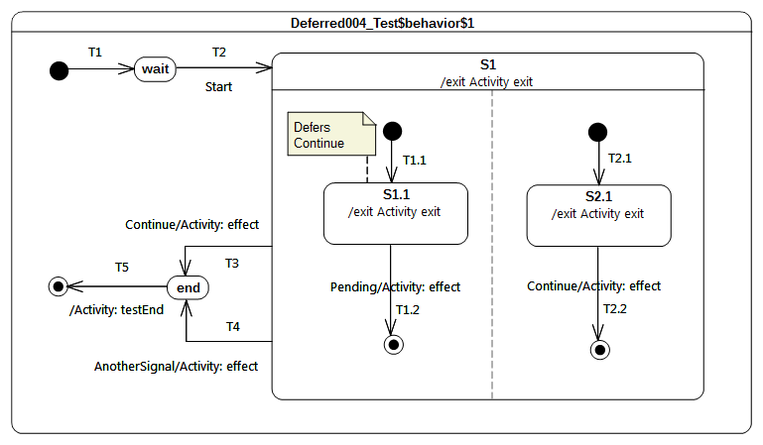Figure 9.78 - Deferred 004 - A Test Classifier Behavior

Test execution
Received event occurrence(s)
- Start – received when in configuration wait.
- Continue – received when in configuration S1[S1.1, S2.1].
- Pending – received when in configuration S1[S1.1, 2.1].
- AnotherSignal – received when in configuration S1.
Generated trace
- S1.1(exit)::T1.2(effect)::S2.1(exit)::T2.2(effect)::S1(exit)::T4(effect)
Note. The purpose of this test is to assess deferred events semantics when used in the context of orthogonal regions. Consider the situation where the state machine is in configuration S1[S1.1, S2.1]. After dispatching of completion events for S1.1 and S2.1, there remains one event occurrence in the pool that is ready to be dispatched: a Continue event occurrence. When the Continue event occurrence is dispatched and accepted by the state machine, it is deferred by S1.1. The current state machine configuration remains S1[S1.1, S2.1]. The next RTC step is initiated by the acceptance of the Pending event occurrence. This starts by triggering T1.2. As S1.1 leaves the state machine configuration, the Continue event occurrence is now available in the pool. The left-hand region completes. T2.2 is triggered by the RTC step initiated by the dispatching of the Continue event occurrence. This leads S1 to generate a completion event. The completion event is lost since S1 has no outgoing completion transition. S1 is exited when AnotherSignal event is dispatched.
Submission Note. [UML] 14.2.3.4.4 states that “if a deferred Event type is used explicitly in a Trigger of a Transition whose source is the deferring State (i.e., a kind of override option)”. In the situation presented in the test case, S1.1 has no outgoing transitions with a trigger using the Continue event type. Consequently, the S1.1 deferring constraint is not overridden. Nevertheless, it also reasonable to think that the outgoing transition of S2.1 (i.e., T2.2) should have overridden S1.1 constraint. Hence in an alternative execution S2.1 is exited first and T2.2 is traversed. The generated execution trace would have been: S2.1(exit)::T2.2(effect)::S1.1(exit)::T1.2(effect)::S1(exit)::T4(effect). This part of the state machine semantics is still under discussion.
RTC Steps
Step | Event pool | State machine configuration | Fired transition(s)
1 | [] | [] - Initial RTC step | [T1]
2 | [Start, CE(wait)] | [wait] | []
3 | [Start] | [wait] | [T2(T1.1, T2.1)]
4 | [Pending, Continue, CE(S2.1), CE(S1.1)] | [S1[S1.1, S2.1]] | []
5 | [Pending, Continue, CE(S2.1)] | [S1[S1.1, S2.1]] | []
6 | [Pending, Continue] | [S1[S1.1, S2.1]] | []
7 | [Pending] | [S1[S1.1, S2.1]] | [T1.2]
8 | [Continue] | [S1[S2.1]] | [T2.2]
9 | [AnotherSignal, CE(S1)] | [S1] | []
10 | [AnotherSignal] | [S1] | [T4]
11 | [CE(end)] | [end] | [T5]

Deferred 004 – B

Tested state machine
The state machine that is executed for this test is presented in Figure 9.79.
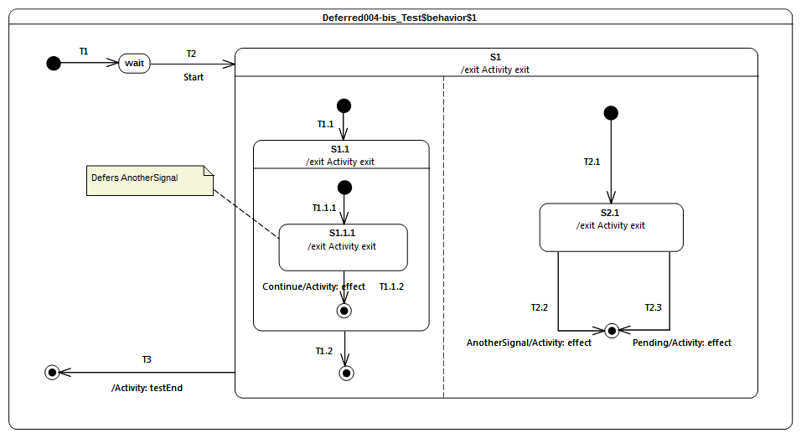Figure 9.79 - Deferred 004 - B Classifier behavior

Test execution
Received event occurrence(s)
- Start – received when in configuration wait.
- AnotherSignal – received when in configuration S1[S1.1[S1.1.1], S2.1].
- Continue – received when in configuration S1[S1.1[S1.1.1], S2.1].
- Pending – received when in configuration S1.
Generated trace
- S1.1.1(exit)::T1.1.2(effect)::S1.1(exit)::S2.1(exit)::T2.2(effect)::S1(exit)
Note. The purpose of this test is is to assess deferred events semantics when used in the context of orthogonal regions. Consider the situation where the state machine is in configuration S1[S1.1[S1.1.1], S2.1]. After dispatching of completion events for S1.1.1 and S2.1, there remain two event occurrences in the pool: an AnotherSignal event occurrence and a Continue event occurrence. When accepted, the AnotherSignal event occurrence is deferred by S1.1.1. The next RTC step is initiated by the acceptance of the Continue event occurrence. T1.1.2 is triggered, which means that S1.1.1 leaves the state machine configuration, so that the event occurrence that was previously deferred becomes available. The unique region of S1.1 completes, and a completion event is generated for S1.1. In the next RTC step, this completion event is dispatched and accepted. This means that T1.2 is triggered, which leads to the completion of the left region of S1. At this point, one event occurrence (i.e., AnotherSignal) remains in the pool. When dispatched, it triggers T2.2 which forces and exit of S2.1, and the final state is reached leading to the completion of the S1 region.
Submission Note. Here again the semantics can be different regarding the interpretation of the overriding transition rule. Indeed, if we consider that when the AnotherSignal event occurrence is dispatched, the event will not be deferred because T2.2 in the right region can fire. In that case the execution trace would be different.
RTC Steps
Step | Event pool | State machine configuration | Fired transition(s)
1 | [] | [] - Initial RTC step | [T1]
2 | [Start, CE(wait)] | [wait] | []
3 | [Start] | [wait] | [T2(T1.1(T1.1.1), T2.1)]
4 | [Continue, AnotherSignal, CE(S1.1.1)] | [S1[S1.1[S1.1.1], S2.1]] | []
5 | [Continue, AnotherSignal] | [S1[S1.1[S1.1.1], S2.1]] | []
6 | [Continue] | [S1[S1.1[S1.1.1], S2.1]] | [T1.1.2]
7 | [AnotherSignal, CE(S1.1)] | [S1[S1.1, S2.1]] | [T1.2]
8 | [AnotherSignal] | [S1[2.1]] | [T2.2]
9 | [Pending, CE(S1)] | [S1] | [T3]

Standalone

Overview
This subclause includes tests related the execution of a standalone state machines, that is, state machines that are themselves active behaviors, as opposed to being the classifier behaviors of other classes.

Standalone 001

Tested state machine
The state machine that is executed for this test is presented in Figure 9.80. Given that a UML state machine is a kind of UML Class, it is legal for this state machine to specialize the Target abstract class (see section 9.2.2.2.2). Hence the state machine itself is the test target, which means that it is able to receive any signals that a Target can receive. Note that the standalone state machine is active (as is required by fUML in order for it to specialize an active class), but it does not have a classifier behavior, meaning that, dynamically, it acts as the context for its own execution.
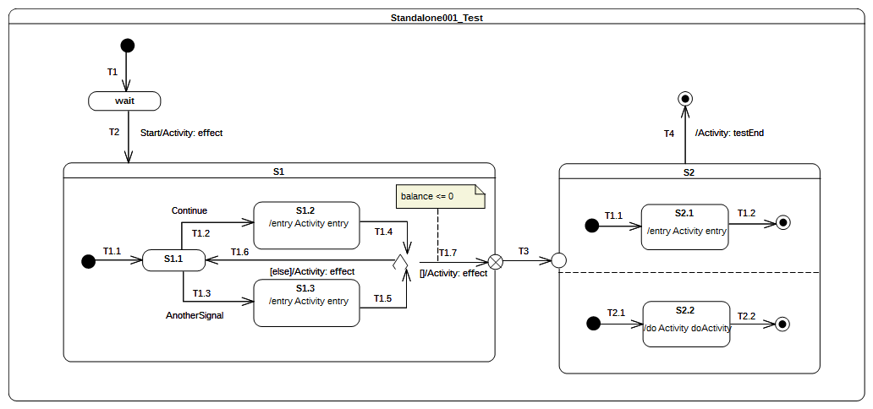
Figure 9.80 - Standalone 001 Test

Test execution
Received event occurrence(s)
- Start – received when in configuration wait.
- Continue – received when in configuration S1[S1.1].
- Continue – received when in configuration S1[S1.1].
Generated trace
- T2(effect)::S1.2(entry)::T1.6(effect)::S1.2(entry)::T1.7(effect)::S2.1(entry)::S2.2(doActivity)
Note. The Start event occurrence is dispatched and accepted while the state machine is in configuration wait. Hence, T2 is triggered (see message T2(effect) in the trace) and S1 is entered using the default entry approach. The S1 region starts executing from the initial pseudo state, T1.1 is traversed, and S1.1 is entered. The next RTC step is initiated by the acceptance of the Continue event occurrence, which triggers T1.2 and whose tarversal leads to S1.2 being entered. The execution of the S1.2 entry behavior updates a property balance owned by the state machine. When this behavior has terminated its execution, a completion event is generated for S1.2. The completion event is used to trigger T1.4. The state machine reaches the choice point and evaluates the guard of T1.7 . The balance (initial value 150) is not lower than or equal to 0, hence the else transition T1.6 is taken, and a completion event is generated upon S1.1 entry. A second Continue event occurrence is dispatched and accepted, and the state machine returns to S1.2 generating a completion event for that state. This time, when T1.4 is triggered, the choice point is reached and the T1.7 guard is true, so it can be traversed. When the exit point is reached, S1 is exited. The continuation transition T3 is then traversed, and S2 is entered through the entry point. Conseqeuntly, both orthogonal regions are entered using the default entry approach. S2.1 generates a completion event when this entry behavior terminated its execution, and S2.2 generates a completion event when its doActivity has completed. Completion events generated by these states are used to trigger T1.2 and T2.2. When both completion events have been dispatched and accepted, S2 can complete. The completion event will be used to trigger T4 and the final state is reached, which will complete the state machine execution.
RTC Steps
Step | Event pool | State machine configuration | Fired transition(s)
1 | [] | [] - Initial RTC step | [T1]
2 | [Start, CE(wait)] | [wait] | []
3 | [Start] | [wait] | [T2(T1.1)]
4 | [Continue, CE(S1.1)] | [S1[S1.1]] | []
5 | [Continue] | [S1[S1.1]] | [T1.2]
6 | [CE(S1.2)] | [S1[S1.2]] | [T1.4(T1.6)]
7 | [Continue, CE(S1.1)] | [S1[S1.1]] | []
8 | [Continue] | [S1[S1.1]] | [T1.2]
9 | [CE(S1.2)] | [S1[S1.2]] | [T1.4(T1.7, T3, T1.1, T2.1))]
10 | [CE(2.1)] | [S2[S2.1, S2.2]] | [T1.2]
11 | [CE(S2.2)] | [S2[S2.2]] | [T2.2]
12 | [CE(S2)] | [S2] | [T4]

Other Tests

Overview
This subclause includes some additional tests based on examples from the UML specification. These tests assess that the intended execution semantics of each example are captured by the PSSM execution model.

Transition Execution Algorithm Test

Tested state machine
This test is based on the example from [UML], Figure 14.2. The state machine that is executed for the test is presented in Figure 9.81.
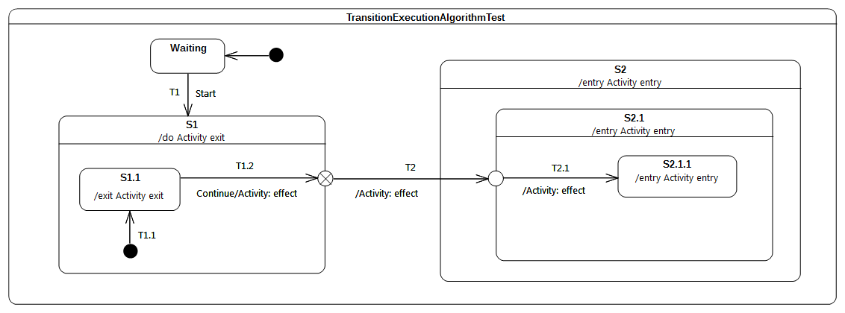Figure 9.81 - TransitionExecutionAlgorithmTest Classifier behavior

Test execution
Received event occurrence(s)
- Start – received when in configuration wait.
- Continue – received when in configuration S1[S1.1].
Generated trace
- S1.1(exit)::T1.2(effect)::S1(exit)::T2(effect)::S2(entry)::S2.1(entry)::T2.1(effect)
Note. Consider the situation where the state machine is in configuration S1[S1.1]. There are two events available in the pool: the first one is the completion event for S1.1 and the second is a Continue event occurrence. The completion event gets dispatched first. It does not initiate an RTC step, since S1.1 has no completion transition and, therefore, the event occurrence is lost. When the completion event occurrence is dispatched, it triggers T1.2. State S1.1 is exited, the T1.2 effect behavior is executed, and the exit point placed on the edge of S1 is reached. This exit point implies exiting S1 and traversal of the continuation transition T2. This leads the state machine to reach the entry point placed on the edge of S2.1. At this point, S2 is entered first and the continuation transition T2.1 is traversed. This means that at the conclusion of the RTC step, S2.1.1 is entered and its entry behavior is executed.
RTC Steps
Step | Event pool | State machine configuration | Fired transition(s)
1 | [] | [] - Initial RTC step | [IntialTransitin]
2 | [Start, CE(wait)] | [wait] | []
3 | [Start] | [wait] | [T1(T1.1)]
4 | [Continue, CE(S1.1)] | [S1[S1.1]] | []
5 | [Continue] | [S1[S1.1]] | [T1.2(T2, T2.1)]
6 | [CE(2.1.1)] | [S2[S2.1[S2.1.1]]] | []

Test Coverage and Traceability

Overview
This subclause presents the complete set of semantic requirements that have been identified for PSSM and shows the coverage of those requirements by the tests in the test suite (as presented in 9.3). The requirements are grouped into the same categories as the tests. The requirements for each category are presented in a table that list, for each requirement, a unique identifier, a description and references to any related tests (or a note as to why the requirements is not testable).
Submission Note. In those cases in which tests for a requirement have not been included in the test suite for this submission, but are planned to be included in the revised submission, the note “To be provided” is given in the “Test(s)” column.

Behavior
ID | Description | Test(s)
Behavior 001 | A State may have an associated entry Behavior. This Behavior, if defined, is executed whenever the State is entered through an external Transition. | See 9.3.2.2
Behavior 002 | A State may also have an associated exit Behavior, which, if defined, is executed whenever the State is exited. | See 9.3.2.3
Behavior 003 | A State may also have an associated doActivity Behavior. This Behavior commences execution when the State is entered (but only after the State entry Behavior has completed) and executes concurrently with any other Behaviors that may be associated with the State, until it completes (in which case a completion event is generated) or the State is exited, in which case execution of the doActivity Behavior is aborted. | See 9.3.2.4 and 9.3.2.5.
Behavior 004 | The execution of a doActivity Behavior of a State is not affected by the firing of an internal Transition of that State. | See 9.3.2.6.

Transition
ID | Description | Test(s)
Transition 001 | It may have an associated effect Behavior, which is executed when the Transition is traversed (executed) | See 9.3.3.1.
Transition 002 | The duration of a Transition traversal is undefined, allowing for different semantic interpretations, including both “zero” and non-“zero” time. | See [fUML], 2.4, on the semantics of time in fUML.
Transition 003 | Transitions are executed as part of a more complex compound transition that takes a StateMachine execution from one stable state configuration to another. | There is no dedicated test for this requirement, but it is supported by the tests in 9.3.3.11.
Transition 004 | A transition is said to be reached, when execution of its StateMachine execution has reached its source Vertex (i.e., its source State is in the active state configuration). | This requirement cannot be tested via the test suite model.
Transition 005 | A transition is said to be traversed, when it is being executed (along with any associated effect Behavior) | This requirement cannot be tested via the test suite model.
Transition 006 | A transition is said to be completed, after it has reached its target Vertex | This requirement cannot be tested via the test suite model.
Transition 007 | A Transition may own a set of Triggers, each of which specifies an Event whose occurrence, when dispatched, may trigger traversal of the Transition. | See 9.3.3.2.
Transition 008 | A Transition trigger is said to be enabled if the dispatched Event occurrence matches its Event type | There is no dedicated test for this requirement, but it is supported by the tests in 9.3.3.2 and 9.3.4.8.
Transition 009 | When multiple triggers are defined for a Transition, they are logically disjunctive, that is, if any of them are enabled, the Transition will be triggered | There is no dedicated test for this requirement, but it is supported by the test in 9.3.3.2.
Transition 010 | kind = external means that the Transition exits its source Vertex. If the Vertex is a State, then executing this Transition will result in the execution of any associated exit Behavior of that State | See 9.3.3.3 and 9.3.3.6. Note that a number of other tests also extensively use external transitions.
Transition 011 | kind = local is the opposite of external, meaning that the Transition does not exit its containing State (and, hence, the exit Behavior of the containing State will not be executed) | See 9.3.3.4, 9.3.3.5, 9.3.3.7 and 9.3.3.8.
Transition 012 | kind = internal is a special case of a local Transition that is a self-transition (i.e., with the same source and target States), such that the State is never exited (and, thus, not re-entered), which means that no exit or entry Behaviors are executed when this Transition is executed. | There is no dedicated test for this requirement, but it is supported by the test in 9.3.2.6.
Transition 013 | Transitions whose source Vertex is a composite States are called high-level or group Transitions. If they are external, group Transitions result in the exiting of all substates of the composite State, executing any defined exit Behaviors starting with the innermost States in the active state configuration. | There is no dedicated test for this requirement, but it is supported by the test in 9.3.6.4.
Transition 014 | In case of local Transitions, the exit Behaviors of the source state and the entry Behaviors of the target State will be executed, but not those of the containing State | There is no dedicated test for this requirement, but it is supported by the test in 9.3.3.4.
Transition 015 | In case of simple States, a completion event is generated when the associated entry and doActivity Behaviors have completed executing | See 9.3.3.9.
Transition 016 | If no such Behaviors are defined, the completion event is generated upon entry into the State. | See 9.3.3.10.
Transition 017 | For composite States, a completion event is generated under the following circumstances: All internal activities (e.g., entry and doActivity Behaviors) have completed execution, and all its orthogonal Regions have reached a FinalState | See 9.3.3.11.
Transition 019 | If two or more completion events corresponding to multiple orthogonal Regions occur simultaneously (i.e., as a result of the same Event occurrence), the order in which such completion occurrences are processed is not defined. | See 9.3.3.12.
Transition 020 | Completion events have dispatching priority. That is, they are dispatched ahead of any pending Event occurrences in the event pool. | See 9.3.3.13.
Transition 021 | Completion of all top level Regions in a StateMachine corresponds to a completion of the Behavior of the StateMachine and results in its termination. | There is no dedicated test for this requirement, but it is supported by the tests in 9.3.3.11 and 11.1.5.1.
Transition 022 | A Transition may have an associated guard Constraint. Transitions that have a guard which evaluates to false are disabled. | See 9.3.3.14.
Transition 023 | Guards are evaluated before the compound transition that contains them is enabled, unless they are on Transitions that originate from a choice Pseudostate | To be provided.
Transition 024 | In the latter case, the guards are evaluated when the choice point is reached | There is no dedicated test for this requirement, but it is supported by the tests in 11.1.1.2, 11.1.1.3 and 11.1.1.4.
Transition 025 | A Transition that does not have an associated guard is treated as if it has a guard that is always true. | There is no dedicated test for this requirement, but it is supported by the tests in 9.3.3.2 and 9.3.3.11.
Transition 026 | Branching in a compound transition execution occurs whenever an executing Transition performs a default entry into a State with multiple orthogonal Regions, with a separate branch created for each Region, or when a fork Pseudostate is encountered. The overall behavior that results from the execution of a compound transition is a partially ordered set of executions of Behaviors associated with the traversed elements, determined by the order in which the elements (Vertices and Transitions) are encountered | There is no dedicated test for this requirement, but it is supported by the tests in 9.3.3.11 and 9.3.5.6.
Transition 027 | If a choice or join point is reached with multiple outgoing Transitions with guards, a Transition whose guard evaluates to true will be taken. If more than one guard evaluates to true, one of these Transitions is chosen for continuing the traversal. The algorithm for making this selection is undefined. (p.329) | See 11.1.1.3 (for choice). (Join to be provided.)

Event
ID | Description | Test(s)
Event 001 | Upon creation, a StateMachine will perform its initialization during which it executes an initial compound transition prompted by the creation, after which it enters a wait point. In case of StateMachine Behaviors, a wait point is represented by a stable state configuration. It remains thus until an Event stored in its event pool is dispatched. | See 9.3.4.2. Note that all tests start executing as described in this requirement.
Event 002 | This Event is evaluated and, if it matches a valid Trigger of the StateMachine and there is at least one enabled Transition that can be triggered by that Event occurrence, a single StateMachine step is executed. | See 9.3.4.3.
Event 003 | A step involves executing a compound transition and terminating on a stable state configuration. | There is no dedicated test for this requirement, but it is supported by the tests in 10.1.1.2 and 9.3.5.6.
Event 004 | It is possible for multiple mutually exclusive Transitions in a given Region to be enabled for firing by the same Event occurrence. In those cases, only one is selected and executed. Which of the enabled Transitions is chosen is determined by the Transition selection algorithm described below. The set of Transitions that will fire are the Transitions in the Regions of the current state configuration that satisfy the following conditions: All Transitions in the set are enabled. There are no conflicting Transitions within the set. There is no Transition outside the set that has higher priority than a Transition in the set (that is, enabled Transitions with highest priorities are in the set while conflicting Transitions with lower priorities are left out). | There is no dedicated test for this requirement, but it is supported by the tests in 9.3.4.7 and 9.3.4.9.
Event 005 | StateMachines can respond to any of the Event types described in Clause 13 as well as to completion events. | To be provided.
Event 006 | Event occurrences are detected, dispatched, and processed by the StateMachine execution, one at a time. | This is covered by fUML CommonBehavior semantics that are not changed by PSSM. The required behavior can be observed in all PSSM tests.
Event 007 | Run-to-completion means that, in the absence of exceptions or asynchronous destruction of the context Classifier object or the StateMachine execution, a pending Event occurrence is dispatched only after the processing of the previous occurrence is completed and a stable state configuration has been reached. That is, an Event occurrence will never be dispatched while the StateMachine execution is busy processing the previous one. | This is covered by fUML CommonBehavior semantics that are not changed by PSSM. The required behavior can be observed in all PSSM tests.
Event 008 | When an Event occurrence is detected and dispatched, it may result in one or more Transitions being enabled for firing. If no Transition is enabled and the corresponding Event type is not in any of the deferrableTriggers lists of the active state configuration, the dispatched Event occurrence is discarded and the run-to-completion step is completed trivially. | See 9.3.4.4.
Event 009 | It is possible that multiple Transitions (in different Regions) can be triggered by the same Event occurrence. The order in which these Transitions are executed is left undefined. | See 9.3.4.5. (But see also 9.3.4.9.)
Event 010 | it is possible for multiple mutually exclusive Transitions in a given Region to be enabled for firing by the same Event occurrence. In those cases, only one is selected and executed. Which of the enabled Transitions is chosen is determined by the Transition selection algorithm described below. | See 9.3.4.6.
Event 011 | When all orthogonal Regions have finished executing the Transition, the current Event occurrence is fully consumed, and the run-to-completion step is completed. | There is no dedicated test for this requirement, but it is supported by the test in 9.3.4.5.
Event 013 | During a Transition, a number of actions Behaviors may be executed. If such a Behavior includes a synchronous invocation call on another object executing a StateMachine, then the Transition step is not completed until the invoked object method completes its run-to-completion step. (p.330). | To be provided.
Event 014 | A Transition is enabled if and only if: 1 All of its source States are in the active state configuration. 2 At least one of the triggers of the Transition has an Event that is matched by the Event type of the dispatched Event occurrence. In case of Signal Events, any occurrence of the same or compatible type as specified in the Trigger will match. If one of the Triggers is for an AnyReceiveEvent, then either a Signal or CallEvent satisfies this Trigger, provided that there is no other Signal or CallEvent Trigger for the same Transition or any other Transition having the same source Vertex as the Transition with the AnyReceiveEvent trigger (see also 13.3.1). 3 If there exists at least one full path from the source state configuration to either the target state configuration or to a dynamic choice Pseudostate in which all guard conditions are true (Transitions without guards are treated as if their guards are always true). | AnyReceiveEvents are not included in PSSM. (CallEvents to be provided.)
Event 015 | It is possible for more than one Transition to be enabled within a StateMachine. If that happens, then such Transitions may be in conflict with each other. For example, consider the case of two Transitions originating from the same State, triggered by the same event, but with different guards. If that event occurs and both guard conditions are true, then at most one of those Transition can fire in a given run-to-completion step | See 9.3.4.7.
Event 016 | In situations where there are conflicting Transitions, the selection of which Transitions will fire is based in part on an implicit priority. These priorities resolve some but not all Transition conflicts, as they only define a partial ordering. The priorities of conflicting Transitions are based on their relative position in the state hierarchy. By definition, a Transition originating from a substate has higher priority than a conflicting Transition originating from any of its containing States. The priority of a Transition is defined based on its source State. | See 9.3.4.8 and 9.3.4.9.
Event 017 | The priority of Transitions chained in a compound transition is based on the priority of the Transition with the most deeply nested source State. | To be provided.
Event 018 | Once a Transition is enabled and is selected to fire, the following steps are carried out in order: 1. Starting with the main source State, the States that contain the main source State are exited according to the rules of State exit (or, composite State exit if the main source State is nested) as described earlier. 2. The series of State exits continues until the first Region that contains, directly or indirectly, both the main source and main target states is reached. The Region that contains both the main source and main target states is called their least common ancestor. At that point, the effect Behavior of the Transition that connects the sub-configuration of source States to the sub-configuration of target States is executed. (A “sub-configuration” here refers to that subset of a full state configuration contained within the least common ancestor Region.) 3. The configuration of States containing the main target State is entered, starting with the outermost State in the least common ancestor Region that contains the main target State. The execution of Behaviors follows the rules of State entry (or composite State entry) described earlier. | See 9.3.4.12 and 11.1.8.2.

Entering
ID | Description | Test(s)
Entering 001 | The rule for this case is the same as for shallow history except that the target Pseudostate is of type deepHistory and the rule is applied recursively to all levels in the active state configuration below this one. | To be provided.
Entering 002 | if a doActivity Behavior is defined for the State, this Behavior commences execution immediately after the entry Behavior is executed. It executes concurrently with any subsequent Behaviors associated with entering the State, such as the entry Behaviors of substates entered as part of the same compound transition. | There is no dedicated test for this requirement, but it is supported by the tests in 9.3.2.4 and 9.3.2.5.
Entering 003 | If the incoming Transition terminates on a shallowHistory Pseudostate of a Region of the composite State, the active substate becomes the substate that was most recently active prior to this entry. | To be provided.
Entering 004 | If no initial Pseudostate is defined, there is no single approach defined. One alternative is to treat such a model as ill formed. A second alternative is to treat the composite State as a simple State, terminating the traversal on that State despite its internal parts. | See 9.3.5.2.
Entering 005 | If the incoming Transition or its continuations terminate on a directly contained substate of the composite State, then that substate becomes active and its entry Behavior is executed after the execution of the entry Behavior of the containing composite State. This rule applies recursively if the Transition terminates on an indirect (deeply nested) substate. | See 9.3.5.3,
Entering 006 | The rule for this case is the same as for shallow history except that the target Pseudostate is of type deepHistory and the rule is applied recursively to all levels in the active state configuration below this one. | To be provided.
Entering_007 | Rules described in Entering_006 do not apply in the case where the most recently active substate is the FinalState, or this is the first entry into this State. In the latter two cases, if a default shallow history Transition is defined originating from the shallowHistory Pseudostate, it will be taken. Otherwise, default State entry is applied. | To be provided.
Entering 009 | If a Transition enters a composite State through an entryPoint Pseudostate, then the effect Behavior associated with the outgoing Transition originating from the entry point and penetrating into the State (but after the entry Behavior of the composite State has been executed). | See 9.3.5.4.
Entering 010 | If the composite State is also an orthogonal State with multiple Regions, each of its Regions is also entered, either by default or explicitly. | See 9.3.5.5.
Entering 011 | If the Transition terminates on the edge of the composite State (i.e., without entering the State), then all the Regions are entered using the default entry rule above. | See 9.3.5.6. Also supported by 9.3.3.11.
Entering 012 | If the Transition explicitly enters one or more Regions (in case of a fork), these Regions are entered explicitly and the others by default. | There is no dedicated test for this requirement, but it is supported by the test in 11.1.2.2.
Entering 013 | Regardless of how a State is entered, the StateMachine is deemed to be “in” that State even before any entry Behavior or effect Behavior (if defined) of that State start executing. | This requirement cannot be tested via the test suite model.

Exiting
ID | Description | Test(s)
Exiting 001 | When exiting a State, regardless of whether it is simple or composite, the final step involved in the exit, after all other Behaviors associated with the exit are completed, is the execution of the exit Behavior of that State. | See 9.3.6.2.
Exiting 002 | If the State has a doActivity Behavior that is still executing when the State is exited, that Behavior is aborted before the exit Behavior commences execution | See 9.3.6.3.
Exiting 003 | When exiting from a composite State, exit commences with the innermost State in the active state configuration. This means that exit Behaviors are executed in sequence starting with the innermost active State. | See 9.3.6.4.
Exiting 004 | If the exit occurs through an exitPoint Pseudostate, then the exit Behavior of the State is executed after the effect Behavior of the Transition terminating on the exit point. | See 9.3.6.5.
Exiting 005 | When exiting from an orthogonal State, each of its Regions is exited. After that, the exit Behavior of the State is executed | See 9.3.6.6.
Exiting 006 | Regardless of how a State is exited, the StateMachine is deemed to have “left” that State only after the exit Behavior (if defined) of that State has completed execution. | This requirement cannot be tested via the test suite model.

Encapsulated
ID | Description | Test(s)
Encaps 001 | Entry points represent termination points (sources) for incoming Transitions and origination points (targets) for Transitions that terminate on some internal Vertex of the composite State. In effect, the latter is a continuation of the external incoming Transition, with the proviso that the execution of the entry Behavior of the composite State (if defined) occurs between the effect Behavior of the incoming Transition and the effect Behavior of the outgoing Transition. | There is no dedicated test for this requirement, but it is supported by the test in 9.3.7.4
Encaps 002 | If there is no outgoing Transition inside the composite State, then the incoming Transition simply performs a default State entry. | There is no dedicated test for this requirement, but it is supported by the test in 9.3.7.5.
Encaps 003 | Exit points are the inverse of entry points. That is, Transitions originating from a Vertex within the composite State can terminate on the exit point. In a well-formed model, such a Transition should have a corresponding external Transition outgoing from the same exit point, representing a continuation of the terminating Transition. If the composite State has an exit Behavior defined, it is executed after any effect Behavior of the incoming inside Transition and before any effect Behavior of the outgoing external Transition. | There is no dedicated test for this requirement, but it is supported by the test in 10.1.1.2.

Entry
ID | Description | Test(s)
Entry 001 | If the owning State has an associated entry Behavior, this Behavior is executed before any behavior associated with the outgoing Transition. | There is no dedicated test for this requirement, but it is supported by the tests in 9.3.2.4, 9.3.2.5. Note that most of the tests extensively use entry behaviors on states and effect behaviors on transitions.
Entry 002 | In addition to Entry_001, if multiple Regions are involved, the entry point acts as a fork Pseudostate. | See 9.3.7.2.

Exit
ID | Description | Test(s)
Exit 001 | Transitions terminating on an exit point within any Region of the composite State implies exiting of this composite (with execution of its associated exit Behavior). | See 10.1.1.2.
Exit 002 | If multiple Transitions from orthogonal Regions within the State terminate on this Pseudostate, then it acts like a join Pseudostate. | See 10.1.1.3.

Choice
ID | Description | Test(s)
Choice 001 | The guard Constraints on all outgoing Transitions are evaluated dynamically, when the compound transition traversal reaches this Pseudostate. | See 11.1.1.2.
Choice 002 | If more than one guard evaluates to true, one of the corresponding Transitions is selected. The algorithm for making this selection is not defined. | See 11.1.1.3.
Choice 003 | If none of the guards evaluates to true, then the model is considered ill formed. To avoid this, it is recommended to define one outgoing Transition with the predefined “else” guard for every choice Pseudostate. | See 11.1.1.4.

Join
ID | Description | Test(s)
Join 001 | All incoming Transitions have to complete before execution can continue through an outgoing Transition. | See 11.1.3.2 and 11.1.3.3.

Terminate
ID | Description | Test(s)
Terminate 001 | Entering a terminate Pseudostate implies that the execution of the StateMachine is terminated immediately. The StateMachine does not exit any States nor does it perform any exit Behaviors. | See 11.1.4.2 and 11.1.4.4.
Terminate 002 | Any executing doActivity Behaviors are automatically aborted. Entering a terminate Pseudostate is equivalent to invoking a DestroyObjectAction. | See 11.1.4.3.

Final
ID | Description | Test(s)
Final 001 | FinalState is a special kind of State signifying that the enclosing Region has completed. Thus, a Transition to a FinalState represents the completion of the behaviors of the Region containing the FinalState. | See 11.1.5.2.

Deferred
ID | Description | Test(s)
Deferred 001 | A State may specify a set of Event types that may be deferred in that State. This means that Event occurrences of those types will not be dispatched as long as that State remains active. Instead, these Event occurrences remain in the event pool until a state configuration is reached where these Event types are no longer deferred. | See 11.1.6.2.
Deferred 002 | if a deferred Event type is used explicitly in a Trigger of a Transition whose source is the deferring State. | See 11.1.6.3.
Deferred 003 | An Event may be deferred by a composite State, in which case it remains deferred as long as the composite State remains in the active configuration | See 11.1.6.4.
Submission Note. There are two additional tests for deferred event semantics which are not directly related to a requirement, included in 11.1.6.5 and 11.1.6.6. They assess the usage of deferred events in the context of orthogonal regions. Execution sequences produced by both tests are still under discussion.

History
ID | Description | Test(s)
History 001 | Deep history (deepHistory) represents the full state configuration of the most recent visit to the containing Region. The effect is the same as if the Transition terminating on the deepHistory Pseudostate had, instead, terminated on the innermost State of the preserved state configuration, including execution of all entry Behaviors encountered along the way | To be provided.
History 002 | In cases where a Transition terminates on a history Pseudostate when the State has not been entered before (i.e., no prior history) or it had reached its FinalState, there is an option to force a transition to a specific substate, using the default history mechanism. This is a Transition that originates in the history Pseudostate and terminates on a specific Vertex (the default history state) of the Region containing the history Pseudostate. This Transition is only taken if execution leads to the history Pseudostate and the State had never been active before. Otherwise, the appropriate history entry into the Region is executed (see above) | To be provided.
History 003 | If no default history Transition is defined, then standard default entry of the Region is performed | To be provided.
History 004 | A Transition terminating on this Pseudostate implies restoring the Region to that same state configuration, but with all the semantics of entering a State (see the Subclause describing State entry). The entry Behaviors of all States in the restored state configuration are performed in the appropriate order starting with the outermost State | To be provided.
History 005 | Represents the most recent active substate of its containing Region, but not the substates of that substate. A Transition terminating on this Pseudostate implies restoring the Region to that substate with all the semantics of entering a State. A single outgoing Transition from this Pseudostate may be defined terminating on a substate of the composite State. This substate is the default shallow history state of the composite State. | To be provided.

Junction
ID | Description | Test(s)
Junction 001 | Junction pseudo state can be used to split an incoming Transition into multiple outgoing Transition segments with different guard Constraints. Such guard Constraints are evaluated before any compound transition containing this Pseudostate is executed | To be provided.
Junction 002 | It may happen that, for a particular compound transition, the configuration of Transition paths and guard values is such that the compound transition is prevented from reaching a valid state configuration. In those cases, the entire compound transition is disabled even though its Triggers are enabled | To be provided.
Junction 003 | If more than one guard evaluates to true, one of these is chosen. The algorithm for making this selection is not defined. | To be provided.

Region
ID | Description | Test(s)
Region 001 | A Region becomes active (i.e., it begins executing) either when its owning State is entered or, if it is directly owned by a StateMachine (i.e., it is a top level Region), when its owning StateMachine starts executing. | There is no dedicated test for this requirement, but it is supported by the tests in 9.3.5.6 and 11.1.5.2.
Region 002 | A default activation of a Region occurs if the Region is entered implicitly, that is, it is not entered through an incoming Transition that terminates on one of its component Vertices (e.g., a State or a history Pseudostate), but either through a (local or external) Transition that terminates on the containing State or, in case of a top level Region, when the StateMachine starts executing. Default activation means that execution starts with the Transition originating from the initial Pseudostate of the Region, if one is defined. no specific approach is defined if there is no initial Pseudostate exists within the Region. One possible approach is to deem the model ill defined. An alternative is that the Region remains inactive, although the State that contains it is active. In other words, the containing composite State is treated as a simple (leaf) State. | There is no dedicated test for this requirement, but it is supported by the tests in 9.3.5.6 and 9.3.7.5.
Region 003 | An explicit activation occurs when a Region is entered by a Transition terminating on one of the Region’s contained Vertices. When one Region of an orthogonal State is activated explicitly, this will result in the default activation of all of its orthogonal Regions, unless those Regions are also entered explicitly (multiple orthogonal Regions can be entered explicitly in parallel through Transitions originating from the same fork Pseudostate). | There is no dedicated test for this requirement, but it is supported by the tests in 9.3.7.3 and 11.1.2.2.

Configuration
ID | Description | Test(s)
Config 001 | A particular “state” of an executing StateMachine instance is represented by one or more hierarchies of States, starting with the topmost Regions of the StateMachine and down through the composition hierarchy to the simple, or leaf, States. Similarly, we can talk about such a hierarchy of substates within a composite State. This complex hierarchy of States is referred to as a state configuration (of a State or a StateMachine) | This requirement cannot be tested via the test suite model.
Config 002 | An executing StateMachine instance can only be in exactly one state configuration at a time, which is referred to as its active state configuration | This requirement cannot be tested via the test suite model.
Config 003 | A State is said to be active if it is part of the active state configuration. | This requirement cannot be tested via the test suite model.
Config 004 | A state configuration is said to be stable when no further Transitions from that state configuration are enabled and all the entry Behaviors of that configuration, if present, have completed (but not necessarily the doActivity Behaviors of that configuration, which, if defined, may continue executing). A configuration is deemed stable even if there are deferred, completion, or any other types of Event occurrences pending in the event pool of that StateMachine | This requirement cannot be tested via the test suite model.
Config 005 | After it has been created and completed its initial Transition, a StateMachine is always “in” some state configuration. However, because States can be hierarchical and because there can be Behaviors associated with both Transitions and States, “entering” a hierarchical state configuration involves a dynamic process that terminates only after a stable state configuration (as defined above) is reached. | This requirement cannot be tested via the test suite model.

- Protocol State Machines
(informative)
  - Overview
ProtocolStateMachines are intended to specify some constraints on sequences of interactions supported by an associated classifier behavior together with their expected outcomes.
According to the UML 2.5 specification, violation of a constraint specified by a ProtocolStateMachine at run time shall result in an exception to be raised. However, since the fUML version upon which this specification is built [fUML] does not support exceptions, it is not possible to define an executable semantics for ProtocolStateMachines. Instead, this annex provides a precise but non-normative interpretation of the UML semantics for ProtocolStateMachines.
This interpretation assumes the following restrictions:
- ProtocolConformance is excluded since the real conformance of one protocol to another depends the valid interaction sequences actually allowed be each of them and cannot simply be claimed.
- Protocols specify contracts constraining all the involved entities. ProtocolsStateMachines are given semantics only in the case where they control binary interactions. This specification constrains them to be associated with an Interface
- There can be more than one protocol defined for given Classifier. The precise semantics specified below assumes that only one protocol is controlling a given interaction. ProtocolsStateMachines are constrained to be associated with a Port, which identifies an interaction point where the protocol applies.
- Neither Operation::precondition nor Operation::postcondition are derived. Therefore, it is not possible to compute them according to the preconditions and the postconditions of enabled ProtocolTransitions they are associated with. Instead, this specification assumes that the constraint implied by an enabled ProtocolTransition is the result of a logical “and” between the preconditions and the postconditions, respectively, of both the protocol transition and its associated operation.
  - Abstract Syntax
Figure A.1 shows classes related to protocol state machines in the StateMachines package from the UML abstract syntax. ProtocolConformance has been excluded from this subset, since it is a declarative statement that can be derived from the actual definition of the involved ProtocolStateMachine.
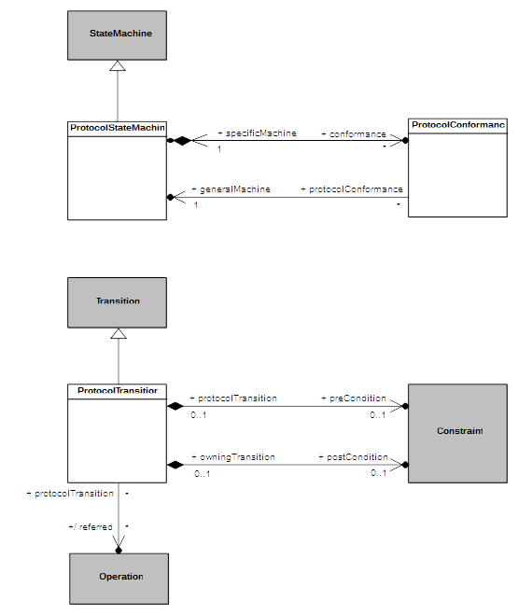Figure A.1 - ProtocolStateMachines
  - Semantics
    - Controlled Events
Interactions controlled by a ProtocolStateMachine are restricted to event occurrences for which this state machine has at least one trigger defined. An occurrence of such a controlled event violates the protocol specified by a ProtocolStateMachine if it is not explicitly allowed according to the current state of the protocol.
    - Protocol States Configuration
The initial state configuration of the protocol is defined according the initial Pseudostate of each active Region within the ProtocolStateMachine. For each occurrence of an event controlled by the ProtocolStateMachine which is not invalid, the corresponding ProtocolTransition is fired, which result in the target State to become the active protocol state.
    - Protocol Violation
A protocol violation shall result in an exception being raised. This occurs in the following cases:
- An occurrence of a controlled event is received while it is invalid. That is, there is no enabled ProtocolTransition for that event for which the precondition is satisfied. In cases where that event is a CallEvent, this precondition is computed as a logical “and” between the ProtocolTransition::precondition and the CallEvent::operation::precondition.
- The postcondition of the ProtocolTransition activated following the occurrence of a controlled event linked o the invocation of a BehavioralFeature is not met when the execution of the corresponding method ends. In cases where that event is a CallEvent, this postcondition is computed as a logical “and” between the ProtocolTransition:: postcondition and the CallEvent::operation::postcondition.

- State Machines for Passive Classes
(Informative)
  - Background and Rationale
The precise execution semantics for StateMachines in the main body of this specification covers the cases in which a StateMachine is either used as the classifierBehavior of an active Class or executes itself as a “standalone” active Behavior. However, StateMachines have also been used to specify the behavior of passive Classes, and support for this can be found in existing UML tools. This annex discusses the semantics of this usage, which are different than the semantics of StateMachines used with active Classes.
To help understand how the behavior of passive classes can be described using StateMachines, it is useful to recall that an essential characteristic of StateMachine behavior is that a response to a particular stimulus (e.g., a CallEvent occurrence) depends on the object’s history; that is, the nature and order of preceding stimuli received by that object. In StateMachines for active Classes, this information is captured concisely by the current State of an object’s classifierBehavior. However, when dealing with passive objects, which do not have a classifierBehavior, this means that, in the general case, each method of the Class of the object needs to include a conditional branch to handle the different responses based on some internal value that, in effect, represents the history of the object.
Consider, for example, the simplest case of a Stack Class shown in Figure B.1. Note that the response to a “pop” Operation will depend on whether the stack is empty or not. Similarly, assuming that the stack is of limited capacity, the response to a “push” Operation will differ when the stack is full compared to when it is not full.
Of course, this can be coded explicitly by defining a suitable local variable of the object (e.g., “stack size”) and using appropriate action language conditional statements. However, this not only obscures the true nature of the behavior in question, but, because it relies on relatively low-level (i.e., “manual”) coding, it is also more error prone and requires more effort by the modeler. This approach becomes increasingly more problematic as the complexity of the behavior grows.

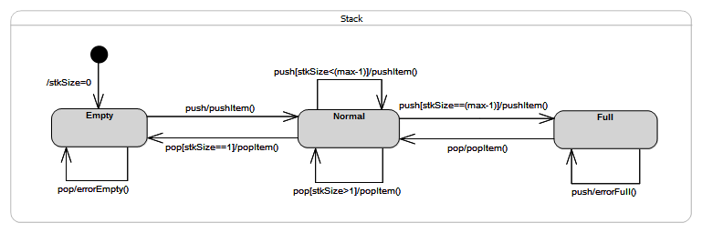Figure B.1 - Stack Example

Hence, the motivations behind supporting StateMachine specifications of passive Class behaviors are to reduce the burden on the modeler, to more clearly describe an object’s behavior using a higher-level formalisms, and to increase both reliability and productivity.
  - Semantics
To avoid gratuitous differences from the familiar semantics of active StateMachines, the general strategy taken here is to be fully consistent with those semantics wherever possible. Note that this approach covers both passive Classes as well as stand-alone passive StateMachines (which are, after all, Classes as well).
The core idea behind the approach is straightforward: map the StateMachine specification into an equivalent set of behavioral fragments and conditional statements distributed across the appropriate methods. For example, all three transitions triggered by the “pop” CallEvent in the Stack example above, would be mapped to appropriate conditional statement cases of a single “pop” Operation method. The control variable of such a statement would correspond to the current state of the StateMachine. This is illustrated by the following pseudocode for the method of the “pop” Operation:
operation pop(): Item {
case (state) {
'Empty': errorEmpty();
'Normal': if (stkSize == 1) then
{popItem();
nextState('Empty');}
else
popItem();
'Full': {popItem();
nextState('Normal');}
};
}
Furthermore, any action associated with the initial Transition would be mapped to the method of the Class constructor.
Of course, in addition to the lack of a classifierBehavior, one key difference between active and passive Class semantics is in how the Transition triggering mechanism works. For active Classes, triggering is realized by a dedicated scheduling and dispatch mechanism, which is external to the StateMachine instance. Among other responsibilities, this mechanism also ensures that run-to-completion semantics are enforced. In contrast, no such mechanism exists for passive Classes; the methods of a passive Class are executed synchronously when some calling behavior invokes the corresponding Operation. Consequently, if two or more concurrently executing behaviors make overlapping calls to the same passive object, there is a possibility of concurrency conflicts that would violate the run-to-completion semantics. (Note that this can occur even if all of the Operations of the passive class are declared as “guarded”, since that only prevents a given Operation being invoked concurrently. However, it would still be possible to concurrently invoke two or more different Operations of the passive class.)
Therefore, to ensure run-to-completion semantics of a passive-Class StateMachine, it is necessary that, for any passive Class whose behavior is defined by a StateMachine, at most one Operation call can be executed (to completion) at a time. This restriction avoids unsafe and error prone designs, and it is consistent the core semantic tenets of UML StateMachines.

UML Profile for MARTE: Modeling and Analysis of Real-time Embedded Systems, OMG document formal/11-06-02, subclauses 7.2.2 to 7.2.5.
OMG Unified Modeling Language, Version 2.1, OMG document ptc/2006-04-02.
The code for this prototype is publicly available in the Eclipse Git repository, at http://git.eclipse.org/c/papyrus/org.eclipse.papyrus.git/tree/extraplugins/moka/org.eclipse.papyrus.moka.fuml.statemachines?h=bugs/465888-SMExecPrototype.
See https://wiki.eclipse.org/Papyrus/UserGuide/ModelExecution.
The exact type and format of such a variable are of no concern here; implementers are free to chose their own.
To simplify the example, we assume here that there are no entry, exit, or do behaviors associated with any of the states.

